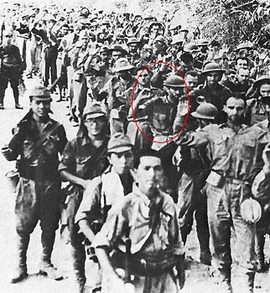
Philip L. Albert
Photo of Albert on left - Bataan Death March.
Albert is circled in red.

Brave soldier, troubled father
My father, the war hero, abandoned his family. He couldn't cope
with the responsibility any longer. Financial burdens overwhelmed
him. Late one Passover night, while I was away at rabbinical college
and my brothers and mother were gathered at my grandparents'
Seder table, he packed his suitcases and departed Chicago for
Florida. His exodus was as rushed as that of the children of Israel
when they ran from Egypt. I never heard from him again.
That was more than 30 years ago. The summer after his departure,
I legally changed my last name from Albert to my mother's maiden
name, Miller. I wanted to deny my father the perpetuation of his
name.
As a Marine, my father had been captured at Bataan and suffered through the Death March. Purple Hearts and a Bronze Star adorned his record. He endured years in the coal mines of Japan but never spoke of his experiences.
He once said that no one would ever understand. I hungered to know more but had to content myself with looking at the most famous photo of the march. It featured my father, hands raised, emaciated.
I was ashamed of the man as a father but was proud of the man as a war hero. As such, I became the keeper of the medals he left behind and had them framed to hang in my rabbinical study. Occasionally, I would read books on the Death March. The one that impressed me most was "My Hitch in Hell" by Lester Tenney, who, like my father, was a young Jewish soldier from Chicago. I resolved to find him and invite him to address my congregation in Newport Beach, Calif. I located him near San Diego, and he warmly accepted my invitation.
I showed him my father's medals and ribbons, and he explained their significance. The last piece of memorabilia I showed him was a yellowed and frayed telegram from the Marine Corps, addressed to my father's parents, informing them of their son's capture. Tenney stared at the telegram and was silent for several minutes. Finally, he asked: "Your father's last name was Albert? But yours is Miller..." "Yes," I answered, "I changed it due to some unfortunate developments."
The 84-year-old man looked at me and said, "Your father was one of my best buddies. We were on the same transport together and we slaved side by side in the mines of Fukuoka Camp 17 for almost four years. We celebrated Rosh Hashana and Yom Kippur together while our friends stood guard, we talked all the time about what we would do if we were ever freed…Phil Albert! You're his son? My God, why didn't you say so?" He then began to tell me about his buddy, filling in what my father had refused to reveal to a young son. Before he left, we spoke of my father's flight from home. Tenney suggested that the war and the march and the camps changed people. Sometimes this alteration manifested itself only years later.
As a rabbi, I have taught Judaism's insistence on personal responsibility and moral accountability. No excuses or evasions are accepted. But how I wanted, at that moment -- and today, on the eve of Father's Day - to accept Tenney's hypothesis that my father's cowardly action in the early 1970s was not his fault, but a result of the torture and fear, the deprivation and starvation that a young Marine suffered 30 years earlier.
I often tell my congregants that although we do not live in the past, we live with the past. And maybe, as Tenney suggested, the past was too much with my father. My belief that you are responsible for your own actions quaked before the rush of desire to accept the diagnosis of my father's friend. The rabbi believed one thing. The son wanted to believe another.
Credit: by Mark S. Miller Los Angeles Times

