Robert Leroy Aldrich

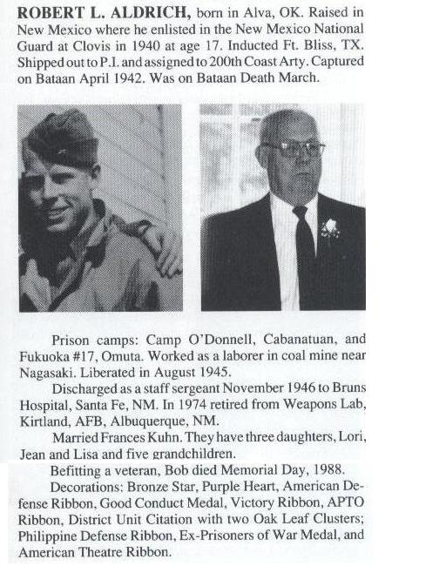
Robert Leroy Aldrich was born in Alva, OK. and raised in New Mexico where he enlisted in the New Mexico National Guard at Clovis in 1940 -when he was just 17. Induction was at Ft. Bliss, Texas and Robert (called Bobby) was soon sent to the Philippines, where he was assigned to the 200th Coastal Artillery. Captured on Bataan, Robert was forced to endure the infamous Bataan Death March.

His Prisoner of War camps: O'Donnell, Cabantuan and then sent to Manila for departure to Japan by hellship. After a 15 day journey from Manila to Moji aboard the Clyde Maru (known to the men as the Mate Mate Maru),
Robert was one of the first 500 POWs to arrive at Camp #17 on 10 Aug 1943.

After the war, Robert was liberated. He was discharged as a Staff Sergeant in November 1946, having been hospitalized in Bruns Hospital, Santa Fe New Mexico for almost a year.
"When Grandpa Bobby returned home from the war, doctors had to remove a piece of bone from his knee to place in his back or spine because of the damage from slave labor while mining. He had to lay in a hospital bed for a bout a year on his belly while it healed. The doctors told him he would never walk again, however he forced himself to learn how to walk with a cane. Some of this paperwork has clippings from his journal about Japanese "war crimes."
About 10 years ago I came across a page from his journal that explained in detail, the beating of a man with a bamboo pole- The Japanese had beaten this poor man to a pulp so badly that he could not be recognized, while they were working in the mines. If I remember correctly, his last name was Silva. They had left him there to die in the mine and my grandfather picked this man up and carried him back to the camp. There is also paperwork about suing the Mitsui Corporation for lost wages, etc.
My mother tells me he was once offered one thousand dollars a month for the rest of his life by the Mitsui Corporation if he would just "shut up", but he turned it down because he wanted it for his "buddies" too- not just himself."
Robert's grandson tells some of his grandfather's military path through these experiences ~

"My grandfather was given a sword at the end of the war. The story is that after the bomb was dropped on Nagasaki, my grandfather and this Japanese prison camp guard were both stumbling around the prison camp site and my grandfather showed the guard where he had placed his 'homemade' explosives which were soon to be detonated as a means of escape. It was then that the guard told my grandfather, “You are a very honorable man' and he gave him this sword."
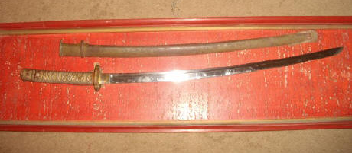
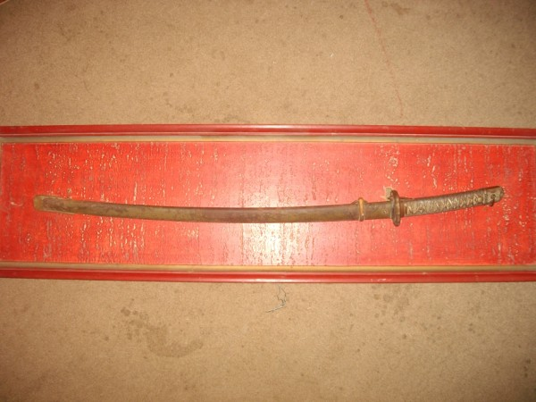

Robert married Frances Kuhn. They had 3 daughters; Lori, Jean and Lisa, and 5 grandchildren.
Michael adds;
"Grandpa Bobby's brother, my great uncle, is still alive in Roswell NM. Grandpa talked him into joining the Army. They both survived The Bataan Death March and were sent to different camps. His name is Jack H. Aldrich. He married a writer named Dorothy Cave, whom has written books on this subject."
“I will forever be amazed at what these soldiers went through and will forever be proud of my Grandpa Bobby. He passed away in St. Augustine, Florida when I was about 7 years old. We, his grandchildren, were playing outside his home when fire trucks and an ambulance pulled up and took him away on a stretcher. He passed later that evening in the hospital. I wish he were still around so I could have all my questions answered, but I am glad to have him watching over me now.”
Submitted by his grandson ~ SPC Michael Hopper NCARNG

