Manuel Armijo
Interview with Manuel Armijo
By Connie Lowe: 12/8/99
Manuel A. Armijo was born in the Albuquerque suburb of Armijo on December 10, 1911 and was raised on a farm close to Manticello. In the 10th grade, Manuel dropped out of school to work for the New Mexico State Highway Department. Later, he joined the Bureau of Child Welfare as a stock boy.
On November 4, 1940, Mr. Armijo married Frances Apodaca in Mora, New Mexico. At the age of 28, he enlisted in the services. By the beginning of 1941, he was on his way to Manila as part of the 200th Coast Artillery (AA) to defend Clark Field from Japanese attack, leaving behind his pregnant wife. When Japan attacked Clark Field, the 200th had been divided into the 200th and 515th Coast Artillery (AA) because Manila also needed defending. Manuel and a fellow soldier, Arthur B. Smith, spotted the Rising Sun under the wings of an airplane and they knew they were under attack. The men battled until April 9, 1942 when they were ordered by General Edward P. King to surrender.
After the surrender, a 55-mile "Death March" began. During this march, Mr. Armijo was denied food and water for the first five days. After the "Death March", he was placed in Camp O’Donnell for 3 months and then he was taken to Camp Cabanatuan where he remained for two years. Mr. Armijo was taken by way of the Mati Maru "Hell Ship" to Omuta, Japan where he remained captive for another year. At the end of that year, Manuel had heard that Japan had surrendered, and he decided to liberate himself. Mr. Armijo and a fellow POW, Ean Garcia, simply left the Japanese labor camp.
The two men made their way to an American air base, then boarded a train, and rode it as far as it went. They walked about ten miles to another air base where they were flown to Manila. By this time, Manuel had lost track of his friend. He remained in Manila until the first of October. He boarded a ship that took 17 days to reach San Francisco. Once he got there, he was taken to Lettermen General Hospital. Finally, on October 28, 1945, Mr. Armijo boarded a hospital train that took him to Santa Fe where he was reunited with his wife and met his three-year-old daughter, Loretta, for the first time.
After World War II, Mr. Armijo returned to the United States. He resumed employment with the State of New Mexico. Manuel is 88 years old, and he is a 30 year state employee retiree.
Manuel and Frances had two more children: Peggy and Manuel; they now have 9 grandchildren: Loreen, Vincent, Dawn, Mark, Nicole, Anthony, Manuel, Jennifer, and Adam. Mr. Armijo still suffers from a crushed disk in his lower back, which was caused when he was hit with the butt of a Japanese rifle. He also suffers from knuckle pain. His knuckles were crushed by a Japanese guard as punishment for eating an onion out of the garden at Camp O’Donnell. The worst thing, however, is that Mr. Armijo still endures are the brutal memories of his days as a Japanese POW.
Bataan Death March Survivor Dies
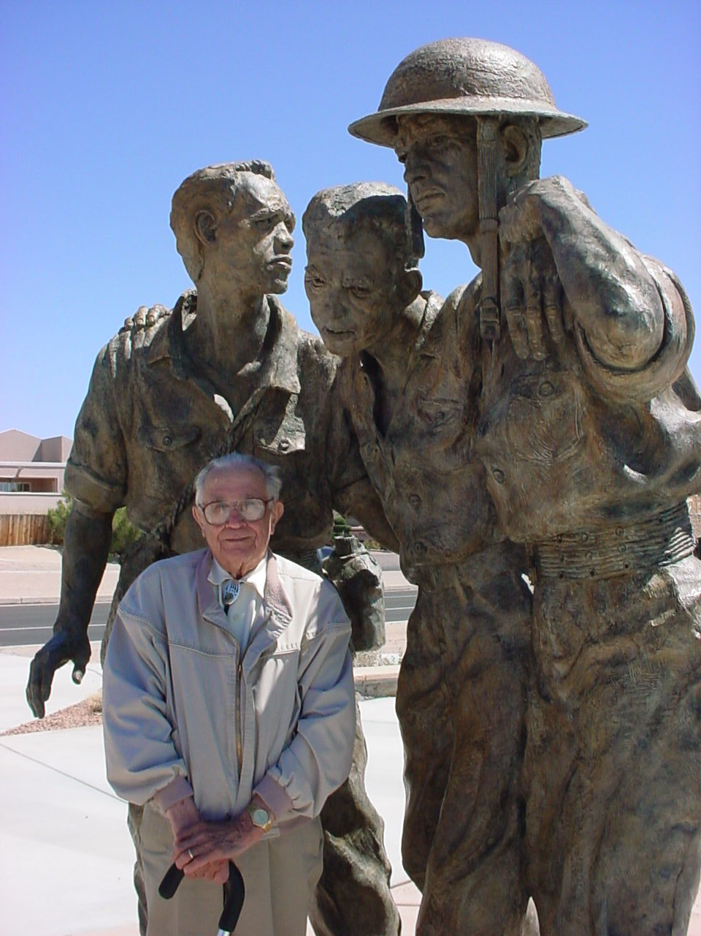
SANTA FE, N.M. - Manuel A. Armijo, of Sante Fe, a veteran of the World War II Bataan Death March who tended to fellow war prisoners through years of brutal captivity, has passed away. Manuel died June 22, 2004 at the age of 92. Family members said Armijo, considered (incorrectly, however) the oldest living survivor of the ordeal, died Tuesday in Santa Fe. He will be buried Friday at the Santa Fe National Cemetery following funeral services at St. John the Baptist Catholic Church.
Armijo, of Santa Fe, and other survivors co-founded the Bataan Memorial Military Museum and Library in Santa Fe and started the annual white-flag surrender anniversary observances held every April 9 near the Capitol. "His heroism and courage will set an example for New Mexicans for generations to come," Gov. Bill Richardson said Wednesday through a spokesman. Armijo's face and words are familiar to historians and others researching the Bataan Death March. He was interviewed for various documentaries and continued to organize the annual surrender observance through this past April, even as his health and vision declined. He gave his last speech at this year's observance. "God has been good to me and my family," he had said. "I'm a little over 92 years old. I'm blind, and I'm tired."
Manuel was born December 10, 1911 in Armijo, New Mexico, the son of Lorenzo and Placida Armijo. He married Frances Apodaca on November 4, 1940 in Mora, New Mexico. He was 29 when he deployed with the New Mexico National Guard in 1940. In August 1941, he visited home one last time before departing for the Philippines. Mr. Armijo was a member of the 200th Coast Artillery serving the Philippines,
Thousands of U.S. and Filipino troops fought off the Japanese for four months before
U.S. Maj. Gen. Edward King ordered the surrender.
Soon after, Armijo and the other prisoners were forced to march 65 miles up the Bataan Peninsula without food, water or medical attention. Those who collapsed along the way were shot or bayoneted. Thousands more died in labor camps or on ships that transported the POWs to camps in Japan, Korea or China.
About 1,800 captives were from New Mexico. Fewer than 900 of them survived. Because he had been appointed first sergeant in his company, Armijo took on the responsibilities of minding fellow prisoners. He repeatedly fought with Japanese captors and insisted on uniting the soldiers from New Mexico at one location. Armijo finally returned home in 1945, but the 3 1/2 years of captivity and forced labor stayed with him. He said he had nightmares and would wake up screaming.
Following his discharge he returned to Santa Fe where he was employed for the WPA Program, later working in the State Government where he was appointed in 1957 as the Director of the State Veterans Service Commission, until he retired in 1966. He was a member of St. John the Baptist Catholic Church. A member and past State Commander, past National Vice-Commander of the VFW, member of the Military Order of the Cooties, Order of the Purple Heart and the American POW Association.
Armijo spent most of his career in state government and was director of the state Veterans Service Commission from 1957 until 1966, when he retired. He was a member of numerous veterans’ organizations.
He was preceded in death by his parents, and his daughters Jenny & Patricia.
He is survived by his loving wife, Frances A. Armijo; three children:
Fred Armijo, Peggy Ruiz, Loretta Lithgow and husband Clarence (Porky);
nine grandchildren, five great grandchildren;
sisters-in law Joesphine Ipotis and Ellen Apodaca
and numerous nieces and nephews and other relatives.

