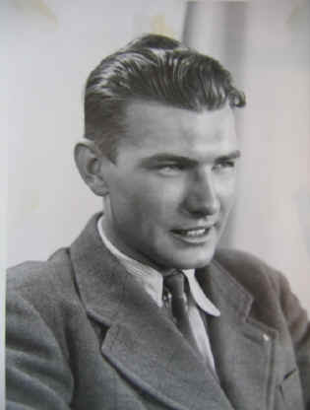
Karel Aster
(as told in correspondence with Linda Dahl Weeks)
photo at left is Karel, age 20.
I was 21 when I volunteered in December of 1941. There was a total of
fourteen Czechoslovak volunteers who went to Bataan in December of 1941.
Since none of us were citizens, our official status was “Employees of the
Department of War.”
Our motive for joining was to do whatever we could to defer the Axis forces,
whose leading member NAZI Germany occupied our homeland. Of the 14
Czechs, seven died during the war. One in Camp O’Donnell as a result of the
Death March, two in Cabanatuan POW camps, three on the hell ship Oryoko
Maru, and one in Fukuoka Camp #17. There were three of us in Fukuoka:
Leo Hermann, Otto Hirsch, and me, Karel Aster. Leo Hermann was with us in
a Cabanatuan Camp until we left there for another camp (Las Pinas) in 1943.
Eventually Leo was transported to Japan in later 1944 although he suffered
from asthma on one of the hell ships. He arrived in Fukuoka early in 1945.
He was ill and placed in the hospital and died in February or March of 1945. The feeling among those who visited him in the hospital was that he died in extremely weakened condition because of his trip but also
from lack of will to live on.
His wife in Manila survived Leo. Both Leo Hermann and Otto Hirsch were Medal of Freedom recipients.
Karel: I have vague recollections of the end of the war. I was working in the mine when orders came, long before the end of our shift, to assemble topside and we were marched to the camp. There were many rumors about the reasons, but one prevailed; we were probably going to be transferred to another camp. When we reached the camp we were immediately ordered into the parade grounds for another “tenko” (count off) formation. However, the number of security guards and their agitated behaviors was a little worrisome. Finally when order was established, the camp commander gave a short speech, of which we understood the most important part – his closing words and I remember them and quote in phonetic Japanese: “CENSO YAME IMA SEMBO TOMADASHI” (War has ended – we are all friends now.)
There was a stunned silence in our ranks and we were marched under guard back to our barracks and ordered to stay in. It was late afternoon – we were not marched to the mess hall for our evening meal and when finally, early in the morning, some of the more courageous men ventured out, the word quickly spread that the entire Japanese garrison had withdrawn and the headquarters were empty.
Soon we found out that the warehouse was filled with food supplies – mostly Red Cross Aid. In a few days, US planes found us and dropped us food and we got the first news of world events from magazines they also dropped. The first American to come to the camp was a newspaper correspondent (I believe from the Chicago Sun Times) and he gave us the big news about the atomic bomb and that Harry Truman was the new President. None of us had ever heard of him before.
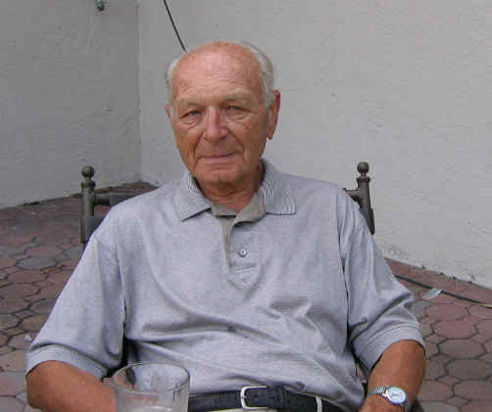
My friend Otto Hirsch and I ventured out of the camp several times and even went to the post office to mail some post cards home. They were never delivered. Eventually a detachment of Marines came and organized our evacuation via train through the ruins of Nagasaki to the harbor and an aircraft carrier.
I still remember my strong emotional reaction when I got off the train in Nagasaki and was greeted and got a hug from a nurse. I nearly passed out.
Otto Hirsch settled in California, died about 15 years ago, and I am in touch with his widow and two children. I have never been able to make contact with Leo Hermann’s widow, although I heard that she came to the US. There were no children. Of the seven survivors, I am the last one alive (age 84) but I am in contact with several of the widows and children.
I was single until, in 1961 I married a widow friend of mine with whom we went to Manila in 1941. She spent the war in Manila and in 1944. Her husband was incarcerated by the Japanese in Fort Santiago and Bilibid Prison for cooperating with the US guerillas. He survived, though very ill, and lived in Manila until 1955 when he immigrated to the USA. He died in 1960 and was survived by his wife Jana, their daughter Joan (born in the USA in 1940 and went with them to Manila in 1941) and son Michael, born in Manila in 1949.
We had a wonderful life together until my wife died in 2003. As a stepfather, I have four grand children and three great-grand children, all doing well.
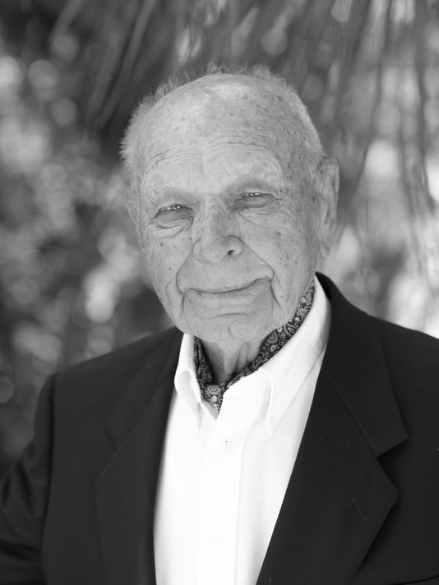
Karel Aster 2005

Karel’s honored with Prestigious Award
The 94-year-old man shifted his weight on a couch in his Captiva home and rubbed the tiny hairs on his head, trying to find the words to describe the horrors of captivity during World War II.

"It's," he said as he crossed his arms, "I don't know what to tell you – horrible."

For four years, Karel Aster was forced into slave labor as a prisoner of war in Japanese camps. While working nearly 15 hours a day in coal mines, he suffered countless beatings, starvation and illness, and witnessed hundreds of killings.

All because he volunteered to fight for the freedom of his homeland.

Aster, the last survivor of 14 Czech nationals who volunteered for the U.S. Army in the Philippines, will be presented an award from the Central European nation Thursday for his work to benefit society, for the promotion of friendship among nations and for the promotion of the Czech Republic around the world, documents from the Czech Republic say.
“The conditions were so terrible it is hard for me to describe them. We no longer behaved as human beings and the only thing that helped us survive was one’s instinct for self-preservation,” Karl said.

Aster will received the Gratias Agit award from the Czech Republic at the Captiva Civic Association. The Czech ambassador to the U.S., Petr Gandalovic, presented the award. The Czech government held an award presentation last year where it "rolled out the red carpet for three days," said Michael Murray, whose wife Jenny is Aster's granddaughter.

Aster was unable to make the trip, so Gandalovic vowed to travel to Captiva to hand-deliver the award, Murray said.

Aster, the last survivor of 14 Czech nationals who volunteered for the U.S. in the Philippines, was presented the award for his work to benefit society, for the promotion of friendship among nations and for the promotion of the Czech Republic around the world. "It's my honor and privilege to be here to hand-deliver the highest award bestowed by the Ministry of Foreign Affairs of the Czech Republic," Gandalovic said as he shook Aster's hand.
For four years, Aster was forced into slave labor as a POW in Japanese prison camps, where he suffered countless beatings, starvation and illness, and witnessed hundreds of killings.

But, frankly, Aster said he doesn't know what makes him special. "I'm surprised there's all this fuss after 70 years," he said. "It's an honor, but I don't know why he chose to come here and honor me with his visit."

Like millions of people who came back from World War II, Aster grappled with memories of his departed friends and struggled with reoccurring nightmares of the horrors he experienced. And like thousands of other POWs in Japanese camps, he was pushed into backbreaking labor and forced into some of the most inhumane conditions people can imagine.
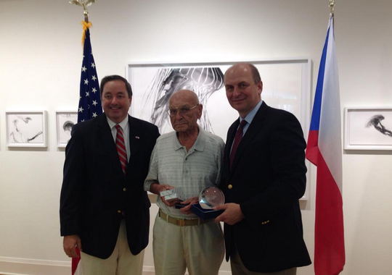
However, Aster is very different in his own way.

Aster also received two medals from the Philippines' head of Veteran Affairs Division: one for bravery during World War II, and the other is a presidential citation.

Before the presentation, Gandalovic met Aster for the first time at his home on Captiva Drive. "This is my first time in Captiva, and I must commend you for choosing such a beautiful place to live," Gandalovic said. Aster spoke about his home, how long he had been living there and about what it was like after Hurricane Charlie came through the area. "After what you went through in Japanese camps, a hurricane must have been a piece of cake," Gandalovic said with a laugh.

Karl passed away August 13, 2017- a very sad day for all who knew him.

