Henricus Wilhelmus Bernardus Beekwilder
12 November 1914 - 27 January 1981
Introduction
This document contains some historic details of my grand father Henricus Wilhelmus Bernardus (HWB) Beekwilder born on 12 nov 1914 te 's-Hertogenbosch, the Netherlands (died on 27 January 1981 in Benidorm Spain). HWB started a career in the Dutch army and finally end up in Indonesia where he joined the KNIL.
(Royal Dutch Indies Army – Indonesia is a Dutch colony at the time of WO II).
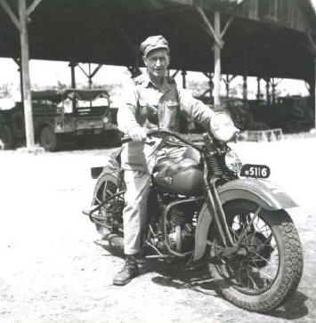
There he met my grand mother Elisabeth Lies Beverloo which he married and had four children with (oldest three born in Indonesia). After the war they moved back to the Netherlands, his home town’s-Hertogenbosch (also Den Bosch).
I, Edwin Beekwilder am the eldest grand son of HWB and show some interest in his military career during WO II.
Photo: 1950 Semarang Indonesia
Prisoner of war during World War II
At some time during his stay in Indonesia, he was made a POW by the Imperial Japanese Army. He was deported to Thailand and Birma to work on the railroad. Several times he went ill (malaria) and – on his and his doctors request – asked for a transfer.
He was finally deported to Japan to work in coal mines near Nagasaki. He worked here for approximately a year and also witnessed the bomb drop on Nagasaki. It appears that HWB was deported to Japan. How he made it back Indonesia to his wife and children is not known (yet) by me.

Camp 1 Thailand, 28 December 1943
Message from P.O.W. Camp 1 Thailand, 28 December 1943 He sent his regards to my father (Henkie),
my aunt (Lieske), his mother in law (Mammie = mother) and his wife.
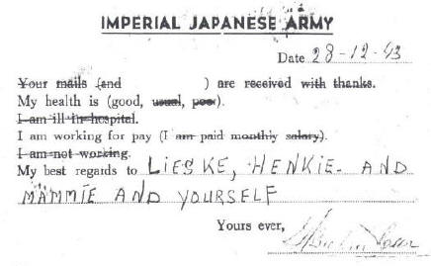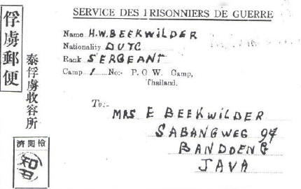

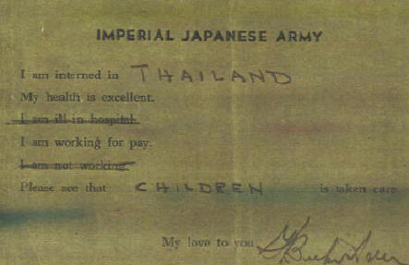
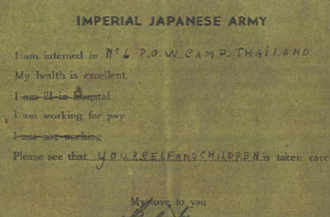
Camp 6 Thailand

Protestant Church
Document below shows HWB’s entrance to the Protestant Church during his imprisonment. He appeared in front of the Church council (imprisoned as well) on December 11, 1944 and was finally accepted in the community on
December 16, 1944.
