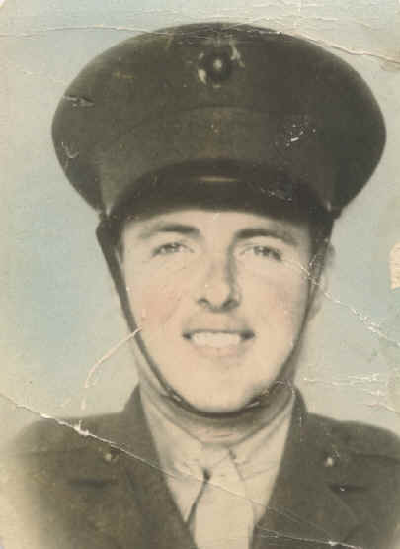
James Oscar Bennett
as told through the memories of his son
(in articles Bennett went by the name Oscar)
My father grew up as an only child (he had lost an older brother that had died as a baby) but living in the home with his grandparents for a few years.
His nickname was Boxcar - relative to his size when he played High School football. He was almost 21 when he graduated from High School due to having to help work on the farm and make ends meet during the 30's. His POW buddies called him Job - his initials - J. O. B. for James Oscar Bennett.
Dad left Wynne, AR in 1939 when he joined the CCC - Civilian Conservation Corps. He spent some time in the Cody, Wyoming area working on various building projects. Dad enlisted in the Marine Corps when the US joined the war in Europe. Dad was in Shanghai, China before his duty on the isle of Corregidor. Dad spent 42 months as a guest of the Japanese, being liberated in September 1945 from the Japanese Fukuoka Camp #17. Dad came home, built a small house and married our mother - Fannie Caubble. He planted a small peach orchard within rock throwing distance of his father and mother, his grandfather and grandmother from his mother's side of the family, his father-in-law and mother-in-law, and one of his wife's brothers and sister-in-law. Literally rock throwing distance! They were all engaged in raising peaches.
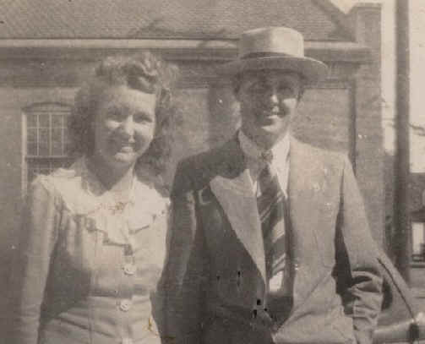
James Oscar and Fannie Bennett - Wedding Photo 1946
Dad had everything paid for in cash - new house, farm, and a new Allis-Chalmers B model tractor - all from his back pay and money that he had sent home over the years. The meddling from his 'neighbors' into his farming practices and family raising, coupled with his nerves, encouraged my Dad to sell out and move a few miles across town to a 160 acre wilderness farm into a two room tar paper shack with no running water, indoor plumbing, or electricity. All of these were added relatively soon as well as over 5,000 peach trees. He raised four children - Janis born in 1947, Vicky born in 1948, Jim born in 1949, and Kathi born in 1951 (had a warm winter in 1950!). The tender limbs from a peach tree at the corner of the house and his Marine Corp discipline guided four children on their life's journey.
Dad added another 30 acres to his farm in the early 60's and planted more peach trees, apples and a grape vineyard. He also took a job with the USPS from which he eventually retired in 1978. Dad sold out the big farm and divided the 30 acres into building lots and exited his farming business in the early 70's. Upon his retirement, he moved to Hardy, AR where he and my mother had built a log house.
Dad loved traveling and camping. Our camping started back in the early 60's in the hay-covered bed of a 2-ton Dodge truck. Camping vehicles over the years progressed all the way from a Camel tent trailer to a nice motor home that he owned when he passed away in 1986. Dad's favorite place to camp was anywhere around Bull Shoals Lake in North Central Arkansas.
Dad had a variety of hobbies, mainly turning rocks into gems and woodworking. Much of his woodwork is still in use today as he built cabinets and signs for many of the Baptist churches he attended. Dad was a deacon in several Baptist churches over the years.
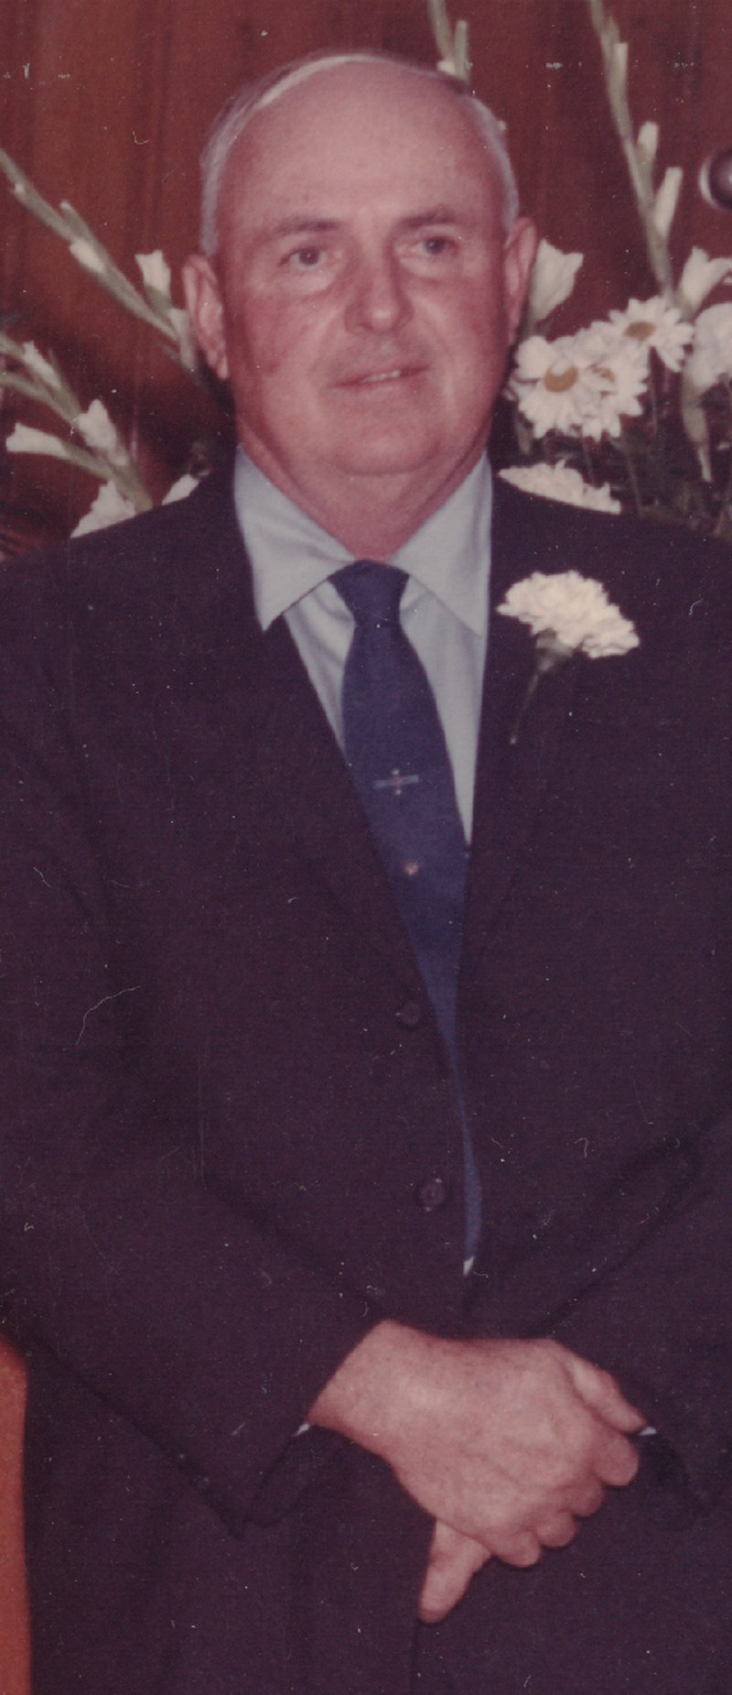
One of the most memorable stories I remember is Dad's trip home from Japan. When the war ended, Dad and his buddies made their way to the coast on a commandeered Japanese train. Being in an emaciated condition, standing at 5'-11" and weighing only 96 lbs., our Government wanted to strengthen and add some weight to these soldiers before letting them get home. He said it was a very slow ship ride from Japan to Seattle, WA. with lots of beer to drink. From Seattle, after a short hospital stay, it was a long train ride across to Chicago and then down to Memphis, TN. Dad had a bus ticket from Memphis to Forrest City, AR, but he had arrived in Memphis in the early afternoon and the bus wasn't leaving until the next day. Since he was only 60 miles from home and had not seen his parents or my mother for over 6 years, that long wait was just too much. He started walking to Arkansas. As he was hitchhiking across the Arkansas-Tennessee Bridge over the Mississippi River, a fellow on a Harley-Davidson motorcycle stopped and picked him up. My Dad said, as they were flying across the bridge, he had one arm around the motorcycle driver and the other holding on to all the possessions he had in a small bag. His number one thought was that he had been gone from home for over 6 years, endured 42 months of Hell at the hands of the Japanese, and was going to die in a motorcycle wreck 60 miles from home. He made it safely to West Memphis, AR and then started hitchhiking on US70. Sometime during the night, a car picked him up and carried him to Forrest City, AR. He was still 20 miles from home and walked the rest of the way in, arriving early in the morning as his mother was fixing breakfast and his dad was heading out to milk the cows. Among his possessions were his Japanese 'Ban' #1201, and the Gideon New Testament that he had concealed from the Japanese.
Dad wrote several stories for the local newspaper that my niece in California has today. I am trying to get a copy of those. I was pulled over by an Arkansas State Trooper one time for speeding and mentioned my Dad to him. He said he enjoyed his stories and wrote me a warning ticket.
My dad loved his Country. His heart was broken when the Challenger shuttle blew up on takeoff January 28, 1986. He sat for hours watching all the news and then watched over and over the recordings he had made. The USA was the greatest country in the world and a tragedy like that should not have been allowed to happen. He loved his God and Savior, Jesus Christ. He was a Democrat most of his life, but I think he would have been voting Republican today. He loved children. He drove a school bus for years and always took the longest bus route. He treated blacks and whites the same. He was always the Marine! His rank at discharge was Gunnery Sergeant.
Dad kept in touch with many of his POW buddies over the years. Roy Hays' web site contains a piece of parachute that my dad signed. For the amazing. See Roy Hayes Biography for Parachute Story and Photo.
When he passed away, he was survived by his mother Ludelle, his wife Fannie, 3 daughters, 1 son, 5 grandsons, and 2 granddaughters. One grandson enlisted in the Air Force, one in the Marine Corps, and one in the Army National Guard.
James Bennett died December 23, 1986. He is buried in a country graveyard in the Ozark hills outside Hardy, AR.

Coal Mining by POW Labor as told by James Oscar Bennett
On September 12, 1944, we made it to the prisoner of war camp at Omuta, Island of Kyushu, Japan. Because of the coal mine and zinc factory, it was a town of considerable size. Toward the last part of the war, a large part of the town was destroyed by American incendiary bombs aimed at the factory and mine. On one of these bombing raids, our camp was hit and we lost 17 of our buildings. Only one POW was injured! After the war I walked through the town and it seemed as if every other building was a small machine shop.
We could tell by the power plant when an air raid was about to happen. It was steam operated and we could hear them letting off steam to reduce the pressure. Because of the ever-present haze, the sun seemed to be a huge red ball. It was easy to see why it was called the “Land of the Rising sun.” We could see why their red and white flag (the one with the disk) resembled a fried egg and other things that cannot be mentioned here.
Our initiation consisted of first, a shorter than a G.I. haircut. Long hair would be difficult to keep clean while working in the mine. Next, out bodies and clothes were sprayed with a disinfectant to kill the bugs and germs, I suppose. Our blankets were taken from us to be fumigated. There were many disappointments when they were returned as we did not receive the ones that were taken from us. Many had the real good thick navy blankets and got thin worn-out ones in return. The one that I turned in was an old Army blanket torn up by shrapnel but it was a lot better than the one that I got back. However, I did manage to find mine and trade for it back.
One of the first things that caught my attention was the construction of a huge mess hall. A large round smokestack made of bricks was being built. Although the work that was going on was a long way from the ground, the workers were moving around on a scaffold made of bamboo poles. These were tied together with rope. Seeing this huge mess hall being built gave some encouragement to a poor, hungry soul but as it turned out it was a big disappointment!
I would have estimated the number of POW’s in this camp at around 1700 or 1800. There were Americans, English, Scots (who I learned not to call ‘Limeys), Australians, Dutch and Javanese. The Javanese were the dirtiest and filthiest (with the Dutch running a close second) of any people that I have ever seen! These were the Dutch in the POW camp and no others. The English were the snobs of the outfit. I had more regard for the Japanese than them. All I can say about them is that they were good soldiers. The Aussies and Scots were fine people. Perhaps a people should not be judged by the way they act in a POW camp, or should they?
The Americans who were already there, because of our arrival were called “Old Americans” and we were called “New Americans.” They worked regular eight-hour shifts around the clock and we worked an eight-hour day shift.
After our haircuts, decontamination, and search for dangerous weapons (they never found my flat knife hidden in the fly of my shorts), we were assigned our barracks and received our first meal – rice and clam chowder. I came to the conclusion that they were trying to make an impression – as the meals from then on were not that good. After that, a ration of rice consisted of a cereal bowl packed for a worker. A sick person (nonworker) received a large slice cut from his cereal bowl of watery soup with the rice. As soup could not be carried to the mine for our meal there, we were given a couple of slices of pickled radish instead. Being hungry and not wanting to take the risk of the noon meal being stolen in the mine, it was eaten with the breakfast meal. Both of the meals were not enough to make one good meal, so by the time for supper, a POW was very hungry.
The different nationalities were housed in the barracks separately. In our barracks, men from the three branches of service were housed together. In each squad room, there were Marines, Army, and Navy. The barracks were long with a hall running down one side. The door to each room was very thin with paper pasted over the squares instead of having glass in them. A bench ran along the entire length of the hall alongside the rooms. We sat on them to take off our shoes. The shoes were placed under the benches. Shoes were not worn in the squad rooms
We had quite a system in order for the guards to keep up with us. Each of us had a wooden tag (kobuck) with out number on it. My number was 1201. There was a peg board beside each door with the names of different places on it. The names of places like hospital, mess hall, brig, camp work, etc. were on it. Our tag had to be beside the name of the place where we were. That was simple except that was not the only peg board. There was one at the front door of each barracks. I think each guard had his own interpretation as to where the tag belonged. If the guard did not like where the tag was, he would pick it up and carry it to the guard shack and we would have to go there and pick it up. There were different kinds of punishment that POW’s had to endure in order to retrieve their tag, which was there for no reason of their own. I know that from first hand experience.
Inside the room was a straw mat floor on which we slept. We had a thin pad for a mattress, and a hard straw mat block for a pillow. The straw mats were a natural harbor for fleas and lice. The lice could be controlled better than the fleas. The fleas were very large and could bite a plug from you with one bite.
There were many nights that my sleep was disturbed by fleas. It seemed as if they became worse just before the war ended. We were given some flea (?) powder but it was no more than ground up chalk. It did no good. I placed a ring if it around my pad but it did not stop them.
If you kept your bed clothes (what few we had), body and the little clothing we had clean – then there was not much trouble with lice. They would hide out in the waist band of your pants and my skin crawls now, when I remember how they felt when they crawled. I was bothered with them very much.
The Dutch and Javanese would sit around all the time picking the lice off themselves and each other. They did not keep themselves very clean. I will explain, later, the way we had to take baths and how they would mess up the water by urinating and defecating in it.
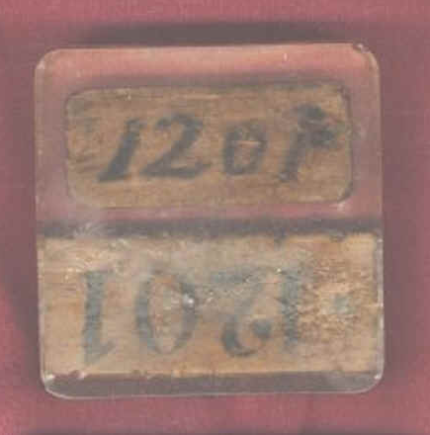
About ten of us slept in each squad room. All of us had to sleep on the floor and the foot of our pads would almost touch. Across from me a boy from Illinois by the name of Derry, slept. He stayed in most of the time because of sickness – dysentery. He would sleep with all of his clothes, including overcoat and shoes, on, and also his bed clothes. One evening upon examining his bed clothes (I was the squad leader) I saw several lice crawling over to my pad. It was during the winter time, the walls were very thin, and we were not allowed any heat. I did not care for any lice to be in bed with me. I knew he was staying in the next day so I told him that he had better wash his clothes. Bed clothes and body, that when I came in, I was going to inspect and if just one louse was found he was going to have to sleep in the latrine. That was a very drastic threat but I meant it. I told him that if he were sleeping in the latrine he would have to tell the Jap guard why, when the guard came it really scared him because when I did inspect his bed clothes there was not a louse to be found. He had shaved and taken a bath. I hardly recognized him. It was not very long that he was completely well. If he had continued the way he was going, he would have died. There were several who did because they completely gave up. I like to feel that I saved his life. In a few days, we were to have some schooling in order to work down in the mine. We were to learn the Japanese name for different tools used in the mine and also the name of different terms such as “dangerous, ceiling,” etc.
There are many things that I remember and maybe will be related later.
James POW (Ban) Number from his internment years.

