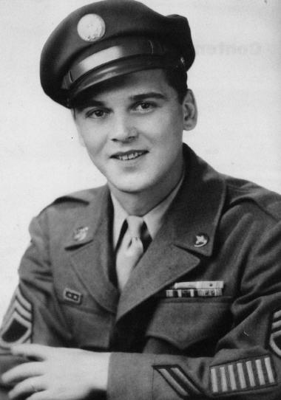
Anton (Tony) Bilek
Army Air Corps S/Sgt.
28th Material Squadron
Author: No Uncle Sam: The Forgotten of Bataan
Great Website Page honoring Tony, complete with photos:
http://philippine-defenders.lib.wv.us/html/bilek.html
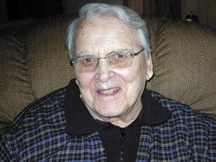 Tony: Age 90
Following is an exert from Tony's book (not for private use, posted with permission form author only!)
CRUSHER - CHAPTER 11
A string of coal cars rumbled up out of the gaping hole. They swayed from side to side, as the contents once again felt the rays of the sun, after more than a million years. The main shaft of the slope mine curved down onto the depths of mother earth, where it cast out fingers in all directions, to catch the riches of her stores. The mine itself was a possession of the giant industrialist, BARON MITSUYI. The war had all but depleted his workforce, and the motherland of the young and strong workers, who had made this a vibrant economy. Now, Mama-sans and Papa-sans took up the hoe and the shovel, to put food on the table and to kept the wheels of industry turning. To help, and to relieve these old and weakened bodies, the Ministry of Labor asked for, and received help from the newly acquired resources of the armed forces. American, British, Australian and Dutch prisoners of war were transported to the Japanese mainland to provide a cheap and available source of manpower. They came in from all parts of the South Pacific, where their disease ridden and starved bodies formed labor pools, and were exploited, much like beasts of burden.
The conveyer, at the coalface, came to a halt, as the shift workers looked for a safe area to wait out the next blast. That blast would break loose another round of transportable coal, for the mines to shovel onto the conveyer. The miners shuffled at a slow pace, their bodies covered with coal dust, their eyes blinking to clear themselves. When they reached the main shaft, they all began to search for a comfortable place to rest. Most sat down with their backs against the stone wall of the shaft. Others lay on the ground, with their heads resting on a rock, comforted only by their cloth miner’s cap. One by one, they shut off their lamps, plunging the shaft into total darkness. They all tried to relax, or even get a few minutes sleep. The Jap overseer and two Americans were still working on the coalface, making the final preparations in laying the charge. The whole mine face had been drilled and the charges inserted. The Jap made a final check, to ensure that the fuses were properly set and most importantly, to make sure that the blast area was cleared of all tools.
The Americans were very irresponsible. They would invariably leave valuable picks, shovels} and jackhammers in the blast area.
The rest period would last from ten to fifteen minutes after the blast. That was the time needed to somewhat ensure that the area was safe to re-enter. It was also the period of time that “the Crusher,” did his dealing and planning. The Crusher wasn’t a big man; he only stood about five foot eight. His skin was milk-white and he sported a short crop of red hair. Crusher was a shy and quiet individual, but he had guts. Nothing scared him.
Hurried footsteps approached the resting miners. No one bothered to see who was coming. They knew that it would be the blasting crew, and that a blast would soon follow. His miner’s cap was tilted forward, and the bill rested on the crown of the Crusher’s nose. This kept the light out of his eyes. The blasting crew was still in the process of making themselves comfortable. Stevens, who was sitting next to the Crusher, turned his head, and in a soft voice, asked, “Do you think we can do it?” “Shhhhh,” replied the Crusher. He raised his arm, and with his thumb, lifted the bill off his nose. His green eyes shrouded by a milk-white background, scanned the lighted area. They watched the Jap, as he cleared an area on the ground. The Jap’s light was the only one that illuminated the shaft. The green eyes watched until the light went out. Then the Crusher closed his eyes and lowered the cap until it once again rested on his nose. “We’ll try,” he said softly, through the side of his mouth. “How we gonna do it?” “You stay near me, and do what I tell you to do. Don’t ask questions. Savvy?” Stevens answered with a soft, almost scared, “Okay.”
A muffled blast shook the tunnel. Dust billowed into the area and settled on the resting men. No one moved. One man began to snore. The men rested.
A light came on at the far end of the resting group. The Jap secured the battery pack around his waist, and adjusted the light under his cap. Then, he turned and cast his light on his men. He let out a loud grunt, and the men began to stir. Lights began to pop on long the shaft. Men rose and stretched their weak and tired bodies. A few remained on the ground, sound asleep. But the rock floor offered neither softness nor warmth, and they were awakened by those near-by. One man got up spitting and coughing. He had slept on his back during the blast, and his mouth and lips were covered by coal dust.
The men moved slowly back to the coal face. There was no talking. They knew what awaited them—tons of coal and rock. A very fine haze filled the air, and the particles sparkled like silver as the miners lights moved about.
“Hiako, hiako (hurry, hurry),” the Jap shouted. But the pace of the men did not change. As the Crusher surveyed the crumbled coal face, his eyes fixed on one area. He turned to see if Stevens was still behind him. With a quick jerk of his head, he indicated for Stevens to follow him.
The coal vein was only two feet thick, the remaining five or six feet was rock. Crusher looked at the slab of the rock that hung loose on the coal face. He and Stevens started to work. The coal went into the conveyer, while the rock was thrown over the conveyer, for pick-up by the follow-up preparation crew. It would be used by them, along with rocks, logs, and debris, to build UMAKS, a continuous wall which would hold up the ceilings. Crusher checked on the location of his overseer.
The conveyer was only eighteen inches above the floor. Crusher stepped on one of the conveyer floor supports, and jumped over the conveyer. The Jap saw Crusher leave his work, and he started toward him.
“Benjo (toilet),” said Crusher, as he pointed toward the rear of the shaft. The Jap nodded his head once, sharply. Crusher walked along to a stone ceiling support column (Umak). He stopped and began and began to urinate. Looking back over his shoulder, toward the coal face, he tried to locate the Jap. But seeing him, and finishing his task, he moved over a step or two, and lifted a large flat rock. Reaching under the rock, he picked up a small Narigi.
The Narigis were used in making the Umaks to support the ceiling. The Narigi was a wood branch about 3-4”in diameter about the size of a baseball bat.
Crusher walked back to the coal face, holding the Narigi close along side his leg, to hide it from the Jap. As he approached the conveyer one of the men pointed towards the end of the machine, where the coal was tumbling into a coal car. He jumped over the conveyer then immediately put the Narigi underneath it.
The Jap left the coal loading area and walked along the conveyer, to see that all the men were working. He stopped near Crusher, looked at him, and then continued on. A man working next to Crusher, began to pick up the loose rock slab on the coal face.
“No,” said Crusher, grabbing onto the pick. “Not yet.” The man put down the pick, and they both began to move rock and coal. The Jap was now making his way back down the conveyer. He passed Crusher and continued on, towards the loading area. It was important for him to watch the loading. Too many rocks were being sent up with the coal. Crasher grabbed Stevens by the arm. “Kneel.”
As they both knelt, Crusher took Stevens right arm and placed it in two rocks.
“Just like that,” he said. “When I tell you, put your wrist on this rock and your elbow on that one.”
The Crusher looked down the conveyer, then back at Stevens. “Ya understand?’
“Yeah.”
Crusher and Stevens stood up and continued to load coal into the conveyer. Crusher kept an eye on the loading area. Satisfied that the Jap would stay there, he picked up a rock about the size of the palm of his hand.
“Which arm?” he asked Stevens. Stevens held up his right arm. Crusher grabbed Stevens’ fingers and said, “This won’t hurt—Put your hand over your mouth.”
When Stevens put his hand over his mouth, Crusher dragged the rock down along his arm, leaving scratches from his elbow down to his knuckles. Stevens sucked in a short quick gasp, as trickles of blood ran down his arm.
“Kneel,” he said.
Stevens knelt and placed his arm on the rock, just like Crusher had instructed him.
“Put your other hand over your mouth.” Stevens obeyed. Crusher knelt down, and looked at the position of the arm.
Satisfied, he reached under the conveyer and brought out the Narigi. He held it like a baseball bat. Looking once more down the conveyer, he saw that the Jap was still occupied, then looked back at Stevens.
“Close your eyes.”
As Stevens closed his eyes, Crusher checked on the Jap once more. Then, quickly, be brought the Nariga up—then down. There was a muffled thump, and a low moan escaped the hand over Stevens’s mouth. Crusher slid the Narigi back under the conveyer. Then he admired his craftsmanship. The forearm was vee-shaped.
“Nice job, good break, easy to set. I’ll knock that slab of rock down. When I do, you fall on it and let out a yell. Ya follow?’ Stevens, still kneeling, looked at Crusher and nodded.
Crusher took the pick, and looked down the conveyer again. He was pleased with all of the time the Jap was giving him. On some of the requests of this nature, the Crusher had to hurry. Crusher put the pick behind the rock, and tugged on the handle, trying to dislodge the rock. The rock would not budge. He jerked at the rock, but it would not move. Placing his chest on the pick handle, he moved back quickly and exerted all of his strength on the handle. There was a sound as the handle broke off the pick. He dropped it, and immediately began to move rocks by hand.
“Stay where you are,” he told Stevens.
The Jap, hearing the foreign sound, stepped back from the loading area, and looked back down the conveyer. Satisfied that nothing was wrong, he continued to watch the coal fall into the car. Another pick was handed from hand-to-hand, to Crusher. This time he drove the pick behind the rock with a quick stroke. He gave a jerk and the slab moved. Another jerk and the slab came down. It struck the conveyer with a jar.
“Get on that rock!” said Crusher. Stevens slid over the large slab.
The Jap was coming. Crusher bent over and grabbed Stevens under that arm.
“Start getting up,” he said.
The Jap was standing on the other side of the conveyer, as the two men struggled to stand up. Crusher held Stevens’ broken arm, and with a pathetic look pointed at the slab. The Jap looked the situation over, than motioned Crusher to take Stevens topside.
On the way out of the mine, Crusher tried to comfort Stevens. He assured him that all of his breaks were good ones. They were clean breaks with very few after effects. He also reminded Stevens that he would expect his payment (three rations of rice), one ration per week, for each of the next three weeks. Crusher also had bargain pries. For only one ration, he would break a finger; however that would only provide seven days off from the mine.
The coal car reached topside, and the Jap guard was waiting for them. The guard motioned Crusher to report back down to the mine, and for Stevens to follow him.
Stevens sat on a small stool in the camp hospital. An American medic was washing Steven’s scratched and broken arm. After the medic had applied iodine to the scratches, Captain Hewlett examined the arm.
“Nice break. Won’t be hard to set. Center of the forearm, same type of scratches.”
He looked at Stevens, and said, “Now look we really don’t need the work. You better tell the guy who’s breaking these arms, to knock it off for a while. There are five men out there now, on light duty, carrying the honey bucket. Each of them has a broken left arm with the same type of scratches. All left arms? Come on. The Japs are going to get wise, and someone’s going to catch hell. The only thing in your favor is that you broke your right arm.”
Having got that off his chest, Hewlett left the emergency room. He left Stevens with the medics, to splint his arm, and to fashion a sling. All was very quiet.
Stevens turned to the medic with a grin, and said, “I’m left-handed.”
Below: Tony’s mess kit
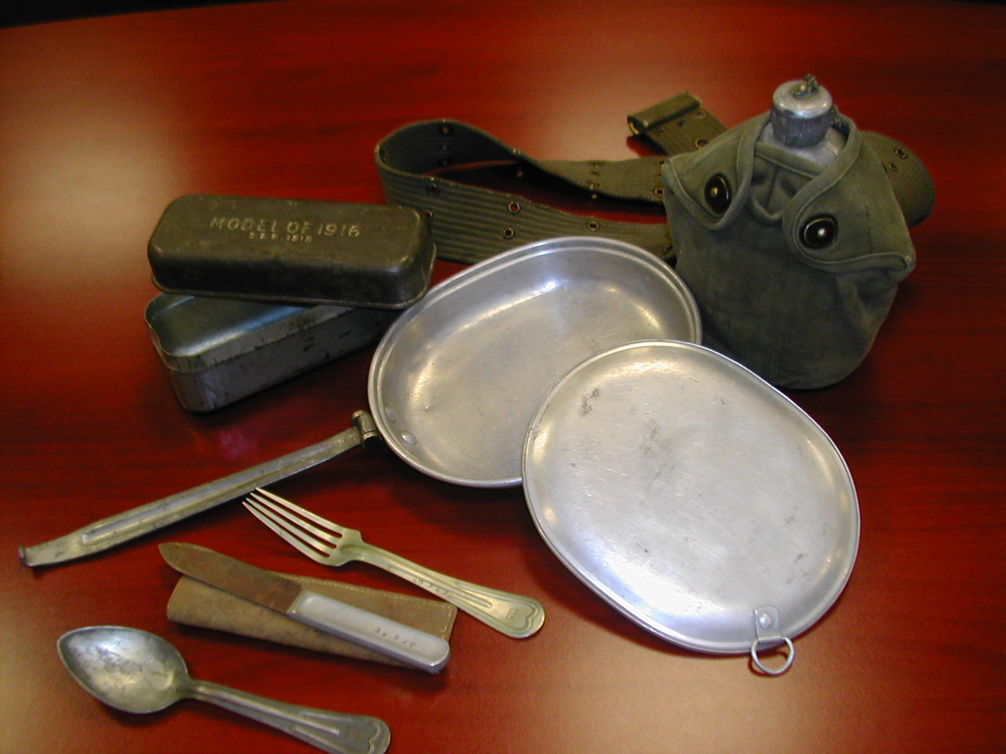
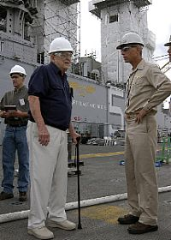
Photo Credit: PORTSMOUTH, Va. (Oct. 19, 2007) - Air Force Master Sgt. (Ret.) Anton "Tony" Bilek, speaks with USS Bataan (LHD 5) Commanding Officer, Capt. Rick Snyder, about his days spent as a prisoner of war in a Japanese prison camp during World War II. Bilek is a Bataan Death March survivor, one of 75,000 American and Filipino troops forced to endure the Death March, a weeklong, ninety-mile hike involving more than 10,000 people. Bilek and his grandson (left) traveled from Illinois for a chance to see the ship.

Tony’s Obituary
Tony Bilek, 94, a long-time resident of Rantoul, died at 3:14 a.m. Monday, Jan.13, 2014, at his home.
Mr. Bilek was born April 11, 1919, in Chicago a son of Anton and Annastazie Bilek. He married Millie Podolak Jan. 20, 1946, in Chicago. She preceded him in death July 10, 2000.
Survivors include two sons, Donnie (Debbie) Bilek of Penfield and Kenny (Debbie) Bilek of Rantoul; a daughter, Karen (Danny) McCartney of Rantoul; 18 grandchildren; 17 great-grandchildren; two great-great grandchildren; a sister-in-law; and nieces and nephews. He was preceded in death by his parents, two brothers and two sisters.
Mr. Bilek came to Rantoul after he graduated high school. Chanute Air Force Base was his first assignment in the United Air Corps. Upon completing his training he was sent to Clark Field in the Philippines, where he was a sheet metal specialist.
Six months before he was to complete his assignment, war broke out. He was captured by the Japanese and survived the Bataan Death March. He was then a P.O.W. for 3 ½ years in Japanese POW camps. After being liberated, he came home to Chicago (1945) and met the love of his life, Millie.
He and his wife were married, started raised a family, built houses and started a greenhouse business. They raised flowers in Rantoul for 42 years and were best known for their beautiful geraniums.
Mr. Bilek was a pro at growing flowers. Along with woodworking and growing flowers, he loved to travel. He and his wife traveled all over the United States and Canada in their motor home and always came back to their house on the “hill” and family.
His other passion was fishing. He and his boys spent many hours out on the lake in Canada trying to see who could catch “the big one”.
Mr. Bilek served 20 years in the United States Air Force and retired as a master sergeant; he then went on to work in civil service for 13 years. He was a life member of the Rantoul VFW and Rantoul American Legion Post 267.

