Gerrit Bras

Dutch Army -2e kl MGD Officer

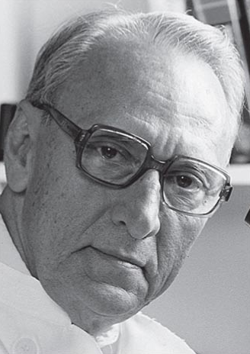
Holland’s “Dr Cholera”
As a 28 year old junior doctor, Gerrit Bras got to understand his later specialty of pathology the hard way after surrendering to the Japanese during the Second World War. He treated his fellow prisoners of war, working on the infamous Burma railway, for cholera, beriberi, malaria, and dysentery. Despite appalling conditions and the most primitive self-made medical equipment, he saved many lives, earning the nickname “Dr Cholera.”

Bras was born in Java in 1913 in the then colonial world of the Dutch East Indies. His father supervised forestry work so Bras played in Java’s forests, gaining practical knowledge that held him in good stead in later years. In 1939 he qualified at the Batavia, now Jakarta, medical school, before studying pathology and anatomy. He met his wife, Puck Bitter, and the two began careers in medical research, studying parasitic worms about which they intended to write their doctoral theses.

Life changed abruptly on 7 December 1941, when Japan attacked the US base at Pearl Harbour and entered the Second World War. Bras was called up to serve as a medical officer in the Royal Dutch East Indian Army. By March the Dutch had capitulated. Puck Bitter was imprisoned in the horrific women’s camp on Java while Bras, together with thousands of other prisoners, was shipped off to Thailand. There he joined forced labourers building the railway later featured in the film The Bridge on the River Kwai. It is estimated that 150 000 prisoners of war died from starvation, mistreatment, and disease.

However, Bras, the trainee pathologist, knew many of the victims of cholera could be saved if treated for their extreme loss of salt and fluids. He improvised, straining dirty river water through neck scarves and then boiling it on a wood stove, borrowing raw salt from the cook, and estimating roughly the concentration. He then used an empty quinine bottle, or a naturally sterile coconut shell, a rubber tube from an old stethoscope, and his only surviving needle to set up an intravenous saline drip.

His single set of equipment required him to move constantly on to the next patient, but his assiduous 24 hour care often paid off. He became known as Dr Cholera both among prisoners and the Japanese, who themselves feared the highly infectious disease.

Although undernourished, suffering from beriberi, and enduring primitive, unsanitary conditions with little artificial light, he still managed to make meticulous patient notes scribbled in tiny pencil marks in his notebook. The book survives, and even 50 years later he was able to inform relatives of the diagnosis and date, place, and cause of death of their loved ones.

Before the end of the war he was transported to the coal mines of Fukuoka on the southern Japanese island of Kyushu and from there witnessed, in the distance, the atomic bomb dropped on Nagasaki.

He returned to medical research, gaining his doctorate in 1950 with a thesis on the 1949 smallpox epidemic in Indonesia. With Indonesian independence, he moved in 1951 to become a founding professor at the department of pathology and anatomy of the University of the West Indies in Jamaica, which had been established in 1950 under the supervision of London University.

There he gained international acclaim for his work on the pathology of veno-occlusive disease of the liver that was endemic on the island. He found it was related to the toxic effects of the Crotalaria genus of bush teas, a local herbal remedy for colds and stomach pains.

In 1971 he became professor at Utrecht University, where later, with veterinarian Morris Ross, he carried out research discovering that rats fed on a low calorie diet lived twice as long as, and had far fewer cancers than, normally fed ones.

He went on to build up the Institute of Pathology, attached to Utrecht University Hospital, developing a fearless reputation. In the 1970s he nearly provoked a riot by insisting that two professors, Herman van Praag and David de Wied, should be allowed to use his institute to discuss what, were then, controversial new developments in drug treatment for psychiatric illness. They had been denied the chance to speak at the hospital because of fears of disorder by radical students who passionately believed psychiatric illness did not have a biochemical cause but was related to social decay.

Bras’ former colleague and successor at the institute, Professor Dr Jan van Unnik, said: “There was a fine riot but the meeting went on.” He felt it was typical of Bras, a colleague who could be extremely loyal, supportive, enthusiastic, and authoritarian at the same time, to “act if he felt something was unjust.”

Another ex-colleague, professor of anesthesiology Dr Bob Smalhout, emphasized that Bras was not just a very good pathologist but a full-blooded clinician. “We shared an old fashioned idea that medicine is more than just the specialism you practice. He was interested in the total illness of patients, their social background, and their complications.”

He believes his actions in Burma reflected a personal interest in every patient fueled by his Christian religious belief in each individual’s worth.

Bras was a member of the editorial board of the Dutch Journal of Medicine and since 1972 a member of the Royal Netherlands Academy of Sciences. Former professor of Pathology University of the West Indies and founder of Utrecht University Hospital’s Institute of Pathology. He retired in 1983, though remained active, riding his bicycle until the age of 92. Upon his death, Gerrit left behind his wife, Puck; a son, Paul, also a doctor; and a daughter, Phyllis.

The following is an article featuring Gerrit’s brother, Jan.
Because it mentions much of Gerrit’s path, we include it here.

From Burma to Nagasaki: the man who walked through hell
Jan Bras endured years of forced labour as a Japanese POW before witnessing the aftermath of the atom bomb. Now 92, he tells Elizabeth Day about the horror and brutality he endured – and how he lives with it today.
All you could see were black hills. The houses were just stones and rubble’: Jan Bras remembers Nagasaki after the bomb. Photograph: Richard Saker for the Observer
Jan Bras does not like to hurt any living thing. If he spots a fly crawling across a table he will cup it carefully in his hand and release it out of the window. “I very quickly feel sorry for people or creatures,” he says, sitting on a beige sofa in the drawing room of the central London flat he shares with his wife of more than 57 years. “That’s one of my things.”
At 92 he thinks this surfeit of empathy comes from having witnessed appalling violence as a young man. From the formative ages of 18 to 21, Jan Bras was a Japanese prisoner of war. When the Japanese invaded the Dutch East Indies during the Second World War, he was transported by “hell ship” and cattle wagon to work on the construction of the Burma railway. Later, he was interned in a camp and sent to work in the perilous coal mines at Fukuoka. After liberation in 1945, he was one of the first to walk through a decimated Nagasaki after the detonation of the atomic bomb. He witnessed unimaginable terror, brutality and death. Throughout it all, Jan Bras survived.
In many ways, his is the story of the Second World War in the Pacific – a conflict overshadowed by memorialization of events in Europe. With the 70th anniversary of Victory in Japan Day on 15 August, stories like his are becoming rarer. Bras is one of only a handful of survivors.
For years Bras did not talk about what had happened to him and this is the first time he has ever shared it publicly. Like many survivors, he found it impossible to convey his experiences to others after the war. The words did not exist.
“He never really talked to us, to my mother or me, maybe until the last 10 years or so,” says his daughter, Gina Jennings. “I think they [the survivors] do feel that nobody understands, so they don’t bother to talk.”
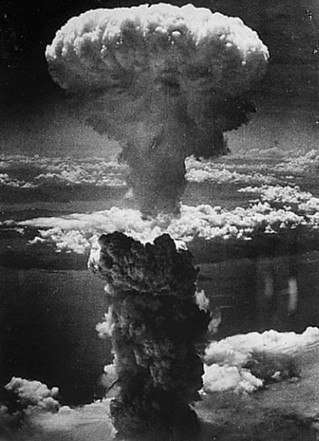
But then, about 10 years ago, the memories started floating to the surface like driftwood. Scraps at first, then entire stories: the occasion he watched his best friend die; the day his older brother was threatened with execution in the camp, the time he and his fellow prisoners were forced to dig their own graves in the days leading up to liberation because their Japanese captors planned to kill them all before the allies came.
The mushroom cloud: a dense column of smoke rises more than 60,000ft into the air over Nagasaki.
“It’s quite grim actually,” Gina says. Growing up, she recalls her father’s absolute refusal to accept authority. She finds it difficult, still, to come to terms with what he went through. “He thinks I’m not interested, but it’s just that I can’t take it. I can’t bear what happened to them all. The random violence … It is a constant horror in the background. You live this so-called normal life, but these real atrocities happened to people you know and love.”

It was Gina who got in touch with me through a mutual friend. She was worried that her father’s recollections would be lost when he died and that the war in the Pacific and East Asia, once immortalized in films such as The Bridge on the River Kwai, was now in danger of being forgotten amid all the commemorations centered on VE Day in May.
This, then, is the story of one man’s war. But it also stands for those many others left untold.
Jan Bras’s father was a Dutch planter living and working in the colonies. Bras was born in Indonesia, the youngest child of eight, two of whom died in childhood. One of his earliest memories is of accompanying his father on a work trip into the jungle and coming face to face with a tiger. He wasn’t scared, he recalls, because tigers “had no bad instinct at all. We were frightened of bears because they climbed up trees and we were frightened they would fall on us”.
Bras and his older brother, Gerrit, joined the Dutch army three months before war broke out. After the Japanese attack on Pearl Harbor in December 1941, Japan was able to pursue its military objectives against the allies, including the conquest of the Dutch East Indies.
By early 1942, the entire Bras family had been taken prisoner. Bras and Gerrit were among thousands transported to Thailand on the notorious hell ships. Their ship was subjected to heavy bombardment and Bras remembers hearing the sound of the bombs dropping in the ocean around them as they made the perilous crossing.
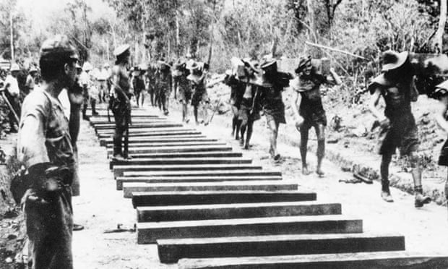
“Yes, we were scared,” he says now. “We thought we would drown like rats. We were deep in the hold, covered from the top by a sheet. Two people suffocated. It was a terrible situation.”
From Thailand they were taken by cattle wagon to the site of the Burma railway. There, the two brothers joined forced labourers digging 5m trenches and setting down sleepers in desperate conditions. Construction of the 415km railway cost the lives of around 13,000 PoWs and 100,000 native labourers. One man died for every sleeper laid.
Photo: Forced labor: Allied POWs working on the Burma railway.
Bras says the danger came not from the beatings the Japanese guards meted out at random intervals (“They passed,” he says phlegmatically, “and they didn’t want to kill us because they needed us to work”), but from the threat of cholera and malnutrition. He recalls being “always hungry”, but thinks he survived because, unlike some of his British counterparts, he was acclimatized to the tropics.
His brother (Gerrit), who was a trainee pathologist, knew it was imperative to boil water before drinking it. Those who didn’t “died like flies”.
There was a seasonal elevation of the Kwai owing to high rainfall. Once, after the waters receded, Bras remembers seeing the corpses of people who had died from cholera littering the branches of the trees bordering the river.
We would be lined up and we had to punch each other and if we didn’t do it hard enough, the guards would beat us
Bras spent two years on the railway. He and his brother would supplement their meagre daily rice rations with strips of young bamboo and the odd squirrel thrown in for protein.
Has he seen the film The Bridge on the River Kwai?
“Yes!” he says, his voice whooping with laughter. “I think it’s a very beautiful film, but completely beyond the truth.”
They did not spend their time singing and dancing and putting on shows, he says. “It [the film] was so ridiculous for a person who experienced the reality. It… it was a joke.”
Extraordinary as it may seem, Bras regards his time on the railway as comparatively tolerable considering what came next. He was taken to Japan, where he was interned in a prisoner of war camp in Fukuoka, on the southern island of Kyushu, and forced to work in the nearby coal mines. It was “very dangerous” work, conducted underground amid the dark and soot, with the constant threat of death. Bras missed being able to see the sky. At night, he was plagued by fleas and could barely sleep. One in three prisoners died in the mines. Bras’s best friend was one; he was made to drill down below a section of lake and was killed when the roof collapsed on top of him.
“I had to wash his clothes,” Bras says. “I found brain tissue on them.”
He looks at me levelly, weariness twitching at the corners of his mouth. He lapses into silence. It is a painful wordlessness, one which suggests all the things he chooses not to say. The way he coped was “by trying to do as little as possible. We were out there to sabotage the place… You try to forget a lot. It was so terrible in the mines. It was hard work, and the Japanese always had a stick to beat you with.”
After a while Bras became so ill with jaundice he was transferred to the camp sick bay, where his brother was working. He became a medical orderly as a means of escaping the mines.
But camp life was relentlessly harsh and unforgiving. “If the Japanese were annoyed for some reason or other, we would be lined up one in front of the other and we had to punch each other and if we didn’t do it hard enough, the guards would beat us up with a stick and tell us to beat each other harder.” His eyes become veiled and tired. “You were beaten by your own kind.”
And yet, he says, the unexpected conflagrations of violence from their Japanese captors were much worse. At least, with an organized beating, you knew “it would end… The unknown things were more frightening.”
The prisoners were expected to bow to the ground and say “Good day” in Japanese every time they passed a guard. On one occasion, when Bras forgot to do so in his haste to carry two buckets of water to the sanatorium, he was savagely beaten. “This guard beat me up until I was really black and blue,” Bras says. He is matter-of-fact when he talks about this, and refuses to dwell on either the pain or the injustice. Almost immediately, he manages to seize on the slenderest filament of a positive: “One of the good things he did was that he never kicked my testicles, which he could easily have done. It sounds silly to you, but I could see there was some sort of honour in him. He beat me up terribly, but he didn’t kick my testicles or my stomach.”I tell him many people would be astonished that, even in the most hopeless situation, he could still find it within him to seek out the good in the man beating him up.
“In those days I believed in God. I was really very religious and I think it might have helped me.”
But did he never think to question why, as a young man, he found himself in this nightmare? Why it was him and not someone else?
“It never occurred to me to question God at that time,” he replies. “Since then I have completely changed my mind.”
These days Bras considers himself an atheist. But perhaps in the midst of such cruelty, clinging blindly on to his faith was the only way to keep going. He says that, unlike many of his fellow prisoners, he never wanted to die.
The camp was liberate in September 1945. Bras vividly recollects the American planes flying overhead, dropping shoes, biscuits and cheese on to the ground below.
Later, the Allied troops transported them to Nagasaki where, a few weeks earlier, one of two atomic bombs had been dropped (the other having obliterated Hiroshima), effectively ending the war. Waiting in a truck by the train station, Bras remembers a Japanese camp guard meeting his eye. This particular guard had never beaten him and had always been polite. The guard saluted Bras. Bras looked away, refusing to return the salute.
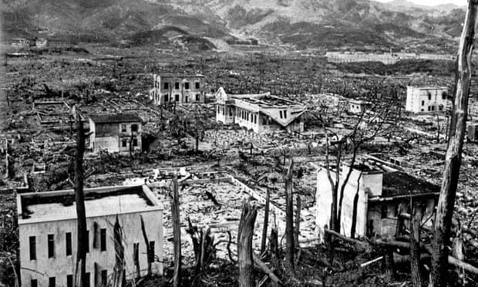
Photo: After the atom bomb: Nagasaki in ruins.
“Until now, I regret it,” Bras says. “I often think of it.”
‘I don’t forgive what the Japanese did.’ Photo: Jan Bras
In Nagasaki the scene was one of utter devastation, stretching 3km in every direction.
“All you could see were black hills; it was completely black. Here and there was a chimney. All the houses were just stones and rubble, and here and there was a Japanese who tried to get some food from the Americans, but the Americans did not want to share their food.
“I remember this fellow, a father who had just bought a bicycle for his son’s birthday, and all that was found was the bicycle, nothing of the son, just the charred remnants of the bicycle. It was just twisted metal... you could not tell what was human and what was not. The whole thing was black, one lot of black rubble.”
Despite the carnage, Bras admits he felt “no pity. I thought: ‘Good for the Americans.’ Some [former prisoners of war] went back after the war to the same area to show they felt sorry [for the Japanese], but I didn’t feel sorry. I never felt sorry. I feel sorry for the boy [with the bicycle], because the boy was dead, scorched. I feel sorry for that particular case, but I don’t forgive what the Japanese did. They were bastards.”
All that was found were the charred remnants of the boy’s bicycle, just twisted metal, nothing of the son
Of the many acts Bras is unable to forgive, the death of his father is the most painful. His father was tortured by Japanese guards: they fed a tube into his mouth and poured water through it until his stomach burst and he died of his injuries. Remarkably, the rest of the family – Bras’s four sisters and his brother – all survived the war.
After it ended, Bras and his mother immigrated to Amsterdam, where he pursued medical studies. For a while he and his brother worked in Kingston, Jamaica, where Bras later met his wife, a Scottish doctor. In 1958 they settled in Wrexham in Wales, where Bras worked as a GP for nearly 30 years.
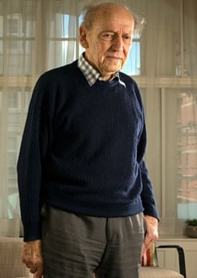
Is he angry, I ask, when he looks back at those lost years. He shakes his head. Why not?
“Well, chance is a funny thing,” he says. “Why should I be angry about the bad things that occur and still accept the good things? I really do not understand life. I do not know what it’s all about.”
He gazes at me, with the same impish smile on his face. There is a pencil drawing of him done by a fellow prisoner in September 1945 looking handsome, with hope still in his eyes in spite of almost three years in captivity.
Today you can see the bones of that young face pressing through his wrinkled skin, and it’s sort of miraculous, really, how strong he is, how unbowed, how his capacity to see the good in people remains.
Of course there is also damage profoundly felt, deeply hidden, and his way of coping lies partly in his iron refusal to bend. He will not forgive. He will not salute. He will not fall, even when the blows come down. And here he is: Jan Bras, 92, walking without a stick and eating biscuits, winning his own war every single day.

Photo: Jan Bras / article credit: The Guardian – July 2015

