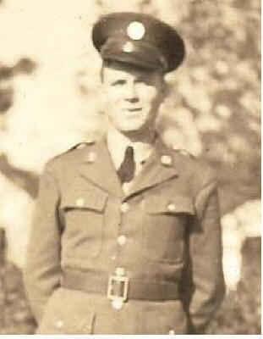
Wesley Clifton Browning, Jr.

BOSSIER CITY, LA - Wesley C. Browning, Jr. 91 of Bossier City, Louisiana fought the
good fight and went home to be with his Lord and Savior on March 19, 2011 after a
lengthy illness. He is survived by his sister Margaret Pierce of South Carolina, his
daughter Patricia and her Husband Jim Engelbrecht of Dallas, Texas, Son Michael
Browning and fiancé Mary Lombardo of McKinney, Texas, Grandchildren Stephen
Box and wife Sanja of Plano, Texas, Emily Alfano and Husband Brian of Dallas, Texas,
Michael Wesley Browning of Allen, Great Grandchild Hayden Alfano of Dallas, Texas.
He is also survived by his devoted fiancé Bobbie Wall of Louisiana.
Extended Family Members include Joanne Fayard, Jane and Charles Beckham, June and Gary
Henninger, Kennon and Alice Harville, Lee & Mimi Harville and Mike Harville; their children & grandchildren.
Wesley was preceded in death by his Wife Josephine Browning of 46 years, Son Joseph Wesley Browning, Father Wesley C. Browning, Sr., Mother Margaret Fennell Browning and Wife Claudia Harville Browning.
Wes loved God, Family and Country with all of his heart where early in his military career he was a member of the 27th Bombardment Group Lt formed at Barksdale AFB, Louisiana and retired a US Air Force Master Sergeant. He served honorably in both World War II and the Korean War. His tour of duty during WWII landed him in the Pacific campaign where he was captured by Japanese forces in the Philippines in April 1942 and forced to endure the Infamous Bataan Death March and 3 ½ years of imprisonment. He was the recipient of the Bronze Star awarded for heroic and meritorious achievement and service in connection with military operations against an armed enemy and the Purple Heart which is awarded to members of the armed forces who are wounded or killed in any action with an opposing armed force of a foreign country in which the Armed Forces of the United States are or have been engaged.
Wes was a Certified Public Accountant and Partner in the local accounting firm Brooke, Mayo and Browning.
He served as President of the Caddo Parish Police Jury and Past Commander of Ark La Tex Chapter No. 1
of the American Ex Prisoners of War Association. He was also a past member of the Shreveport Optimist Club, POW-MIA Association and The American Defenders of Bataan and Corregidor Association.
Wes was very active in civic, community and church endeavors and proudly called Airline Drive Church of Christ in Bossier City his church home. Others left to cherish his memories are all of his many friends and fellow veterans with whom he spent many hours lifting spirits, counseling those in need or sharing stories with anyone who would benefit from his life experiences. He was a Christian man who lived every day to serve his Lord and set a good example for all to follow…"Well done good and faithful servant". Matthew 25:23
Wes was a man of integrity and humility with an infectious sense of humor that will be missed by all.
"Dad we were so proud of you for your family values, patriotism and your walk in your spiritual journey. We all have a better life because of your sacrifices and you were the best example of a loving father…We were blessed to call you our Dad".
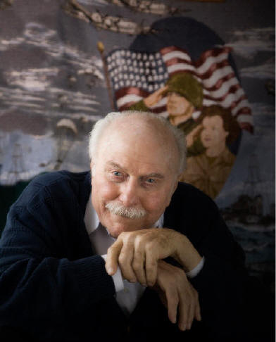
Obit Submitted by son, Michael Browning
Note from Wes’s son. “I am sorry to bring you the news that my father and another member of Camp 17 passed away Saturday March 19th at 2:30am after a very strong bout of Malaria that would just not leave him alone.”

From 3/23/2011 E-mail:

Hi Linda,
I am sorry to bring you the news that my father and another member of Camp 17 passed away Saturday March 19th at 2:30am after a very strong bout of Malaria that would just not leave him alone. It has been a difficult time for my sister and I going through the process of closing his estate. I am available and have all of his resources at my disposal should you need any additional information and I will be in contact with you to discuss facts related to the book on his life I am writing.
Please feel free to share this sad news with your readership as Camp 17 survivor numbers are dwindling. It will be up to people like us to carry on the legacy and the stories of these corrageous men who served our country honorably. To update you on the diary posted by Roy Hogg...I was never able to receive a response or present any other photos of the journal before his death. I would like to continue persuit of the original owner of that particular document that is out there somewhere.
Take care and I look forward to hearing from you.
Michael Browning
Attachment: Wesley C. Browning, Jr. Obituary

