Jean Marie Brunsmann
Dutch Army
The following is from an e-mail correspondence with Jean Brunsmann's son, Ian.
Jean Brunsmann was first made a POW at a place called Bandoeng and from there he was taken to Djakarta.
Then to Singapore at the Changi camp (not the changi prison) and on to Siam (Thailand). The prisoners were then sent to Bampong where they had to walk towards Burma. About half way to Burma Jean was put in a small camp (he cannot remember the name). At that camp Jean was made to drive trucks, which was probably one of the best jobs there. At first the other prisoners gave him a hard time about getting an easy job, and his reply was "I don’t have a choice and if I don’t drive the truck you don’t get food because 90% of the time that is what I am carrying".
It was here where the first of the stories my father shared comes in. As he was driving into the camp Jean saw his brother Eddy (Eduard Marius Brunsmann) running away from a young elephant. Eddy ran across in front of the moving truck. He made it ok but the elephant slammed into the side of the truck causing some damage to the truck. Jean got out of the truck and asks his brother Eddy what he did to make it (the elephant) do that. Eddy said, "I don’t know I just walked past it and it got angry.” Then my father thinks he is going to get flogged by the guards over the damage to the truck. Fortunately some of the Japanese saw it happen and they thought it was so funny they didn’t do anything to Jean.
After that Jean was sent to Singapore and then on to Japan where he spent the rest of his time in Fukuoka camp #17. At that camp he was made to work in a mine. It was in that mine he was very nearly killed when the roof collapsed. The man standing next to him was killed, but Jean was ok, suffering only a broken foot.
This is where the second story comes in also involving Jean's brother.
One day the Japanese brought to the camp a small whale that had beached it self somewhere along the Shaw. It was cut up and made part of the meal that day. Eddy was not keen on this idea and swapped his whale meat for something else. The next day everyone who ate the whale meat was sick, except for Eddy who was telling everyone "I told you so".
Then one day the Japanese made an announcement that it was all over and that they are all friends now. My father was probably thinking this is what they say before they kill the lot of us. They remained at the camp until the Americans took them to Nagasaki. He was then taken by ship to Manila, where the Dutch took over from there.

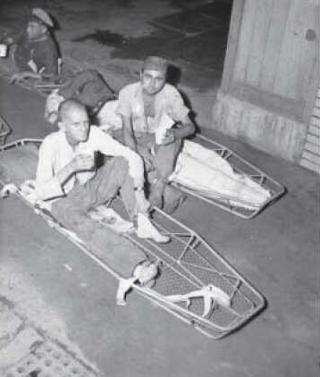
Jean Marie Brunsmann is the former POW, directly in the center of the photo, facing the camera. This picture was taken shortly after liberation: 15 Sept. 2915
Jean Brunsmann lives in Brisbane Australia. His brother Eddy died on 26/08/2003 in Brisbane Australia.
Addendum: Jean passed away July 13th, 2008
at the age of 86 years on 03 March 1922 - 13 July 2008
There was also a third brother that was a POW during WWII. His name was Charles Brunsmann, he was not at Fukuoka -he was somewhere else- where they were making Isuzu trucks (family is unsure where). Eddy’s wife Gesine and his sons Bart and Rob were interned by the Japanese along with Jean and Eddy's mother and father.
Read on for a wonderful story!!
Hi, I randomly came across your site and was very surprised to see an article about Jean Brunsmann a Dutch POW.
By way of explanation I am the eldest son of Leo van Ommeren who was a Dutch POW in Kinsaiyok (amongst other camps)
My father first met Jean in Kinsaiyok (circa 1943 ?) and fastly became good friends. My father and Jan were very close, and on hearing that Jan had also been taken prisoner my father tried very hard to get to the same camp. It was not to be. Jean was sent to Fukuoka whereas my father Leo stayed in Kinsaiyok.
As such they lost contact. My father immigrated to Australia in 1956 from the Netherlands, unfortunately I have no recollection of how & when Jean came to Australia. It would most likely have been in the early to mid-sixties when my father pulled in for fuel to a Shell service station in the suburb of Deagon in Brisbane. In those days you did not fill up your car, a service attendant would do it for you, to my father’s astonishment Jean came out of the building to serve him. From that day on until my father’s passing in 2006 they were the best of friends.
Shortly before my father passed, I clearly remember Jean holding my father’s hand and saying, “So long Leo, you were always a true friend”. Three weeks before Jean’s unfortunate passing he met with me and Peter Byrne (a work colleague) at my mother’s house. Peter had been interested in speaking to Jean as Peter’s father was also a POW in Fukuoka but as an Australian POW. Peter had taken along some photos of Australian POW’s, when he pointed out his father Jean exclaimed “I know that man!” - and went on to tell us that they had spoken together several times as POW’s.
Jean was always a very honest kind man and I will always remember him fondly.
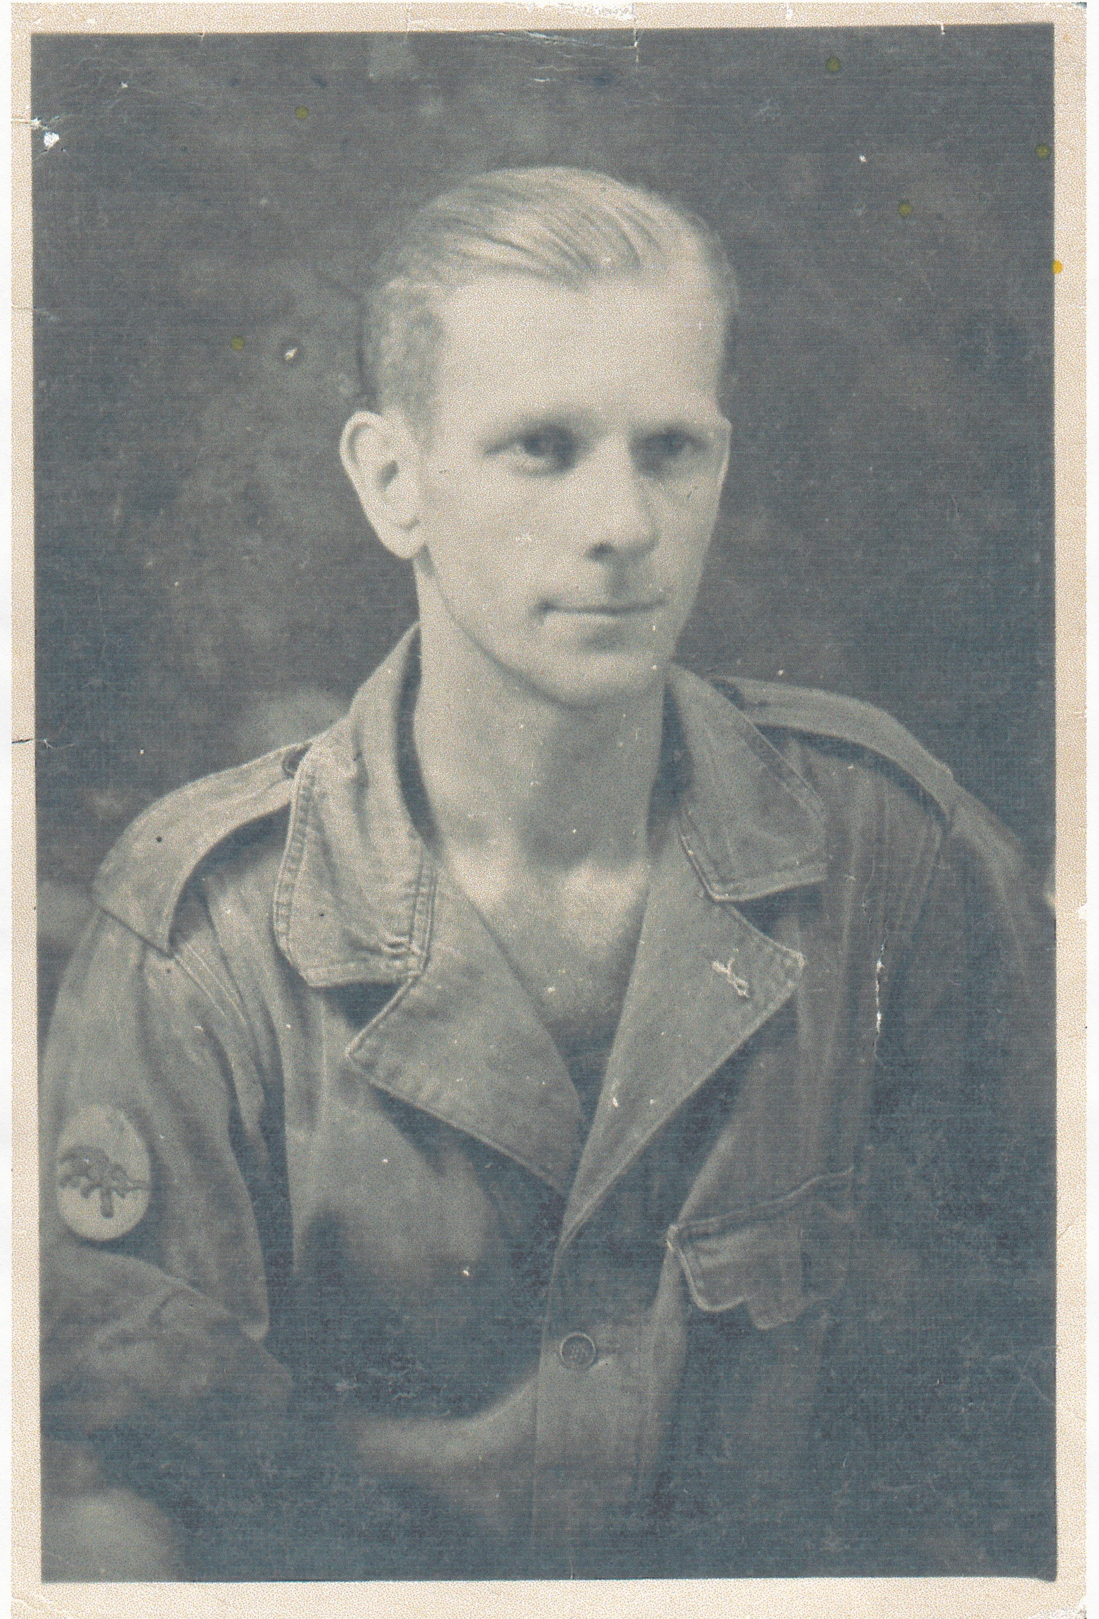
Best Regards, Lex van Ommeren

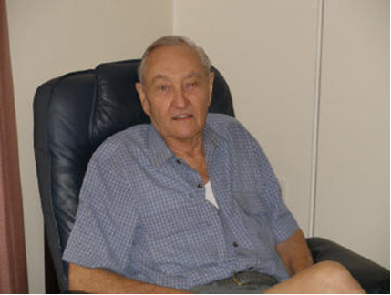
Photo left - Leo, Jan’s best buddy.
Jean – right photo

