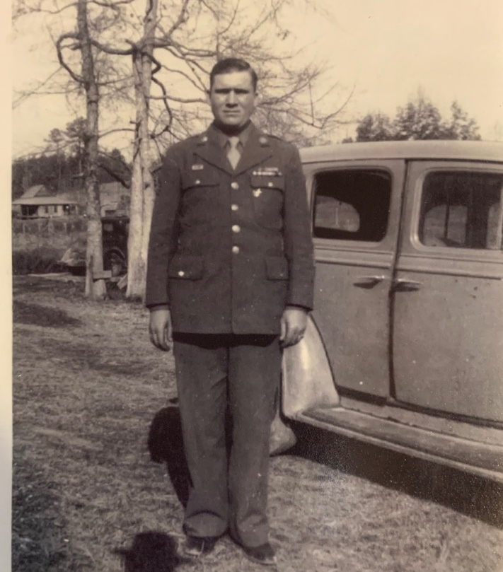
Drolan Chandler

DOB: 06/15/19 in Detroit, Lamar County, Alabama
DOD: 01/04/03
DOS: 11/11/40 – 11/15/45
Rank: Sergeant
Unit: USAF Headquarters Squadron 27th Bomb Group, Transportation Group

Deceased: 04 Jan 2003

Myra Jones, the niece of Drolan, is writing his story in her book, Never Give Up. The following is the prologue from the book.

NEVER GIVE UP

Prologue
The defense lines had crumbled. Starving, disease-ridden Filipino-American troops fled in panic. We met people out from Mariveles who were traveling toward Bagac. They told us troops were to meet at designated places—Infantry in one, Marines in another, and Navy and Air Force at other locations—and they told us how to get to the checkpoint for our units.
April 9, 1942: We got word that Major General Edward King, who was in command of Luzon, and Lieutenant General Jonathan Wainwright had gone to Corregidor and surrendered our forces on Bataan to Lieutenant General Masaharu Homma. The Japanese had not yet appeared to take prisoners.
Arriving at the appointed place for the Air Corps, our officers informed us, “This is it. We don’t know what’s going to happen: your guess is as good as ours. Every man is on his own.”
Jim Dyer and I, along with four other guys, talked it over and decided to head for the mountains on foot, armed with guns and ammunition.
Before long, we ran out of water from the long hike. We were hot and dry from the heat wave that permeated the area.
“Cover for me, and I’ll get us some water,” I told the rest of them and set out for the creek we could hear nearby, which ran down the side of the mountain. I looked in all directions, but didn’t see anyone. Keeping an eye out for the enemy, I laid my gun on the bank, slid down to the water, and dipped the canteen in the stream.
“Don’t get that water. It’s contaminated.” I whirled around, startled, and came face to face with a Japanese officer. I hadn’t seen him standing nearby underneath a washed-out ledge. I was astounded that he spoke English better than I did!
“Get some out of this barrel,” he instructed. “It has been boiled.”
I sloshed over to the barrel, filling the canteens, and as nonchalantly as possible, started up the bank, hoping to ease over to my gun. He wasn’t interested in playing my game.
“Come here,” he ordered, as two other officers joined him. I decided the odds were against me and obeyed. He reached out, grasped my dog tags, and read them aloud.
“Drolan Chandler, Detroit, Alabama. Is that close to Sulligent?” he asked.
“Yes, sir, it is.” I spoke from my shocked state.
I was so stunned you could have knocked me over with a feather! Most Americans have never heard of Detroit, located in the northwest corner of Alabama. I’m not even sure it was on the map at that time. And if Sulligent was on the map, it was only a minute dot, ten miles southwest of Detroit, near the Alabama and Mississippi state line. I was astounded!
“Have you eaten?” he inquired.
I told him I hadn’t, so he ordered me to eat since they had already finished. My knees were weak while I puzzled over the strange encounter and the gravity of the moment. I was captured!

**************************************
Drolan Chandler grew up on a farm in Detroit, Alabama. He was the eldest of five children, born to Elizabeth Real Chandler and Minos Nelson Chandler.
He enlisted in the service in Birmingham, Alabama, and was sent to the Savannah Air Base in Georgia. He was assigned to duty in the USAF Headquarters Squadron 27th Bomb Group, Transportation Group.
Drolan’s group took a train ride across the United States to San Francisco, where they boarded the SS President Coolidge, destination: PLUM. They were at Fort William McKinley when the Japanese invaded the Philippines on December 8, 1941.
He was one of the 76,000 to make the dreadful Death March. He was taken to Bilibid Prison, then to Camp O’Donnell, and ended up at Camp Cabanatuan. He suffered many of the atrocities that the Japanese inflicted on the prisoners, as well as severe health issues of beriberi, malaria, and more.
On July 23, 1943, Drolan was transported in the hell ship, Clyde Maru, as one of the first 500, to Omuta, Japan, Camp 17. He worked in the unsafe coal mines until liberation.
Drolan’s story is told in a book, Never Give Up, as told to his niece, Myra McDonald Goode Jones. The book will be available by Summer, 2020. His sense of humor and bulldog determination contributed to his survival, and is an inspiration for this generation and those to come.

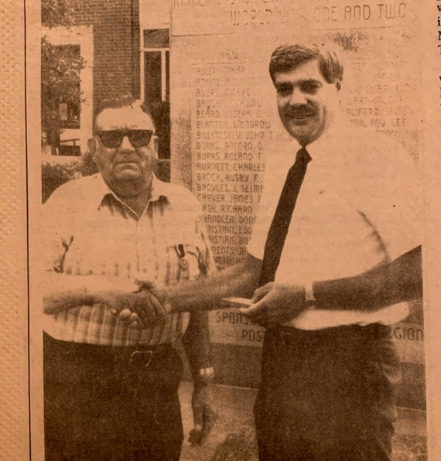
Photo taken from the informative article, “Prisoner of War Medal Awarded to Drolan Chandler,” in the Lamar Democrat and The Sulligent News, in 92nd year, no. 38, Wednesday, June 15, 1988.
Veterans Officer David Barnes presented Drolan with the Prisoner of War Medal in front of the WWI and WWII monument in Vernon, Alabama, on June 9, 1988.

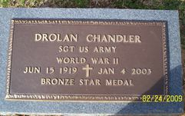

If you knew Drolan, or have comments, corrections, input, etc., please contact his niece at myramjones@gmail.com.
Please type: POW-DC Profile Comments in Subject box so it does not go to spam.

