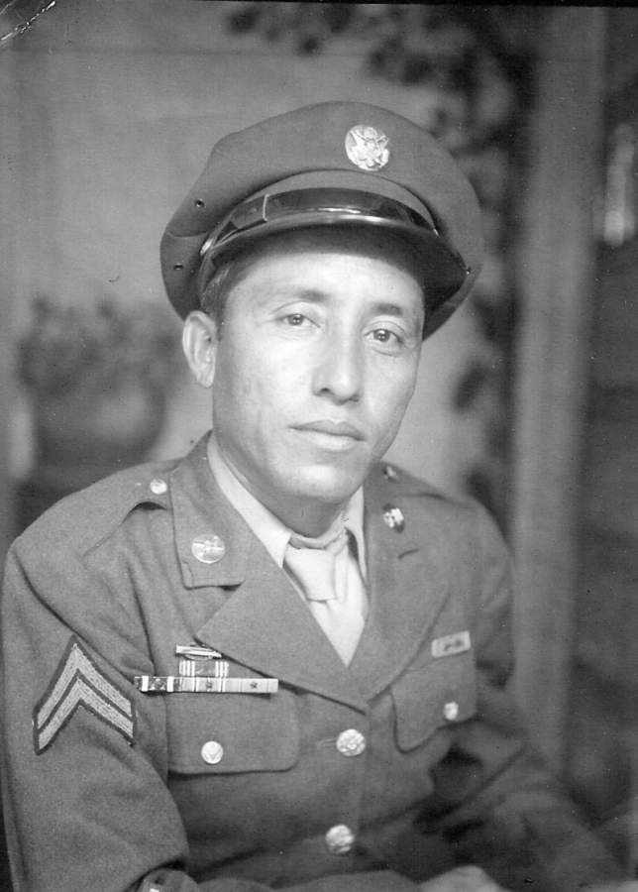
David Nunez Chapa
Corporal David Nunez Chapa * 11/2/1916 – 9/16/2008 * Sandia, Texas – Little Canada, MN
WWII 1941 – 1945 * Philippine Division 200th Coast Artillery * 1st Battalion “A Battery

In honor of Corporal David Nunez Chapa, US Army, WWII 1941–1945 *
11/2/1916 – 9/16/2008. Born in Sandia, Texas November 2, 1916, Corporal David
Nunez Chapa, 200th Coast Artillery 1st Battalion A Battery was a patriot who was
proud to serve his country. He had a big heart and a generous spirit. He served with
others from the New Mexico area and was shipped to the Philippine Islands and Clark
Air Force base on September 8, 1941. Clark Air Force Base was attacked the day
after Pearl Harbor and David’s unit was responsible for covering the retreat of the
Northern Luzon Force into Bataan. As the war situation began to deteriorate David’s
regiment was surrendered to the Japanese Army where he survived the atrocities of
the 65-mile “Bataan Death March” only to be held prisoner for over 3 years and 8
months. David was never bitter but believed he survived because he
was “a good work horse,” he said the Japanese kept him alive so he could work and he
learned about hard work from his father while growing up on a farm in Texas.

After the war and his rescue from the concentration camp David went home to Texas but later decided to start a new life and moved to St. Paul, Minnesota where he found work, met and married his wife Mary and raised his 5 children and 5 grandchildren.

As I reflect on my father David’s changing medical needs over the last few years of his life I realized how well he did with balancing his independence and his limitations due to chronic and complex health conditions. I learned many life lessons from Dad but I especially remember the importance of “listening” to the client, I hear his voice in my ear every time I want to make decisions and assumptions based on my own knowledge and experiences. My father was right about 98% of the time, he knew his body and how it responded or not to various medications or treatments and he had to remind me and his physician that sometimes what we thought would work, did not work for him. He was a good sport though, he would try things for us only to prove to us he was right and not suffering from any forms of dementia, the joke was usually on us. As a registered nurse, I realize how important the many gifts my father left behind would be for me personally and how they make a difference in the life of my client.

After my father died, I thought about how much I used my nursing skills to manage his medical care over several years, I did the same when my mother was dying from cancer and subsequently other friends and family members would request my help. When my sister died this spring unexpectedly I organized the work that needed to be done, coordinating with family and friends to close out all her personal affairs. Having navigated through end of life activities for my father, mother and a younger sister I learned through very different experiences and it became clear that being a daughter, sister and friend with a health, healing and end of life background could be helpful to others. Perhaps this is the real gift my father left me, the gift of care and concern for others who may not have family readily available to help them during difficult times. Some choices are obvious and other decisions come to us unlooked for but life is an interesting journey and I consider myself a strong independent woman; a survivor and leader with gifts to share, I learned from my Dad.

David Nunez Chapa died suddenly on September 16, 2008 at the Veterans Hospital in Minneapolis but his sense of humor, love of family and generous spirit will live on as I demonstrate the life lessons of listening with my heart.

Rest in Peace Dad, your memory lives on in the lives I touch every day. ~ Daughter, Mary Elizabeth

In Honor of Veterans - Contributed by David’s daughter, Mary, May 31st, 2010
It’s Memorial Day week end and I stopped by the florist yesterday to order a small wreath to place on my father’s grave at Fort Snelling Cemetery. Memorial Day is a special day of remembrance for our veterans and my Dad always made sure we understood the contributions of those who served because of his own military experience. In honor of veterans I want to share one of Dad’s stories from his video recordings of his WWII/POW experience.
“Well, I was born and raised on a farm in Texas, I joined the service (US ARMY) in 1941 just before the war started, I had my training in Texas. From Texas they were filling in right now and I wind up in Fort Bliss, Texas and they draft an outfit from the state of New Mexico, they were the National Guard and it was the Calvary mind you the Calvary and they made them the Coast Artillery so I filled in with all my outfit here in Texas you know, so with the state of New Mexico they formed the 200 Coast Artillery and we wind up on the Philippine Islands and there was no war then.
I was on Clark (air) field on the Philippine Islands when they (Japan) bombed Pearl Harbor, they bombed Pearl Harbor and then they bombed us a couple of days later. They devastated everything so we fought from day one, I think we fought for about 3-4 months and we lost all our supplies and everything then the Japanese came and took over.
And I was captured.
I put my time in the Bataan death march and worked in the Philippines for almost two years in the fields building this and building that and from there the Americans were coming in and taking over the Islands close by so they (Japanese soldiers) picked up the people they wanted and they took us to Japan. I went to work in the coalmines of Japan and I worked there in the mines until they dropped the (atomic) bomb, not very far from where I was staying. I was in Fukuoka the island and the bomb (Atomic bomb) was dropped on the next island the main island. Yes, it was the Atomic bomb but we didn’t know, we didn’t know what it was; for three years we were dead; we didn’t know what was going on. We were in the coal mines when they dropped the bomb and when we came out… the Japanese were going back and forth and we knew something was going on, something was wrong but we didn’t know what and then we found out we were Free! So now we were waiting for someone to come and get us.
When I left Japan, we were in camp (Fukuoka #17) with a lot of sick people and the planes would fly over and drop stuff down to us and that was the first news we got from them (Americans). They dropped food and messages to us and they told us to wait, they couldn’t come in because there were a lot of mine fields so they had to bring in a lot of minefield sweepers before they could come in and get a lot of the sick and wounded. We knew the Americans had built a small airfield close by but we didn’t know where it was and we didn’t have transportation available.
So we went wild you know and a bunch of guys a few at a time we escaped from the prison camp, but we didn’t really escape because we were Free. So one day, me and I think four guys we walked to town with some guns we took from the Japanese because they were afraid after the bomb was dropped. So we got on a train and we made a guy (Japanese) take us to where the airfield was, we had the guns and they were afraid and they didn’t know what was going on so we got on a train and then we stole a truck so we could get to the Americans.
We made the Japanese take us to the American air force base and they were afraid, I think they thought they were going to be killed but when we got close we told them to go. That’s when I saw the first Americans, we were a small group of just a few together, and that’s how I got back to the states, step by step.”
Obituary:
In Loving Memory 1916 - 2008 Age 91, of Little Canada, on September 16, 2008. David was born in Sandia, TX and was a WWII Prisoner of War survivor of Bataan
Proceeded in death by wife, Mary. Survived by children, Mary (Ray Hogen) Chapa, Faye Chapa, David Chapa, Linda Chapa-Baierl (Ken), Lisa (Mabi) Ekiyor; grandchildren, Shannon, Erin (Ryan) Franklin, Mandee, Chase, Simone; also survived by other family in Texas and numerous friends. Burial: FORT SNELLING NATIONAL CEMETERY on Friday, September 19, 2008.

“My father was a very proud man and he was especially proud to be a Texan, of Mexican heritage, a family man and a friend to many. He was proud of his service to country during WWII and expected us to take advantage of our right to Vote on Election Day. Dad loved to be surrounded by family and friends, to share stories, jokes, a cold beer and a good Mexican meal. He found peace from his war experience as he grew old and he loved his grandchildren; his wish for all of us was to work hard, laugh, be grateful and to take care of each other.”

Quote by Mary Elizabeth Chapa, daughter.
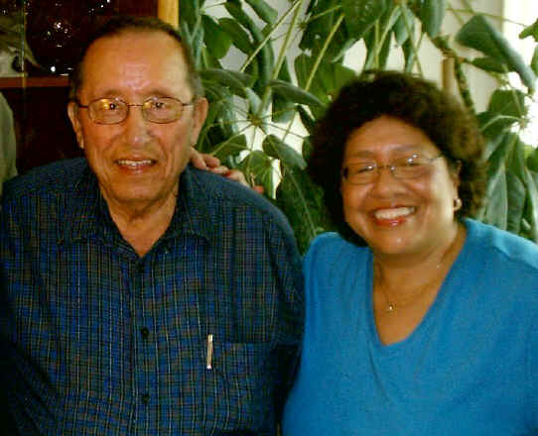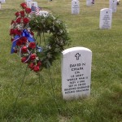

Above: David and daughter Faye & David's gravesite

