Don Christison
Some Recollections

As told to Project Manager, Linda Dahl Weeks
I joined the Australian Imperial Forces in November 1939 as an eighteen year old private.
I was commissioned as Lieutenant in 1940 and left for the Middle East in September that year. I served in Palestine, Egypt, Libya, and Greece and was taken prisoner by the Germans in April 1941 in Greece.
I spent four years as a P.O.W in Germany and returned to Australia in August 1945. Soon after arriving home I had the opportunity to join the 1st Australian P.O.W Contact and Enquiry Unit whose task it was to go to Japan and assist with the evacuation of prisoners. As far as I know I was the only Australian to have seen both German and Japanese P.O.W camps.
We arrived in the Philippines on 21st of August 1945 and were formed into recovery teams consisting of a U.S Lieut, and N.C.O an Australian Lieut and N.C.O and a Dutch Navel Lieut and N.C.O to deal with different nationalities.
On September the 8th we left Manila for Okinawa where we boarded. The U.S.S Chenango, an Aircraft carrier which was to be used for the Evacuation of POWs. The following day we left for Nagasaki where we joined the Hospital ship Haven temporarily and then left by train for Omuta. We had U.S. Navel medical personnel attached.
The group’s recovery teams to which I belong were given four camps to process; Camp 17, 23, 25 and 26. Captain A. J. Lawrence, U.S. Infantry was in command of these groups.
In the photo below, I am kneeling, on the left.
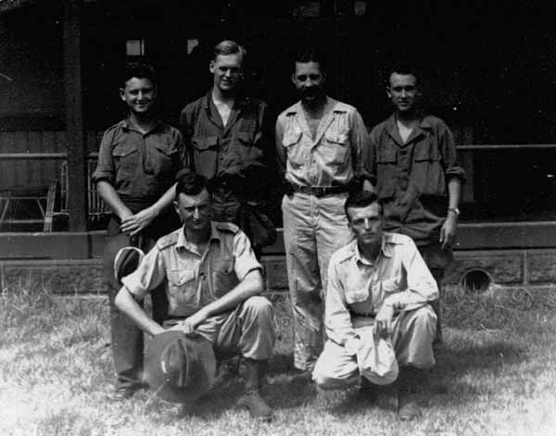

On completion of evacuating those four camps we where to check several other camps which had already been evacuated by the Japanese to Nagasaki. We finished these inspections by the 2nd of October.
When I saw the appalling conditions in the Japanese P.O.W. camps, it completely altered my view on the years I had spent in Germany, which could almost be regarded as a holiday in comparison.
I returned to Australia in November and was discharged from the Army soon afterwards. I have farmed in Victoria for about 50 years and kept most of the information I got in Japan. I have enclosed some of that information which I hope you will find useful and interesting.
Don Christison - Yarram, Australia.

