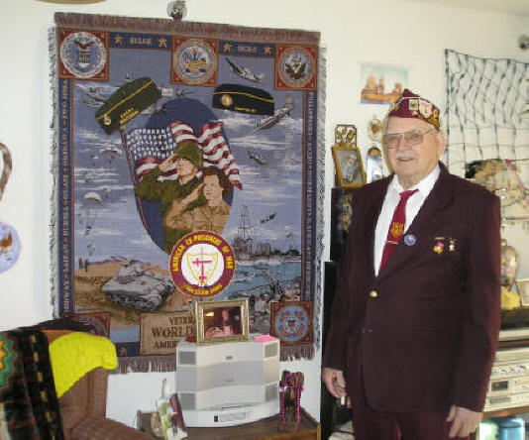
JOHN RUDOLPH CICHA
My war years (World War II)
I enlisted in the Navy in 1939, and was sent to the Asiatic
Fleet in early 1940. I was assigned to a submarine tender, the
USS Canopus. I was stationed mainly in the Philippine Islands,
and mostly in Manila Bay. In the summer time we would go to
China on Good Will tours.
When the war broke out we stayed in Manila Bay still servicing
submarines. When we started running low on supplies, the
submarines pulled out and went to Australia. By then we could
not get out since all the islands were taken over by the
Japanese. We took our ship to Marveilies, behind the lines of
Battan and serviced Army equipment with our machine,
carpenter and sheetmetal shops.

When Battan was falling we got our ship underway and scuttled it in the main channel and evacuated to Corregidor, where we were captured less than a month later.
We then were sent to the Cabanatuan prison camp, then to Los Pinas and then Bilibid, an Old Spanish prison. Then they put us on a ship, on Dec. 15, 1944, starting from Manila Bay on the Oryoko Maru, heading to Japan; we just passed Corregidor into the China Sea when we were bombed by American planes. There were Japanese soldiers, civilians and us POW’s on this unmarked ship, and the American pilots were hungry for a kill. The ship stumbled back into Subic Bay and the American planes finished the sinking with a loss of many lives. We abandoned ship and swam ashore were the Japanese picked us up and kept us there for about 2 weeks until they could get trucks to take us inland to San Fernando train station. By train they took us to Lyngayon Gulf, were there were 2 ships. We were put on the Enura Maru and made it to Taiwan and anchored in Takao Bay. It is a very shallow bay and we were loading sugar for Japan, when again the American planes found us and sunk that ship too. Being a shallow bay, the ship just settled down in the mud. Again, many lives were lost. Then the Japanese put us on the 3rd ship, the Brazil Maru, which finally got to Japan on January 31, 1945. Out of some 1600 POW’s that left Manila, only about 300 of us made it to Japan.
The last 6 months of our captivity was spent in Fukuoka Camp #17. From there we were liberated and Freedom!!
John's Note:
I am a first generation Czechoslovakian, and speak, read and write it.
In Cabanatuan I met up with the Czechoslovakian men and visited with them frequently and the same in Los Pinas camp. After the war ended and the breakup of Camp Fukuoka #17, we went our ways not knowing what happened to anyone until Jane (Bzoch) Cambers wrote an article in the “QUAN” American defenders of Battan and Corregidor magazine mentioned that Karel Astor lives in Florida. My friend and I had a trip planned to Florida – not knowing that he lived there until I saw the article. So I wrote to Karel telling him of our plan to visit Florida, and he wrote back and said that Jane Bzoch Cambers was coming the same time. Her father was also a POW and I knew him. We were on the same ship that was taking us to Japan and he was killed when the American planes bombed it – of course not knowing that there were POW’s on it. All in all we had a wonderful visit with Karel and Jane.
I really enjoy reading about all the news you have on the website.
I got married in 1947 and we have five children, twelve grandchildren and eight great grand children. On April 9th we are going to celebrate my 89th birthday. I was a late bloomer – possibly the reason I look younger that I am. I didn’t even shave until I was in my mid twenties!!

