Horace J. Comeaux

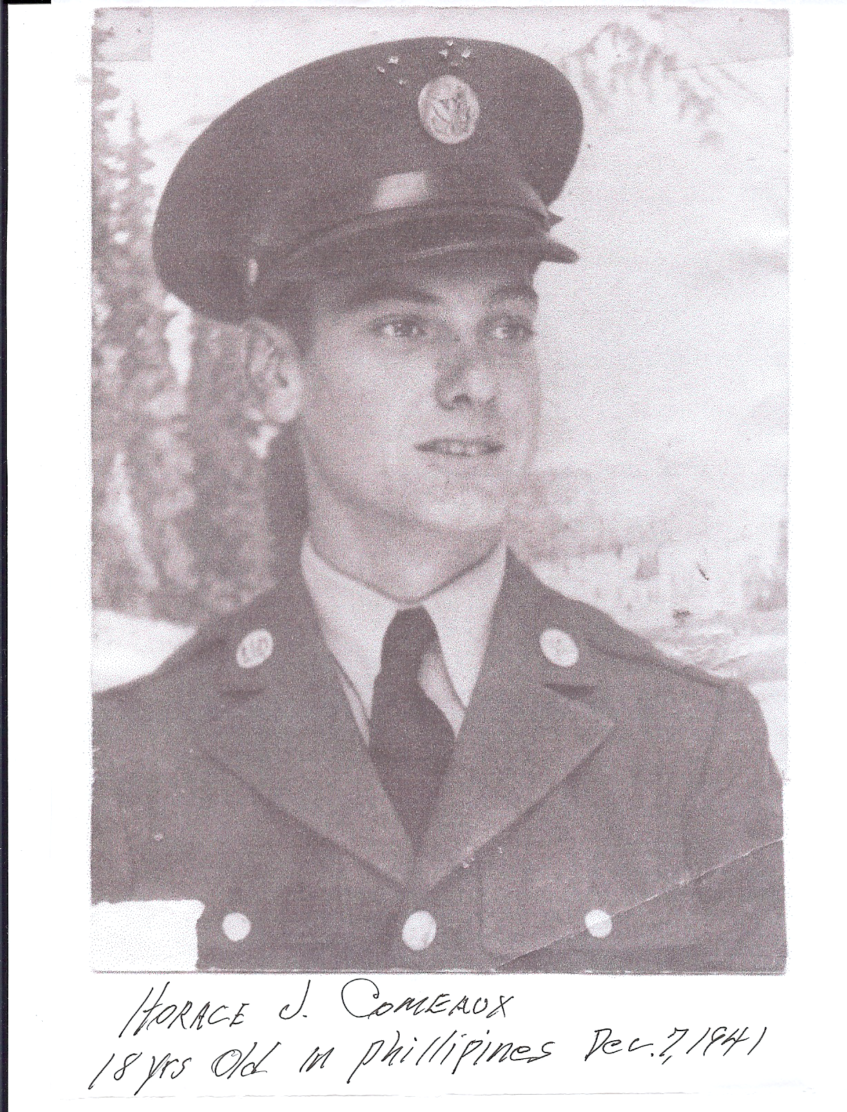
I was in the Army Air Corps,
27th Bomb Gp (Light) 16th Sqdn.
Arrived in the Philippines 18 days before
Pearl Harbor and was on Bataan when it fell.
Prison camps I was in were:
O`Donnell, Gapan, Cabanatuan and Bilibid.
Left Manila July 2nd 1944 by ship,
landed in Moji, Japan Sept. 2nd;
worked coal mines at Fukuoka #17.
I was liberated Sept. 15th 1945.
I worked for Chevron Oil Company for 32 years
in Port Arthur, Texas; have been retired 15 years.
I am 75 yrs old now and in pretty fair shape.
Have been married for 52 years;
have 2 children & 3 grandchildren.
by Horace J. Comeaux
Rayne, Louisiana

