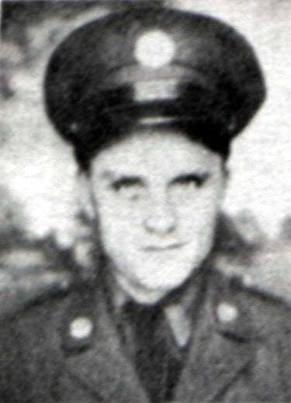
T/5 Artie P. Cope

Born: September 1918 - California Home: Salinas, California
Enlisted: California National Guard
Inducted: U. S. Army - 10 February 1941 - Salinas Army Air Base
Training: Fort Lewis, Washington
Unit: 194th Tank Battalion - C Company = Transferred to Headquarters Company when it was formed
Overseas Duty: Philippine Islands
Engagements: Northern Luzon, Battle of Bataan
Prisoner of War 9 April 1942 - Death March
Prisoner of War: POW Camps: O'Donnell, Cabanatuan, Fukuoka Camp #17 (coal mining)
Hell Ship: Clyde Maru, Sailed: Manila - 23 July 1943 - Arrived: Moji - 9 August 1943
Liberated: September 1945

Credit: Jim Opolony: 192nd & 194th Tank Battalion

