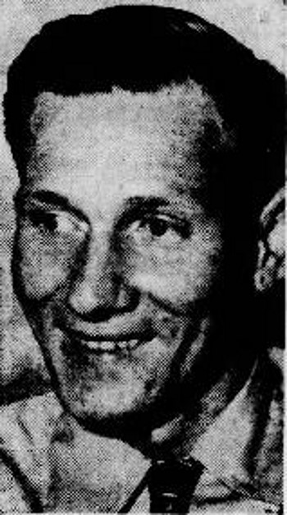
Maynard C. Cravens

Born: 16 October 1918 - Home: Hart County, Kentucky
Parents: Dell & Belle Cravens - Siblings: 2 brothers, 1 sister
Inducted: U. S. Army - 21 January 1941
Training: Fort Knox, Kentucky, Camp Polk, Louisiana
Overseas Duty: Philippine Islands
Engagements: Northern Luzon, Battle of Bataan
Prisoner of War: POW Camps: Cabanatuan, Fukuoka Camp #17 (coal mining)
Hell Ship: Clyde Maru, Sailed: Manila - 23 July 1943 - Arrived: Moji - 9 August 1943
Liberated: September 1945 - Died 1951
Buried: Zachary Taylor National Cemetery

Credit: Jim Opolony: 192nd & 194th Tank Battalion

