George Wyman Crowell
Navy Pharmacists – First Class

Born 29 Jan 191 / Deceased 24 Dec 1982
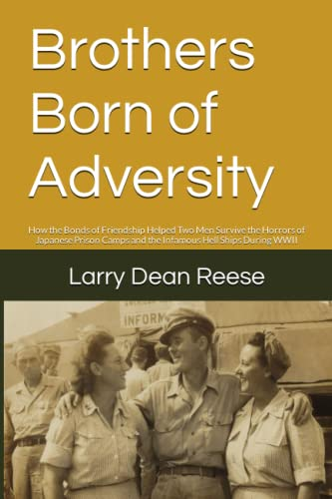
A World War II veteran, George first entered the military just after his 19th birthday, in February 1931.
Arriving in the Philippines January, 26, 1940, George would be stationed at the U.S. Naval Hospital, Canacao.
During the attack Japanese of the Philippines, George would care for the sick and wounded at various locations, until he and others were moved into hospitals within Manila City. They would end up at Santa Escolastica Hospital where they would be surrendered January 3rd, 1942.
George’s fight for survival had already begun, yet now it was a fight for body and mind.
His very existence would be challenged; from the caring for patients at Pasay School and then Bilibid Prison, to the horrific ordeal of transport on the hellships Oryoku Maru, Enoura Maru, and Brazil Maru, for the purpose of being used as slave labor by the Japanese.
George would spend the remainder of his battle for survival at Fukuoka POW Camp 17, Omuta.
His story, and that of his friend, Frank “Max” Maxwell (Navy Corpsmen) are told in the book by Larry Dean Reece -
Brothers of Adversity: How the Bonds of Friendship Helped Two Men Survive the Horrors of Japanese Prison Camps and the Infamous Hell Ships During WWII.
Photo – next page

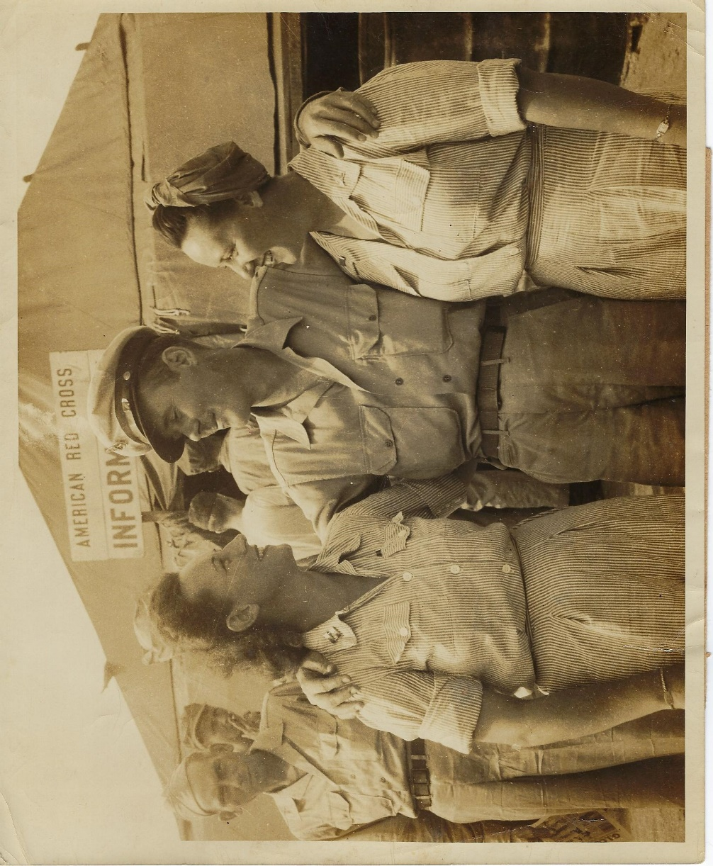
The photo at left was published in George’s home town paper with the following caption, “Okinawa, Sept. 1945 – C. Ph. M. George Crowell, a former prisoner of the Japanese is reunited with his sisters, Capt. Aller Crowell, left, and Lt. Thelma Crowell, Army nurses from Berry, Alabama, who appealed to the American Red Cross recovered personnel locator service to help find their brother. They located him the moment he arrived at the Okinawa transient camp.
(American Red Cross photo by Hamlin) E879.”

