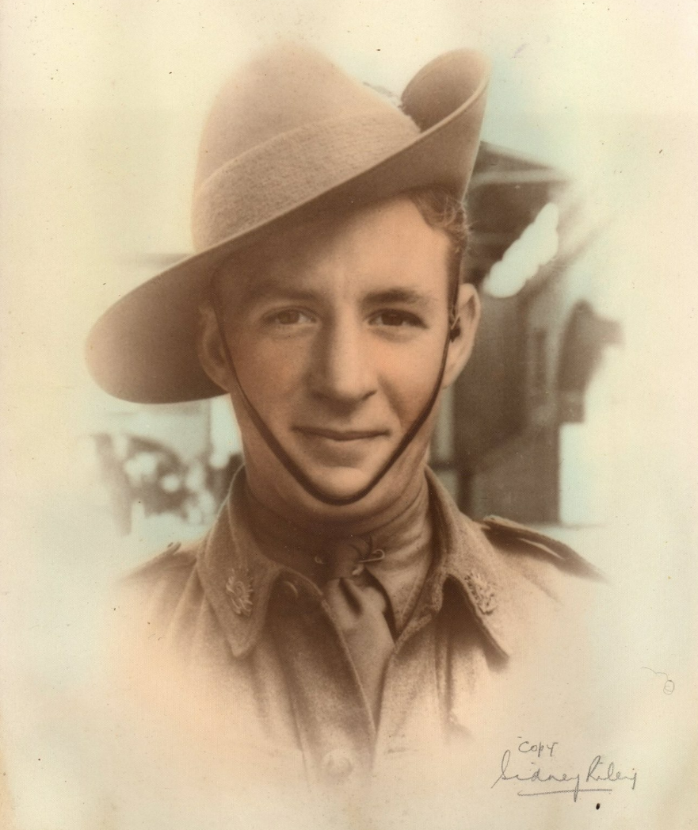
Douglas Frank Curby

Service Number - NX26106
Date of birth - 25 Feb 1920 - Place of birth - HORNSBY NSW
Place of enlistment - PADDINGTON NSW

Douglas was an Australian Soldier who was captured during the fall of Singapore and worked on the Thai-Burma Death Railway, andeventually transported by Hell Ship to Nagasaki.
Douglas was with the third group to arrive was a mix of Australian (#507-655), British (#657-664), and Dutch (#668-928) POWs who arrived on 18 June 1944 after sailing on the Teia Maru (ex Aramis), for internment in Fukuoka Camp 17 until the end of the war.

Douglas was rescued at the end of the war and returned to Australia. He passed away in 1994.

Profile information submitted by Grandson, Michael Sharpe.

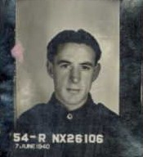

Documents following:

