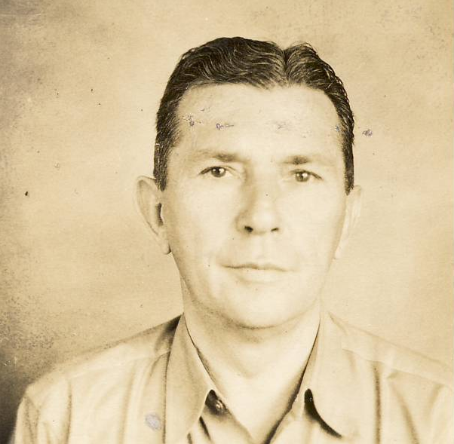
George Lester Curtis

Born 1st March 1893, New Bedford, Mass.; Died 22 July 1971, Los Angeles, Calif
George came from a large family of Portuguese immigrants. His parents were Manuel E. and Maria Curtis, the Americanized spelling of Cardoza, who emigrated from Lisbon in 1879, according to census records. Family gossip has it that Maria was actually Spanish, from Seville, and was nearly 30 years younger than Manuel, being his second wife. Manuel was a whaler out of New Bedford, then settled down to farm a small plot outside the city. George was the second-to-last of their brood of 12 children, seven of whom survived to adulthood.

After working the farm as a teenager, George and his older brother Jack migrated to New York City about 1914 where George found work as an auto mechanic. When the United States entered the First World War, George enlisted in the Army and was sent to France late in the war. His unit was subjected to a German gas attack in September 1918. In October, according to a contemporary New Bedford newspaper article, when communications between his unit and headquarters were severed by fighting, George volunteered at severe risk of his life to run messages from the front to headquarters, all while riding a bicycle. He also worked to re-establish telephone communications, all while under German fire. For this act of bravery, George, a 25-year-old first sergeant, was cited by his command and also received a coveted Croix de guerre from the French Army. He demobilized following the war and was given an honorable discharge.

He returned to New York City and, instead of being a mechanic, found a position as a car salesman, an avocation he would maintain for most of the rest of his life. He was very successful at it and, as the 1920s became the 1930s, he found jobs in several cities around the eastern seaboard of the country. The Depression, however, ruined the car business as it did nearly everything else, and his job was eliminated around 1936.

A year or so later, he was offered the position of general manager of a Packard dealership in Manila, Philippine Islands, then an American colony. The dealership was named the Estrella Auto Palace and by all accounts was quite successful, although it seemed to cater to the large American community. George, my mother's uncle, told me while I was a teenager that he very much enjoyed the Philippines and working with Filipinos.

When the Japanese attacked Luzon on 8th December 1941, Americans still living there tried to get out but were largely unsuccessful. The car business, as well as most other businesses, closed up. George took a job based in Mariveles, at the tip of the Bataan Peninsula, setting up and repairing telephone and radio communications for the American and Filipino forces who were mounting a desperate last-ditch effort to stave off the invading Japanese until promised reinforcements arrived. Those reinforcements never came. In April 1942, George withdrew once again to the island fortress of Corregidor but was forced to surrender along with Gen. Wainwright on 6 May. After a few days incarcerated in a former maintenance garage, the Japanese moved the prisoners to Mariveles to begin their portion of the Bataan Death March. His group was among the last to endure this ghastly march and he later told me that, with his hair beginning to gray, the Japanese soldiers there would place him on a truck from time to time because of their respect for age (he was just shy of his 50th birthday). It was the last respect he would receive from the Japanese.

Arriving at San Fernando, Pampanga, the Japanese decided to divide them up. Some went straight to the new detention center for American prisoners at Cabanatuan. Others, including George went to Old Bilibid Prison in Manila, a fortress-like relic left over from the Spanish colonial days, a true dungeon if ever there was one. Starvation rations were the order of the day. Over the next two years, he was shunted between Cabanatuan and Bilibid, with a brief stint at the old Clark Field air base to work as a laborer. George's days were spent laboring under the hot Philippine sun, either on airfields (Clark Field or Cabanatuan), a farm, or any other duty the Japanese found useful. He told me that, at one point, he was made to repair Japanese army radios. Rather than assist the enemy in this way, he and some other prisoners swallowed several tiny parts, making the radios useless. They were caught, and as punishment he said the Japanese allowed some mountain tribesmen who thoroughly disliked American to yank out their toenails with pliers.

In October 1944, with the approach of MacArthur's forces, George was with a large contingent of Cabanatuan prisoners who were deemed healthy enough to be shipped to Japan for further slave labor purposes. Two more months in Old Bilibid, fighting disease, malnutrition and mistreatment followed while they waited for a ship to transport them. That ship came in the form of the notorious Oryoku Maru, at one time a luxury liner plying the seas between San Francisco, Tokyo, and Sydney. The Oryoku Maru departed Manila Harbor on 13 December 1944 with 1619 prisoners in its hot, airless holds. The next day, it came under attack by fighter-bombers from the USS Hornet. Its steering mechanism damaged, the Oryoku Maru dropped anchor the night of the 14th off the old American Navy Base at Subic Bay. The next day, the carrier bombers returned to finish the job, sinking the ship. As it began to list, the prisoners, some of whom had been shot by their guards as they tried to climb out of their prison-like holds, were finally allowed to evacuate the ship. Those unlucky enough to jump off on the starboard side, which faced out to sea, were deemed by the Japanese as trying to escape and they were picked off by pistol and rifle fire. George abandoned the ship on the port, or shoreward side.

Upon reaching shore, exhausted, he was rewarded for his efforts by being bayoneted in the leg by an edgy Japanese soldier. Several nights in an abandoned tennis court with no food and little water followed. Trucks arrived to take them, they hoped, back to Bilibid, but they found themselves at San Fernando, Pampanga, again and were herded onto cattle cars on Luzon's only railway line. They headed north to San Fernando, La Union, where they were loaded onto two other ships, bound for Takao (Kaoshiung), Formosa (Taiwan). During a two-week stay in Takao's harbor, their ship was severely bombed by more American bombers, their pilots unaware that American POWs were aboard.

Their numbers now reduced to about 1200, the barely-alive prisoners were herded onto a small freighter/liner (the Brazil Maru) for the final two-week haul to Japan. They had gone from suffocating in Manila's tropical heat to freezing in the waters off southern Japan in January 1945, with snow accumulating not only on the decks but inside the holds containing the prisoners. With barely 400 still alive (an average of 30 died each night), they reached Moji (Kitakyushu) on the island of Kyushu, Japan, on the afternoon of 29 January 1945. The next day they stepped off the ship, the same day as a raiding party liberated the Cabanatuan Camp they had departed nearly four months previously.

George's group was assigned to Fukuoka Camp #17 which was actually in Omuta where they worked in the Mitsui Company coal mines for the next six months, almost never seeing the sunlight, George told me. Japan's surrender in August/September brought a slow increase in their relief, but the remaining prisoners did not get the medical treatment they needed until American occupation forces arrived at the camp in early September.

After several months, George went back to Manila to try to recover some of his belongings (and found virtually nothing). On 11 and 12 January 1946, he gave testimony to a War Crimes Investigation Unit in Manila, then was repatriated to the United States. Once home in New Bedford, he began a handwritten account of the sea voyage in 1944-45 that he titled, "47 Days On the Hell Ship." When he visited our family in Ohio, my mother typed up the manuscripts for him. George eventually returned to work in the automobile sales business.

While in Los Angeles in the early 1950s, he met a woman that I believe was named Nancy and they married. She had some money and together they bought a farm outside Oroville, Calif., to raise alfalfa, hay, and olives. The farm did not bring in enough to keep it and both the farm and the marriage failed. George wound up in Carlsbad in San Diego County and once again, at age 70 was selling cars. He lived near us and this is when I became acquainted with him and loved listening to his stories of his time as a POW. He could also tell tales of the car business and we found him delightfully funny.

He started having strokes in the mid-1960s. He was eventually admitted to Veterans Hospital in Los Angeles. While a patient there, I was led to believe that all his records and his manuscripts were lost. He passed away on 22 July 1971 while I was teaching in Australia and was buried in the Los Angeles National Cemetery. His manuscripts were found in late 2009 and I typed them up, this time into computer format for posterity so that many people could read what he and the others endured so long ago.

Credit: Michael Doty 11 December 2009

Addendum:
George Curtis is mentioned in George and Anthony Weller’s book "First Into Nagasaki". Curtis is also mentioned in George Weller's Oryoku Maru news account.
George Weller was a Pulitzer Prize winning reporter and wrote a series of articles on the sinking of the Oryoku Maru entitled, Seven Weeks in a Jap Made Hell.
Here is an excerpt from those articles:
Sees Friend Shot.
The last American shot by the Japanese while still on the decks of the Oryoku Maru, according to George L. Curtis, 53-year-old native of New Bedford, Mass., from Portsmouth, Ohio, who had been the Packard agent in Manila, was his friend Scotty Lees, a Philippine mining engineer whose wife was a school teacher in Freeport, Ill.
"When I got on deck and felt the boat sinking, I saw Scotty a little way off," says Curtis. "I was just starting to go toward him, and turned away for a moment to see something. When I turned back he was staggering and I saw that he was shot, for he was bleeding heavily in front."
Dazed from being struck by the hatchway's beams, Curtis barely made his way ashore
Some 57 civilians were in the party when it left as prisoners, and less than a dozen are believed to have arrived. More civilians perished from the bomb in the stern of the Oryoku Maru than any other cause.

