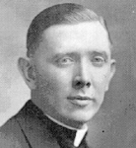
John E. Duffy
Survivor of the Bataan Death March after being bayoneted and left for dead. Fought with guerrilla units for several months before again being captured and sent to provost jail. Naval officers requested he be assigned as the Catholic Chaplain at the POW hospital where he offered daily Mass, Communion, the Rosary and visitations. Father Duffy was appointed as pastor of Our Lady of Lourdes Church in New London, Ohio in 1947 where he remained until his retirement, March 27, 1958, due to health reasons. Father Duffy was a past Commander of American Legion Post 292, New London, when he was appointed National Chaplain in 1952. He was also a Chaplain of the State of Ohio American Legion.
Father Duffy's Plaque Goes to New London - January 6, 1999
Father John E. Duffy, a St. Wendelin priest in the late 1920s, who was recently inducted into the Ohio Veterans Hall of Fame. Father Duffy was an authentic American hero during World War II. He assisted in the defense of Pearl Harbor and survived the Bataan Death March in spite of being twice bayoneted. He escaped to serve with Filipino guerrillas before being recaptured by the Japanese. From 1943 until the war's end, he was interned in several Japanese POW camps. Throughout his imprisonment, he selflessly ministered to the spiritual and physical needs of other prisoners.
On Dec. 14, a delegation from the Seneca County Veterans Commission presented the plaque to the New London Broome-Wood American Legion Post 292. Attending were Joe Gehring, Tom Evans, Tom Gernert, Jim Rochester and Jim McAuliffe.
Following his discharge from the Army in 1946, Father Duffy became pastor of New London's Our Lady of Lourdes Church, a position he held until his death. In addition, Father Duffy served as Commander of Post 292, 1947-49. He was also the Legion National Chaplain in 1952-53 and Chaplain of the State of Ohio American Legion.So it was fitting that the plaque honoring his service should find a permanent place in the community that knew him best. Joe Gehring presented the plaque to Post 292 Commander Ted Mahl.
"I knew Father Duffy when I was 10 or 11 years old," said Joe. "He came to visit me. I had double pneumonia and he gave me last sacraments. That always stuck with me. He tapped me on the left knee, I'll never forget it. He said, 'You're going to make it, kid."
Commander Mahl said that Father Duffy was "a true American and a true humanitarian...and we all share in this great man's life."
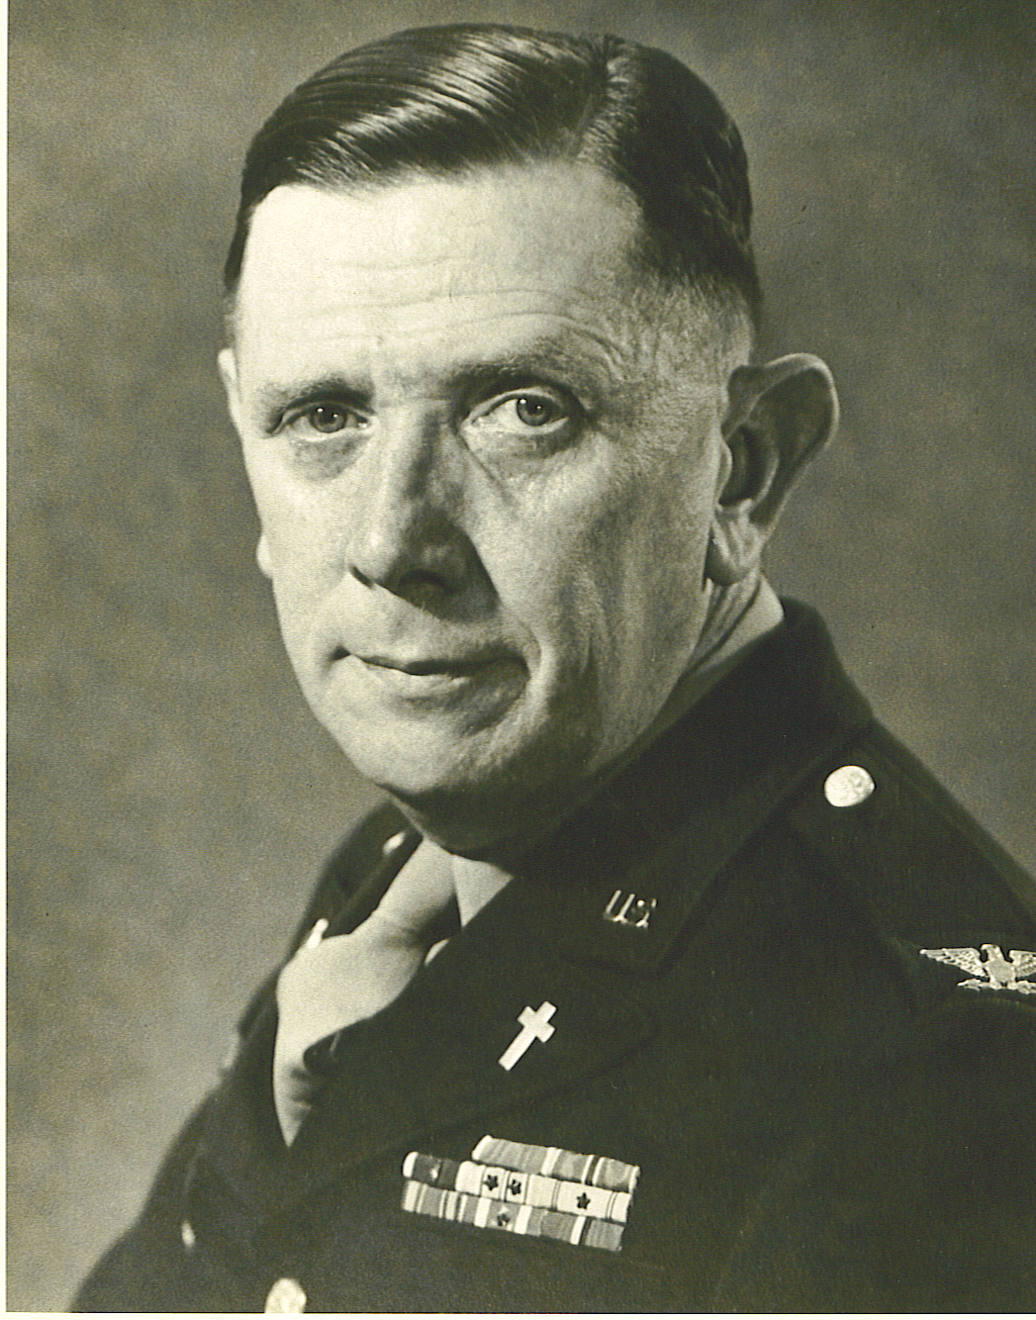
Father Duffy is still remembered by several New London residents. Former New London mayor Gerald Fowden recalled, "Father Duffy was interested in all the affairs of the village and he was one fine gentleman."
“He was a powerful personality, but not overwhelming and always polite," said former teacher Rock Laborie. "He was also quite a musician."
Father Duffy was also an able organ player. "He loved life," said Lois Kirkpatrick. "I think the number of times we almost lost him (in the war) increased his enthusiasm. He was very approachable. The children in the church and in the community were all very fond of him. He was a real leader."
Before going to New London on the 14th, Joe and Tom Gernert met with Rep. Paul Gillmor to request that Father Duffy be considered for the Congressional Medal of Honor, the nation's highest military award, given for distinguished service in combat at the risk of life and above the call of duty.
Father John E. Duffy was also inducted into the Ohio Veterans Hall of Fame. There is a display case devoted to Father Duffy's memory. His duffel bag, medals (including the Purple Heart and Bronze Star), several photos, a sword and other items reside there, including two drawings depicting life as Japanese POW's, by Father Duffy's friend and comrade, Ben Steele, who lives in Montana. Steele drew these striking scenes from memory after the war.
Father John Duffy died in San Francisco in 1958 at the age of 59. He is buried in the presidio in San Francisco CA. Yet the sacrifices he made, the strength of his character and his devotion to freedom can touch us still. We have but to remember.
Book on Father Duffy’s life……..By RON VIDIKA – Morning Journal
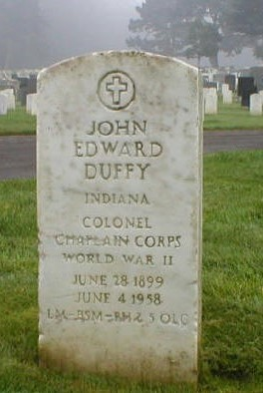
There is a display case in New London's Broome-Wood American Legion Post 292 containing mementos from chaplain Duffy's military service, including a sword, his duffel bag, a Purple Heart and a Bronze Star.
New London native Dan Murr, 70, now a resident of Jacksonville Beach, Fla., has written a book about Duffy, titled, ''But Deliver Us from Evil: Father Duffy and the Men of Bataan'' (Stanton and Samuel Publishers). Murr, who wrote sports for the former Lorain Journal from 1961 to 1963, decided to base his sixth book on Duffy because of his ties to New London.
When Duffy was discharged from the Army as a military chaplain in 1946, he assumed the pastorate of Our Lady of Lourdes Church in New London, a post he held until 1958. Although Murr was a senior in high school in 1947, his father, Kenneth Murr, was New London chief of police back then and knew Duffy well. Duffy's story, said Murr, began Dec. 8, 1941, the day after the surprise attack on Pearl Harbor by the Japanese.
''The Japanese attacked Clark Field, the American Army Air Force base on the Philippine island of Luzon, '' said Murr. For a day and a night, Duffy ministered to the wounded, performing last rites and helping bury 99 men. For four months, American and Philippine soldiers, led by generals Douglas MacArthur and Jonathan Wainwright, gained ground as the Japanese retreated down the Bataan peninsula, said Murr.
On April 8, 1942, his army low on bullets and food, Wainwright surrendered to the Japanese. It was at this time, Duffy was taken prisoner along with 70,000 other soldiers, said Murr. That began one of the most brutal episodes of World War II, the Bataan Death March.
''The atrocities and killing that went on was absolutely horrendous,'' said Murr. ''The Japanese beheaded, bayoneted and beat the soldiers. They gave them no water and they were so thirsty, they'd dive into a ditch and drink muddy water.''
Weary, sick from malaria, and weakened by hunger, the American and Filipino soldiers were forced to march back up the Bataan Peninsula under a blazing sun for 60 miles. ''Sixteen thousand men died on that march,'' said Murr.
''As a POW, Father Duffy was bayoneted and left for dead,'' said Murr. ''They stabbed him in the back. Then they sliced his foot with a bayonet to see if he was still alive.'' Murr said Duffy crawled off the road and slid into a pond. For four days, he stayed in the pond with only enough of his head above water so he could breathe. On the fifth day, he was rescued by Philippine guerrillas.
''In January, 1943, he was recaptured by the Japanese,'' said Murr. Special Japanese police tortured him, then put him aboard a prison ship. Twice, the ship was attacked by American planes unaware of the innocent human cargo aboard.
Father Duffy was wounded in his arm and neck, said Murr. When the prisoners left the sinking ship, Duffy helped one of them who couldn't swim. In August 1945, Duffy and the other prisoners were finally freed when Russian troops marched into their POW camp in Manchuria, said Murr.
Upon his return home, Duffy insisted that he not be sent to a large parsonage but a small one. ''He told the bishop of the Toledo Catholic Diocese that he didn't want a big church. He's rather have a small church that was in need,'' said Murr. Murr's father told him stories about Duffy hanging out at with the other veterans at the local post. ''He was a very popular priest, not only because of who he was, but because of the way he treated people,'' said Murr.
During his tenure at Our Lady of Lourdes, Duffy started a renovation program that ended up with the church getting new stained-glass windows. A POW friend of Duffy, Ben Steele, who served with the Army Air Corps, started drawing in prison ''to keep from going nuts,'' said Murr. Sailing on the prison ship with Duffy, Steele lost all of his drawings to the sea. ''He re-drew them from memory,'' said Murr.
Steele eventually became an art professor at the Cleveland Institute of Art and Kent State University. ''Father Duffy was going to write a book about his experiences and he wanted Ben to illustrate it,'' said Murr.
Unfortunately, that dream never became a reality and ended with Duffy's death in 1958 from cancer.
He was 59.
Photos, courtesy of Jack Mullen.
Father Duffy was his great uncle, his grandmother's brother.
Father Duffy is buried in the presidio in San Francisco

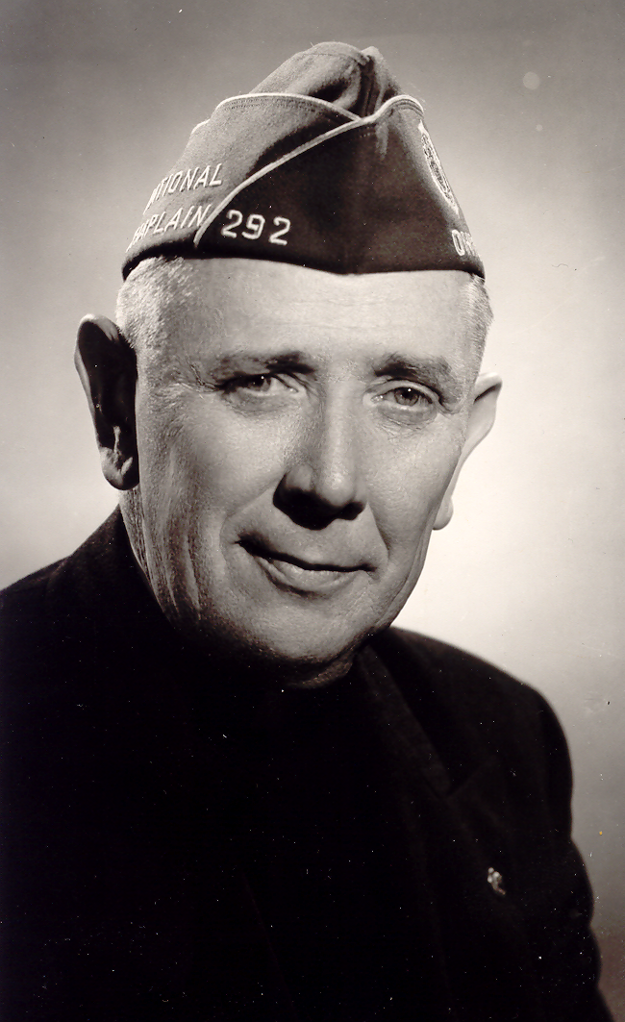
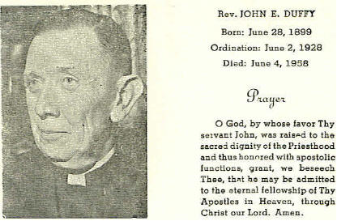

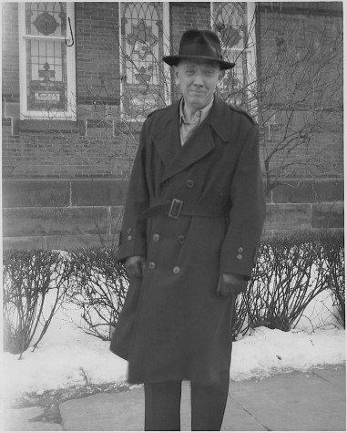

Fukuoka Camp 17 Project Manager's Note: I have been able to find few written articles of Father Duffy, except where he is mentioned in books or accounts. But the resounding theme of each memory is always the same; an extraordinary tribute and respect for Father Duffy. He is always referred to for his selfless sacrifices and dedication to the men on Bataan and in the POW camps. I wish I could do more to honor his memory.

