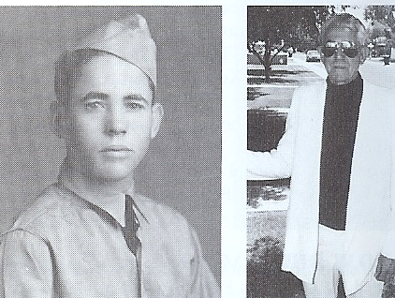
Robert Lee Dunlap Sr.
Nickname: "Brodie/Bob"
F Btry 200th CAC Regt (AA)

Born August 22, 1919 Lorenzo, Texas, Robert joined
Battery A 158th Field Artillery with the New Mexico National Guard in August 1941. He was transferred to the US Calvary, F Troop in Carlsbad, NM in 1938. Later converted to the 200th Coastal Artillery, Robert was called to active duty Jan. 6, 1041 and became a part of F Battery 200th CAC Regt (AA).
Robert was sent to the Philippines in August 1941 and assigned to Clark Field.

In a news article, Robert spoke of his time as a POW, and stating he was on the Bataan Death March 11 days. He recalled how the Japanese did not hesitate to bayonet or decapitate those who fell or stopped for water.
Dunlap recalled some POWS were so desperate to escape the mines that they broke bones or amputated their own legs under railroad cars. Later, Robert was forced into slave labor in Japan, at Omuta, Fukuoka Camp 17.

“I had to break my arm to get out of the mines,” he said. In fact, Dunlap remembered his arm was in a sling when the Americans dropped the bomb in Nagasaki. “We were standing there watching when the bomb was dropped because we didn’t know what it was that we saw.”

Dunlap also vividly remembers being beaten with split bamboo until his shoes were “filled with blood.” He said he (and others) found and devised ways to “get back and fight back” before the war was over. “I was sabotaging their mines,” he recalled.

(Credit: Heidi Bender/staff write Scottsdale Progress)

Family and Obituary:

Robert married Peggy Louise Watson Jan. 2, 1946 in New Mexico. The couple had one daughter, Cynthia Ann Bath, and one son, Robert Lee Jr.

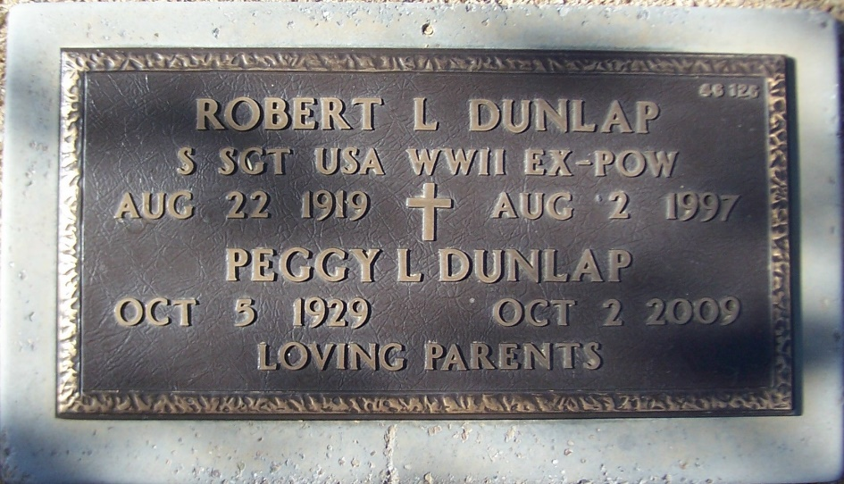

Robert Lee Dunlap, Sr., 77, Obituary

Robert Lee Dunlap, Scottsdale AZ, a retired self-employed contractor, died August 2, 1997. He was born in Crosby County, TX, and was an Army Veteran, and a member of the Disabled American Veterans and the American Defenders of Bataan and Corregidor.

He was assigned to the 200th CAC, NM, National Guard, when mobilized for active duty. He labored in the coal mines at Camp 17 in Japan until liberated at the end of the war.

Survivors include his wife, Peggy; daughter, Cynthia Bath; son, Robert Lee, Jr.; sisters Christine Edwards and Ruth Dodgen; brother, Wilburn; and three grandchildren.

