Tjeerd Eijsvoogel, Army Corporal, Dutch POW
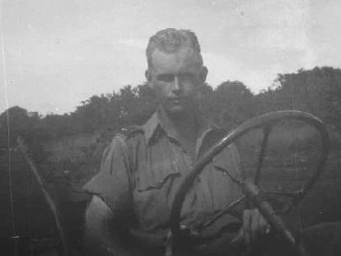
Tjeerd Eijsvoogel was born on 3-July 1922 in Tegal, Indonesia and died in 1975 in Holland.
His age was 52 when he died. His whole life he was in the army.
In Indonesia he was in the army, named KNIL. In Indonesia during the war he was taken prisoner of war. The Japanese took him to Java, Singapore and after that Japan kamp XVII in Omuta. (Fukuoka Camp 17)
In September 1945 he was liberated. I know he was very grateful for that. In Oktober 1945 he went to Indonesia, Balikpapan, and he was in army again. My mother was even born in Indonesia, and she was in the army too. She was taken in prison too (Adekkamp)
In 1948 my father and mother went to Holand, where we all (4 kids) were born.
My father and mother never told us anything about the horrible time in Indonesia and Japan.
Submitted by son, Wim Eijsvoogel Photo credit: son Wim
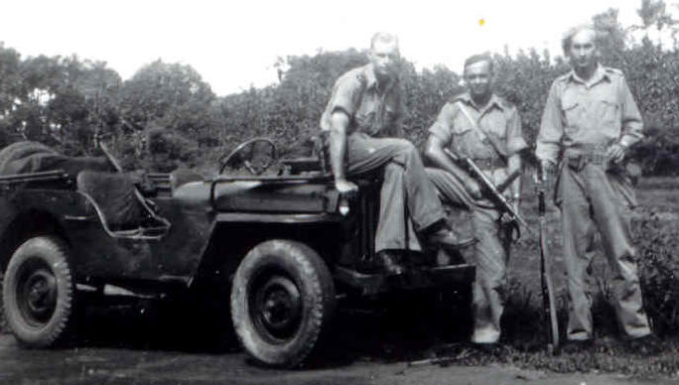
Above: Tjeerd on left Below: Tjeerd on hood of jeep
