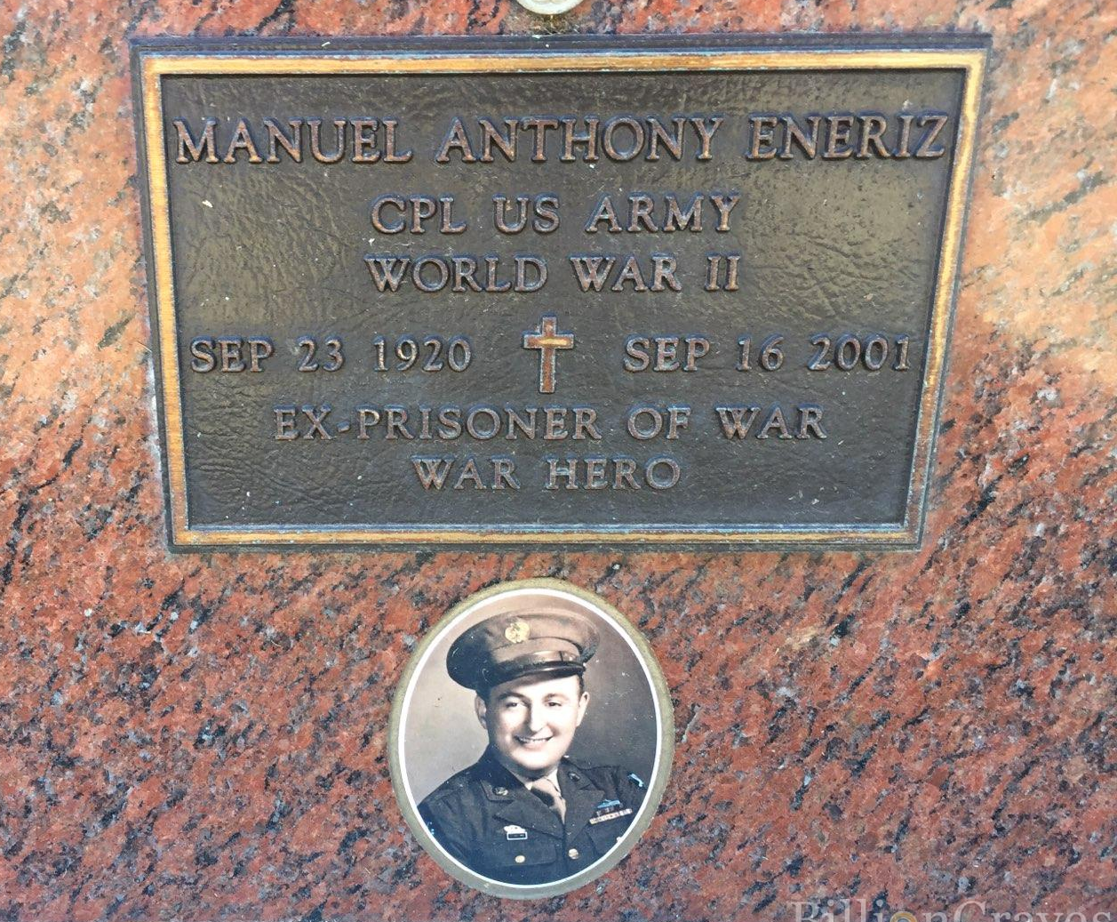
Manuel Eneriz

It was 3:40 p.m. on Aug. 9, 1945, and POW Manuel Eneriz was being marched back to his camp 30 miles outside Nagasaki, Japan.
Then he heard a noise like nothing he had ever heard before.

"It was actually two explosions," Eneriz recalled this week. "Maybe one was an echo. We looked up and saw that huge mushroom shape." In the telling of it half a century later, he still cries.

Today, on the 52nd anniversary of the bombing of Nagasaki, Eneriz will go about life as usual in his Camarillo home.

But he will also think back to where he was on that historic day, when the detonation of the atomic bomb known as "Fat Man" effectively ended World War II. "We had been getting American bombing raids coming over regularly," said the 76-year-old Eneriz, who was an Army corporal when he was captured in the Philippines in 1942.

"But this bomb . . . you felt almost like an earthquake," he said. "Those other raids didn't feel like that. Afterward, the wind blew and it rained. The only thing we could think of was that maybe the Americans had bombed an ammo dump. "We still didn't realize it was anything special until we were liberated," he said. "The Japanese guards at the POW camp only told us 'No more war' four days after the bomb.

"Then the Americans came and got us a couple of weeks later and put us on a train to the harbor. That was when we saw how Nagasaki was destroyed. "But we still didn't really understand. We said, 'Atomic bomb? What's that?' "

After his capture in the Philippines, Eneriz survived the infamous Bataan Death March before being shipped to a Japanese coal-mining POW camp.

There, he survived bouts with malaria, dysentery, scurvy, pellagra and the occasional beating and stab wound by his captors. Those wounds earned him a Purple Heart many years after his discharge.

Interned with other soldiers from America, the Netherlands, Australia and England, he labored 10 hours a day in the mine until the day he saw the mushroom cloud. The next day, his Japanese guards declared an "emperor's holiday," which meant the prisoners did not have to work their shifts.

On being liberated, his first act was to stuff himself with chocolate and doughnuts offered to the POWs. It was a mistake. "In 15 minutes I was so sick," he said. "For 3 1/2 years, all I'd eaten was rice."

But after what he had endured, Eneriz didn't mind paying the novel price of eating too much rich food. Today, his health is not particularly good. But Eneriz, who survived colon cancer in 1980, thinks it is amazing he is alive at all.

"After all that, and here I am at 76, hanging on. I met my wife, Angelita, in a Van Nuys Army hospital. I have four sons living in Southern California and 13 grandchildren." Eneriz spent 30 years working in quality control for Litton Systems in Woodland Hills before retiring in 1979.

After moving to Camarillo with his family in 1966, he made an unsuccessful run for a Camarillo City Council seat, but he says he is "a little too old to run again." He also did a stint on the Ventura County Grand Jury two years ago. Eneriz says he will probably never know what relationship his exposure to the bomb's radiation had with his cancer.

"They say that in the epicenter--a 3-mile radius--you don't make it," he said. "A 10-mile radius gives you radiation burns. The doctors wrote me a letter saying the amount of radiation I was exposed to was like two X-rays."

To this day he keeps a rosary made of black plastic beads nearby. He was wearing it around his neck when he was captured.

"Usually they'd take something like that away from you, but this Japanese guard had a string around his neck with a Buddhist pouch on it, so I pointed to his pouch, then to my rosary, like they sort of meant something similar, and he let me keep it."

The rosary never left Eneriz's neck during his ordeal. And, he said, he forgives many of those who imprisoned him.

"Those guys, I guess they fought for their country like we did."

Credit: August 09, 1997|BRENDA LOREE/ LA Times

The following is a news article submitted by Manuel in 2007

A Granddaughter’s Tribute
by Monica Eneriz (when she was a student at Stanford University)

A frail skeleton of a man sat among other skeletons on the dusty floor of a roughly constructed barracks. Nothing in his appearance or actions could eve r have suggested that this emancipated figure had been a happy, laughing boy of 19 only six months before.

His eyes were dark and blank and sunken deep in his face. They seemed to reflect nothing but pain and darkness. His other facial features were sharp and hollow. Skin clung to his bones and his ribs clearly displayed themselves through his chest. The men around him were just the same. The stronger held on despite the dysentery, starvation, and malaria. The week lay helplessly on the floor in agony. Others had not been able to withstand the disease and hunger, and they lay in silence. They had quietly and mercifully slipped into another existence during the night. Their suffering was over. Soon their cold, decaying bodies would be dragged out and thrown into the crowded earthen pit that would serve as their final resting places.

The young man stood among this horror, but was not deranged by it. This was his reality. All the tears he could have possibly cried had already fallen. The images of torture were enough. He could still vividly see his friends and comrades dying in his arms, the battlefield strewn with body parts.

The trenches and barricades he had cowered behind during combat were covered with their blood and his own – the blood that now mingled with poisonous gas and shrapnel from explosives.

His hell did not end there, though. In the prison camp, he was to experience more torment. More friends died, leaving behind their cold remains to be feasted on by rats and flies. Some comrades were executed and dismembered before him. He watched others slowly go insane. His body, however, fared no better than his crippled soul. The few handfuls of rice he was able to receive were crawling with the larva of insects. These creatures plagued his body. When he was not given enough food, they slowly began to devour his stomach and continued to eat him, from the inside out.

He constantly lived with the pain of hunger and disease while visions around him constantly played in his mind. Yet, despite all this he held on to life and his sanity. Somewhere, deep in his psyche, his heart faintly grasped at the loving images of his family and home so far away. This was what made him one of the strong and the living.

Soon a stern, uniformed soldier would come to gather the men who had survived the night. Another day in the coal mines awaited him.

This short description is a general view of what my grandfather, Manuel Eneriz, experienced for almost four years in a Japanese POW camp During WWII. When he was surrendered, his life changed forever, and he experienced one of the most traumatic events of his life. It has left permanent scars on his mind and body.

He was forced to walk for six days (a portion of the Bataan Death March) without food or water, seldom rest, and through 90 to 115 degree heat. After that horrific journey he was placed in a POW camp, then put on a Hellship to be forced into slave labor in the mines at Omuta.

He survived because he never stopped having faith in God, in his country, and in himself. It was his incredible hope and inner strength that sustained him throughout his imprisonment that inspires me today.

When I think of how much he suffered, it puts my failures and problems in perspective. His example of courage encourages me to be a stronger person. The fact that he continues to share his terrible experiences, despite the pain, demonstrates another type of courage. He wants his family to learn about his life and the history he was a part of in order to help us understand ourselves today.

For these reasons, I consider my Manuel Eneriz a hero.
U.S. Flag Sustained POW
Dear Young American,
Envision your country's flag. You salute it when you enter the classroom. It flies over your school, your parades, parks and playgrounds. You honor it in church or synagogue. It flies, too, from your own front porch, in your backyard, on a camp pole.
Yes, you recognize the Stars and Stripes. But is it saying something to you? Are you angered when you see it defiled or ridiculed? Does your heart throb? Do your eyes glisten with tears when you behold it unfurled in the breeze? Or is patriotism perhaps like religion? You don't know if you've "got it" until you need it?
I was once a young American, too, and no more or less patriotic than you. I pledged allegiance to the flag and sang "America" as best I could, until Adolph Hitler raised a heavy hand and smashed his fist into the heart of Europe, until Japan directed a savage attack on our shores.
I was launched into a wartime world I could never have imagined.
I became a soldier. My comrades and I followed our flag as it billowed against a gray sky. We saw the colors ground into the sands of Bataan, on the coral of Corregidor. I watched our flag until it was no longer there to watch.
We surrendered to overpowering Japanese armed forces in Bataan. I was marched along at bayonet point; I existed under a flag that boasted a rising sun.
What my captors failed to realize is that although they shaved my head, starved my body, deprived my soul and denied me basic human rights, an American flag fluttered on in my heart. Pride in what the "Red, White, and Blue" stands for buoyed my spirit. God watched over me, my compatriots sustained me, and I survived.
Can you understand what a blessed, beautiful sight that flag was to me when I viewed it at last in San Francisco? Why that flag waves to me from sea to shining sea, beckoning me to my family? That flag cried out:
"Look, look! I'm flying still! I always will!"
I did look. I wept. I thank the Lord above for returning me home to this good land.
And now, will you do something for me? Take another look, a good hard look, at the flag!
Manuel Eneriz
Credit: Ventura County Star June 14th, 2007

Manuel Anthony Eneriz, 1920 - 2001
Manuel Anthony Eneriz was born on September 23 1920.
Manuel passed away on September 16 2001, at age 80.
He was buried in Conejo Mountain Memorial Park Cemetery, Camarillo, California, United States.

