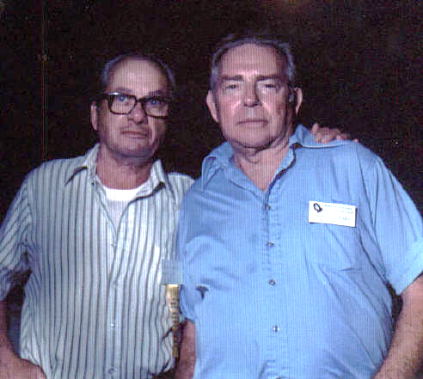
Harold Feiner
On Left: Al Dubois, former Camp 17 POW # 388
Right: Harold Feiner, former Camp 17 POW # 282
Harold Feiner, who held the office of Judge Advocate with the American Defenders of Bataan and Corregidor for many years,
died on December 10, 2003 after a short illness.
Harold was born in New York City in the year 1918. He enlisted the Army in the year 1940 and was classified as an electrician with Co. A 19th Ordinance Bn. with the first Armored Division at Ft. Knox, Kentucky. The company was deactivated and then designated as the 17th Ordinance Co. Armored, which immediately was ordered to the Philippines, arriving there on September 26, 1941.
Harold’s company was then based at Ft. Stotsenberg where the unit joined the 192nd and the 194th Tank Battalions and later identified as the Provisional Tank Group, US Army Air Forces in the Far East.
They first saw action on December 8th, 1941 when Japanese planes attacked Clark Field. After the Japanese landing at Lingayen Gulf the tank group was dispatched to defend the area. The tank group later defended the area as various other military units were ordered to withdraw to the Bataan Peninsula. During the defense of Bataan, the tanks supported the infantry at every opportunity and on every trail. The tank group was ordered to surrender after destroying their equipment on April 9, 1942.
Harold became a prisoner of war on April 10, 1942 at Mariveles, Bataan and then he became a part of the infamous Bataan Death March, led to Camp O’Donnell. In June, 1942 he was moved, with other POW’s to Camp Cabanatuan. In August 1942 he was transported on one of the Hell Ships to Japan where he was interned at Camp 17, Omuta, Japan working a coal mine owned by Mitsui Company.
Harold subsequently retired from the Army. Among the many awards he received were the Purple Heart, Bronze Star
and the Presidential United Citation.
After his retirement Harold began another career; assisting his fellow prisoners of war. He was elected to the position of Judge Advocate and worked diligently for many years. In addition, Harold was a member of the litigation & legislation committee of the ADBC where he worked with fellow CAMP 17 POW Frank Bigelow.
Harold was a strong supporter of the Florida Chapter of the ADBC in which he also held office of Judge Advocate. Harold worked extensively with the Kissimmee Filipino community in their recognition of the defenders of the Philippines Islands and the beautiful memorial dedicated at the community park of that city.
Harold’s last official trip was in November 2003, traveling to the executive meeting in Cincinnati with his daughter, Laurice. From Cincinnati Harold and his daughter traveled to Wellsburg, W. VA. For the dedication of the ADBC library. Then on to Newport, Virginia where they attended a dinner and recognition ceremony given by the crew of the USS Bataan. Laurice stated that her father was enjoyed the trip so much, mostly due to the gracious hospitality shown to him wherever then went.
Harold is survived by his daughter Laurice; son Martin; a sister Lorraine Resnick; five grandchildren and eight great-grandchildren. He was laid to rest at the Bushnell National Cemetery. Along with family and friends there was in attendance Linda Goetz Holmes, who is a noted author on Japanese Prisoners of War. National Commander John Oliver read the eulogy and Randall Edwards recited a special poem and Harold’s granddaughter performed a beautiful rendition of taps on her bugle.
This is a touching description of a person who loved and served his country. He was a patriot pure and simple.
Harold will be greatly missed by his family, friends and members of the American Defenders of Bataan and Corregidor.
Credit: Quan February 2004

