James Finley

Born: 25 January 1918 - Oklahoma
Son of John D & Sara E. Finley
Inducted: U. S. Army - 17 March 1941
Training: Fort Knox, Kentucky, Camp Polk, Louisiana
Units: 753rd Tank Battalion, 192nd Tank Battalion
Overseas Duty: Philippine Islands - Engagements: Battle of Bataan
Prisoner of War: 9 April 1942, Death March
POW Camps: Philippine Islands: Camp O'Donnell & Cabanatuan
Japan: Fukuoka Camp 17 – slave labor: coal mining
Hell Ship: Clyde Maru, Sailed: Manila - 23 July 1943
Arrived: Moji - 7 August 1943
Liberated: September 1945
Trade: Carpenter
Died: 9 March 1974 - Wife: Grace Amelia Leonard
Buried Arlington memorial Gardens – Spencer, OK
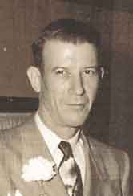
Credit: Jim Opolony: 192nd & 194th Tank Battalion

