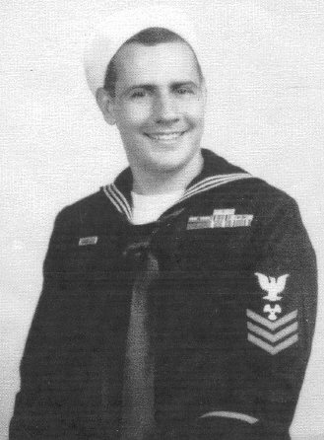
Lawrence (Larry) I. Freeman
Deceased March 21, 2006
Wife: Esther (Deceased August 2, 2007)
Larry was from Worcester, Massachusetts
Assigned to the engine room of the USS Canopus
POW Camps: 92nd Garage, Bilibid, Port Area,
Cabanatuan, Fukuoka Omuta#17
Hell ship: Mati Mati Maru (Canadian Inventor)

