Evans R. Garcia
200th Coast Artillery Battery "H"
Bataan death March survivors: Son of New Mexico, Evans Garcia’s story
By April MacIntyre May 28, 2007

Bataan Day is celebrated in honor of the American and Filipino troops who defended the Bataan peninsula in the Philippines against the Japanese during World War II.
In the University of New Mexico documentary, 'Colors of Courage, Sons of New Mexico, Prisoners of Japan, I first “met” Evans Garcia, courtesy of his proud granddaughter, Dolly Romero, by chance at a private screening of the film.

Evans’ story of surviving Bataan, the death ships and being a prisoner of the Japanese taken eventually to Japan is told in the film, along with so many boys of New Mexico. The filmmakers show the hard sacrifices the 200th and 515th Coastal Artillery made when World War II ramped up in the Pacific theater. The Hispanic contributions made in World War II for America were overwhelming. The excellent documentary is directed by Tony Martinez, also the son of Eddie Martinez, a Bataan Death March survivor, 200th C.A. Battery 'A' was narrated by Oscar winner Gene Hackman, and illustrates the devoted service of New Mexico's 200th and 515th Coast Artilleries that lost nearly 50 percent of their units in the Bataan Death March. It also details the horrific Japanese death ships transport of the soldiers, and 3 ½ years at the hands of the Japanese in prisoner of war camps.

Soldier Evans Garcia was born in Dona Ana, New Mexico on June 19, 1913. His work ethic was established by the age of 10, when he began working in his grandfather’s alfalfa field, minding the horses that transported the alfalfa into a bale-making machine. He attended New Mexico State University in 1934, but did not graduate, as he chose to work full time to help out his Mother. He volunteered for the Army at a late age, 27, becoming a member of the historically rich 200th Coastal Artillery, Battery H of the New Mexico Army National Guard, which was sent to the Philippines in September of 1941.

The 200th was born from the early New Mexican Calvary that was dispatched to Cuba to fight with Teddy Roosevelt’s “Rough Riders.” When New Mexico became a state in 1912, several decades later the Calvary was federalized and the 200th became one of the most ethnically diverse National Guard battalions in the United States. The men of the 200th were among those who fiercely fought in key battles after the Japanese attacked the Philippines on December 7, 1941, keeping the Japanese army from taking the islands quickly as they had planned too.
Their tenacity gave the US military time to re-fortify and plan for the European front, possibly changing the course of the war. These brave soldiers were responsible for the defense of the islands of Luzon, Corregidor and the harbor defense forts of the Philippines. These “sons of New Mexico” were captured by the Japanese and forced to surrender, becoming prisoners of war and forced to endure the infamous Bataan Death March.

Evans Garcia spent 42 grueling months in prison camp, but kept his hope and spirits intact by his devout faith; his unwavering optimism and belief in helping his fellow soldiers buck up and stay strong, despite the daily brutalities they all faced. Martinez’s documentary features the only known interview with one of the perpetrators of those war crimes on Bataan, a Japanese soldier who confirms details of the numerous atrocities on the Death March. Listening to the Japanese soldier describe how the Japanese soldiers honed their torture skills on a blindfolded American soldier, learning how to decapitate slowly in an exercise called “meat cuts”, is beyond comprehension. The Japanese had lived up to their reputations from the Manchurian invasion of 1931, and their follow up invasion of China in 1937 where they bayoneted screaming babies and women in the villages. These facts were fresh on the minds of the frightened prisoners of war in Bataan, who knew too well the Japanese past war crimes. The conditions the Americans encountered and the aftermath of the battle were unique. They fought in a malaria-infested region, near starvation and surviving on half or quarter rations with virtually no medical assistance. They fought with outdated equipment and practically no air power.

On April 9, 1942, tens of thousands of American and Filipino soldiers were surrendered to Japanese forces. The Americans were Army, Army Air Corps, Navy and Marines. Among those seized were the 200th Coast Artillery, New Mexico National Guard. They were marched for days in the scorching heat through the Philippine jungles. Thousands died. Filipino villagers risked their own lives trying to give the suffering marchers water; some were killed right in front of their families. Those who survived faced the hardships of a prisoner of war camp.

They were then horded into the “death ships” that were unmarked as POW ships by the Japanese, where the men were force in tightly standing up the entire sea voyage that took weeks, always at risk of being fired upon by American ships not knowing what lay in their cargo holds. No water, no food, and the results were the worst of it for many men, as American soldiers went mad from thirst and drank urine and blood of deceased soldiers. Those that survived this were headed to more misery: POW work camps in Japan.

Dr. Tobias Durán, along with Martinez and producer Scott Henry, who both wrote and directed the documentary for the Center for Regional Studies at the University of New Mexico in 2002 and 2003, have together created an important historical marker and a must see film for all interested in World War II and the actual events that transpired.

They went to Bataan and the Philippines for the film, interviewed more than 30 Death March survivors, experts and historians. The Army ROTC Department at New Mexico State University began sponsoring the memorial march in 1989 to mark a page in history that honored New Mexico's 200th and 515th Coast Artilleries, the most decorated units of World War II.

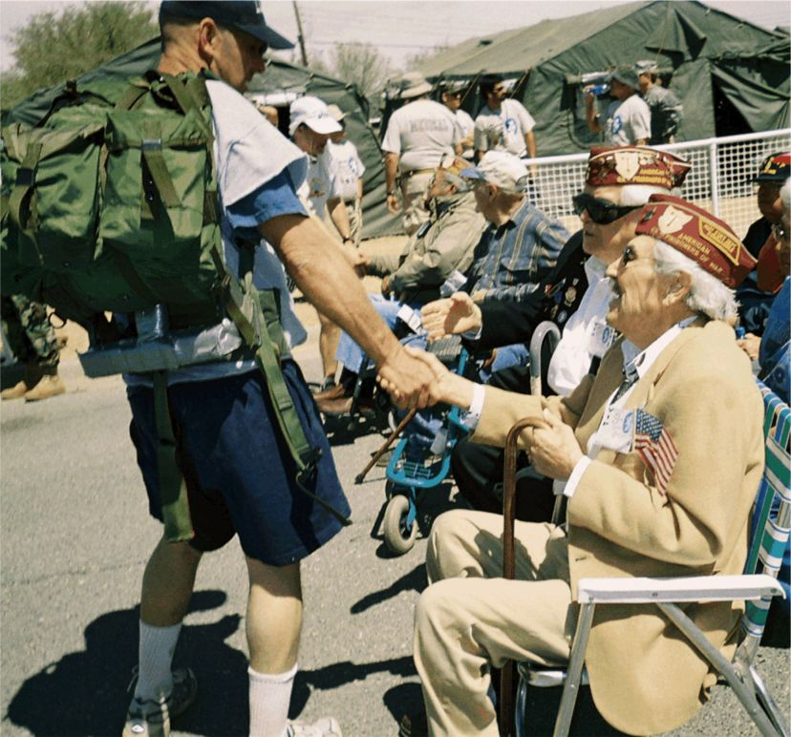
Since its inception, the memorial march has grown from about 100 to some 4,000 marchers from across the United States and several foreign countries. While still primarily a military event, many civilians choose to take the challenge. Marchers come to this memorial event for many reasons. Some march in honor of a family member or a particular veteran who was in the Bataan Death March or was taken a prisoner of war by the Japanese in the Philippines.

Family and friends of Evans Ramirez Garcia and the New Mexico State University Foundation, Inc. have established the Evans Ramirez Garcia ROTC Scholarship at New Mexico State University. The first award was given March 24, 2007 to a NMSU ROTC student at the annual Bataan Memorial March Ceremonies at White Sands Missile Range, New Mexico. The scholarship fund is structured in such a manner that the award will be given annually in perpetuity to a deserving ROTC student at the Memorial March.
The most recent Bataan Memorial this last March in White Sands had survivor Evans Garcia there once again to signed books, shirts, programs, posters, contestant numbers and completion certificates by the hundreds. Garcia also got to welcome his granddaughter, Dolly, who marched this year.
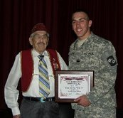
Photo above & below: Garcia shaking hands with a finisher. Dolly at the finish.

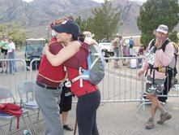
Garcia was also proud to honor to the very first recipient of NMSU ROTC Evans Ramirez Garcia scholarship to Cadet Anthony Filosa III. Filosa hails from Truth or Consequences, New Mexico, where Evans once lived after age 16.

Evans and the first recipient (right) of his scholarship, Cadet Anthony Filosa III

For more information, contact UNM CRS at (505) 277-2857 or crsinf@unm.edu.
Contributions will keep Evans Garcia’s wish alive – that no one ever forget Bataan and its lessons. Please make checks payable to NMSU Foundation INC, with the memo portion that it is for the Evans Ramirez Garcia ROTC scholarship.
The address is: New Mexico State University Development Office, Dove Hall, MSC 3590 PO Box 30001, Las Cruces, NM 88003-8001

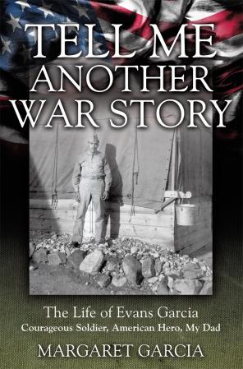
Tell Me Another War Story: The Life of Evans Garcia…
by daughter, Margaret Garcia.

The book is about the life and legacy of Evans Garcia, from his rural upbringing in New Mexico, and his service in World War II with New Mexico National Guard's 200th Coast Artillery (AA) in the Philippines. From the fight on Bataan, to his POWs years, it covers his harrowing near-death hardships as a POW, a hellship voyage, and as a slave laborer in a condemned Japanese coal mine. Through it all, he kept his faith in God, and had a way of finding the silver lining, and often, humor, in the midst of the anguish of war. After the war, Evans returned to New Mexico, worked in Santa Fe with the Selective Service System for 25 years, and poured his energy into veteran activities, always ready and willing to serve his fellow soldier. His daughter, Margaret, listened to and wrote down his war stories for years. Initially, she did not realize the importance of them, but at one point, was inspired to pull her notes together and tell his story. "Dad's mantra to me was, 'Do everything you can so they don't forget Bataan, '" Margaret said, "That was one of my goals in writing this story, and it took me on an unexpected and unforgettable journey that has made my life richer." Margaret lives in Albuquerque with her cat, Tyson.

Sadly we lost Evans on January 29, 2011
GARCIA – Evangelisto (Evans) R. Garcia, age 97, passed away peacefully Saturday, January 29, 2011. He was born in Dona Ana, New Mexico on June 19, 1913 and was a long-time resident of Santa Fe before he moved to Albuquerque in 1994. He is survived by his three children: daughters, Pauline Garcia and Margaret Garcia of Albuquerque; and son, Anthony Garcia and wife, Lisa of Torrance, California. He is also survived by his grandchildren, Theresa Fuentes and husband, Robert Dell Angelo, Antoinette Fuentes-Knapp and husband, David, Antonio Garcia and wife, Maria, Dolly Romero-Wilberding and husband, Jason, Matthew Fuentes, and Frances Garcia; and great-grandchildren, Anthony and Michael Antonucci, Talia Dell Angelo, Brian, Lauren and Lindsay Knapp, Ben and Luke Wilberding, Esteban Sena, and Caige and Rein Fuentes. Mr. Garcia was preceded in death by his father and mother, Belzan and Juanita Garcia; his sisters, Adela Bowen and Crucita Daby; and his son, Evans.
Continued…
Mr. Garcia graduated from Hot Springs High School, then studied accounting at the LaSalle Extension University and attended New Mexico State University. He enlisted in the U.S. Army on April 4, 1941 and served in the Asiatic Pacific Theatre of Operations during WWII, participating in the Philippine Defense Campaign with the New Mexico National Guard 200th Coast Artillery and 515th Coast Artillery. These brave soldiers held off the Japanese against all odds, without enough food or supplies, and inferior weapons.
Mr. Garcia, along with other New Mexico guardsmen, was captured by the Japanese Army on April 9, 1942 and forced to endure the infamous Bataan Death March. He spent 3 and a half grueling years as a Prisoner of War, held in several prison camps in the Philippines and was sent on a Hell Ship to Japan and held in Fukuoka Prison Camp No. 17 until liberation on September 12, 1945.
As a result of his dedicated service to our country, Mr. Garcia received the following citations and decorations: Asiatic Pacific Theatre Ribbon with one Bronze Service Star, American Defense Ribbon with one Bronze Service Star, Philippine Defense Ribbon with one Bronze Service Star, The Victory Medal, Good Conduct Ribbon with Clasps, Seven Overseas Service Bars, The Distinguished Unit Citation with Three Oak Leaf Clusters, The Bronze Star, The Purple Heart, and more recently, the POW Medal.
As the Korean Conflict escalated, Mr. Garcia enlisted with the U.S. Army on June 28 of 1949 and was discharged on October 17, 1950. After the war, Mr. Garcia settled in Santa Fe and worked with the Selective Service System. His four children were born in Santa Fe and he often took them up north to camp and fish. He always enjoyed hunting and fishing with his many friends. He retired from Selective Service in 1967. Following his retirement, he was active in the VFW Post 2951 and served in many capacities, including Commander. During his tenure, the Post grew and prospered. He was also very active in the Bataan Veterans Organizations in Santa Fe and statewide, the DAV, and volunteered hundreds of hours at the VA hospital in Albuquerque. He was actively involved with his grandchildren, traveling with them and especially teaching them to fish. He was very proud of his grandsons Antonio and Matthew as they chose to follow in his footsteps and join the military to serve their country.
Interment will follow mass at the Santa Fe National Cemetery. Pallbearers will be Antonio Garcia, Matthew Fuentes, Fred Armijo, John Ojinaga, Sam Ojinaga, and Corky Ojinaga. Honorary pallbearers will be members of the New Mexico National Guard.

Continued….

A Daughter’s Journey
Margaret Garcia’s Reconnection with Her Father’s Legacy
I just returned from a trip overseas, and had the opportunity to visit many memorials to World War 2 soldiers.
One was a 20-acre cemetery, comprised of The United Kingdom section, the Australian section, the Canadian and New Zealand sections, and the India section. Within the cemetery is a cremation memorial, containing a large urn of 335 cremains of soldiers, sailors, and airmen of the Commonwealth, the United States, and the Netherlands.
The grounds are beautifully tended to, and ceremonies are held annually to remember the departed veterans.
Another memorial I visited was to honor Dutch, British, American, and Australian POWs. The inscription on the memorial says: “In memory of those who lived in such harsh circumstances, to which some of them succumbed, and with a profound sense of remorse, we proclaim our fervent hopes for everlasting peace in the world. “

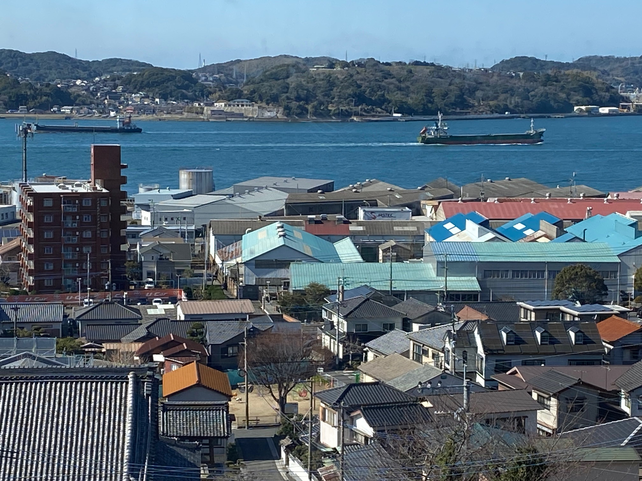
My visit to these hallowed grounds was not to France, not to Belgium not to Italy or the Philippines, but to Japan, where many memorials across the country remember the sacrifice of U.S. and other Allied nations.
The 20-acre cemetery I mentioned is the Yokohama War Cemetery, not far from Tokyo, remembering those who died in Japan as prisoners of war or with the occupying forces after the war.
(photo- Port of Moji showing Kanmon Strait that connects Sea of Japan to Japan's Inland Sea)
The second one I mentioned is Fukuoka No.2 Prisoner of War Camp in Omuta, not far from the POW Camp where my Dad, Evans Garcia, and many of the men of the 200th and 515th were held.

Seeing POW memorials in Japan was very much unexpected. We were invited to lay flowers at the base of both the cremation urn at Yokohama War Cemetery and the POW Camp Fukuoka no. 2. In Omuta.

We travelled to Nagasaki, and visited a memorial dedicated in 2021 to the American, Dutch, Australian and British POWs in Camp Fukuoka 14-B. This camp was located 1.15 miles from the dropping of the second Atomic Bomb.
Most of the POWs died in the blast. Along the base of the memorial are the words: Peace, Friendship, Freedom… written in English and Japanese. Embedded in the memorial are sculptures of cranes, the Japanese symbol for peace.
When the memorial was dedicated, the guests included the Nagasaki City Council, Ambassadors from Japan and the Netherlands, and descendants of the POWs who were in this camp.

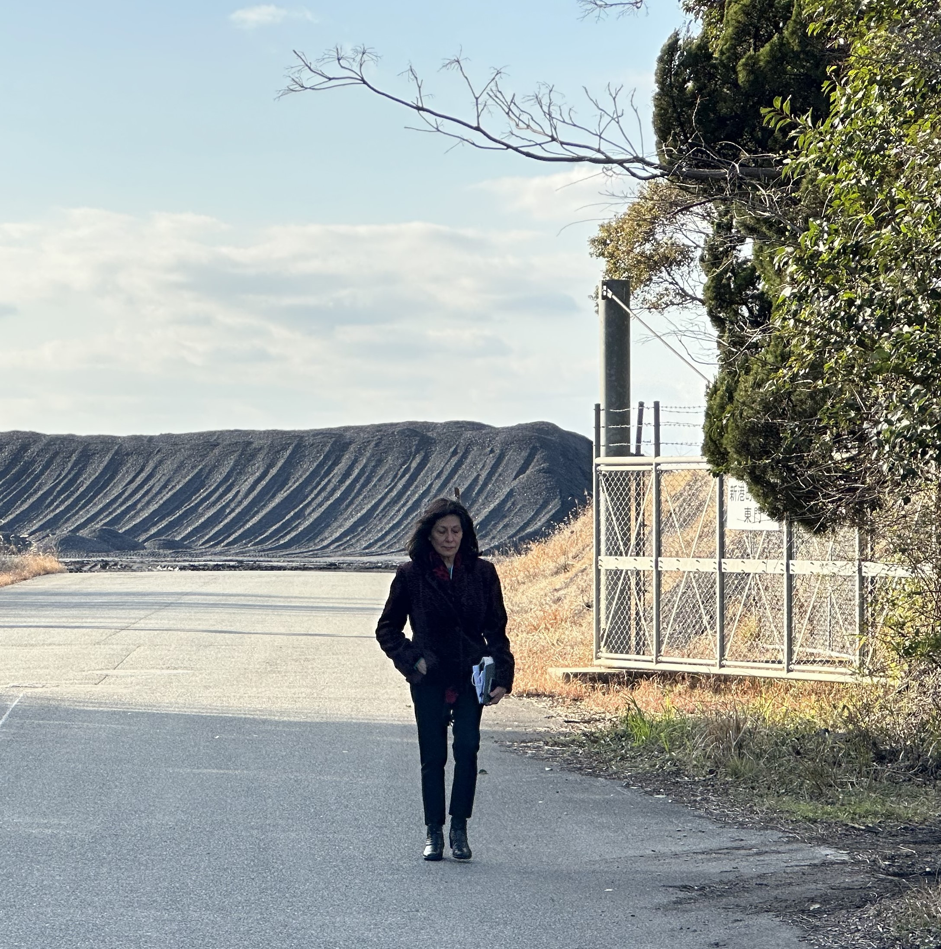
My trip to Japan was one of the POW Friendship Tours that was established in 2009 by the American Defenders of Bataan and Corregidor, a group that our Dads started in 1946. The tours are coordinated between the US Embassy and the Ministry of Foreign Affairs in Japan. The first visits were by POWs who were invited, all expenses paid, to visit Japan, to visit the memorials, and most importantly, to receive formal apologies from the highest-ranking officials of Japan. Now that our fathers are gone, we descendants are invited. Seven of us went in February. I found the Japanese people kind and generous, respectful, and very curious about our history and the abuse our fathers were subject to as Prisoners of War. That part of their history was largely ignored after the war, and many are just now learning about the tragedies of the POWs. The Japanese, especially the younger generation, are hungry for knowledge, they said they hope that we do not hate them for the past.
We visited Temple University Japan Campus in Tokyo.
As we rode the elevator to classroom, the dean told us that this was their biggest event of the year! Meeting descendants of American POWs! The room was packed, and they were anxious to hear the details of our fathers’ POW captivity.

The most profound experience for me was when I visited Fukuoka Camp 17 in Omuta, 550 miles south of Tokyo. This was the site of the condemned coal mine where my Dad was a slave laborer, along with Gap’s dad, Agapito Silva, and Manuel Armijo, Thomas Barka, George Craig, Frank Lovato, Joe Medina, Thomas Nunn, Gavino Rivera, Jesus Silva, Eddie Tafoya, Francis Van Buskirk, Oscar Otero, and others from the 200th/515th. The POW barracks are long gone, but the grounds where they were located are still there, used for coal storage. We visited the site, and I walked up the road to the open gates of the vast coal storage area.
(photo) Knowing that our dads walked that road, every morning 3 miles to the hellish mines, then back, for two and a half years, was very emotional, to say the least. Continued….

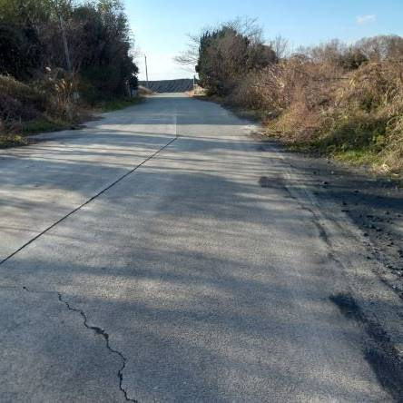
(photo: Fukuoka Camp 17 - road to coal mines)
Now, if Dad were here, he would feel our sadness, and say, “Well, it wasn’t all bad – Manuel, let’s tell them how we got the hell out of Camp 17! A few days after the war was over, news reporter George Weller, from the Chicago Daily News, came to Camp 17 to interview the POWS. He told them about the atomic bomb they had seen and how it stopped the war.
NOTE: Anthony Weller, George’s son wrote a book about his father’s experiencers and interviews, using his father’s notes and dispatches. A fantastic book;
First Into Nagasaki: The Censored Eyewitness Dispatches on Post-Atomic Japan and Its Prisoners of War
The Red Cross began to drop supplies of food and clothing, packed in barrels, into the camp from B-29 bombers; the POWs had never even heard of the B-29! The falling barrels, attached to parachutes, were a beautiful sight as they floated into the camp, several of them breaking open when they hit the ground. Evans and Manuel kept a few parachutes to barter with, and traded them for food with the Japanese civilians in the area. But two days later, they started thinking, It would be 30 days until the Americans could build a runway and fly the POWs out.’
George Weller told them there were planes flying empty from Kanoya, south of Camp 17, where an American air base was, located, so Evans and Manuel decided to take off and find the base. Dad traded his parachute for sake. “We had to go by train 200 miles—we didn’t know it at the time—to get to the airfield. We had directions from the Japanese
civilians how to get there. Manuel traded his last parachute for sake, and we drank it while we were walking to the train station. Dad said, “We got there and sat down. I was resting, about half- asleep, when Manuel hollered, ‘Evans, the train is coming!’ We jumped on, and Manuel got in the back passenger car, with the chickens, pigs, and families.
“I crept up to the engineer’s cabin. When I got there, a Japanese guard was lying there in a hammock, sound asleep. He had a 38 pistol. I snuck up on him, grabbed the pistol, and he fell out of the hammock. I waved the pistol at him and told him to get up there with the engineer that I was taking over.
Continued….

The engineer was scared, but knew the Japanese had surrendered, so he didn’t resist. “We got to the end of the track early in the morning. We saw a few families, building huts, and they helped us, told us there was a lake ahead we had to cross.” Evans and Manuel came to the lake not far away and found a Japanese man in a boat, who charged people a fee to get to the other side. Evans pulled out the gun, pointed it at him, and signaled that he
was to take them across the lake. After they were a distance away from shore, Evans noticed a long, glistening sword in the boat. He grabbed it and threw it into the water. The man screamed and cried, as the sword has probably been
a family heirloom for decades. Evans just wanted to get rid of a weapon that might be used against them.
When they got to the other side, “We couldn’t pay him, because we didn’t have any money,” said Manuel, “but he just let us go.” Evans said, “He had no choice!” At the end of the lake, the men walked about five miles, and found the American air base. “We saw Americans with strange helmets. At first, we thought they were Germans,” Evans said.
The American soldiers looked so big, and asked Evans and Manuel, “You guys Americans?” The two buddies said, “Yes, we survived Bataan.” Evans said, “They took us by jeep to the kitchen where we ate and stayed there that night.” The following day, Evans and Manuel were flown from Kanoya to Okinawa. It was there at Okinawa they saw WACs for the first time, and as the war-beaten men came down the ramp, the WACS saluted them.
“We wondered, what happened to the Army?” but their curiosity faded quickly, as they were more interested in finding food than looking at the women. A few days later, they were flown to Manila.
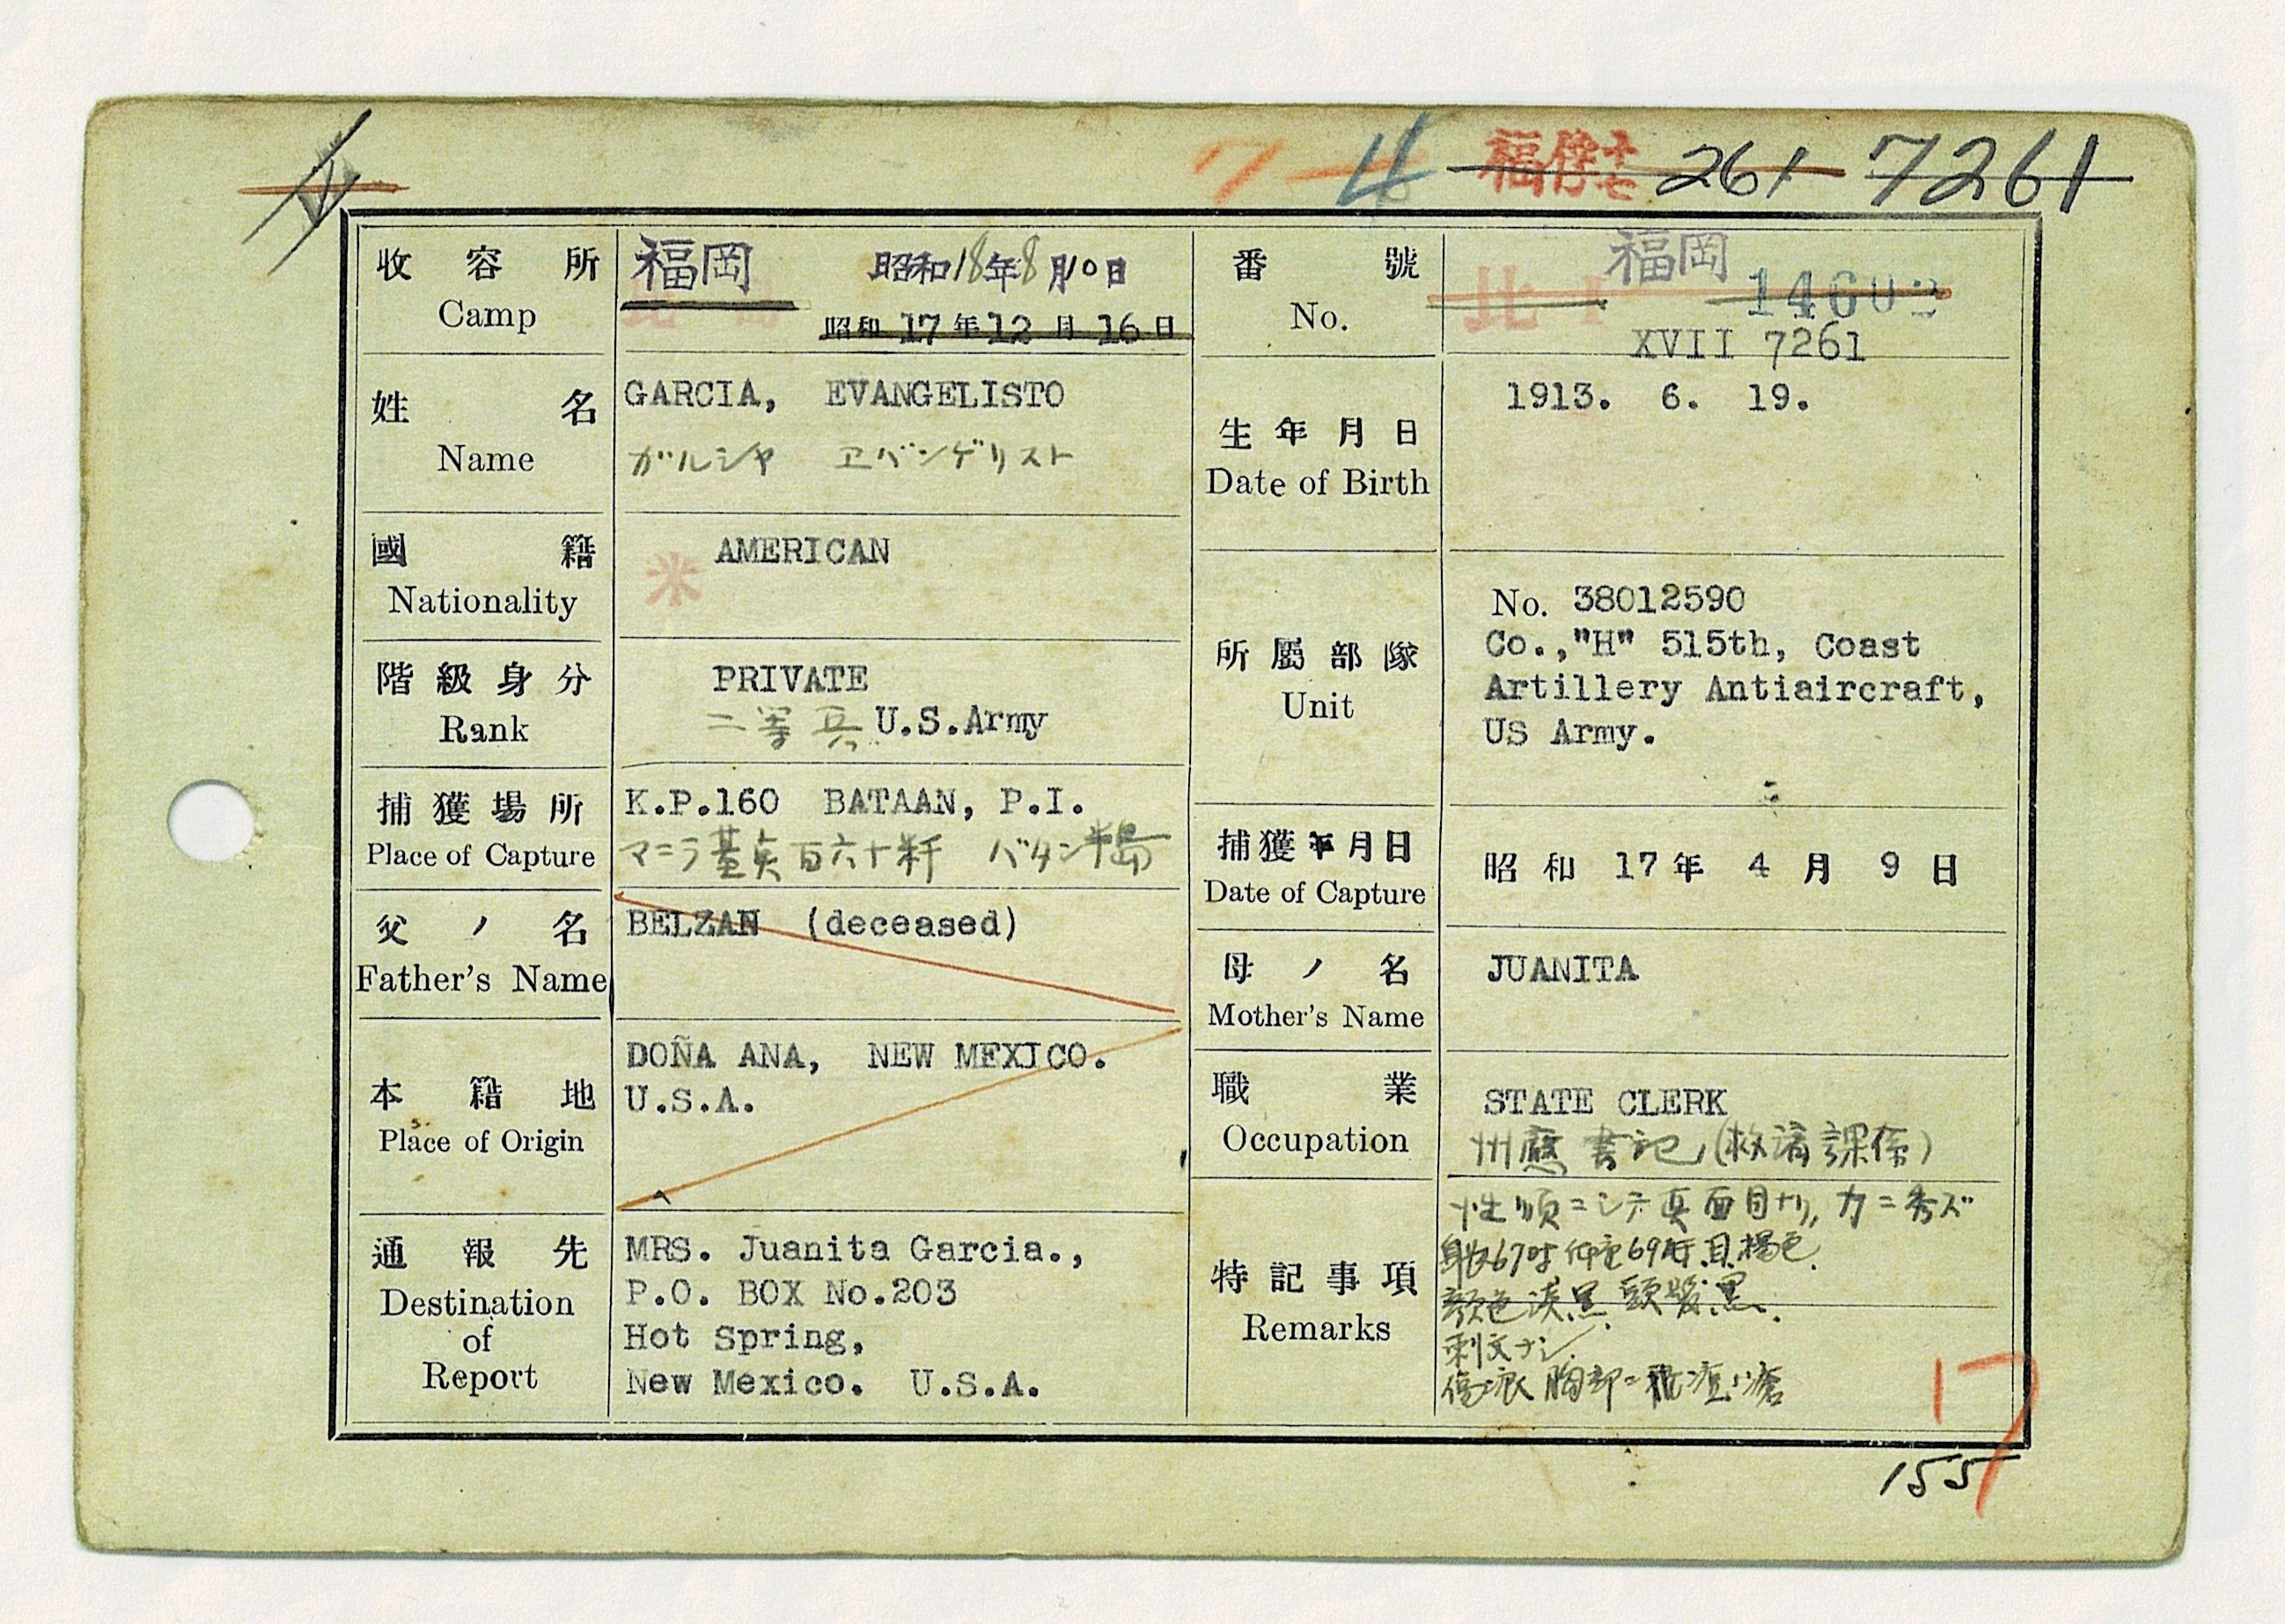
(Margaret continues thoughts of her journey) When I set out on this trip, honestly, I had mixed feelings. But as soon as I boarded Japan Airlines, I experienced the graciousness and generosity of the Japanese. We were greeted at the airport by our hosts from the Japan International Cooperation Center, with great enthusiasm. They had done extensive research for months to find out all about our fathers, and arranged visits to each one of the sites where our fathers had been POWs.
Most of the POW sites are gone; Fukuoka 17 was an exception, but the companies that are near to the sites provided maps and detailed history about where the camps used to be located. One afternoon, we were guests of Japanese State Minister of Foreign Affairs, Mr. Yamada Kenji, and he gave us a copy of our Fathers’ POW records – a moving and unexpected gesture!
(Photo- Evan’s POW record card)
Continued….

In September of 2017, The Bereaved Family Association of Japan visited Pearl Harbor. They’re children, grandchildren, relatives, descendants like us, whose fathers and grandfathers were in the Japanese military. Many of our fathers came home, most of theirs did not. A group of 36 children, grandchildren, and other relatives of fallen Japanese soldiers went to Pearl Harbor to pay their respects- They laid flowers and a wreath at the USS Arizona memorial.
The group’s vice president, Yukio Udagawa, bowed his head in prayer as he and others honored those entombed in the warship just below the turquoise waters of Pearl Harbor.
When Dad came home from war with his raging demons, his mother gently said, “Son, it only hurts you when you have hate for the Japanese.” I, myself, left Japan with a renewed heart and truly, great respect and fondness for the people. I plan on returning to Japan someday, and pray that I have the compassion, and the courage, to lay flowers and a wreath at Nagasaki’s and Hiroshima’s ground zero.

To everything there is a season, and a time to every purpose under the heaven:
A time to love, and a time to hate; a time of war, and a time of peace.
REMEMBER BATAAN – ALWAYS. Thank you. Margaret Garcia
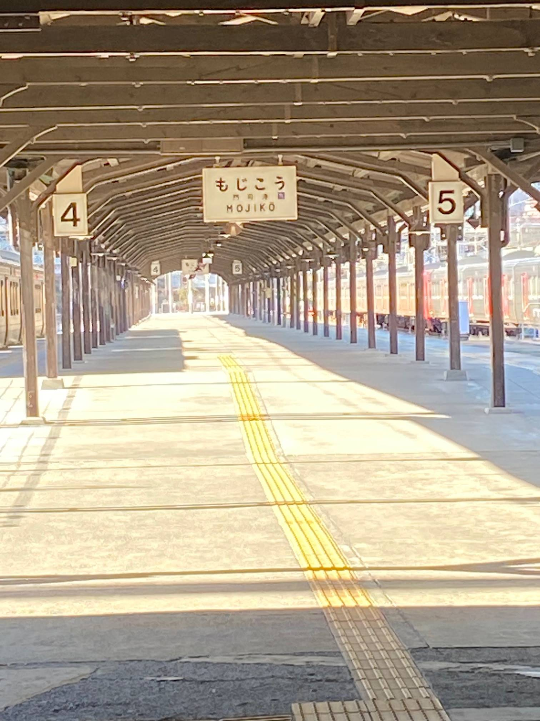
Photo left- Moji train platform -used for transporting POWs
Below– Omuta Japan
