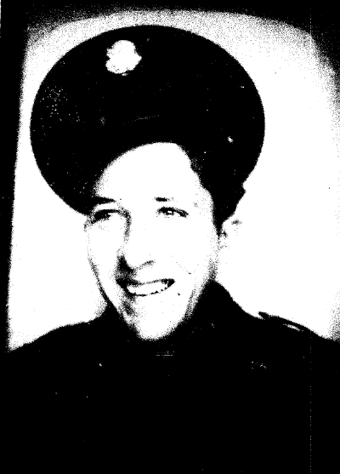
Charles William Gardner
HQ Co. 1st Bn. 31st Inf. Regt (US) Phil. Div.
Birth 2 Nov 1919 – De Queen, AR
Death 16 Jan 1992 (aged 72)
Burial Pleasant Point Cemetery
Charles was an Army infantryman, PFC, Co C 110th
He lived most of his life in Fort Worth Texas and retired as an auto
mechanic. He married Dorothy Keeton Gardner and they had two
daughters; Glenda Garner Ochoa and Margaret Gardner Jackson.
