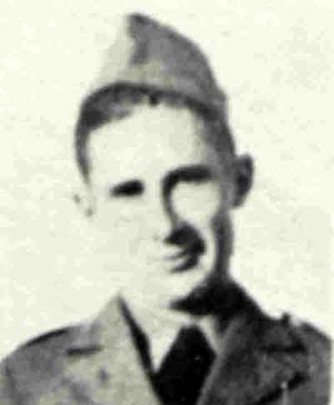
J.C. Garrett
(Name is incorrectly listed as J.D. Garrett on NARA)
192nd - B Co., 192nd Tank Battalion, Clyde Maru, Provisional Tank Group
Pvt. J. C. Garrett was born on November 24, 1915, in Caddo County, Louisiana, to Charles & Mattie Garrett. With his two sisters and three brothers grew up in Panola County, Texas, on the family farm. He attended Greenwood High School, in Greenwood, Louisiana, but he left high school to work on the family farm.
On February 12, 1941, he was inducted into the U.S. Army and did his basic training at Fort Knox, Kentucky. While there, he attended school and qualified as a tank mechanic. After basic training, he was sent to Camp Polk, Louisiana, where he joined the 753rd Tank Battalion.
From September 1 through 30, the 192nd Tank Battalion took part in maneuvers in Louisiana. After they ended, the battalion was ordered to Camp Polk instead of returning to Ft. Knox as had been expected. The members of the battalion had no idea why they were being kept there. What they were told, on the side of a hill, was that they were being sent overseas. It was at this time that members of the battalion, 29 years old or older, were allowed to resign from federal service. Replacements for the released men were taken from the 753rd Tank Battalion. J.C. had his name drawn and was assigned to B Company of the 192nd.
The decision for this move – which had been made on August 15, 1941 – was the result of an event that took place in the summer of 1941. A squadron of American fighters was flying over Lingayen Gulf, in the Philippines, when one of the pilots, who was flying at a lower altitude, noticed something odd. He took his plane down and identified a flagged buoy in the water and saw another in the distance. He came upon more buoys that lined up, in a straight line for 30 miles to the northwest, in the direction of a Japanese occupied island which was hundreds of miles away. The island had a large radio transmitter. The squadron continued its flight plan south to Mariveles and returned to Clark Field. When the planes landed, it was too late to do anything that day.
The next day, when another squadron was sent to the area, the buoys had been picked up by a fishing boat – with a tarp on its deck – which was seen making its way to shore. Since communication between the Air Corps and Navy was difficult, the boat escaped. It was at that time the decision was made to build up the American military presence in the Philippines.
The battalion’s new tanks came from the 753rd Tank Battalion and were loaded onto flat cars on different trains. The soldiers also put cosmoline on anything that they thought would rust. Over different train routes, the companies arrived at Ft. Mason in San Francisco, California, where they were ferried, by the U.S.A.T. General Frank M. Coxe, to Ft. McDowell on Angel Island. On the island, they were given physicals by the battalion’s medical detachment and men found with minor medical conditions were held on the island and scheduled to rejoin the battalion at a later date. Other men were simply replaced.
The 192nd was boarded onto the U.S.A.T. Gen. Hugh L. Scott and sailed on Monday, October 27. During this part of the trip, many tankers had seasickness, but once they recovered they spent much of the time training in breaking down machine guns, cleaning weapons, and doing KP. The ship arrived at Honolulu, Hawaii, on Sunday, November 2 and had a two-day layover, so the soldiers were given shore leave so they could see the island.
On Wednesday, November 5, the ship sailed for Guam but took a southerly route away from the main shipping lanes. It was at this time it was joined by, the heavy cruiser, the U.S.S. Louisville and, another transport, the S.S. President Calvin Coolidge. Sunday night, November 9, the soldiers went to bed and when they awoke the next morning, it was Tuesday, November 11. During the night, while they slept, the ships had crossed the International Dateline.
On Saturday, November 15, smoke from an unknown ship was seen on the horizon. The Louisville revved up its engines, its bow came out of the water, and it shot off in the direction of the smoke. It turned out the smoke was from a ship that belonged to a friendly country, while two other intercepted ships were Japanese freighters hauling scrap metal to Japan.
When they arrived at Guam on Sunday, November 16, the ships took on water, bananas, coconuts, and vegetables before sailing for Manila the next day. At one point, the ships passed an island at night and did so in total blackout. This for many of the soldiers was a sign that they were being sent into harm’s way.
The ships entered Manila Bay, at 8:00 A.M., on Thursday, November 20, and docked at Pier 7 later that morning. At 3:00 P.M., most of the soldiers were taken by bus to Ft. Stotsenburg. Those who drove trucks drove them to the fort, while the maintenance section remained behind at the pier to unload the tanks.
At the fort, they were greeted by Colonel Edward King who apologized that the men had to live in tents along the main road between the fort and Clark Field. He made sure that had what they needed and that they all received Thanksgiving Dinner – which was stew thrown into their mess kits – before he went to have his own dinner. Ironically, November 20 was the date that the National Guard members of the battalion had expected to be released from federal service.

The members of the battalion pitched the ragged World War I tents in an open field halfway between the Clark Field Administration Building and Fort Stotsenburg. The tents were set up in two rows and five men were assigned to each tent. There were two supply tents and meals were provided by food trucks stationed at the end of the rows of tents.
The area was near the end of a runway used by B-17s for takeoffs. The planes flew over the tents at about 100 feet blowing dirt everywhere and the noise from the engines as they flew over was unbelievable. At night, they heard the sounds of planes flying over the airfield which turned out to be Japanese reconnaissance planes. In addition, the khaki uniforms they had been issued also turned out to be a heavy material which made them uncomfortable to wear in the tropical heat.
For the next seventeen days, the tankers worked to remove cosmoline from their weapons. The grease was put on the weapons to protect them from rust while at sea. They also loaded ammunition belts and did tank maintenance as they prepared to take part in maneuvers with the 194th Tank Battalion. Ten days before the attack on Pearl Harbor, the reconnaissance plane pilots reported that Japanese transports were milling around in a large circle in the South China Sea.
On December 1, the tanks were ordered to the perimeter of Clark Field to guard against paratroopers. Two crew members had to be with their tank at all times. They received their meals from food trucks.
On the morning of December 8, 1941, the members of B Company were informed of the Japanese attack on Pearl Harbor. His tank and the others were sent to the perimeter of the airfield to guard against Japanese paratroopers. About 12:45 in the afternoon as the tankers were eating lunch, planes approached the airfield from the north. At first, the soldiers thought the planes were American. It was only when bombs began exploding on the runways that they knew the planes were Japanese.
The tank battalion received orders on December 21 that it was to proceed north to Lingayen Gulf. Because of logistics problems, the B and C Companies soon ran low on gas. When they reached Rosario, there was only enough for one tank platoon, from B Company, to proceed north to support the 26th Cavalry.
On December 23 and 24, the battalion was in the area of Urdaneta. The bridge they were going used to cross the Agno River was destroyed and the tankers made an end run to get south of the river. As they did this, they ran into Japanese resistance early in the evening. They successfully crossed the river in the Bayambang Province. Later on the 24, the battalions formed a defensive line along the southern bank of the Agno River with the 192nd on the right and 194th on the left.
On December 25, the tanks of the battalion held the southern bank of the Agno River from Carmen to Tayung, with the tanks of the 194th holding the line on the Carmen-Alcala-Bautista Road. The tanks held the position until 5:30 in the morning on December 27, when they withdrew following the Philippine Army, to the Tarlac-Cabanatuan Line and were near Santo Tomas and Cabanatuan on the 28 and 29.
On December 31/January 1, the tanks were stationed on both sides of the Calumpit Bridge when they received conflicting orders, from Gen. MacArthur’s chief of staff, about whose command they were under and to withdraw from the bridge. The defenders were attempting to stop the Japanese advance down Route 5 which would allow the Southern Luzon Forces to withdraw toward Bataan. General Wainwright was unaware of the orders.
Because of the orders, there was confusion among the Filipinos and American forces defending the bridges over the Pampanga River and about half the defenders withdrew. Due to the efforts of the Self Propelled Mounts, the 71st Field Artillery, and a frenzied attack by the 192nd Tank Battalion the Japanese were halted. From January 2 to 4, the 192nd held the road open from San Fernando to Dinalupihan so the southern forces could escape.
At 2:30 A.M., the night of January 5/6, the Japanese attacked at Remedios in force and using smoke as cover. This attack was an attempt to destroy the tank battalions. At 5:00 A.M., the Japanese withdrew having suffered heavy casualties.
During the withdrawal into the peninsula, the night of January 6/7, the 192nd held its position so that the 194th Tank Battalion could leapfrog past it, cross a bridge, and then cover the 192nd’s withdraw over the bridge. The 192nd was the last American unit to enter Bataan before the bridge was destroyed by the engineers at 6:00 A.M.
Over the next several months, the battalion fought battle after battle with tanks that were not designed for jungle warfare. The tank battalions, on January 28, were given the job of protecting the beaches. The 192nd was assigned the coastline from Paden Point to Limay along Bataan’s east coast. The Japanese later admitted that the tanks guarding the beaches prevented them from attempting landings.
The company also took part in the Battle of the Pockets – from January 23 to February 17 – to wipe out Japanese soldiers who had been trapped behind the main defensive line after a Japanese offensive was stopped and pushed back to the original line of defense. The tanks would enter the pocket one at a time to replace a tank in the pocket. Another tank did not enter the pocket until a tank exited the pocket. Doing this was so stressful that each tank company was rotated out and replaced by one that was being held in reserve.
To exterminate the Japanese, two methods were used. The first was to have three Filipino soldiers ride on the back of the tank. As the tank went over a Japanese foxhole, the Filipinos dropped three hand grenades into the foxhole. Since the grenades were from WWI, one out of three usually exploded.

The other method used to kill the Japanese was to park a tank with one track over the foxhole. The driver gave the other track power resulting in the tank going around in a circle and grinding its way down into the foxhole. The tankers slept upwind of their tanks.
While the tanks were doing this job, the Japanese sent soldiers, with cans of gasoline, against the tanks. These Japanese attempted to jump onto the tanks, pour gasoline into the vents on the back of the tanks, and set the tanks on fire. If the tankers could not machine gun the Japanese before they got to a tank, the other tanks would shoot them as they stood on a tank. The tankers did not like to do this because of what it did to the crew inside the tank. When the bullets hit the tank, its rivets would pop and wound the men inside the tank. It was for their performance during this battle that the 192nd Tank Battalion would receive one of its Distinguished Unit Citations.
Since the stress on the crews was tremendous, the tanks rotated into the pocket one at a time. A tank entered the pocket and the next tank waited for the tank that had been relieved to exit the pocket before it would enter. This was repeated until all the tanks in the pocket were relieved.
What made this job so hard was that the Japanese dug “spider holes” among the roots of the trees. Because of this situation, the Americans could not get a good shot at the Japanese.
The tankers, from A, B, and C Companies, were able to clear the pockets. But before this was done, one C Company tank which had gone beyond the American perimeter was disabled and the tank just sat there. When the sun came up the next day, the tank was still sitting there. During the night, its crew was buried alive, inside the tank, by the Japanese. When the Japanese had been wiped out, the tank was turned upside down to remove the dirt and recover the bodies of the crew. The tank was put back into use.
At the same time, the company took part in the Battle of the Points on the west coast of Bataan. The Japanese landed troops but ended up trapped. One was the Lapay-Longoskawayan points from January 23 to 29, the Quinawan-Aglaloma points from January 22 to February 8, and the Sililam-Anyasan points from January 27 to February 13.
The defenders successfully eliminated the points by driving their tanks along the Japanese defensive line and firing their machine guns. The 45th Infantry, Philippine Scouts followed the tanks eliminating any resistance and driving the Japanese Marines over the edge of the cliffs where they hid in caves. The tanks fired into the caves killing or forcing them out of them into the sea.
In February 1942, B Company was also given the job of defending a beach, along the east coast of Bataan, where the Japanese could land troops. One night while on this duty, the company engaged the Japanese in a firefight as they attempted to land troops on the beach. When morning came, not one Japanese soldier had successfully landed on the beach.

After being up all night, the tankers attempted to get some sleep. Every morning “Recon Joe” flew over attempting to locate the tanks. The jungle canopy hid the tanks from the plane. Walter Cigoi aggravated about being woken up, pulled his half-track on the beach and took a “pot shot” at the plane. He missed. Twenty minutes later, Japanese planes appeared and bombed the position. Frank took cover under a tank.
After the attack, the tankers found Richard Graff and Charles Heuel dead, and Francis McGuire was wounded. Another man had his leg partially blown off. The tankers attempted to put the man in a jeep, but his leg got in the way. To get him into the jeep, his leg was cut off by T/4 Frank Goldstein.
The soldiers were hungry and began to eat everything they could get their hands on to eat. The Carabao were tough but if they were cooked long enough they could be eaten. They also began to eat horse meat provided by the 26th U. S. Cavalry. To make things worse, the soldiers’ rations were cut in half again on March 1, 1942. This meant that they only ate two meals a day.
The Japanese also were dropping surrender leaflets with a scantily clad blond on them. The Japanese would have been more successful at getting the Americans to surrender if the picture had been hamburger since the men were so hungry that they most likely would have surrendered for a good meal.
In March, the amount of gasoline was reduced to 15 gallons a day for all vehicles except the tanks. This would later be dropped to ten gallons a day. At the same time, food rations were cut in half again. Also at this time, Gen. Weaver suggested to Gen. Wainwright that a platoon of tanks be sent to Corregidor.
On April 3, 1942, the Japanese launched an all-out attack supported by artillery and aircraft. A large force of Japanese troops came over Mount Samat and descended down the south face of the volcano. This attack wiped out two divisions of defenders and left a large area of the defensive line open to the Japanese.
A counter-attack was launched – on April 7 – by the 57th Infantry, Philippine Scouts which was supported by tanks. Its objective was to restore the line, but Japanese infiltrators prevented this from happening. During this action, one tank was knocked out but the remaining tanks successfully withdrew. C Company, 194th, was attached to the 192nd and had only seven tanks left.
It was the evening of April 8 that Gen. Edward P. King decided that further resistance was futile, since approximately 25% of his men were healthy enough to fight, and he estimated they would last one more day. In addition, he had over 6,000 troops who sick or wounded and 40,000 civilians who he feared would be massacred. His troops were on one-quarter rations, and even at that ration, he had two days of food left. He also believed his troops could fight for one more day.
At 2:oo A.M. April 9, Gen. King sent a jeep under a white flag carrying Colonel Everett C. Williams, Col. James V. Collier and Major Marshall Hurt to meet with the Japanese commander about terms of surrender. (The driver was from the tank group and the white flag was bedding from A Company.) Shortly after daylight Collier and Hunt returned with word of the appointment. It was at about 6:45 A.M. that tank battalion commanders received this order: “You will make plans, to be communicated to company commanders only, and be prepared to destroy within one hour after receipt by radio, or other means, of the word ‘CRASH’, all tanks and combat vehicles, arms, ammunition, gas, and radios: reserving sufficient trucks to close to rear echelons as soon as accomplished.”
The tank crews circled their tanks. Each tank fired an armor-piercing shell into the engine of the tank in front of it. They also opened the gasoline cocks inside the tank compartments and dropped hand grenades into the tanks. Most of the company waited in their bivouac for the Japanese to make contact, while others attempted to reach Corregidor which had not surrendered.
Gen. King with his two aides, Maj. Cothran and Captain Achille C. Tisdelle Jr. got into a jeep carrying a large white flag. They were followed by another jeep – also flying another large white flag – with Col. Collier and Maj. Hurt in it. As the jeeps made their way north they were strafed and small bombs were dropped by a Japanese plane. The drivers of both jeeps and the jeeps were provided by the tank group and both men managed to avoid the bullets. The strafing ended when a Japanese reconnaissance plane ordered the fighter pilot to stop strafing.
About 10:00 A.M. the jeeps reached Lamao where they were received by a Japanese Major General who informed King that he reported his coming to negotiate a surrender and that an officer from Japanese command would arrive to do the negotiations. The Japanese officer also told him that his troops would no attack for thirty minutes while King decided what he would do.
After a half-hour, no Japanese officer had arrived from their headquarters and the Japanese attack had resumed. King sent Col Collier and Maj Hunt back to his command with instructions that any unit inline with the Japanese advance should fly white flags.
Shortly after this was done a Japanese colonel and interpreter arrived. King was told the officer was Homma’s Chief of Staff and he had come to discuss King’s surrender. King attempted to get insurances from the Japanese that his men would be treated as prisoners of war, but the Japanese officer – through his interpreter – accused him of declining to surrender unconditionally. At one point King stated he had enough trucks and gasoline to carry his troops out of Bataan. He was told that the Japanese would handle the movement of the prisoners. The two men talked back and forth until the colonel said through the interpreter, “The Imperial Japanese Army are not barbarians.” King found no choice but to accept him at his word.
On the morning of April 9, 1942, at 6:45, the tankers received the order, “crash,” so they circled their tanks. Each tank fired an armor-piercing shell into the engine of the tank in front of it. They also opened the gasoline cocks inside the tank compartments and dropped hand grenades into the tanks. Most of the company waited in their bivouac for the Japanese to make contact, while others attempted to reach Corregidor which had not surrendered.
After the Japanese made contact with B Company, the members of the company made their way to Mariveles at the southern tip of Bataan. They were now officially Prisoners of War. At Mariveles, the Japanese took blankets and other items from the POWs that they could use. The tankers striped anything from their uniforms that indicated that they were tankers. They heard the rumor that the Japanese were looking for them.
From Mariveles, the tankers made their way north toward San Fernando. They were given little food or water. On the march, J.C. carried Abner Humphrey, D Company, who had been wounded. The two men remained friends for the rest of their lives. When they arrived at San Fernando, they were put in a bullpen. In one corner was a slit trench that was the washroom for the POWs. The surface of it moved from the maggots.
The POWs were ordered to form detachments of 100 men. They were taken to the train station and packed into small wooden boxcars used to haul sugarcane. The cars were known as forty or eights since they could hold forty men or eight horses. The Japanese put 100 POWs into each boxcar. Those who died remained standing since there was no place to fall. At Capas, the POWs disembarked and the dead fell to the floor of the cars. The POWs walked the last ten miles to Camp O’Donnell.
Camp O’Donnell was an unfinished Filipino Army Training Base that the Japanese pressed into use as a POW camp on April 1, 1942. When they arrived at the camp, the Japanese confiscated any extra clothing that the POWs had and refused to return it to them. They searched the POWs and if a man was found to have Japanese money on them, they were taken to the guardhouse. Over the next several days, gunshots were heard to the southeast of the camp. These POWs had been executed for looting.
There was only one water faucet in the camp, and the prisoners stood in line from two to eight hours waiting for a drink. The Japanese guards at the faucet would turn it off for no reason and the next man in line would stand as long as four hours waiting for it to be turned on again. This situation improved when a second faucet was added.
There was no water for washing clothes, so the POWs would throw out their clothing when it had been soiled. In addition, water for cooking had to be carried three miles from a river to the camp and mess kits could not be washed. The slit trenches in the camp were inadequate and were soon overflowing since most of the POWs had dysentery. The result was that flies were everywhere in the camp including the POW kitchens and in the food.
The camp hospital had no soap, water, or disinfectant. When the ranking American doctor at the camp wrote a letter to the camp commandant, Capt. Yohio Tsuneyoshi, asking for medical supplies, he was told never to write another letter.
The Archbishop of Manila sent a truckload of medical supplies to the camp, the Japanese commandant refused to allow the truck into the camp. When the Japanese Red Cross sent medical supplies the camp the Japanese took 95% of the supplies for their own use.
The POWs in the camp hospital lay on the floor elbow to elbow and only one of the six medic assigned to care for 50 sick POWs was healthy enough to care for them. When a representative of the Philippine Red Cross stated they could supply a 150-bed hospital for the camp, he was slapped in the face by a Japanese lieutenant.
Each morning, the bodies of the dead were found all over the camp and were carried to the hospital and placed underneath it. The bodies lay there for two or three days before they were buried in the camp cemetery by other POWs who were suffering from dysentery and/or malaria. To clean the ground under the hospital, the ground was scraped and lime was spread over it. The bodies of the dead were placed in the cleaned area, and the area they had lain was scraped and lime was spread over it.
Work details were sent out on a daily basis. Each day, the American doctors gave a list of names to the Japanese of the POWs who were healthier enough to work. If the quota of POWs needed to work could not be met, the Japanese put those POWs who were sick but could walk, to work. The death rate among the POWs reached 50 men dying a day. The Japanese finally acknowledge that they had to do something, so the opened a new POW camp at Cabanatuan.
It was at this time that his family received a message from the War Department.
“Dear Mrs. M. Garrett:
“According to War Department records, you have been designated as the emergency addressee of Private J. C. Garrett, 38,054,134, who, according to the latest information available, was serving in the Philippine Islands at the time of the final surrender.
“I deeply regret that it is impossible for me to give you more information than is contained in this letter. In the last days before the surrender of Bataan, there were casualties which were not reported to the War Department. Conceivably the same is true of the surrender of Corregidor and possibly other islands of the Philippines. The Japanese Government has indicated its intention of conforming to the terms of the Geneva Convention with respect to the interchange of information regarding prisoners of war. At some future date, this Government will receive through Geneva a list of persons who have been taken prisoners of war. Until that time the War Department cannot give you positive information.
“The War Department will consider the persons serving in the Philippine Islands as “missing in action” from the date of surrender of Corregidor, May 7, 1942, until definite information to the contrary is received. It is to be hoped that the Japanese Government will communicate a list of prisoners of war at an early date. At that time you will be notified by this office in the event that his name is contained in the list of prisoners of war. In the case of persons known to have been present in the Philippines and who are not reported to be prisoners of war by the Japanese Government, the War Department will continue to carry them as “missing in action” in the absence of information to the contrary, until twelve months have expired. At the expiration of twelve months and in the absence of other information the War Department is authorized to make a final determination.
“Recent legislation makes provision to continue the pay and allowances of persons carried in a “missing” status for a period not to exceed twelve months; to continue, for the duration of the war, the pay and allowances of persons known to have been captured by the enemy; to continue allotments made by missing personnel for a period of twelve months and allotments or increase allotments made by persons by the enemy during the time they are so held; to make make new allotments or increase allotments to certain dependents defined in Public Law 490, 77th Congress. The latter dependents generally include the legal wife, dependent children under twenty-one years of age and dependent mother, or such dependents as having been designated in official records. Eligible dependents who can establish a need for financial assistance and are eligible to receive this assistance the amount allotted will be deducted from pay which would otherwise accrue to the credit of the missing individual.
“Very Truly yours, J. A. Ulio (signed), Major General
On June 1, 1942, the POWs formed detachments of 100 men each and were marched to Capas. There, they were put in steel boxcars with two Japanese guards. At Calumpit, the train was switched onto another line which took it to Cabanatuan. The POWs disembarked and were taken to a schoolyard where they were fed cooked rice and onion soup. From there, they were marched to Cabanatuan which had been the headquarters of the 91st Philippine Army Division and was formerly known at Camp Pangatian.
To prevent escapes, the POWs set up a detail that patrolled the fence of the camp. The reason this was done was that those who did escape and were caught were tortured before being executed, while the other POWs were made to watch. It is believed that no POW successfully escaped from the camp. The POWs were sent out on work details to cut wood for the POW kitchens.
Meals on a daily basis consisted of 16 ounces of cooked rice, 4 ounces of vegetable oil, and sweet potato or corn. The POWs worked on the camp farm from 7:00 in the morning until 5:00 in the evening. Most of the food they grew went to the Japanese not them. Other POWs worked in rice paddies.
The POW barracks were built to house 50 POWs, but most held between 60 and 120 men. The POWs slept on bamboo slats without mattresses, covers, or mosquito netting. The result was many became ill.
Each morning, the POWs lined up for roll call. While they stood at attention, it wasn’t uncommon for them to be hit over the tops of their heads. In addition, one guard frequently kicked them in their shins with his hobnailed boots. after arriving at the farm, the POWs went into a tool shed to get their tools. As they left the shed, the guards hit them on their heads.
While working in the fields, the favorite punishment given to the men in the rice paddies was to have their faces pushed into the mud and stepped on by a guard. Returning from a detail the POWs bought or were given, medicine, food, and tobacco, which they somehow managed to get into the camp even though they were searched when they returned.
The camp hospital was composed of 30 wards. The ward for the sickest POWs was known as “Zero Ward,” which got its name because it had been missed when the wards were counted. The name soon meant the place where those who were extremely ill went to die. Each ward had two tiers of bunks and could hold 45 men but often had as many as 100 men in each. Each man had a two-foot-wide by six-foot-long area to lie in. The sickest men slept on the bottom tier since the platforms had holes cut in them so the sick could relieve themselves without having to leave the tier.
After arriving in the camp, J.C. developed malaria and diphtheria. He was admitted into the camp’s hospital on June 18, 1942. He remained in the hospital until he was discharged on February 1, 1943.
While he was hospitalized, his family received a second message from the War Department since he was still listed as being MIA as of June 25. The following is an excerpt from it.
“The last report of casualties received by the War Department from the Philippines arrived early in the morning of May 6. Through this date, Private J. C. Garrett had not been reported as a casualty. The War Department will consider the persons serving in the Philippine Islands as “missing in action” from the date of the surrender of Corregidor, May 7, until definite information to the contrary is received.

“Efforts to secure prisoner of war lists from the Philippines have not been successful to this date due to the lack of communication and the fact that the Japanese Government has not yet given permission for the Swiss representative and the International Red Cross delegates to make visits to prisoner of war camps in the islands. When the lists of prisoners are received, we will clear the name of your son and send you any additional information that we may have.”
On June 3, 1943, he was listed on an official Army report as being held a Prisoner of War of the Japanese government. A few days earlier, his family had received a telegram from the War Department.
“=REPORT JUST RECEIVED THROUGH THE INTERNATIONAL RED CROSS STATES THAT YOUR SON PRIVATE J. C. GARRETT IS A PRISONER OF OF WAR OF THE JAPANESE GOVERNMENT IN THE PHILIPPINE ISLANDS LETTER OF INFORMATION FOLLOWS FROM THE PROVOST MARSHALL GENERAL=
ULIO THE ADJUTANT GENERAL.
Within days of receiving this telegram, the family received this letter.
“The Provost Marshal General directs me to inform you that you may communicate with your son, postage free, by following the inclosed instructions:
“It is suggested that you address him as follows:
“Pvt. J. C. Garrett, U.S. Army / Interned in the Philippine Islands / C/O Japanese Red Cross, Tokyo, Japan
Via New York, New York
“Packages cannot be sent to the Orient at this time. When transportation facilities are available a package permit will be issued you. “Further information will be forwarded you as soon as it is received.
“Sincerely, “Howard F. Bresee “Colonel, CMP “Chief Information Bureau”
J.C. was still at Cabanatuan when his name appeared on a list of POWs being sent to Japan during July 1943. Trucks arrived at the camp and took the POWs to Bilibid Prison.

The POWs were marched to the Port Area of Manila and boarded the Clyde Maru on July 22. The ship sailed on July 23 to Santa Cruz, Zambales, Philippine Islands. Arriving there the same day, manganese ore was loaded onto the ship. Three days later, the ship sailed. This time it was headed for Takao, Formosa.
While at sea, 100 POWs, at a time, were allowed on deck form 6:00 A.M. until 4:00 P.M. The ship arrived at Takao on July 28 and remained there until August 5, when it sailed at 5:00 A.M. as part of a nine-ship convoy. It arrived at Moji, Japan, on August 7, but the POWs remained in the holds until the next morning when they disembarked and formed 100 men detachments.
The POWs were marched to the Moji train station and boarded a train that departed at 9:30 A.M. on what was a two-day train trip. At 7:30 P.M. the next day, J.C.’s POW detachment was disembarked at Omuta, Japan, and marched 18 miles to Fukuoka #17. Those too ill to walk were driven by trucks to the camp. It should be mentioned that it was at this time that his family received a POW postcard from him. The postcard was the first word that they had from him since he was captured by the Japanese.
In August 1943, his mother received a POW postcard from J. C. which was the first communication she had from him since he became a POW. The form card indicated he was in good health and was not injured. The card was signed by him and had been sent from Cabanatuan.
At Fukuoka #17, the POWs were housed in 33 barracks that were 16 feet wide by 120 feet long with a washroom. The camp was 200 yards wide by 1000 yards long. In each of the barracks, there were ten rooms. Four officers shared one room while the other rooms held four to six POWs. Around the camp was a ten-foot to the twelve-foot high wooden fence that had three electrified wires. The first wire was about six feet off the ground.
The POWs were used as slave labor in a condemned coal mine owned by the Mitsui Coal Mining Company but operated by the Japanese Army. The POWs worked three shifts with 100 POWs assigned to work on each shift for twelve hours in the mine. They worked bent over since they were taller than the average Japanese miner. At the mine, each prisoner was expected to load three cars of coal a day.
The POWs worked 12-hour workdays with the constant threat of rocks falling on them. POWs who the Japanese believed were not working hard enough were beaten. The POWs worked in three shifts with a 30-minute lunch and one day off every ten days. One shaft was known as the “hotbox” because of its temperatures. To get out of working, the POWs would intentionally have their arms broken by another POW.
Meals consisted of rice and vegetable soup three times a day. Those POWs working in the mine received 700 grams a day, while camp workers received 450 grams a day. Officers, since they were not required to work, received 300 grams a day. Those working in the mine received three buns every second day since they did not return to camp for lunch. The meals were cooked in the camp kitchen which was manned by 15 POWs. Seven of the POWs were professional cooks.
The kitchen had 11 cauldrons, 2 electric baking ovens, 2 kitchen ranges, 4 storerooms, and an icebox. To supplement their diets, the prisoners also ate dog meat, radishes, potato greens, and seaweed. As they entered the mess hall, they would say their POW number to a POW standing at a board who would take a nail and place it in the hole in front of the man’s number to show he had been fed. After all the POWs had been fed, the board was cleared for the next meal.
There were also bathing rooms in the camp with two bathing tanks that were 30 feet long, 10 feet wide, and 4 feet deep. The tubs were heated with very hot water. The POWs working in the mine bathed during the winter after cleaning themselves before entering the tubs. They did not bathe during the summer months to prevent skin diseases.
The camp hospital was a building of ten rooms that could each hold 30 men. There was an isolation ward for 15 POWs usually men suffering from tuberculosis. The POW doctors had little to no medicines or medical supplies to treat the ill. Dental treatment consisted of removing teeth without anesthesia.
In addition, the sick were forced to work. The Japanese camp doctor allowed the sick, who could walk, to be sent into the mine. He also took the Red Cross medical supplies meant for the POWs for his own use and failed to provide adequate medical treatment. Food that came in the packages was eaten by the guards. Those POWs working in the mine were given more Red Cross supplies than the other POWs.
Corporal punishment was an everyday occurrence at the camp. The guards beat the POWs for the slightest reason and continued until the POW was unconscious. The man was then taken to the guardhouse and put in solitary confinement without food or water for a long period of time.
The Japanese interpreter in the camp refused to perform his duties resulting in the POWs receiving beatings because they could not explain the situation. He also would inform the guards of any alleged violations of camp rules which resulted in the POWs being severely beaten. This happened frequently at the mine with the interpreter usually the person responsible. He also, for no reason, slapped and beat the POWs.
On one occasion, in November 1944, shirts had been stolen from a bundle, sent by the British Red Cross, from a building. The Japanese ordered all the POWs to assemble and told them that they would not be fed until the shirts were returned. The men who stole the shirts returned the shirts anonymously, and the POWs received their meal at 10:00 P.M.
During the winter, the POWs, being punished, were made to stand at attention and had water thrown on them as they stood in the cold, or they were forced to kneel on bamboo poles. It is known that the POWs were made to stand in water and shocked with electrical current. At some point, two POWs were tied to a post and left to die. This was done they had violated a camp rule.
Life at Fukuoka #17 was hard and prisoners who would steal from other prisoners, especially clothing. To prevent this from happening, the POWs would “buddy-up” with each other. While one man was working in the mine, the POW who was not working would watch the possessions of the other man. There were also POWs who preyed on other POWs by trading cigarettes for their food. One member of J.C.’s battalion ran the largest scam in the camp until the Japanese shut it down.
In June 1945, another POW from a camp was allowed to make a shortwave radio message to his family. In the message, the man mentioned J.C. and asked whoever heard the message to send J.C.’s regards to his sister who resided in Carthage, Texas. It was from this message that his family learned he was in Japan.
On August 9, 1945, some of the POWs saw the atomic bomb dropped on Nagasaki. Those who saw it described that it was a sunny day and that the explosion still lit up the sky. The pillar of smoke that rose from the bomb was described as having all the colors of the rainbow. Afterward, the POWs saw what they described as a fog blanketing Nagasaki which seemed to have vanished.
The POWs went to work and talked to the Japanese civilians who spoke about how those, who had survived the blast, would touch their heads and pull out their hair. They stated these Japanese died within days. They also told of how they heard about a detachment of Japanese soldiers sent into Nagasaki to recover victims and how its members suffered the same fate.
When the POWs came out of the mine, they found that the next shift of POWs was not waiting to go to work. That night, the POWs were made to stand at attention for two hours. They all had their blankets because they believed they were going to be moved. Instead, they were returned to their barracks. The next day, when it was their turn to go to work, they were told it was a holiday, and they had the day off. They knew something was up because they had never had a holiday off before this.
Finally, the POWs were gathered in the camp and told that Japan and the United States were now friends. They were also told to stay in the camp. They also found a warehouse with Red Cross packages and distributed the packages to the camp. One day, George Weller, a reporter for the Chicago Daily News entered the camp. He told the POWs that there were American troops on Honshu. The camp was liberated on September 13, by a POW Recovery Team and on September 18, at 7:09 A.M., the POWs left the camp and were taken to the Dejima Docks at Nagasaki, where they boarded a ship and were returned to the Philippines.
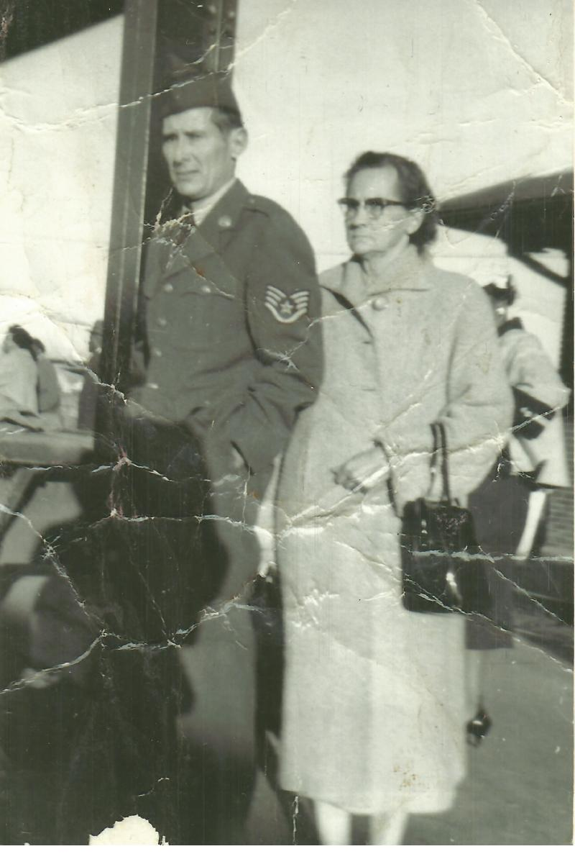
His mother received a telegram from the War Department about his liberation.
“Mrs. Mattie Garrett: The secretary of war has asked me to inform you that your son, Pvt. J. C. Garrett was returned to military control Aug. 13 and is being returned to the United States within the near future. He will be given the opportunity to communicate with you upon his arrival if he has not already done so.
“E. F. Witsell ~ Acting Adjutant General of the Army”
J.C. was liberated on September 13, 1945, and returned to the Philippines for medical treatment. He later returned to the United States on the S.S. Simon Bolivar arriving at San Francisco on October 21, 1945. J.C. was discharged from the Army, but on July 2, 1946, he reenlisted but this time in the Air Force. He was discharged again on July 1, 1950, but this time when he reenlisted again and rose to the rank of sergeant.
J.C. retired from the Air Force and returned to Texas. He married and became the father of two daughters and a son. On April 18, 1970, J.C. Garrett passed away in Panola County, Texas, and was buried at International Old Fellows Cemetery in Carthage, Texas.
Credit: Jim Opolony Bataan Commemorative Research Project: 192nd & 194th Tank Battalion
Photo above: JC and his mother when he retired from the Air Force
Next photos: JC and his family
JC and his children (Susan, Nancy & Charles) ~ Biggs Air Force Base, Texas around 1958/

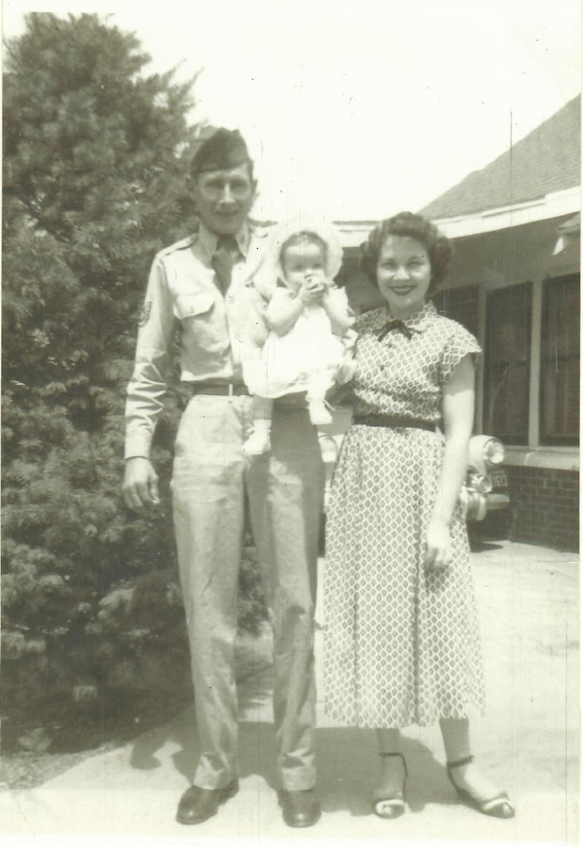
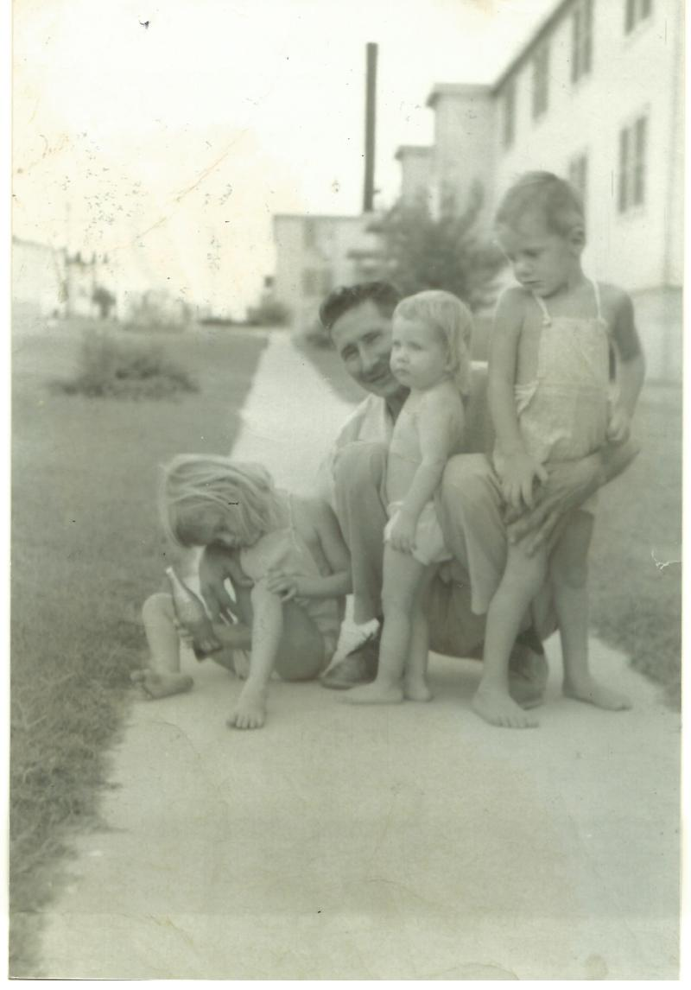

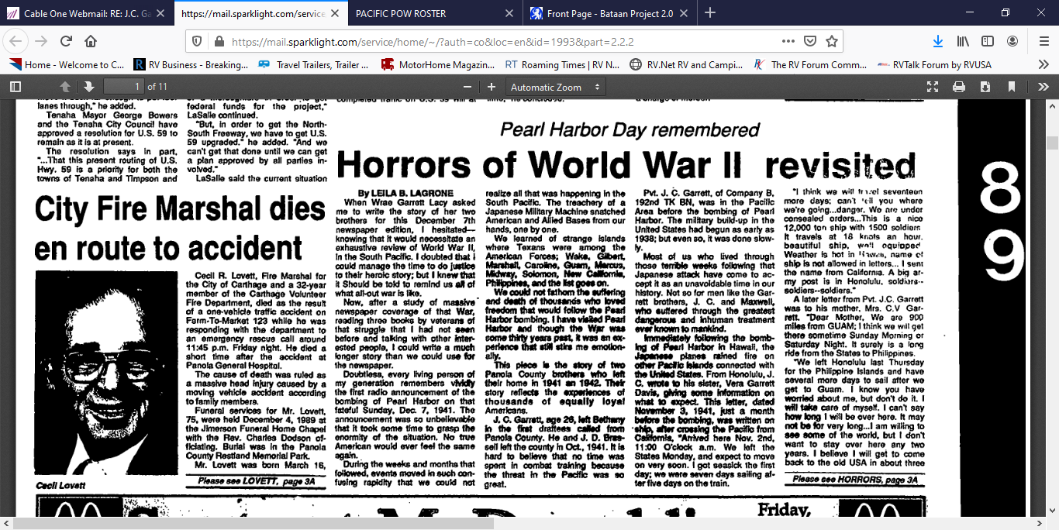
The Panola Watchman News 1989

