Weldon Hamilton
U.S. Army Air Corps

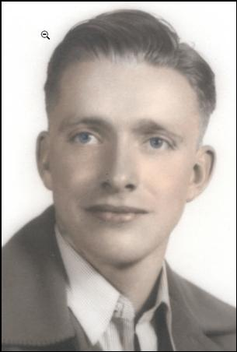  Weldon ~ San Francisco Sept. 1941 ~  photo his mother had taken when he joined the military | 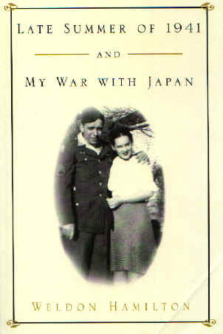

Weldon Hamilton joined the U.S. Army Air Corps on October 5, 1940. He was shipped to the Philippines in November of 1941. He fought the battle of Bataan, a battle that the Japanese planned to win in three weeks, but required four months instead. When food and ammunition ran out, Bataan was overrun.

Mr. Hamilton was taken prisoner of war by the Japanese. He survived the infamous Death march. On the Death March it is estimated that more than 10,000 men died. Hamilton was held for 1,256 days. He was held in the Philippines for over two years; first in Camp O’Donnell, where over 25,000 men died in less than two months. He was then held in Camp Cabanatuan, where 3,000 died, the most Americans ever to die in an overseas prison camp, and second only to Andersonville in all our history. Hamilton was then taken to Japan on one of the notorious “Hells Ships”.
At the end of the war he was 30 miles from Nagasaki, where he witnesses the dropping of the Nagasaki atomic bomb.
After liberation, Hamilton continued on in the Air Force and retired as Chief Warrant Officer CWO-4 in 1969. He has many decorations, including The Presidential Unit Citation with two oak leaf clusters and the Bronze Star.

AN EXERT FROM WELDON HAMILTON’S BOOK
”Late Summer of 1941 and My War with Japan”

Upon arrival in Camp 17:

We were all set up for a new experience in these barracks. There was a row of rooms down the side hall into the back. Also, we had a bathroom right in our building. We had a place to go, like a commode. It wasn’t a commode, just an outhouse attached to the building. We had a pegboard outside of our room and on the pegboard everyone would hang their number. If you were in the room, your number hung on the “in room” line. If you were at work you moved your peg down to “at work”. If you were eating at the dining room, you’d have it hung there. If you were at the bathroom there was a place to hang it there. So if you weren't where your tag said you were, you were in big trouble. For example there were 13 of us in the room. If a guard came by in the night and looked in your door and counted only 12 people, then he would look at the pegboard and see if 12 were in the room. They never turned the light off. There was one big bulb that hung in the middle of the room and kept the whole room bathed in a bright light at all times. I don’t recall if it was during the day. Surly, it was just at night. If one peg was moved down to the bathroom, then he’d go down to the bathroom and see if someone was there. If the count didn’t work out, you could bet somebody was going to get beat up. For example, if it said that 13 were in the room and there were only 12 and he went down to the bathroom and one was down in the bathroom, well, the guy in the bathroom was in for a beating. So, any time we weren’t where we were supposed to be, or if one of us went to the bathroom and left the tag on “bathroom” and came back and laid down and went to sleep, the guard would come, find the number and call out that number, then call you out and beat you. You were going to get a beating if you weren’t you were supposed to be.

Work in the Mines:

The Americans, Australians, and Dutch worked in the coal mines. The British worked in a zinc factory. Although the coalmine was hell in many ways, I’m we worked there instead of the zinc factories, because they fired the furnaces and the story of that is pretty horrible. The British who worked there looked horrible. Their skin was browned or scorched with something because they fed these furnaces with temperatures up to 3500 degrees. They’d feed coal into these furnaces. As I recall, the British would tell us they’d shovel for 15 minutes and jump in a water tank for about 15 minutes to cool off. In the coal mine, we worked in three complete shifts. The work was endless. There was no change in the schedule. That meant we had eight hours of working plus we had time tacked onto the end of our shifts to make up for when we had lined up, marched over, got organized and went down into the mines. We had to relieve the other guys just as they were coming off their shift. This added an hour or two to the end of each shift so it ended up that we were gone at our job for 10 to 12 hours. The shifts in the mine were continuous. We were lined up inside the camp, counted off, and marched to the mine. The mine had big buildings where there were workshops and people working around the mine. We would go over into the actual mine area where the entrance trains where and we’d be lined up again. There was a great enormous statue of Buddha. We were required to bow down to the statue every day before getting on the train to go down. We didn’t know what we were supposed to say, but we were to take off our hats and bow at the same time. It sounded like they said, “Hats off”. We would take our hats off, bow and say, “Hats off”. This seemed to work just fine.

When we got this routine out of the way, we’d all catch our train. The entrance to the mine was slanted at an angle that appeared to be in the neighborhood of 45 degrees; however, it was probably not quite that steep. This is where the trains would go down. As you looked down into the mine, you’d see the track leading off on an inclined plane. Since the mine was under the ocean, it was pointed down that way. When we were at the bottom of the shaft, we could look back up and see a tiny pinpoint of life that was the outside. It was an enormous entrance, 75 feet high. It was a long way up to the top and a long ways down. Anyway, we’d get on the trains and down into the mine we’d go. We normally worked on Dia Roku, which meant level six. We’d get down to the bottom, unload from the trains, and go to our various workstations. I was normally assigned to wall and roof bracing which was the preparation part of the work. The last shift had been the coal shovelers. Now we were the workers that would reconstruct and build the braces against the ceiling, brace out the wall where it had been dug out. The next crew who would come in would be the dynamite crew in my area. It was rotated in the various areas. The crew that followed my particular shift was the dynamite crew. They would come in and drill into the coal face. Normally, they would drill 125 holes. After they got all the wholes drilled, they would put dynamite in the holes and as their day ended they would blow all the coal face down. When they left, the shoveling crew would come in and they would spend their shift shoveling the coal into the troughs and carrying the coal away. I worked down there for a year.

Conversation With My Son:

My son Robert, who lives in Montana, said, “Your story is good, Dad. It’s a great book, but you left out the real part, the part you could not tell any of us kids, because not only were we too young to understand, we were too young to fathom the depth man can sink to in his quest for power over others. As an adult, I have read in other books the things you could not tell us or write about. I understand your reservations about reliving that hideous time and putting it down on paper. Maybe I’m asking too much, but your story, as you tell it, is so full of wonder and love; of the simplest moments of living we all take for granted; of moments of joy and humor in those degrading years, without hope of deliverance; of values lost or held in abeyance because your world had lost its mind. We need to know the worst of it to fully evaluate the courage and bravery you were blessed with as your eyes saw and your body felt the wrath of your captors. Dad, tell the real story for those who did not come back. Tell why they did not return and why we must not let something like this ever happen again-an addendum to your story, short by necessity, because in the telling the images become so real again it can only be endured briefly and reverently. Tell them, Dad.” I said, ”Son, maybe your right. I think I’ll just write it down and let the reader know why I could not fill in my story with the literal truth of those years. It is almost beyond belief, but I’ll try my best for as long as I can.”

I’ve already given the enormous numbers of those who fell during the death march, died at camp O’Donnell, died at Cabanatuan, on the hell ships, and in the Japanese prisons. More American POWs died in those Philippine prisons than in any foreign prisons before or since. When I was moved into Hospital #2 in the dysentery area with nine other men, within two weeks those nine were dead. I was in different wards with different diseases for one year and as far as I know, I was the only man to come out of those wards during that time alive. Every morning when I woke up, five to seven men would be dead from malaria or dysentery or for many other reasons. The men lay on filthy straw with their mouths open, green blow flies crawling in and out while their last gasps of life drifted away. All night long, I would listen to them struggle for their last breath. Some died from just plain neglect, no name attached as a reason for their death; some just gave up. Did you know that you can sit down, close your eyes and be dead in 10 minutes or 3 days, and no one will notice until you are covered with flies and fail to brush them off? Then that body, along with many others, may not be buried for 4 days, because those still living did not have the energy to drag the bodies out and dig holes in the hard ground.
The slit trenches that served as latrines were so full of bloody defecation that sometimes a body fell in. The men were fighting to eat their pitiful rations of sloppy rice, unable to keep dozens of blow flies off their mess kit. At the slit trenches, men struggled to stand, and the trails back to the camp would be sloppy with their bloody defecation. Other men walking on those same trails would slip in their bare feet and fall, needing help to stand again.

I was so weak, I could not step over a 2 by 4 doorsill. I had to turn sideways and slide my feet over the sill. I had pellagra blisters 2 or 3 inches across my legs and hands. People with beri beri were swollen up like huge fat people, their testicles sometimes as large as volleyballs. And their penises as big as a large sausage. Generally, they swelled up until they burst; their bodily fluids drained out of them; and they died. Sometimes, the skin on their legs would split open and they would die of infection.

People developed large ulcers as big as a baseball all over their bodies. I saw ulcers over the spine and could not see the actual vertebrae sticking out while they died a slow, miserable death. I came down with diphtheria and when I entered the hospital ward, I was told they had already had 200 men die from the disease. It generally blocks the throat and the person chokes to death. I lay and listened most of the night to a man from my hometown slowly choking to death. Starting about midnight, his gasps became more and more labored until it was finally over at about three in the morning. I sat leaning against the building for 3 hours, a pleasant night, the stars shining clear and beautiful, heard the last gasp, and then silence.

In the Zero Ward because no one was expected to leave alive, the most likely to die in the night were lined up in the order of expected deaths. Sometimes it was called “St. Peter’s Ward”. I was there and I came out alive. How or why, I will never know.

The hell ship I was on took 62 days to get to Japan. There were 1000 men on board with nowhere to sit upright or even to lie down. When the hatches were closed, the heat was horrible; it cut out the light and air. At night no one was aloud to go topside to go to the toilet. We had 5-gallon cans in the middle of the floor and when they were full, they just ran over. We tried to stay as far away from them as possible so the liquid would not run over us or on us. We lay in the dark, wondering how many days, weeks or months we would be on this horrible ship. We finally made it to Japan, and strange as it seems, life got a little better. But, my story tells that part.

I could tell more, Robert, but I can’t bear the images any longer. All of this did happen and by the grace of God, I somehow survived. I don’t think the reader should have to visualize any more degradation of his fellow man, either. Suffice to say, man can endure the most horrible things and still come out whole on the other side. If people are reposed by what I’ve written, it is unfortunate, but this is only a small part of a long, unbearable period of terror, misery and death. Let us all vow to never let it happen again, and live our lives for gratitude for our beautiful country and all the freedoms we enjoy under the protection of our armed forces and the flag so many have died to protect.

This, my son, is my part of the real story. You were right; it did need to be told. It needed to be told from memory so memory will not become fiction. Memory is tiny when seen through the large end of a telescope. I hope I am preserving memory and all of its spirits, which have been wandering through my mind. Memory is selective and imperfect; yet as antique it has lasting qualities, especially when pulled from a shelf and read, because memory has need of help.

Weldon - on left receiving service award Weldon and Linda - 2003
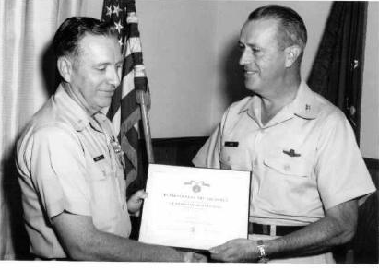
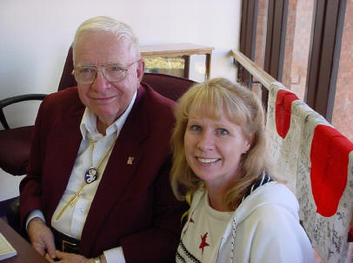
Tribute and Obituary for Weldon

Weldon Curtis Hamilton CWO-4 USAF

We loved him so very much!
Weldon Curtis Hamilton was a survivor of The “Batann Death March”, hell ships, camp O’Donnell, Camp 17 and 30 kilometers from Nagasaki when the Nuclear bomb was dropped. Mr. “don’t call him a hero” he said, he’s just a survivor. A hero to all of us died on April 16,2008 eleven months after recovering from a fall, a couple of trips to the hospital then a month in hospital rehab followed by two weeks in an eldercare home then six months at my house.
When he arrived he was in a wheelchair and unable to climb stairs and capable of walking with a walker for 50 feet or less. Within a few months he was walking with the walker and we were able to park the wheelchair. A few more weeks and he was up and walking without any assistance except for a safety strap around his chest. The last couple of months of his life he was walking, doing exercises and planning for the future. He received calls and letters every week from those that were very close to him. His sister Viona call every week and his best friend in Las Cruces called every week. They and others who wrote cards and letters give him a lot of happiness in his last year of life.
We all know him from different vantage points of our lives with him. He was my father, he was grandfather to a lot of children, some of whom he helped raise, he was an inspiration to all of us.
He was amazed with life and its relentless evolution. He and I spent many days talking about his experiences, expectations and observations of life and it’s constant change. Vivid retelling of the snowy nighttime move into the Kansas farmhouse they borrowed from a family that couldn’t find a renter during the depression because like many other families during that time and place they had no money and no place to stay. Grandfather worked hard to keep the family eating and warm. Jobs came and went. Most were more of a wish and a prayer than a real job but he managed to keep the family afloat.
Before the war he tried flying and told me many times how amazing it is to him today that then he was able to get in a small plane and take it to 3500 feet as instructed and stall it. Fear was not a thought he felt when the nose of the plane flopped down toward the ground and began to sweep around the horizon. If it turned more than three times he was to climb out the small window and parachute to the ground. What were the chances he thought of that working: just getting out that little window with your parachute would be a miracle and then it was a high probability the tail would clobber you and you would impact the ground unconscious. It was all just fun to him at the time chasing chickens with an air plane scaring everyone but himself.
His emotional contrast near the end of his life was so different to him that the early life felt slightly more of a dream than a memory. Near the end the fear of death and what form that might take became a topic we discussed. Dad and veteran Bataan survivors liked to call themselves the battling bastards of Bataan after they defeated and survived all that the Japanese could throw at them. One of his favorite stories was from the movie “Grumpy Old Men” where Jack Lemon says to Walter Mathau did you hear about ……?
He died in his sleep last night, to which Walter’s character says “lucky bastard”. Dad was as he had hoped; “a lucky bastard”.

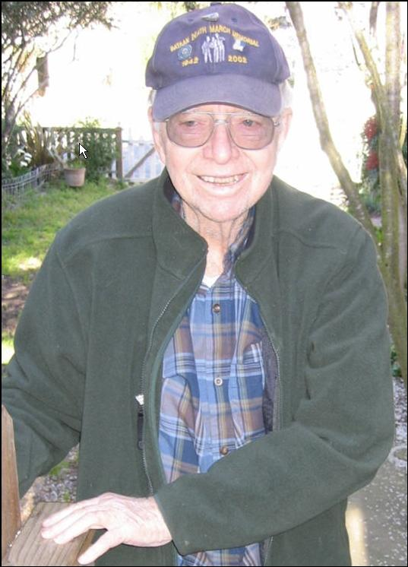
Weldon one month before he passed away - enjoying a walk.
This is the same man who learned Japanese at the end of a bat like club and stood near ground zero of the Nagasaki nuclear bomb strike and witnessed the fireball rise about the carnage and destruction of the world’s first nuclear war. As was dad’s view of the world he described the beauty of the cloud, light and color and did not focus on the obvious horror.
Our mother Dora Jean Bronaugh known as Jean Hamilton to our extended family and us as mom would tell dad that it disturbed her that dads recanting of the days of prison and torture seldom focused on the torture but most often on the wonder and beauty while giving us a whimsical insight into human interaction with his slightly cocked, crooked, wry smile.
After all that he experienced, he always focused us on God and the value of each human including those that had tortured him and held him captive for 3 and ½ years. He was a Bataan death march survivor, he loved life, family and friends. He always said I’m not a hero just a survivor. Not to us..
I love what you wrote about Grandpa, but I feel as if you left out the most important part, he was ready to see his Jeanne again. I feel that it should be noted the love they had for one another to the end. He stood by her and longed to be with her after she was gone. As you said, we all know him from different vantage points of our lives, and the way I have found myself remembering him, is as the man standing by his wife showing not only her, but the world the unconditional love, (the best kind of love), he had for her. I remember visiting them after the cancer treatments had taken her hair, made her frail, and unable to do some of the thing she loved most in life, and he walked over to her kissed her on the head and looked at her with all the love and passion of a newlywed man, in his eyes she was always his beautiful bride. I believe I can say without a doubt that he was happy to be going home to his Lord, our God, and his Jeanne. by Jeani
Memorial Courtesy of the Hamilton family Website - http://hamiltonclan.com/

