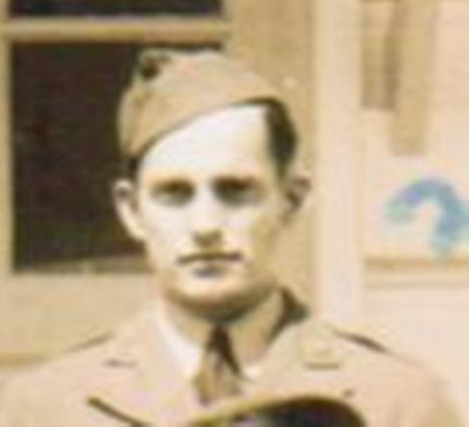
Robert R. Harp
April 2, 1920 – September 28, 1991
U. S. Army Air Corp
Savannah Air Base, GA
27th Bomb Group, Headquarters’ Squadron
Robert R. (Bob) Harp was in Manila, Philippine Island when Pearl Harbor was bombed on December 7, 1941. Originally trained to be a tail gunner on an airplane, he had no plane. He and the other brave men had arrived on the island with little or no supplies or equipment. They fought as best and as long as they could until April 9, 1942. At that time he became part of the infamous Bataan Death March.
Bob was able to hang on to his military canteen during the 3 ½ years that followed. He scratched names, places and dates into the metal to record significant events as they occurred. The following list of places are on the canteen, they represent the timeline of his military experience:
• Savannah Air Base, GA • Manila, Philippine Island • Bataan
• O’Donnell Prison Camp • Tayabas Road Detail • Billibid Prison
• Cabatuan Prison Camp • Japan Coal Mines
Crosses are scratched in the metal along with names of his buddies who perished during the ordeal.
Bob recounted that when victory was declared no one had to tell them at the prison camp. They woke up that morning unguarded. There were no Japanese in sight. He and some of his buddies (including Wayne Carringer) left the camp and took a train to meet the American troops before they made it to the prison to liberate the men. He noted that the Japanese people felt they were dishonored because they had lost the war and that the Japanese people they encountered were humble and of no threat to them.
He had suffered malaria, starvation and dehydration and back injuries as a result his ordeals. He weighed approximately 92 lbs when he was admitted to the military hospital.
Bob and his bride, Athleen Lewis Harp, had been married a mire five months when Bob was shipped over to the Philippines. She met him back on American soil exactly 4 years (to the day) in Tacoma, Washington.
They were married 41 years before she preceded him in death in 1982.
Family members never heard a lot of the details of his war experiences. They always felt it was too painful for him to discuss. Most of the stories and recounts of experiences were learned from POW conventions that he attended each year. The men were able to talk among themselves of things they couldn’t with others because they shared the experiences. Hearing these conversations is how the family learned most of the events that happened.
Submitted by: Mandy Harp Vassey (daughter) Jackie Howell Hutchinson (granddaughter)

