Noah Cecil Heard
Note: Last name "Hurd" on 1925 Kansas State Census

Born: 31 Jan 1925- Lyon, Kansas - Parents: William & D. Heard
WWII enlistment record shows Noah's year of birth as 1922.
He may have lied about his age to join the National Guard.
His father's first wife died;
Noah was the only child from his father's second marriage.
His father died before Noah was born or during Noah's first months of infancy.
Siblings: 2 half-sisters, 1 half-brother. Home: Salinas, California
Enlisted: California National Guard - Inducted: U.S. Army - 10 February 1941 - Salinas Army Airfield
Training: Fort Lewis, Washington - Units: 194th Tank Battalion
Overseas Duty: Philippine Islands
Engagements: Battle of Luzon, Battle of Bataan
Prisoner of War: 9 April 1942- Death March
POW Camps: Philippine Islands: Camp O'Donnell, Cabanatuan #1,
last: Japan: Fukuoka #17
Hell Ship: - Clyde Maru - Sailed: Manila - 23 July 1943
Arrived: Moji, Japan - 9 August 1943

Executed: - 3 May 1944 - caught "stealing" food - Beaten and stabbed to death -
Some accounts and affidavits of POW's from camp state Heard was beheaded by sword.
POWs Lt Charles P. Christie, John H. Allen, and Owen W. Romaine were forced to witness.
Jim Opolony provides a detailed account:
Monday - 1 May 1944
- Heard broke into canteen and stole supplies
- sentenced to 25 days of solitary confinement
Saturday - 20 May 1944
- Heard escaped cell and broke into the warehouse and stole supplies
- had previous escaped twice before and stolen articles
- released from guardhouse and assigned to mess hall; warned that if he stole anything else, he would be killed
- caught stealing rice 4 days after he was released; sentenced to one week in guardhouse
- Capt. Archille Tisdelle - ranking American officer attempted to get Heard sent to another camp
- Japanese guards beat him with their fists as they took him to guardhouse
Tuesday - 30 May 1944
- Heard had been confined to guard house for stealing; he had previously been caught stealing 5 or 6 times
- the first time he was caught, he was confined 3 or 4 days in the guardhouse

Execution:
- According to an affidavit by former POW, Major Thomas H. Hewett, Heard had escaped from the guardhouse where he had been place for stealing food. The date of the escape was the night of 30 May 1944, sometime around midnight. The affidavit also stated that Heard was caught during the night in a latrine.
- 1st Lt. Kei Yuri ordered that Heard be beaten; he was beaten with fists, clubs, and rifles
- Wednesday - 31 May 1944
- Lt John H. Allen and Lt. Owen W. Romaine were called to the commandant's office
- Lt. Kel Yuri stated he would execute Heard, stated Japanese Army Field Regulation allowed it told the
American officers what he was going to do; camp interpreter stated Yuri said he was going to, "Get rid of him."
- some reports state Heard had been caught stealing food; others state Heard stole Red Cross packages
- trial transcripts state Heard had escaped six times from the camp; Yuri considered him incurable
- Lt. John H. Allen's, 192nd Tank Battalion, account of Noah Heard's execution:
"Yuri stood in front of Heard running his thumb along the blade of his sword. Then he put the sword in its scabbard but pushed Heard's head back with the scabbard. Heard was taken behind guardhouse and ordered by Yuri to kneel
- According to Lt. Allen, Heard staggered as he was taken behind the building. Allen and others slipped into an empty building to see what the Japanese were going to do. Allen told the court what he saw.
"At the command of Lieutenant Yuri, a Jap guard bayoneted Heard in the middle of his back. Heard grunted and as he rolled over, he screeched. A second Jap bayoneted Heard in the abdomen. Yuri, the interpreter, and others examined the body. It was still twitching so another guard slashed Heard vertically across the throat. Other guards came out and slashed his abdomen to ribbons."
Allen also stated that while Heard was on the ground twitching, a Japanese guard walked up to him and cut his throat.
Note: 1st Lt. Kei Yuri was later sentenced to death and hung on April 26, 1946.

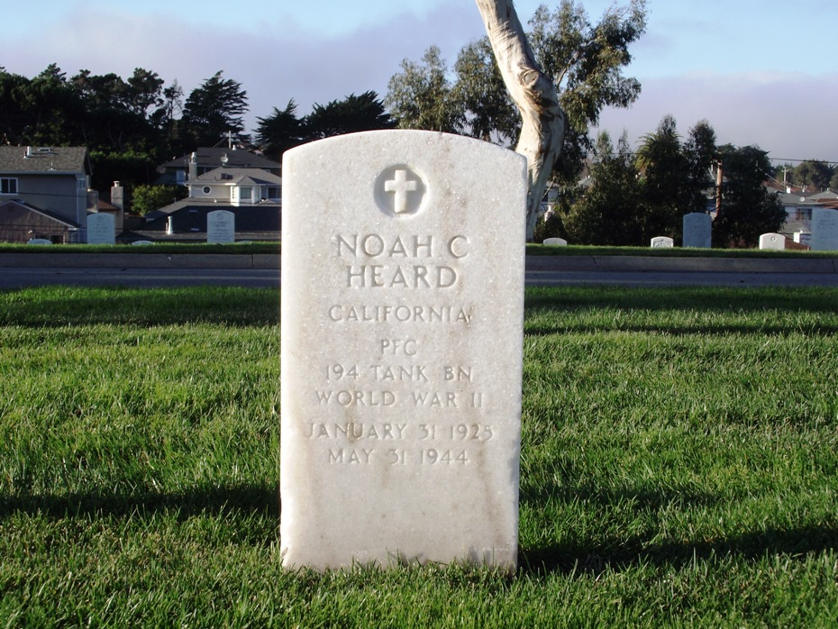
Buried in the camp cemetery
Reburied: Golden Gate National Cemetery - San Bruno, California

A detailed account of Noah’s fight on Bataan with the 194th can be found here: https://bataanproject.com/HeardN.html

Credit: Jim Opolony: 192nd & 194th Tank Battalion
POW card sent home; as with most of the cards, they were dictated by the Japanese; none of the information was true.

