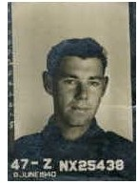
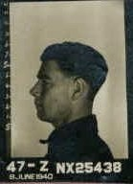
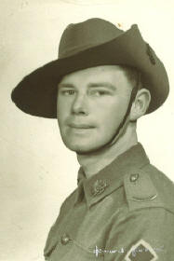
Allan Charles Herd
(left) Allan's enlistment photos

- Born 1917 in Grafton, NSW, Australia
- Joined Australian Army on 20 May 1940 at Homebush, NSW (a suburb of Sydney, NSW), Number NX25438
- Posted to the 2/6th Field Company, Royal Australian Army Engineers, attached to the 7th Division, 2nd AIF
- Embarked from Sydney for the Middle East on the original "Queen Mary" and changed ships in Bombay to the Dutch liner "SS Slamat"
and arrived in Egypt
- Transferred with 7th Division to Palestine where the division took part in the successful Palastine-Lebanon-Syria campaign
against the Vichy French.
- 2/6 Field Company attached to the British army during the defeat of Italian forces in the Sahara Desert prior to the arrival of Rommel
and the German Afrika Korp.
- 7th Division was withdrawn for return to Australia for defense against the Japanese
- "SS Orcades" was separated from its convoy after stern debate between the Australian Government and Winston Churchill, who want
to send the 7th Division to Malaya and the Australian Govt refused.
- "SS Orcades" was carrying around 3,000 Australian troops, mostly support, and landed in Batavia, Java, without their weapons,
which were with the rest of the convoy, which proceeded home to Australia. Parts of "Black Force" were, therefore, poorly armed
and short of ammunition.
- 2/6 Field Company was attached to "Black Force" commanded by Brigadier Arthur S Blackburn, V.C., commanding officer of the
2/3rd Machine Gun Battalion- "Black Force" comprising of Dutch, Australian, British & American troops and under the overall command
of the Dutch Army.
- The Dutch surrendered to the Japanese and the remaining British, Australian & American troops were also ordered to surrender
- The 2/6 field Company (and Allan) were rounded up as prisoners of war and incarcerated in an old Dutch military base later known
as "Bicycle Camp" in February 1942.
Note: The 2/6 Field Company did continue to fight through many battles with the 7th Division throughout the remainder of WW II.
- Subsequently transferred to Changi, Malaya and finally to the Burma end of the brutal Burma-Thailand Railway work gangs
- Allan survived the railway and was again sent through several camps in southeast Asia to the docks in Singapore.
- From Singapore to Japan, on the "hell ship" Teia Maru" (ex Aramis), Allan was part of the third group to arrive at Fukuoka #17
Omuta, Kyushu. The group was a mix of Australian, British, and Dutch POWs who arrived on 18 June 1944.
They would be forced into slave labor in the coal mines.
- Allan survived the coal mines (somehow) until the wars end when the prisoners were rescued by the American army and
transferred to and American hospital ship "USS Haven". Allan was eventually repatriated to Australia, where he spent some time
in the hospital before release and demobilization.
- Allan's Camp 17 prisoner number was 1444 ~ in Japanese "Sen Yon Harku Yon Ju Yon"
- Allan married after the war and had 3 sons and one daughter (one of whom is deceased).
- Sadly we note; Allan died on 18 July 2012, aged 95 years.
Credit: Alexander C Heath, whose wife is the niece of Allan Charles Herd

Allan's statement regarding POW conditions:

SURVIVAL – A MIRACLE

This is an extract of a 1982 Narrative by former Lance Corporal Allan Herd, Second Sixth (2/6th) Field Company, Royal Australian Engineers, Seventh Division, Army, 2nd Australian Imperial Force. Prisoner at Java, Changi, Burma-Thai Railway and in Japan.

I take up the story where the brutalized & emaciated survivors of the “Death Railway” are shipped to Japan, told by Lance Cpl. Herd.
“ After Saigon….we were sent back to Singapore to await embarkation to Japan. Of the first 2000 prisoners sent on the Jap Hell Ships, only about 300 were to survive, after being torpedoed by American Submarines “Barb”, “Queenfish”, “Pampanito” and “Sealion”. The full account of this hell at sea can be found in Return from the River Kwai.

Subsequent ships got through to Japan when the American submarines were withdrawn for the attack on the Philippines. Entering Camp 17 was like a journey through the Gates of Hell itself; it was freezing cold with inches of ice underfoot and sleet ice blowing over the ice and snow into the camp 24 hours a day, week in and week out.

The camp was set up on a cliff edge, with electric wires and sentry boxes all around; with the constant sleet and ice adding to the isolation and desolation. . There were no birds, no grass, nothing alive, the fumes from the nearby zinc works had killed everything.

God had forgotten this place on Earth, for to know it was to know death.

The camp could have been Satan’s own; The Camp commander and Japanese and Korean guards were the most cruel and sadistic you could ever find, for they reveled in torture, and death was metered out for the most trivial things; the average person in Australia cannot comprehend and does not believe the suffering of the prisoners.

After the Japanese, the camp was controlled by the Americans, who had been there for some time, being survivors of the Philippines campaign at Bataan and Corregidor. Outside of a small minority, the bulk of them were the lowest form of white men you could find – treacherous racketeers ….who became like animals in order to survive. Men hardly spoke to each other, only snarled……. The Australians found it particularly hard to be put into different rosters or shifts from their comrades who had supported each other under adversity since 1940.

I will not tell of the terrible torture, of death and sadism practiced by the guards and the Japanese Commandant, for this is told in such books as Slaves of the Son of Heaven.”

The Australians were put to work in the nearby Mitsui coalmine which eventually collapsed in the late 1950’s with great loss of life. “ It was the biggest and oldest in Japan …where death would reap a bountiful harvest ….among the miners. Every man had his quota of trucks to fill before he could finish ….. 12 hours each shift…..the last two where he would be belted and driven by his “Joe” (Korean Guard) to finish on time.

Men’s lungs collapsed from the terrible cold and they died in terrible agony and there was nothing anyone could do. Prisoners were fed a starvation diet of millet (birdseed), which passed through the body in less than an hour, and the hunger then worse than ever. There was no laughter, no joking or horseplay that characterized the Australian character, just terrible cold, and starvation, and work in the bowels of the Earth. After a while we did not even speak, we knew we were doomed, and death would be a welcome release.”

Lance Corporal Alan Herd had been too sick to go down the mine “I knew my days were numbered, for I was living in another world, the twilight world where there was no hate, nor fear of death, no wanting to go home, only a peace so complete that it cannot be described. Then it came, on a bright clear day – thousands of bombers and fighters that the sky was black with them…..the ground and the buildings shook …the fighter escorts swooped so low and must have realized we were prisoners … no bombs fell on us.

A few days later no shifts went to the mines.… we realized the War was over. So terrible had been the suffering, so far gone were the men, so exhausted and spent … there was not one cheer … just nothing. If anyone spoke, he was snarled at and abused.
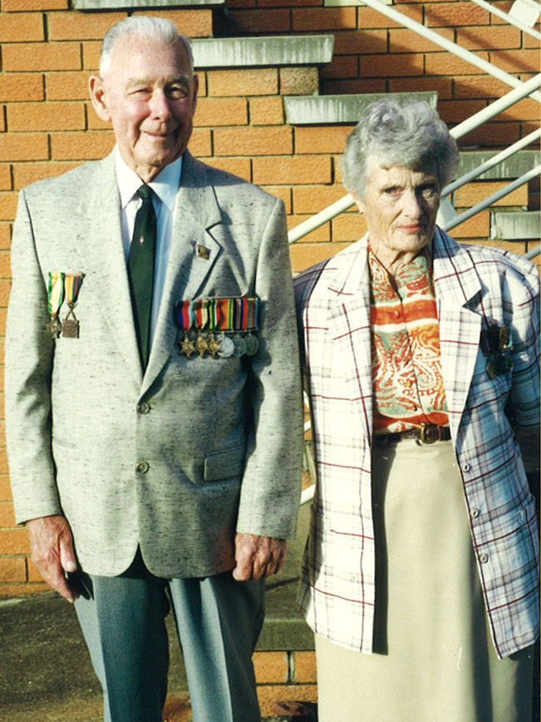
The Japanese disappeared after about a week and we were found by American War Correspondents, who parachuted into the camp and contacted MacArthur’s Headquarters; bombers then dropped food into the camp.

After about four weeks the Australians were moved by train. “We came to the site of the city of Nagasaki … the atom bomb meant nothing to us, but if the human race could all see what we saw … no life, be it human, bird, insect, no nothing, just desolation and destruction for hour after hour as the train stopped and started … there would be no more war.”

We were put aboard a hospital ship, the USS Haven (a name so appropriate), in the harbour. The Americans cheered us and gave us coffee and donuts. However they did not touch us or shake our hands, for we were not human to look at. We were more like animals, with lice and coal dust ground into our shaven scalps and eyes, with our starved bodies in rags”

Note: The story of Australians at Camp 17 is told in “Sappers of the Silent Seventh”, published by the Seventh Division Engineers Association, Sydney, 1982.
and the excellent book, "Slaves of the Son of Heaven" by R. H. Whitecross, published 1951

