Eric Horton
A POW’S REFLECTIONS ON LIBERATION AND A MEMORY OF FUKUOKA #17
My father, Eric Horton, was in the Territorial before the war, and was called up in June 1939. He saw action in France in May 1940, in the retreat and defense of Dunkirk. Similarly, he was involved in fighting at Singapore. He worked on the railway in Thailand before Japan.
My father was Articifer Quarter Master Sergeant A.Q.M.S. Eric Horton, one of the Warrant Officers with the British troops who worked in the zinc foundry at Omatu Fukuoka 17. They were Shotai 17,18,19 and 20. My father was 19 shotai-cho. The senior WO1 was Freddie Fields, who led the shotais out through the gate at Camp 17 Omuta to work at the zinc foundry.
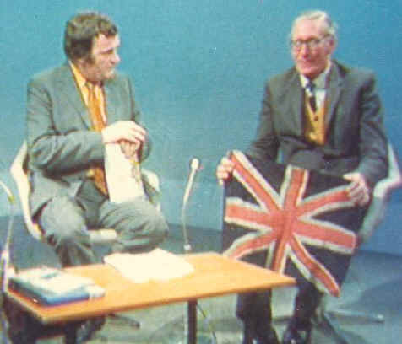
This is how my father described August 15th 1945 to me:
For the first time no one left the camp to go to work. In the afternoon we were told to parade, the camp commandant and the interpreter joined us and made a speech. The interpreter's version "Hostilus" will finish forthwith, no one leave camp." The parade was over we decided the war was as well. We had at the evening meal as much rice as we needed, so good to have a full stomach. Later that evening the thought came to me we need a Union Jack to show we are British and proud of it. For us to show our flag to the Americans, Aussies and Dutch and for the Japs to bow to.
So first the search for material:
The blue from an old hospital shirt ...
The white from an old mine workers shirt...
The red from around the edging of a mosquito net. The problem of sewing thread; I decided to shred an Army issue webbing belt. With the help of Bert Humphries, the flag was completed about 3.00 am on the following morning of the 16th August.
The Union Jack was suspend from cords cut off a mosquito net.
It was hung outside our hut. When a guard approached the hut, they were astonished, but bowed.
On arrival at Omuta in June 1944 the 200 British soldiers, plus their 2 Officers were met by Lt Yuri and the very thin Captain Tisdelle, Camp Commander.
This is a description by one of the two British Officers on their arrival at Camp 17 Omuta:
Shortly later, a small group of fit-looking and well-nourished Americans came into the compound, carrying wooden buckets of soup and huge trays of freshly-baked buns of bread. They were the camp cooks and they looked very different from the emaciated "ordinary" Americans who were eyeing us over the fence and exchanging details of past histories. Their chief cook, CPO G., offered the rations to our group of officers and WOs first, and was taken back by our reply: "Please feed the troops first" He said quietly: "You'll soon change here, gentlemen!"
Our own WOs organized the lines for the issue, and as he was coming to the end, the cook again approached us, the two Lieutenants, and said, Lieutenant, if you don't get your bread now, there won't be any for you. Six buns were stolen on the way. We told him to carry on serving: and sure enough, he was six short. He ordered 6 bowls of rice be fetched from the "galley". By that time our troops knew of the disaster of our bread - we had not eaten bread for more than 2 years - and many of them offered us some of theirs. The cooks and Americans were flabbergasted: they must have decided that British officers and WOs were mentally deranged!
Perhaps that single, simple incident created a bond not only between us and our men, but also between us and the men of the US forces, some of who had too long forgotten their duties to their troops. Even the Japanese guards seemed amazed but our actions.
Padre J Carmel Hamel said of the British troops: "Discipline among the British was excellent; their barracks gave one the impression of immaculate cleanliness. Their Lieutenants B and A knew how to keep order and unity among their troops, and both untiringly watched the interests of their men.
My father returned home to be reunited with my mother and sister who was born pre 1939. After a period of time recovering, he returned to his old trade of diesel fitting. I was born in 1949, considered a miracle boy, had a wonderful youth and I was extremely lucky my father talked to me about his travels and experiences during World War II.

