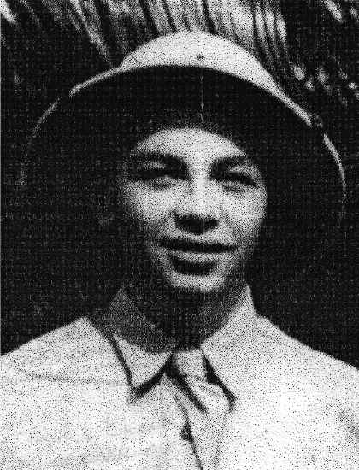
Paul Inzer
Born December 6, 1925 and enlisted in the Air Corps on June 13, 1941 at Knoxville, Tenn., making him just 15 years of age at time of enlistment.

He was a prisoner of war 45 months and 12 days. He retired from the Air Force on August 8, 1969.

Account as told to Linda Dahl: Answers from a series of questions by her students - Summer of 2003
"I am honored to think that a group of students, their teacher, and supporters would remember 'The Battling Bastards of Bataan'.
If you will allow me to expound - you see, we few (approximately 18,000) men on Bataan, who were abandoned, left to hold off an enemy army, we felt much like a bastard must feel when left by an uncaring mother.
So consequently someone coined the phrase: "Battling Bastards of Bataan". Then a song was written to baptize the phrase. It went something like this;
"We’re the Battling Bastards of Bataan, with nothing in the pot, just a bunch of soldiers that Uncle Sam’s forgot", ….etc. "Why did I have two numbers? The numbers were 1300 and 415. Upon arrival to Camp #17, I was assigned number 1300. I was then transferred to Camp Fukuoka # 3, that was 415.”
"After a few days in the hole of Black Death (coal mine) there were men intentionally placing their legs under a coal car, loaded with coal, and being crippled so they would no longer be expected to go down in the mine. Believe me it was that bad. I hated the dark hole also, but I wanted to keep my legs, so I flatly refused to go down into the mine. Sure, I knew there would be consequences, -even death. But I was sick and tired of that torture so I changed it - they beat me until I passed out and then they beat me again – passed out again".
"How many times? I do not remember – still I refused." "Why they did not kill me, I do not know. I was carried by the Japs back to the barracks and I was quietly transported to another camp. Camp #3 in Moji, northern Kyushu I assigned another number, #415. There, after my recovery, I was put to work as a Stevedore to work on the docks until the end of the war.”
Biography – "No, I do not have one written. But I do have memories of those 5,475 days spent in 8 different hellholes, plus the Death March, and the hell ship, Moti Moti Maru (also known as Mati Mati) on the way to Japan from the Philippines.”
In response to a question asking Paul if he had a memory of being called “The baby or boy of Bataan”, due to his young age at enlistment:
“Oh! No offense intended, but I was truly not a baby. I walked as a man, served as a man and for all intent and purpose I was a man from the age of 11 until now. You see, I was raised on a farm in the state of Tennessee, known as the Volunteer State.”
“In the 30’s and the 40’s and after WWII for a short while, this was a great country.
And you know, until I received your letter, hearing about your students, reading about what they and you were doing, I was beginning
to feel that the country had totally gone down the drain, but you give me hope for the future.
I hope and pray that there is many more like you all".
Thank you - Paul

A Story about a Death March Picture
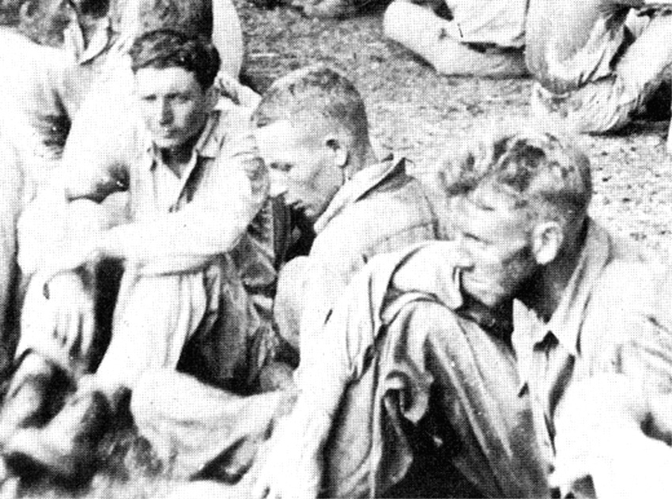

(From Left to Right) Preston J. Hubbard, age at the time: 23;
Paul G. Inzer, age at the time: 16, and a soldier not identified.
This picture is of a rest stop, on the Death March, in Balanga, Bataan.

Paul tells the story behind this photo…

When Bataan fell, we were at Little Bagiuo, a few miles north of Mariveles, the tip of the Bataan Peninsula.
I was ordered to man the Field Telephone Switchboard, so that the CO would know how close the Nips were at all times--so he would know at exactly what time to destroy all vital equipment and information. You see Gen. King surrendered all forces on Bataan near the front where most combat was in force. While the 409th Signal Corps Avn. were performing their duty in Little Bagiuo a number of miles behind the front. I was, personally, captured while performing my duty, manning the field switchboard.

The Nips ordered me to load the switchboard on a truck and for me to get on as well. One of the two nips drove while the other sat in back with me, all the way to Mariveles. We stopped at a group of about four houses and the both of them went inside, forgetting about me. So, I jumped off the truck and ran for my life.

I wondered through the jungle underbrush for at least twenty four hours and finally, I was on the main road headed north. Never thinking about food, sleep, or anything else, except for the Nips. Would I be killed? I was sure I would be. There was no one or no vehicles on the road, it was clear of any activity. I was alone, no different than the underbrush I had been struggling through. I was constantly looking over my shoulders frightened out of my skull. Just then I saw, way up the road, a car off the road in a ditch, and a Nip was standing in the middle of the road with his hands on his hips staring at me. I was too scared to turn and run, anyway it was too late to run--he had seen me.
I approached him and the car. He was looking at me all this time. He said to me, “I'm glad you came along, now we can push the car from the ditch”, which we did.

After the car was back on the road and the driver was in the driver's seat waiting for the Officer or NCO whom had been talking---He turned to me and said: "Thank you very much for your help--pausing for a second, --he questioned me, "How old are you son"?--I was thinking all the time that he would swing that big knife at me any moment--but NO he was very friendly. Finally I answered him with, "I'm 18 sir". Looking at me with a big grin on his face he said, "Sure... you are, and well thanks again.” And at that he turned and got into the car and drove away, leaving me with a whole lot of relief.

Walking on--north, I turned to look over my shoulder and I saw a soldier stepping into the road the same as I had an hour or so before. He spotted me and came running towards me--I didn't know whether to run or just drop dead. I stood there, frozen stiff with fear. As he narrowed the gap between us, then I saw he was one of ours.

We walked together for a mile or two when we rounded a corner in the road where we saw six rough looking Nips. We stopped and just stood there, not knowing what to do. I started to turn, and the guy I was with, grabbed me and said I wouldn't if I were you. The Nips motioned for to come near them, so we did. They gave us a musette and motioned for us to cut grass for their horses. Up the road, a few hundred yards in front of us, there were a large group of US soldiers sitting around --just waiting. We joined them. That is how the Death March got under way for me.

