John Isaacs - British Army
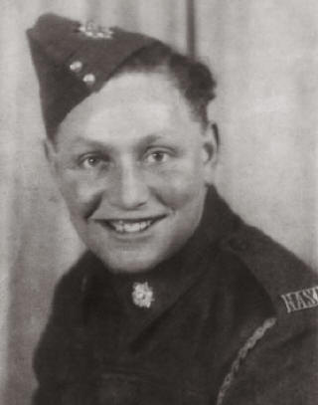 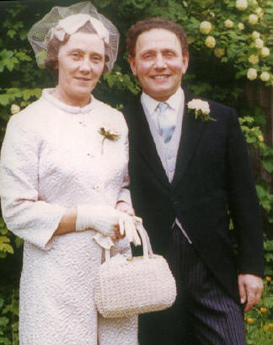
John, military photo - 1940 John and wife Heather - Wedding Day April 4th 1970
Timeline of John's war years:
Enlisted 15 January 1940 aged 22, Driver for 55th Company 18th Division Royal Army Service Corp.
Captured, Singapore 15 February 1942 Changi under Col. Preston. Imprisoned there until 15 September 1942.
Sent to Thailand, 20 September 1942 under Col Clarke RA. 1943 sent to "camp Quema". **
1 January 1944 imprisoned at Hindato until 25 May 1944.
(note: At Hindato John played the part of Nell in the camp show, New Year 1944.)
Sent to Japan 28th June 1944 - Camp 17 Fukuoka under Major Schott USA (Robert William, Medic/Dr)
Liberated 15th September 1945
Then Returned to the UK via Canada
** John is mentioned in "No Time for Geisha's" by Geoffrey P Adams. Page 93 of the paperback copy.
Adams is quoted here, telling of the prisoners’ arrival into the "camp" while on a cattle drive for the Japanese. "We were not allowed to cross the stream, as the Japanese feared cholera; but one of the 55 Coy's drivers, John Isaacs, happened to be working in the camp as a servant, and he did me proud, with a cigarette and a cup of coffee, and a cup of sweet tea, which I shared with Sergeant North. Johnny provided hot food by sunrise - though we had not seen the sun for a day or two - and after long drinks we were away.”
John Isaacs POW card and Liberation card
