Gene Samuel Jacobsen
Dr. Gene Samuel Jacobsen, 85, a prominent Utah educator and author, and World War II survivor, died May 5, 2007.
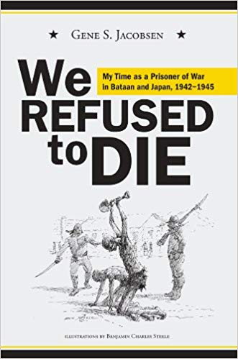
Jacobsen was the author of “We Refused to Die: My Time as a Prisoner of War in Bataan and Japan, 1942- 1945” the story of being a prisoner of war in the Philippines and Japan for three and a half years, after surviving the infamous Bataan Death March. His book was awarded the “Top National Honor, Public Communications Category in 2005,” by the Freedom Foundation at Valley Forge.

He was born September 19, 1921 in Bloomingdale, ID, the son of Joseph Cowley Jacobsen and Ethel May Draney Jacobsen.
He enlisted in the Army air Forcer and was sent to the Philippine Islands with the 20th Pursuit Squadron.

As a POW he worked in several Japanese camps in the Philippines; then was transferred to Kyshu, Japan where he worked in a coal mine until the war ended in August 1945. Upon returning to the United States he was reunited with his high school sweetheart, Barbara Perkins who was a gunnery instructor in the U.S. Navy WAVES. They Married November 10, 1945. He received BS and MS degrees at Utah State University, a doctorate at the University of California at Berkeley, and served on the faculty at the University of California, Davis.

He was a member of a team that established the faculty of education at the Haile Sallassie University, was a UNESCO expert with the Singapore Ministry of Education, and superintendent of the Saudi Arabian International School System in Dhahran, Saudi Arabia. At the age of 60, Jacobsen was awarded the rank of professor emeritus and became executive secretary of the Society of Utah Superintendents and Associate Executive Director of the Utah School Boards Association.

He was a public speaker and consultant, author, and a member of the leadership in the Church of Jesus Christ of Latter-day Saints. He and his wife served LDS missions in Zimbabwe Africa and in Tempe, AZ. He is survived by Barbara, his wife of 61 years; and their children, Dr. Michael (Pam) Jacobsen, Pleasant View; JoAnn Jacobsen Wells (Joe Leverrich), Murray; Sue (David) Vicchrilli, Murray; 12 grandchildren; brothers Whitey, Forrest, and Larry. He was preceded in death by his parents, brothers Marsel and Darrell; and a sister, Shirley Note.
Credit: Quan Christmas 2007

