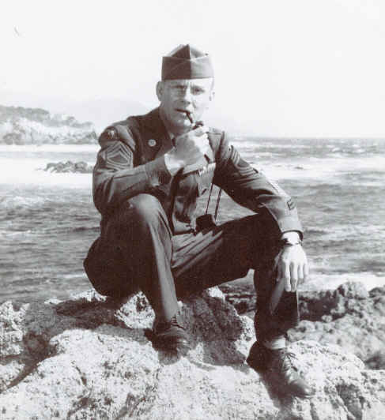
Lyle H. Jensen
Prisoner # 31 - Camp No. 17 Omuta, Japan
Lyle H. Jensen enlisted in the United States Army on 10 September 1940 at Omaha, Nebraska. Upon enlisting he was immediately transferred to Fort McDowell, Angel Island, California. (photo below)
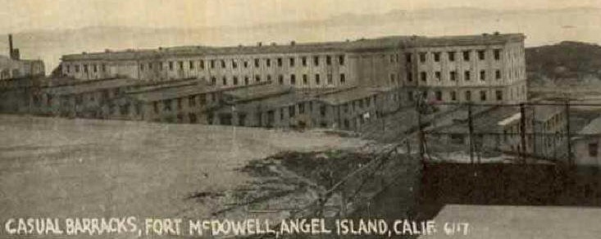

Shortly thereafter he was transferred to an overseas assignment in the Philippine Islands. Upon his arrival in the Philippine Islands on 1 November 1940, he was assigned to the Harbor Defenses of Manila and Subic Bay –stationed at Fort Mills, Corregidor Island. He was assigned to the 60th CAC (AA), “E” Battery and later was reassigned to the Regimental HQ Battery of this artillery (anti-aircraft) regiments.
Upon the outbreak of hostilities with Japan on 7(8) December 1941, Lyle fought in the defense of the Philippine Islands until the surrender of the United States Armed Forces in the Far East to the Imperial Japanese Military Forces on 6 May 1942 at Corregidor.

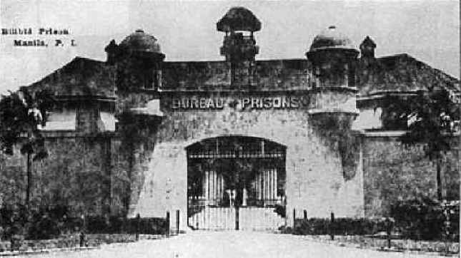
Following the surrender of the American Armed Forces in the Philippine Islands, he was interned in various prisoner of war camps at Corregidor, Cabanatuan Camp No. 3, Lipa, Bilibid Prison Hospital (photo left), and Cabanatuan Camp No. 1 until July 1943. In July 1943, Lyle was included in a group of 500 American prisoners of war who were taken to Japan for continuing internment. This group of prisoners was transported to Omuta, Kyushu, Japan – here they were interned in Camp No. 17 (Omuta).
While interned in the prisoner of war camp (Camp No. 17) in Omuta, Japan, he was subjected to forced labor in the coalmines of the Mitsui Mining Company. Such enforced labor, which was of extremely long work hours in the coalmines was most physically demanding – the working conditions in the mines were most dangerous and unsafe – the internment camp living conditions were hardly better than adequate or primitive.
Prior to the cessation of the ongoing hostilities, Lyle’s weight had declined to approximately 95 pounds and if the armed conflict has continued another six months, he would have most surely succumbed due to overwork and lack of adequate nutrition. Aside, from the starvation diet and the inadequate living conditions – the greatest or most perceptible danger to him and his fellow POW’s encountered, was the ever present possibility of serious injury or death from work related accidents while working in the coal mines. He was most fortunate in this respect, his injuries were not too serious – although he sufferer several broken bones in the hand, crushed fingers, severe lacerations of the hands and legs, and other resulting injuries from the premature explosions while in the coal mines.
On 15 September 1945, the American Occupational Forces in Japan liberated Lyle and his fellow POW’s of Camp No. 17. He departed Japan, via Nagasaki, and arrived in San Francisco on 1 November 1945.
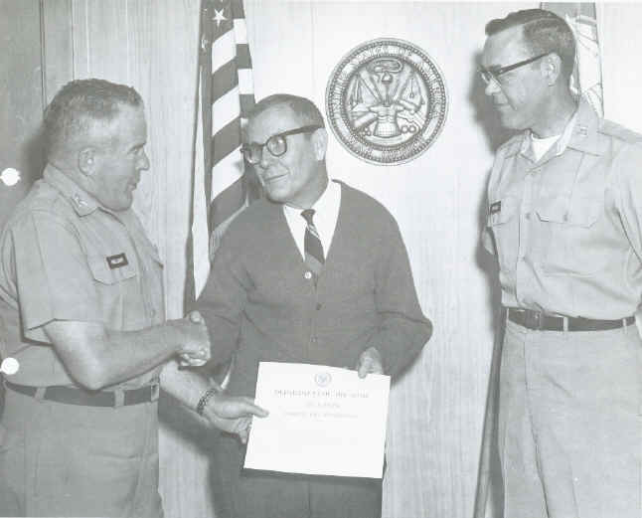
Lyle was medically retired from the United States Army in June 1954 with the rank of Warrant Officer (Junior Grade). Following his medical retirement, he was employed as the Senior Draftsman for the Post Engineer at Fort MacArthur, San Pedro, California until his Federal Civil Service retirement in June 1982.
May 1969 at Fort MacArthur, Ca.
Lyle Jensen is awarded for his outstanding performance
as the Senior Draftsman at Fort Mac.
Lyle passed away in June 1997 and was survived by his wife, Caroline and his three children, Peggy, Paula, and John.

