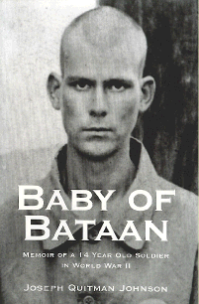
Joseph Q. Johnson (Baby of Bataan)
In January 1941, Joe enlisted in the Army and volunteered for the 31st Infantry Regiment
(the “Polar Bears”) stationed in Manila, P.I. He was fourteen years old. He was assigned
to a machine gun squad in D Co, a heavy weapons company. Not long after basic training,
Joe was selected as the company’s bugler and was often chosen from among the
musicians in the First Battalion to play General’s Call when Gen. MacArthur would arrive at
his headquarters. Peacetime duty in the Philippines was good.
Hours after Pearl Harbor was attacked, Manila was bombed. War had come to the
Philippines. When Japanese forces invaded the island of Luzon, Joe’s regiment was
mobilized. Joe’s position as bugler also made him the company runner, giving him a first-
hand vantage point of the fighting along the line. Traveling with MacArthur to Corregidor in
late December, D Company sustained its first casualties of the war from enemy bombers. When his company joined the rest of the regiment on Bataan, Joe fought his way down the
Peninsula with his machine gun squad until April 9, 1942. He escaped to Corregidor, just
avoiding the Death March, when the Bataan garrison was surrendered. Joe defended the beaches of Corregidor with the Marines until May 6, 1942 when Corregidor fell. Young Joe began his life as a prisoner of the Japanese.
Back home in Memphis his mother was frantic. All correspondence with the Philippines had been suspended.
The Memphis papers dubbed him the “Baby of Bataan.”
After being marched through Manila he was moved from camp to camp. First, he was taken to Cabanatuan # 1, then to the horrific Nichols Field detail, then to Bilbid. He was then placed on a succession of Hell Ships. The first ship, Oryoku Maru was sunk off the coast of the Philippines.
Next came the Enoura Maru, then the Brazil Maru. Many did not survive the horrific conditions of the ships, and many lost their lives when American planes and submarines sank the Hell Ships. Those that did survive, including Joe, had to confront slave labor in Japan.
Surviving brutality, starvation, threatened execution, near fatal injuries and mine cave-ins, Joe’s courage, determination and internal fortitude kept him alive. He was close enough to Nagasaki to see a curious huge white cloud hovering over the city a day before American planes began dropping food on his camp.
The war was over. Joe’s long journey home began.
Of the thirty-one men in his recruit platoon who fought in the war, twenty-one had perished, most as prisoners of the Japanese. Joe returned home at the age of 19. He served several more enlistments in the armed services before he retired. He was in the Army Air Corps and then served as a Marine Drill Instructor in San Diego. He was wounded in action in Korea.
Joe lived many years in Sun City, Arizona -with his wife, Marilyn.
Joe published his memoir in a book entitled “Baby of Bataan.”
Marcus Brotherton published a sequel to Joe’s story,
“A Bright and Blinding Sun: A World War II Story of Survival, Love, and Redemption”
Joseph Q. Johnson (Baby of Bataan) Photo Gallery
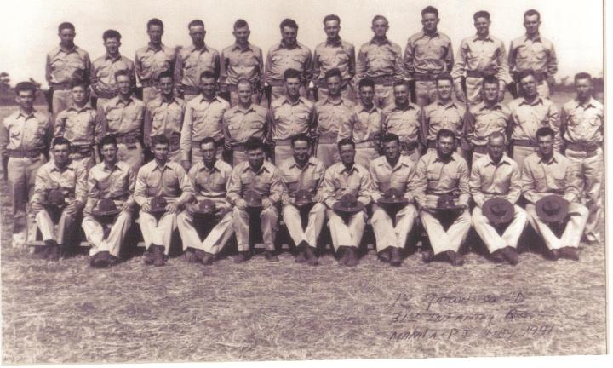
Recruit graduation picture 31st Infantry Regiment, D Company, 1st Battalion.
2nd from left, middle row, Pvt.
Joseph Q. Johnson, age 15. 1st from left, middle row, Dale L. Snyder. 3rd from left, top row, Raymond Rico.

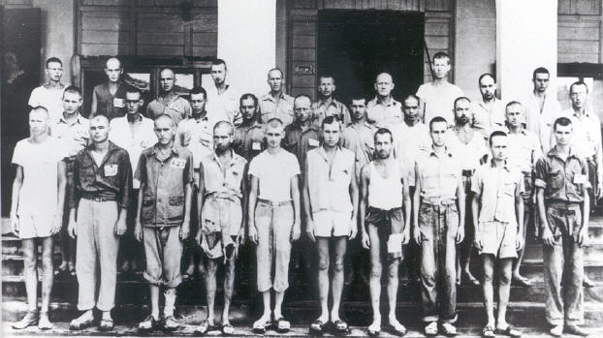
Joe as a POW (top row, 2nd from
left) at the notorious Pasay School, Nicholas Field Slave
labor detail.

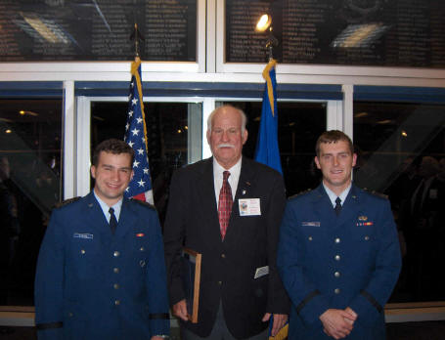
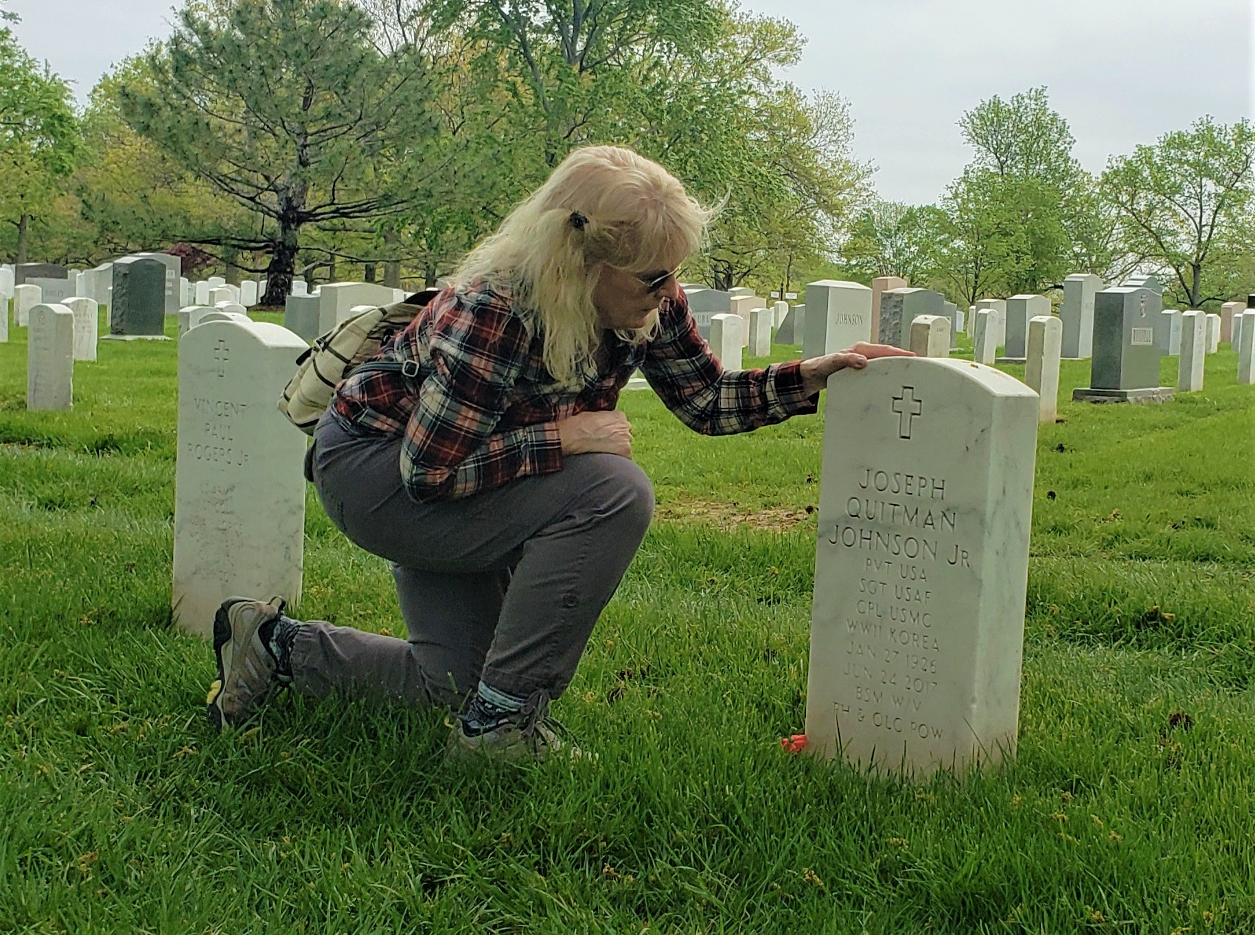
Joe Johnson at Air Force Academy 2005
Linda, at Joe’s gravesite, Arlington National Cemetery
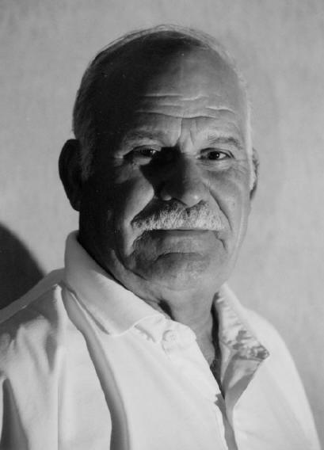
POW- MIA SPEECH
PAST---PRESENT---FUTURE
by former POW Joseph Q. Johnson
Thank you Sgt. Cooke, General Neubauer, distinguished guests and fellow patriots. We gather here today to honor our POW’s and MIA’s from the Past, and Present. In W.W.II there were approx. 126,000 American POW’s. There were approx. 30,000 American’s listed as missing in action. In Korea there were approx. 8000 American POW’s. There were approx. 5000 Americans listed as missing in action.
In Vietnam there were Approx. 770 Americans POW’s. There were approx. 1800 Americans listed as missing in action.
I represent an era of W.W.II that many in our present generation are not aware of. I’m speaking of the Defense of The Philippines at the start of W.W.II.
When the Japanese attacked Hawaii on the morning of Dec. 7th 1941, at the same time they were attacking the Philippines. Within hours the Japanese were landing at Hong Kong, Malaysia, Borneo, Java, Indonesia, and other islands in the Far East. Because of the International Dateline it was Dec. 8th in the Far East. At the start of W.W.II there were approx. 23,000 American servicemen of all branches of the service in the Philippines. I was 15 years old when the war started. I had been in the service for almost a year and had been stationed in Manila assigned to the only American Infantry Regiment in the Far East.
The first American ground combat in W.W.II was the defense of the Philippines. After about a month of fighting the Japanese landings, we withdrew into Bataan Peninsula. Bataan is a small peninsula bordered on the east by Manila bay and on the west by the China sea. The Battle of Bataan lasted almost 4 months.
The first 3 Medals of Honor of WW II were awarded on Bataan. The 1st Army Air Corps hero of W.W.II, was Colin Kelly, who gave his life while piloting a B-17 defending the Philippines.
I turned 16 while fighting on Bataan. When Bataan was surrendered, approx. 300 of us American servicemen made it to Corregidor. Corregidor was an Island Fortress at the mouth of Manila Bay. It was approx. 5 miles across from the tip of Bataan.
Once on Corregidor many of us were assigned to a Marine Regiment defending the beaches of Corregidor. On May 6th 1942 after one month of fighting, Corregidor was surrendered and I became a prisoner of War. One of the most degrading events that can befall any American serviceman or servicewoman is to become a prisoner of war. No amount of training can prepare you for this experience. It affects your emotions, both physical and mental. At first I felt disbelief, then anger and defiance. Then as hours passed, and reality set in I felt humiliation and shame. I was to spend almost 4 years as a Japanese POW. The first couple of years working as a slave laborer on various work details in and around Manila.
In 1944 as MacArthur and his forces came closer and closer, the Japanese crammed all the able bodied American POWs they held in the Philippines into the holds of unmarked Japanese merchant ships in an effort to transfer us to Japan to work as slave labor in their mines and factories. I was on three of these unmarked ships, I survived the sinking of two ships and finally arrived in Japan on the third ship. Other unmarked ships were sunk by American submarines or aircraft. Several thousand American POWs lost their lives in the holds of these ships. Those of us who survived these hell ships were put to work in factories and coal mines.
When Japan surrendered in August of 1945 I was 19 years old. I had matured both physically and mentally during those trying years.
When I entered the service I was 5 ft 7, weighed 135 lbs. When freed from Prison camp, I was 6 ft 3 and weighed 115 lbs. I was lucky or blessed, probably both. Of the approx. 30,000 servicemen captured by the Japanese in the Far East by the Japanese in W.W.II, only about 12,000 came home alive. Less than 300 of us are alive today from the Philippine Campaign, Our average age is middle to upper 80’s.
We know that war not only affects the serviceman, it affects those at home who were close to him. It affects mothers, fathers, wives, husbands, brothers, sisters, neighbors and friends. They all suffer the ordeal of separation, the uncertainty, the anguish and heartache.
I was listed as missing in action for over a year before the War Department notified my family that I was a Prisoner of War. The joy of finding out that I was still alive was tempered with the uncertainty of my health and treatment.
Through recent wars, many American families have suffered this emotional distress. Sometimes false hopes and heartbreaking rumors have plagued their lives. After all, those three words, “Missing in Action “offers some hope. These families pray that somewhere, somehow, their loved one, by some Miracle, is still alive and struggling to make it back home.
We Americans today enjoy blessings & freedoms that those who are still listed as “MISSING IN ACTION “fought for.
I am confident that this present generation and future generations will fulfill their duty and make sure that all Americans will still be enjoying these same freedoms in the years to come. It is our obligation and duty to never give up hope on any fellow serviceman who might still be alive somewhere in this world.
We must try and write a final chapter for each missing servicemen. Their families deserve a final closure.
America is a caring Nation. America is a Selfless Nation. America is a Loving Nation. America is a Giving Nation
and America is a Forgiving Nation May God continue to shower down his love and blessings on this Great Nation.
A Personal Note from Joseph Q. Johnson
“You only hurt yourself when you harbor hate and bitterness for deeds inflicted by others in the long ago past. It is not easy, but time and patience will help you finally get over it. You learn more about life and surviving and human spirit from experiencing five years of pain, hardship and tribulations, than from 50 years of tranquility and contentment. It takes too much of your time and energy to seek revenge against those who inflicted pain and suffering and misdeeds on you in the many years past.

It doesn't mean that you forget, you just file it in an unused chamber in your brain and go on with your life.
There is great inner comfort and a feeling of worthiness in fighting for the rights and happiness of people less fortunate, even if the battle is lost at times. Love makes you feel good all over, inside and out.”

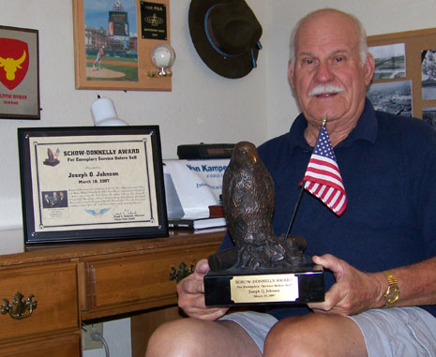
Bataan Survivor Wins National Award
In his lifetime, Joseph Quitman Johnson has endured things that no one should ever have to experience. Through those hardships, the Sun City West man emerged a survivor, dedicating his life to helping others who are in similar circumstances. Johnson recently won a prestigious national honor for his work. Johnson, 81, got away with enlisting in the U.S. Army when he was 14. He was sent to the Philippines and served in the 31st Infantry Regiment. Though his age was soon discovered and plans made to send him back home, fate entered. He fought at Bataan and Corregidor until he was captured on May 6, 1942, and taken as a prisoner of war. He was just 16 years old.

He spent the remainder of World War II doing slave labor, enduring torture and watching scores of his friends die. Johnson came to be known as the "Baby of Bataan," because he was believed to be the youngest prisoner of war in that arena.
Johnson spent much of his time helping to educate people about the plight of prisoners of war and those who are missing in action, a particularly timely subject given current U.S. military involvement in Iraq and Afghanistan. In addition to lecturing at Kiwanis, Lions and other service clubs, Johnson worked with high schools in Illinois, Idaho, and Tennessee, as well as students from Ironwood High School in Glendale. He also worked 2 days a week as a courier for Recreation Centers of Sun City West, Inc., in its golf operations division.
Johnson wrote a book entitled Baby of Bataan: Memoir of a 14 Year Old Soldier in World War II, detailing his experiences in the war. It helped shed light on what happened to many of the soldiers during those bleak years. "I didn't write a war book, I wrote a book about me growing up," he said. "I made up my mind to just make this book about me. People don't realize how wars are fought, and that plans don't always pan out."
Adee nominated Johnson for the Schow-Donnelly Award, a national honor given each year to one military veteran and one civilian for their exemplary service to the nation and community. "Joe, through his selfless dedication and efforts, has brought renewed interest in our servicemen and women, and brought the plight of our POWs & MIAs to the public's forefront, moving us closer to bringing them home," Adee said. "This is the true essence of the Schow-Donnelly Award and why I nominated Joe . . . he's touched me more deeply than anyone I've ever met."
Johnson received his award In March of 2007, during a special ceremony. He said he was humbled by the experience. "It was a great ceremony. It was quite an honor. I met many fine Americans there, whose lives you would be doing well to emulate." When asked if there were ever times he wished he hadn't enlisted in the Army, Johnson became philosophical. "I have no regrets. Everyone would like to go back and relive their life, but you have to be realistic."
Photo above: Joe at home with the Schow-Donnelly Award
We lost a wonderful man to heaven, but as Joe once told me, Heaven is always better.
Born on January 27, 1926 in Ruston, Louisiana / Passed away on June 24, 2017 in Sun City West, Arizona
Joe’s Memorial Page and Arlington National Cemetery burial:
https://www.facebook.com/pg/Joseph-Q-Johnson-Memorial-426216157765525/posts/

