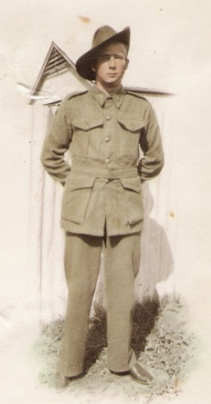
Allen Godfrey Jones
Prisoner of war at Changi, Great World Camp, River Valley Road Camp,
Fukuoka #1 and #17
A daughter’s Tribute
My father was known as Bill. He was in the 4th Anti-Tank regiment.
My father’s death 21st September 2009. Always remembered.
Allen Godfrey Jones was born 4th August 1919 Porepunkah Victoria. He was the son of George Albert Jones and Christina Marion Buchan. He had 10 siblings.
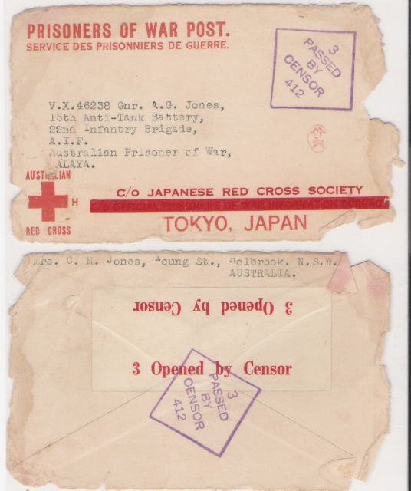

Allen’s daughter, Kathryn, has built a wonderful tribute to her father here:
http://www.angelfire.com/folk/ww1/agj.htm
It contains many documents, photos, and information, including many photos of other Australian servicemen and POWs.

The following is a letter from Allen to his mother in 1942. Obviously written before he was a POW. I have transcribed the letter below. It’s amazing that he wrote it to his mother in 1942 and when she died it must have been returned to him. I was given this letter by my mother.
4th Anti-Tank
Malaya 30/01/1942
My dear Mother
In answer to your most welcome letter, I received last night, one came for me and one for Peter and also a letter from Eric for Peter and another letter came this morning from you mother for Peter and I.
I can tell you dear Mother I was very pleased when the letters came. It has been such a time since we had a letter the 31st December was the last. Up till now the food problem has been pretty decent. I haven't lost any weight yet.
Jack is in hospital at present. Dear Mother he has some fever. I guess it is malaria. Peter was saying he was shaken about by the bombs he was caught in the open, one day.
For a while, the truck used to bring our food around to us. Jack was getting the food this day and was taken by surprise the dive bombers came at them. They ran into some ruins and the bombs landed very close to him. Since then Peter said he hasn't been so good. I suppose the shock helped to bring on the fever. Poor old Jack he is a great scout. I can tell you dear mother it isn't the best when down a hole and they start to dive bomb.
I can well imagine how Jack felt to be caught in the open. They use to machine gun us also. I did not mind the machine gunning but the bombing wasn't so good. We were never real close to any of the bombs but quite close enough for me. Some of our mates had narrow escapes. One chap was in a cement bath the people have them around their homes. He was in one of them this day and the bomb landed almost on to him, he could reach out and touch the crater the bomb made.Another few feet and it would have been all over. One other of our mates was in a drain of some sort and a bomb landed about ten feet off him. He said he could hear it falling, he was covered in mud after the rain cleared and his steel hat was about five feet away from where he was.
The noise of the plane was more than the bomb they scream when they are diving we used to watch them diving if they were not too close.
You should see the locals carting their food away. They go right past us. At present there are some going by and where they are taking it dear mother I have no idea perhaps into the jungle away from the Japs. In some cases some will be taking the food to the Japs quite a number do this. This place is full of that sort.
We aren't so very far from Singapore now and I have an idea we will be in Singapore before very long. It is about the only place left for us to go to. At present we are waiting for a few tanks or anything else to show up we will then be able to try our old gun out so wish me good shooting dear mother. This is a strange place just now a woman came along with two kero tins full of sugar. It is all she can do to carry them and over the other side of the road a man is telling her how to carry them. He has the great load of one coconut. It has me beat dear mother the men and women are just the same over here. In Aussie if we saw a woman carrying anything the first thing we would do would be to offer to carry whatever we could, but here no. They take no notice whatever, of a woman carrying a load.
I have seen the women with a little baby tied onto their backs and carrying something either on their heads or shoulders. It makes a chap feel glad we have a little freedom. Believe me dear mother give me dear old Aussie any time. This is the first decent letter I have written to you dear mother for some time so I am making a job of it. All I hope is that it reaches you in good time
(Note: The rest of the letter is missing.) Submitted by his daughter, his daughter Kathryn Jones-Lucas.
On the website dedicated to her father, Kathryn writes, “My father had a little leather bound pocket book. This is what he wrote in it after the war. I am surprised and grateful he made it out alive. I have typed the following from his original handwriting so I may have made errors in transcribing the words especially the Japanese ones.”
The letter is very interesting; be sure to visit the website: http://www.angelfire.com/folk/ww1/agj.htm
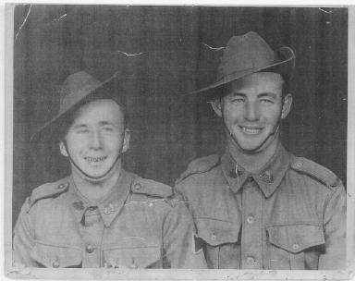
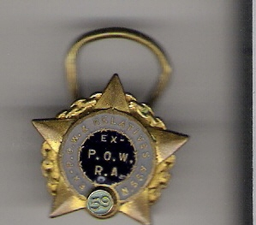
Photo is of Allen (Bill) on the left, his brother, Peter, on the right.
Photo right is Allen’s POW medal.

