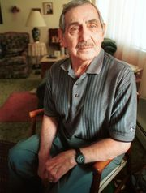
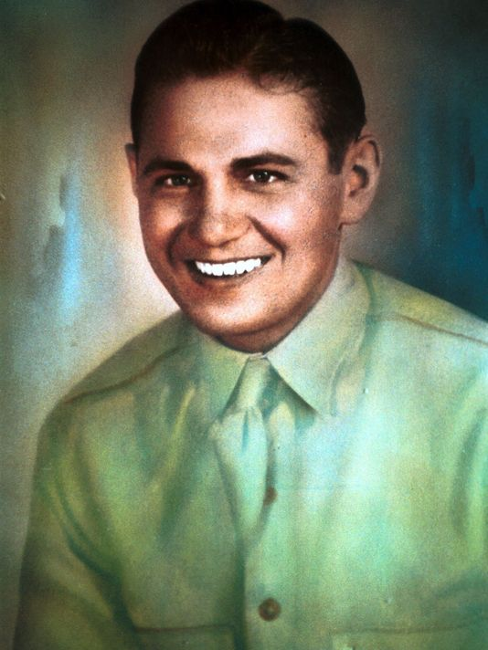

Charles Karmendat

…at age 79 in 2000

In 1940, when 19-year-old Charlie Karmendat enlisted in the Army and left Port Huron, he was lean and well-muscled from a year of manual labor with the Civilian Conservation Corps. He weighed maybe 150 pounds. Five years later, when he emerged from a Japanese prison camp at the close of the Second World War, he weighed 60 pounds. He was a skeleton with a pulse, a survivor of Corregidor and Palawan and Nagasaki, someone who had endured 39 months of slave labor. "I was a healthy young man when I went into the service," Kamendat told me when I first met him nearly 15 years ago. "I came back a broken man."
Karmendat is 93 now, among the last of his generation. He and his wife, Maxine, live at MediLodge of Port Huron, a nursing home in Fort Gratiot.
I thought of him on Christmas Day after watching "Unbroken," the blockbuster movie directed by Angelina Jolie and starring Jack O'Connell. The film shares the real-life story of Louis Zamperini, a Californian who broke the collegiate record in the mile run and competed in the 1936 Olympics, performing well enough to earn an audience with Adolf Hitler. During the war, as a bombardier with the Army Air Corps, he survived a couple of crash landings and an astonishing 47 days adrift in a raft in the Pacific. When the raft reached the Marshall Islands, Zamperini was taken prisoner by the Japanese and put through two years of brutality in prison camps. His story seems epic, a modern Odyssey, but here's the strange thing: It wasn't an anomaly; it wasn't unique. It's one story among thousands from an age of legends, a time when heroes were called to do things that push the limits of human capacity.
Charlie Karmendat is one of those legends. Here's his tale, taken in large part from a column I wrote in July 2000.
The easiest way to tell Karmendat's story is to simply start at the beginning. He was born in Detroit on July 17, 1921, but he grew up in Port Huron during the Depression. He quit school after 10th grade and worked for a year with the Civilian Conservation Corps in Wisconsin. Afterward, he returned to Port Huron and took a factory job, but didn't much like it.
"I joined the Army in 1940," he recalled. "I went to the recruiting sergeant and said, 'How far can I get from Port Huron?' "He said, 'How about Manila in the Philippines? It's 12,000 miles.'"
He arrived at Corregidor, an island-fortress on Manila Bay, in May 1941. His timing was dreadful. On Dec. 7, 1941 — "a date which will live in infamy" — the Japanese attacked Pearl Harbor. After destroying much of the U.S. Pacific fleet, the Japanese turned their focus on the Philippines. For five months, against overwhelming odds, American and Filipino defenders held out at Corregidor, the "Gibraltar of the East." "After you run out of everything, what can you do?" Kamendat asked. "We exhausted everything we had."
A British historian, Lord Edward Russell, has connected the "uncivilized ill-treatment of prisoners of war by the Japanese" with "bushido," the samurai code calling for death before surrender. Karmendat witnessed the contempt Japanese soldiers felt for their prisoners. "They really liked to embarrass people," he recalled. "When Corregidor fell, the first thing they did was tell us to take our clothes off. When there was a pile of clothes 10 feet high, they said, 'Okay, now everybody has five minutes to get dressed.'"
The prisoners were taken first to Bilibid, an old Spanish prison in Manila, then to Cabantuan camp No. 1 for a month or so. The next stop for Kamendat was Palawan, an island on the Sulu Sea in the southern Philippines. Palawan is one of the most remote places on Earth. "It's also one of the most beautiful," Karmendat said. After building a military airstrip, most of the prisoners were shipped back to Bilibid Prison. It was a brief stay. "After a day or two, they lined up 500 Americans and put us on what we called a hell ship," he said. "We were packed like sardines in the holds of the ship. There was no room to move. You used the bathroom where you sat." In hindsight, a voyage to Japan aboard a hell ship was preferable to Palawan, where Japanese guards butchered their American prisoners rather than let them be rescued as Allied forces retook the island in December 1944.
Karmendat became a slave laborer at Coal Mine near Omuta, located across a bay from Nagasaki in southern Japan. The mine had been abandoned years earlier by Mitsui Mining Co., but pillars of coal remained to support the roof. To remove those pillars was to challenge death. It was the job given to POWs. "We worked with 90-pound jackhammers. The jackhammers weighed more than I did," Kamendat said. "We'd drill holes and pack them with dynamite, then go around the corner and wait for the blast. We'd shovel coal and go on to the next pillar." It's what he did 12 hours a day, seven days a week, month after dreary month. "We got a box of rice to eat every day," Kamendat said, using his hands to describe a box about the size of a paperback.
The prison camp, known as Fukuoka No. 17, at one point held 1,859 prisoners, nearly half of them Americans but also large numbers of Australian, British and Dutch captives. Of those, 138 men died, mostly from disease — pneumonia, colitis, scurvy, beriberi, tuberculosis, malaria — aggravated by malnutrition and exhaustion. Others were murdered. One unfortunate Marine, James Pavlokos, was locked up and starved as punishment for stealing food. It took him 62 days to die.
"I have so many little stories," Kamendat told me, gazing out the window. Cruelty was the common thread.
At the mine, soldiers guarded the prisoners outside, but civilians ran things inside. One of Mitsui's superintendents, Kamendat recalled, "was exceptionally cruel. He liked having his sport with us. One day he told me to go into a hole and dig out the coal. I knew if I did, I was dead. "He said, 'If you don't do it, I'll kill you.' I didn't do it, and he didn't kill me." Karmendat shrugged. He did not smile.
"If you didn't look right, they'd kick you, knock you down. Or they might kill you for no reason at all. They had a thing for redheads; they didn't like redheads at all. I never found out why, but redheads didn't have a chance."
Another of his little stories: "One morning a sergeant woke up with a hangover and decided to take it out on a few of us. He broke my nose, then my collarbone. "Here's a funny thing. The Japanese never hit you with their hands. They'd hit you with whatever was handy, but never with their hands."
Illness was a fact of life. Kamendat contracted malaria, scurvy, pellagra and intestinal worms. Worst of all was beriberi, caused by a lack of vitamin B1. "Man cannot live on rice alone," he observed. The "wet" form of beriberi caused his legs to swell to elephantine enormity. He would have lost his legs except for a physician and fellow prisoner, Capt. Thomas Hewlett. Equipped with a razor and scissors, he operated on Karmendat's legs, draining off the fluid. "It felt so good, I almost passed out," Kamendat said.
Hewlett later published an account of the ordeal at Fukuoka No. 17. It is full of macabre anecdotes, such as: "One prisoner was executed for attempting to learn to read Japanese. He was utilized as the target for a bayonet drill by the guard detail. His body when examined showed over 75 stab wounds."
The doctor, writing in 1978, also lamented the Department of Veterans Affairs' long reluctance to recognize psychological wounds. "The philosophy of the prisoner of war is a strange one, individually developed to make survival possible in the most hostile environment," Hewlett observed. "He first learned to laugh at the tragedies that comprised the everyday life. He completely obliterated the pangs of hunger. The starving man would willingly trade his meager ration for a few cigarettes."
Karmendat still wears a scar from a head wound suffered when a slab fell from the mine roof. He was lucky. The rock also struck Sgt. Hez Sallee, of Harrodsburg, Kentucky. "It cut him in half," Karmendat said.
For all his suffering, the young private from Port Huron never lost his will to live. "One of the fellows told me, 'You've got the right stock in you. You're going to make it.' And I told him, 'Well, my Mama wants to see me, not you.' I always knew I'd survive."
For many years, he spoke at local schools, carrying a message of perseverance: "I tell them, 'Nothing's so bad you can't overcome it.'"
On August 9, 1945, an American atomic bomb fell on Nagasaki. In a heartbeat, 40,000 lives were lost. Coupled with the bomb at Hiroshima, which killed as many as 80,000 people in the initial blast, it broke the Japanese will to continue the war.
Across the bay, 35 miles from Nagasaki, August 9th was just another day of digging coal. "We were in the mine when they dropped the bomb," Kamendat said. "We were down four levels, which is deep. I didn't feel anything, didn't hear anything, which isn't surprising. It's noisy in a mine." What does surprise Kamendat is that so many people know about Hiroshima and Nagasaki, and so few know of Nanking, the Chinese city where as many as 300,000 civilians were massacred by the Japanese with horrific efficiency: babies bayoneted, pregnant women gutted, soldiers wielding machetes until they could no longer raise their arms. He is unsure why most people know the Nazis killed 6 million Jews, but almost no one in the United States realizes the Japanese killed as many as 20 million Chinese civilians. "People will tell you it was wrong to drop the atomic bomb," he said, "and when you talk to them, you find out they've never even heard of the Rape of Nanking." He shook his head and again gazed out the window.
With the war at an end, the POWs had one thought: getting home. "Rather than wait for someone to come and free us, we took it upon ourselves," Karmendat said. He and a few other POWs found their way to an airfield where a B-29 Superfortress sat on the runway. "The pilot was a good guy," Kamendat recalled. "He said, 'Where do you fellows want to go?' "We said, 'Well, where are you going?' "He said, 'Manila.' "We said, 'Let's go.'" In Manila, they were put aboard a Coast Guard ship for the voyage to San Francisco where Kamendat — 60 pounds soaking wet — was hospitalized for malnutrition and a heart disorder, likely caused by beriberi.
On his return to Port Huron, he took a job at Mueller Brass, where he would retire after a long career. Despite lingering heart-related problems, he stayed trim and fit, bearing himself in the way of old soldiers, erect and vigilant.
This man who gave so much of himself — and who lost so much — holds no grudge against the Japanese people. "Have I forgiven them?" he said, repeating the question. "Sure. People today in Japan don't know any more about it than the young people here do." Not least of all, he has forgiven himself.
"After the war, we were ashamed of our situation, and we were quiet about it. I still remember feeling embarrassed about being a prisoner of war," he said. "I'm not ashamed any more. I'm not angry either."
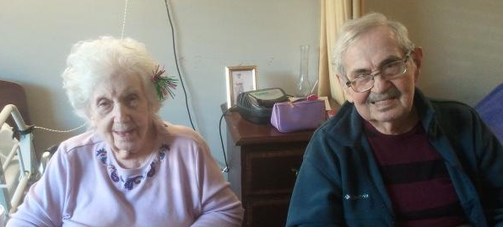

Credit: Michael Connell, Times Herald Dec 2014

