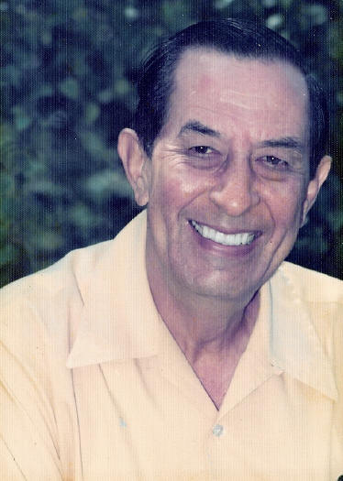
Ferdinand Maurits (Fred) Kentgens

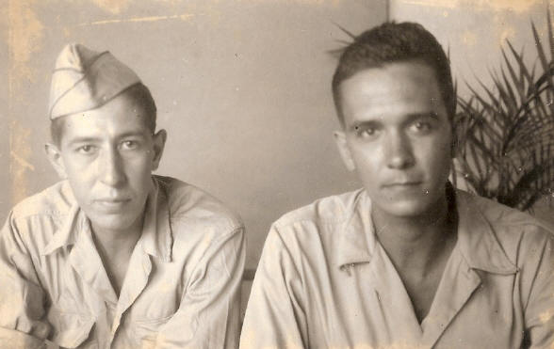
Deceased 19 July 2003

Fred Kentgens and (on left -above right photo) with his brother Richard Kentgens.
This photo was taken just after WW2. Richard labored at the Burma Railroad

