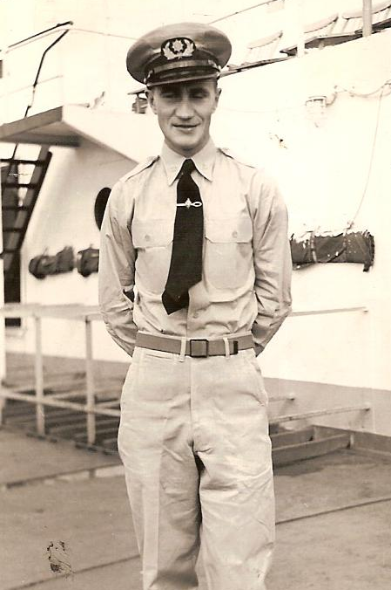
Torvald A Kibsgaard
Listed as a Norwegian Civilian by US reparation documents, Torvald Kibsgaard actually served on a US army transport ship. According to the website, warsailors.com, Torvald's son, Thore, and a US Army document, Torvald joined the US Army. Warsailors.com describes the account as follows...
Torvald A. Kibsgaard worked as able seamen on this ship, but became sick and was paid off in Manila on Sept. 9-1941 where he was admitted to a hospital. When the Japanese attacked Pearl Harbor Torvald and some other Norwegians were transferred to a motel in the city. After the attack on Manila they were unable to get out due to the fact that Norwegian ships were directed elsewhere, so in order to avoid internment, they all joined the US Navy. Torvald, age 23, was put in charge of the tug S/S Henry Keswick and transported supplies to Corregidor. On New Years Eve (after D. MacArthur had decided to withdraw) Kibsgaard was again sent to Corregidor, and from then on the two Norwegians transported supplies back and forth between Corregidor and Bataan. The USAT Henry Keswick was shelled and sunk at "North Dock", Corregidor, and in March the two shipmates were on the (previously Chinese) S/S You Sang. While loading bombs during the battles for Bataan, the You Sang was sunk at the Bataan harbour Mariveles.
Photo Above - 1948
After the fall of Bataan in April 1942, Kibsgaard took part in the ammunition transport to the gun positions on Corregidor using trucks. The day after the invasion, on May 5, he was given a gun and ordered to the trenches with the other soldiers, but when he started to display symptoms of severe shock he was picked up and taken to a hospital at Malinta Tunnel, where he was diagnosed with shock as well as malaria.
After Corregidor had fallen (May 6-1942), Torvald was ordered by the Japanese to clean up after the battles, remove the bodies etc. From then on he was a prisoner of the Japanese, first sent to Cabanatuan, then in 1943 to Batangas (both on Luzon) to forced labor building the airport there. When the Americans bombed the airport they were working on early in 1944 he was transferred to Camp Murphy where he stayed until Oct.-1944. His next stop was the Bilibid prison, Manila where he met several other Norwegians.
After MacArthur began retaking the Philippines, the Japanese wanted to avoid letting the prisoners fall into the hands of the Americans, so thousands were moved to Japan.
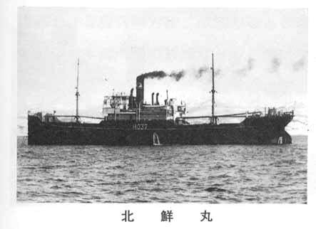
Kibsgaard and two other Norwegians (Johan Skulstad and Ragnvald Augustin) were placed on the cargo ship Hokusen Maru, initially bound for Japan. After 41 days of terror they landed in Formosa (now Taiwan).
Several ships in the convoy had been sunk by American submarines because the Japanese ignored the Geneva Convention and did not mark prisoner of war ships, and a lot of prisoners had died on the ship due to the horrendous conditions on board. After about 4 weeks on Formosa they were put on another Japanese transport and moved to Omuta, Japan, where they worked in the Fukuoka Camp 17 coal mines for about 6 months until the war was over and the prisoners were liberated.

A wonderful tribute site has been developed by the family.
It follows his prewar year, war years, and life after liberation. https://www.tkibsgaard.com/

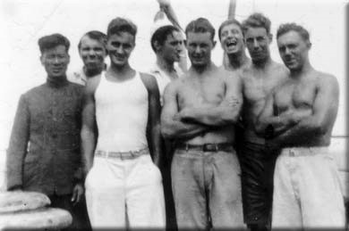
Left: Torvald is third from left, in white singlet, 1941.
2nd on right is Ingvald Øksenholt.

Photo right - 80 years of age.

For more information: http://www.warsailors.com/singleships/williamstrachan.html

https://www.tkibsgaard.com/a1939-42/

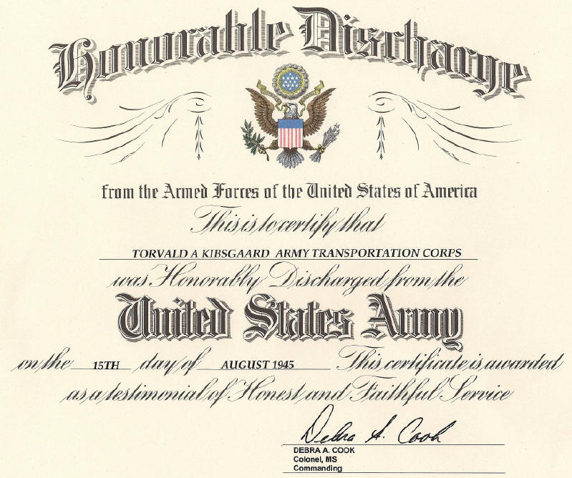
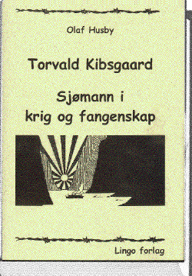
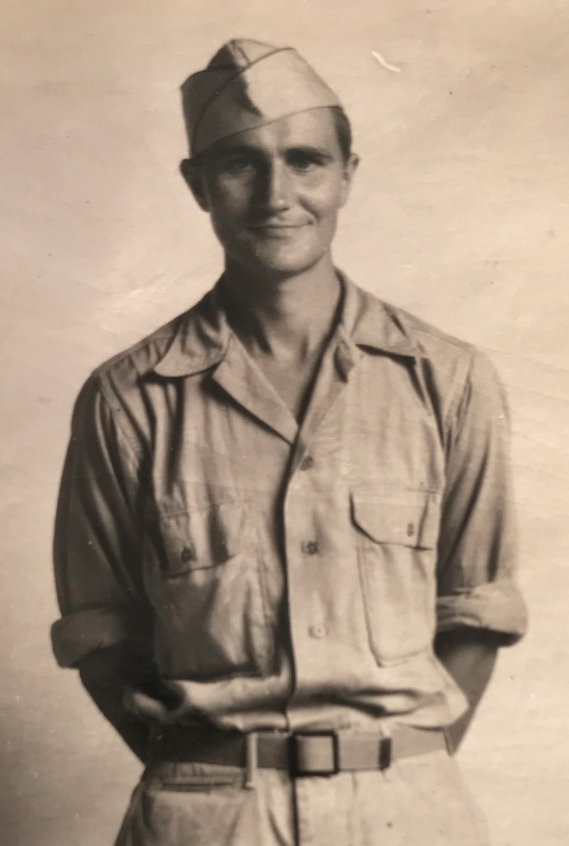

Torvald 1945

