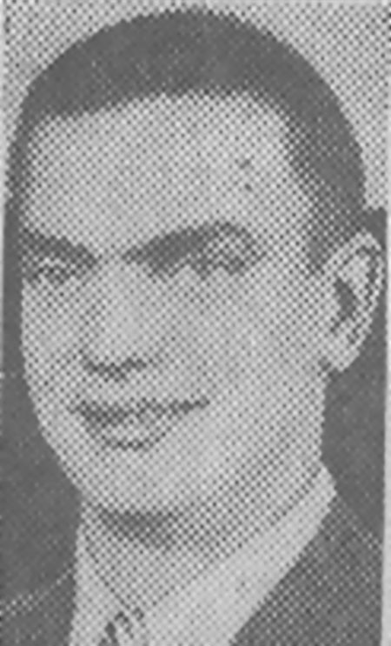
Herbert (Bud) Kirchhoff, Jr.
Pvt. Herbert C. Kirchhoff, Jr. was born in 1919 to Lucille & Herbert C. Kirchhoff, Sr in Peoria, Illinois. He was known as "Bud" to his family and friends. Herb lived at 717 North Second Avenue in Maywood, Illinois, and attended Proviso Township High School. Herbert joined the Illinois National Guard's Maywood Tank Company because a friend talked him into it. In November of 1940, Herbert was sent to Fort Knox, Kentucky, when the company was called into federal service. It was there that the company became Company B, 192nd Tank Battalion. While at Fort Knox, he trained as a tank driver. The company next went to Camp Polk, Louisiana, and was personally selected by General George S. Patton to go to the Philippines.
When the Japanese invaded the Philippines in December of 1941, Herbert was involved in a number of battles as a member of Sgt. Walter Cigoi's tank crew. Herbert would later command his own tank.
Herb's worst memory of battle involved a Japanese attempt to break the Filipino-American line of defense. The Japanese attacked after dark and the fighting went on all night. The line of defense held by the 192nd almost broke. When dawn came, the tankers had held onto their position. Despite being in the middle of several battles, Herb was never wounded. Herb, with his company, continued to fight the Japanese until Bataan was surrendered on April 9, 1942.
Herb took part on the death march. The Japanese divided the Prisoners of War into groups of 100. Each group had six guards who marched with them. Those prisoners who fell out were beaten by the guards. According to Herb, the worst part of the march was the lack of water and the heat. At the end of each day, the POWs were placed in a bullpen for the night. The next day the prisoners were led out of the pen four at a time. When 100 men had been counted, their march would start anew. Only those prisoners who marched were fed. Those who stayed in the bullpens were not fed or given anything to drink. Herb, on several occasions, found himself unable to march because of sore feet. He stayed in the bullpens and went without food or water.
As a POW, Herb spent ten days at Camp O'Donnell before being sent to Cabanatuan. He spent seven of these days sick with pneumonia. He remained at Cabanatuan until being sent to Japan in July of 1943.
Herb was boarded onto the Clyde Maru on July 23, 1943. On the trip to Japan, one of the Japanese officers known to the prisoners as "Big Speedo" allowed the POWs out of the hold. He also made sure that they were fed. In Herb's own words, "He was a good guy." The ship arrived at Moji on August 7, 1943.
In Japan, he first was imprisoned at Fukuoka 17 with other members of Company B, Jim Bashleben, Lester Tennenberg and Bob Martin. A short time later, Herb was sent to another camp and unloaded boxcars. He also built earthen embankments for what the Japanese believed to be the coming invasion of Japan.
During his imprisonment in Japan, Herb witnessed on several occasions prisoners beaten to death by a guard they called, "The Beast." This guard would beat prisoners to death with his bare fists. Herbert believed that this guard received "justice" from several prisoners after the war.
On several occasions, he experienced signs that the Americans were aware of the POWs . While unloading ships, a B-29 bomber flew over the docks taking pictures. The plane circled the POWs letting them know that its crew knew the POWs were there. The plane then dropped a map to the POWs that showed the location of every camp.
On a different occasion, an American bombing mission leveled the town his camp was located next to. The camp was next to a power station. In the morning, the prisoners saw that the entire town had been leveled except for the power plant. It was located too close to the camp.
The last camp Herb was held at was located 75 miles from Nagasaki. Although he did not see the atomic bomb because he was working in a mine, he heard about a "big boom." It was not long before the Japanese assembled the prisoners and announced to them that they were free. The Japanese told the former POWs that they could leave, but that they should leave behind the things they really did not need.
Herbert then spent the next month roaming Japan before returning to the United States. Returning to Maywood, he would marry and raise a family. Today, he resides in Coeur d 'Alene, Idaho.
Credit: Jim Opolony: 192nd & 194th Tank Battalion
Footnote: I have met Bud on two occasions and find him to be a man with a wonderful sense of humor. Tho quiet about his experiences, I am, blessed that he trusts me and opens up when I ask. June 2008 had a share a time together at the NW reunion of ADBC in Coeur d'Alene, Idaho. It was there that he related to me the following story...
"We worked 3 shifts in the coal mine at Fukuoka 17, all of which we rotated. One time “swing” shift came in (from work) and it woke me up. I decided everyone was busy with the shift change and so it would be a good time to steal food. I was going to steal it from the Jap kitchen. Well, if you went anywhere you had to take your “Ban” (POW) number and hang it outside your barracks on a tag. To say where you were, if you were gone. I came out from the kitchen with a shirt full of onions and was caught by a guard. I then realized, I had forgotten to hang my Ban number on a tag. They (the Japs) made me say (in Japanese) “I am a thief”. Then they took 3 bamboo poles, put one behind my knees as they were bent and 2 on the ground that I had to kneel on. I had to kneel all night long.
Ironically they let me go. I do not know why, most of the time you were tortured much longer or killed.
It was our Japanese interpreter who tortured me.
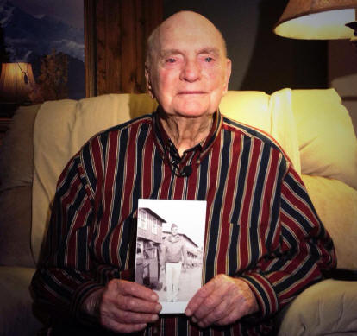
Article Featuring Bud - September 21, 2013
Credit: SPOKANE, Washington - KHQ News
In 1941, a young Bud Kirchhoff was deployed to Clark Air Base in the Philippines. Just 18 days later his life would change dramatically. Friday, at a ceremony remembering those who were taken as Prisoners of War and those who were never found, he told his story.
A Staff Sergeant in the 192nd Tank Battalion, Bud remembers December 7th vividly. Overshadowed by the bombing of Pearl Harbor, Clark Air Base was also bombed, destroying the airfield and all of the aircraft lining it.
Shortly after the attack, the Japanese took between 60,000 and 80,000 American soldiers as Prisoners of War. Among them was Bud Kirchhoff. For a year, and a half Bud lived as a POW, even surviving the infamous Bataan Death March. Eventually, he was moved to Japan, where he spent another two years under Japanese control working in a coal mine.
Liberated at the end of the war, Kirchhoff finally jumped aboard an Indian freighter and made it back to Seattle on Navy Day in 1945.
He became a commander with the ex-POW's here in Spokane, offering his support for others who went through the same thing he did.

History Corner - by Idaho Journalist, Syd Albright

On December 7, 1941 when Japan attacked Pearl Harbor, they also attacked the Philippines, Guam, Wake Island, Malaya, Hong Kong, Thailand and Midway Island. Army Private Herbert (Bud) Kirchoff Jr. of Coeur d’Alene was at Clark Field in the Philippines and witnessed Japanese aircraft bomb, strafe and destroy American aircraft caught on the ground.

Two weeks later, Japanese forces landed in Linguyen Bay and headed for Clark, 65 miles south. The unprepared American and Filipino troops were no match and were driven back onto the Bataan Peninsula, a 30-mile long mountainous finger of land sheltering Manila Bay from the South China Sea. At Bataan, some 80,000 soldiers, sailors, airmen and civilians battled for three months.

Kirchoff and his 192nd Tank Battalion unit ended up with their backs to the sea at Mariveles on the southernmost tip of the peninsula. As the Japanese were closing in, he and some companions were surprised to find a beautiful blue Buick in a tank maintenance area and filled it with supplies they planned to take to the troops.

On the way, they were suddenly stopped by an armed Japanese soldier and taken to a Japanese general—a West Point graduate—sitting under a tree. He confiscated the Buick, and then strangely released the men. The freedom was short-lived however, and they were soon picked up and made prisoners of war.

A month after Pearl Harbor, Manila fell but the battle continued on Bataan and Corregidor Island in Manila Bay just south of Bataan, with no naval or air support. Supplies, food and ammunition were quickly running out. General Douglas MacArthur believed his troops could hold out there until supplies arrived, but they never did and the Japanese forces closed in. Then tropical sickness and disease brought even more misery.

Under orders from President Roosevelt, MacArthur and his family along with other personnel left his headquarters on Corregidor on March 11, 1942. They speeded south to the big island of Mindanao on four decrepit PT boats, and then continued to Australia aboard three B-17 bombers.

Lieutenant General Jonathan M. Wainwright (“The Fighting General”) was left behind to deal with the Japanese. Valiantly, they continued to fight on Bataan and Corregidor but it was no use. With no help coming, U.S. Major General Edward King Jr. surrendered his troops on Bataan on April 9—the largest military surrender in American history. He told his men, “You men remember this. You did not surrender…. You had no alternative but to obey my order…. We were asked to lay down a bunt. We did just that. You have nothing to be ashamed of.”

Then the horrors of the Bataan Death March began. It would be 85 miles of torture to Camp O’Donnell and an unknown fate. Prisoners under armed guards with fixed bayonets were lined up in groups of one hundred—four abreast and 25 deep—and force-marched north in the scorching tropical heat.

“The men, already desperately weakened by hunger and disease, suffered unspeakably during the March,” the National Museum of the U.S. Air Force says. “…. POWs who could not continue or keep up with the pace were summarily executed. Even stopping to relieve oneself could bring death… Some of the guards made a sport of hurting or killing the POWs. The marchers were beaten with rifle butts, shot or bayoneted without reason.

“Some enemy soldiers savagely toyed with POWs by dragging them behind trucks with a rope around the neck…. The Death Marchers received almost no water or food, further weakening their fragile bodies. … “Filipinos alongside the road tried to give POWs food and water, but if a guard saw it, the POW and the Filipino helper could be beaten or killed.”

Arriving at the city of San Fernando, the prisoners were stuffed into boxcars and taken by rail to the town of Capas. From there they continued on foot, ending the Death March at Camp O’Donnell at a cost of thousands of lives—mostly Filipino.

Bud was fortunate. Though he developed pneumonia along the way and saw some dead bodies, he says he did not witness the atrocities, and had enough food and water to make it.

Linda (Dahl) Weeks, Fukuoka Camp 17 Project Manager, who has studied the Bataan Death March extensively, agrees that some soldiers could have missed witnessing the worst of the atrocities. However, she states that such an occurrence was very rare.

After the march, many more died at O’Donnell, so many in fact, that the Japanese closed the camp. “I’d wake up in the morning and the guy next to me on both sides and across from me were dead,” Kirchoff said. After he recovered from the pneumonia at O’Donnell, he was sent to another POW camp near Cabanatuan. “We grew vegetable gardens, but the guards took most of the veggies for themselves.”

Meanwhile, General Wainwright and about 10,000 men were holed up on Corregidor, but their plight was also hopeless and on May 6, they too surrendered. The general was held prisoner and mistreated for the rest of the war in POW camps in Luzon, Formosa (now Taiwan) and—like General King—was sent to prison in Manchuria (called Manchukuo by the Japanese).

At Cabanatuan, deaths occurred daily from malnutrition, disease and mistreatment. Bud was there until July 1943, when 500 prisoners were sent to Japan aboard a freighter, the “Hell Ship” Clyde Maru (also known as the Mate Mate Maru). The men were herded into cargo holds with little ventilation, no proper toilet facilities, and given little food or water during the 15-day voyage.

Kirchoff remembers the trip as a terrible experience but tolerable. One of the Japanese officers nicknamed Big Speedo by the prisoners spoke English and occasionally allowed prisoners on deck and made sure they were fed. “He was a good guy,” Bud said. “He fed us some cured ham sent to Japan by us in 1922—and it was still good!”

Conditions were much worse on many of the other Hell Ships, and they certainly lived up to their nickname. Several were torpedoed or bombed by Americans, not knowing that there were Allied POWs on board because the Japanese refused to acknowledge the Geneva Convention and designate the ships as holding POWS.

In Japan, Kirchoff was sent to Camp 17 at Omuta, some 40 miles south of Fukuoka on Kyushu Island. There he slaved in Mitsui-owned coalmines. The men were fed three skimpy meals a day—two of rice with soybean paste and vegetables, and one meal a bun. “The guards pretty much left us alone if we did our job,” he said. Yet, that does not mean there were no deaths or beatings at the camp. Those who “laid low” and kept their eyes downward usually avoided the brutal treatment that others received. He was also put to work loading boxcars, building earth embankments and other jobs. Several times he was hit with bamboo sticks for minor infractions, but he saw some prisoners beaten to death with karate blows.

When Japan surrendered on August 15, 1945 the POWs were told the war was over and they were free to go. Then the Japanese guards melted away into the countryside. Bud and some pals wandered around for a month awaiting rescue and were respectfully and kindly treated by the civilians.

Soon American planes were dropping food, clothing and other supplies by parachute. Then ground troops showed up and sent the liberated men to Nagasaki for a Navy ship home.

A freed Dutch sailor named Gerry Nothenius wrote:

“When we approached our destination we saw how horrendous war is. We entered the precinct of Nagasaki and I can remember a peculiar smell. A stink of burning and carrion…. We were traveling through a desolate wasteland, everything looked like pulverized dust and on the hills on either side of the valley were skeleton-like trees…. On the low wasteland were curious looking things like hardened lumps of cement…. skulls and bones and other remains which weren't obliterated completely.”

Bud Kirchoff left the Army as a staff sergeant and returned to Chicago and worked for his father’s electrical contracting business, followed by a 28-year career with a company that made abrasives. He married Audrey McRitchie of Canada and they raised four children, then in 1976 moved to Coeur d’Alene. Audrey passed away in 2003.

Of the estimated 80,000 Americans and Filipinos on the Bataan Death March, only a third survived the war.
Reflecting on those horrendous times, Bud Kirchoff said “I just took it one day at a time. You do what you have to do today to survive,” he said, “There’s nothin’ you can do about tomorrow.”

He was one of the lucky ones.
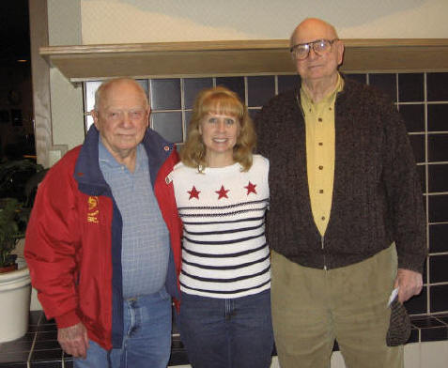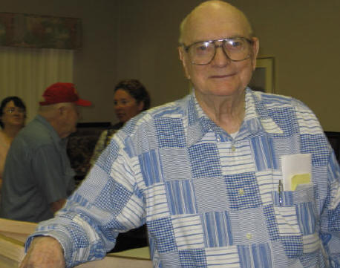
Roy Weaver (Camp 17 POW-left) and Herbert (Bud) Bud (Herbert) Kirchoff
with Linda. April 17, 2006 at ADBC - NW Chapter Reunion June 2008

