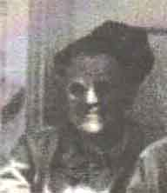
John Kolecsek
Born: 10 January 1915 Hometown - Cleveland, Ohio
Inducted: U. S. Army - 25 Match 1941 Cleveland
Training: Ft. Knox, Kentucky, Camp Polk, Louisiana
Overseas Duty: Philippine Islands
Engagements: Battle of Luzon, Battle of Bataan
Prisoner of War: 9 April 1942 - Death March
POW Camps: Philippine Islands: Camp O'Donnell, Cabanatuan;
Japan: Fukuoka Camp #17 - Slave Labor - coal mining
Hellship: Clyde Maru: Sailed from Manila 23 July 1943
Arrived Moji, Japan 9 August 1943
POW's taken by train to Omuta, Kyushu
Liberated: September 2, 1945
Died: 29 July 1987
Credit: Jim Opolony Bataan Commemorative Research Project

