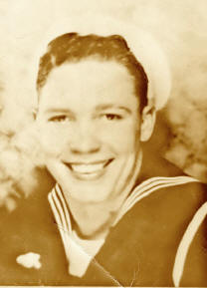
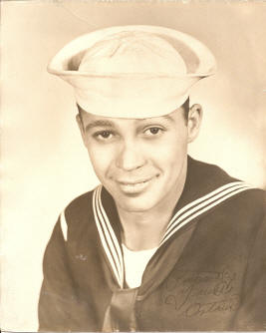
Arthur Franklin Krutsch
The following is a personal affidavit by Arthur Krutsch
PERPETUATION OF TESTIMONY OF
Arthur Franklin Krutsch
(Formerly Seaman 1/c, SN 311905)
Jackson, Michigan
My name is Arthur Franklin Krutsch. My home address is 316 Best Pearl Street, Jackson Michigan. I was formerly a seaman 2/c of Battery overhaul station at Olongapo, P.I., having enlisted in the Navy on December 6, 1939. I went overseas to Hawaii in February 19th. I was at Olongapo when the war started. After a brief period at Manila a Naval Battalion was formed at Mariveles which I joined. After a few months of combat, we volunteered as beach defenders of Corregidor. On May 7, 1942, Corregidor fell and I was captured along with two hundred other Navy men by the invading Japanese Army. I stayed on Corregidor until November, 1942, when I was transferred to Cabanatuan Philippine Island. I stayed at Cabanatuan until June 1943, when I was transferred to Prison Camp No. 17 at Fukuoka, Japan.
I escaped from Fukuoka in September 1945 and reached the American troops in Yokahoma.
Note: Sating he "escaped", we believe Arthur means he "ran away" at the news of the end of the war.
POWs were instructed to stay in camp until further orders, however many, such as Arthur, chose to "escape".
Once while in Corregidor, I was feeling ill and tried to get out of work. I was discovered by a Jap soldier while sleeping in a hidden spot. The Jap had a golf club and hit me a hard blow on the top of my skull. I escaped from the soldier's presence and bloodily reported to the Japanese Commanding Officer. I know nothing of the Jap soldier, as I had never seen him before and never saw him again after that.
At another time during my stay on Corregidor, I was beaten for about five minutes with a stout frayed end of a bamboo stick by a Jap Corporal who was in charge of my detail that was loading Ammol on a freighter. The beating was not severe and I cannot identify the Jap. This was in October, 1942. The cause of the beating was a misunderstanding on the part of the Jap.
In February, 1943, I was in prison camp No. 1 at Cabanatuan. One morning about 8 a.m. I went to the tool house in the prison camp to get a tool with which to work. I saw a bar of soap on the shelf. In a much as a bar of soap was a rare and valuable as good food, I took it. As I was leaving the tool shed, a Jap soldier nicknamed "Big Stoop" came in and halted me. He looked around and missed the soap. Then he asked me in Japanese where it was. I said, "I don't know." He searched me and found it in my pocket. He them picked up a small axe handle about 18" long and hit me across the right side of my face. I immediately blacked out. I was told by my comrades that I was then beaten continuously for about three hours by various Jap guards. I regained consciousness about noon, when I was stood up in front of the guard house. I was forced to hold the bar of soap in my left hand above my head. Every time my arm lowered a little, a Jap rushed out of the guard house and beat on my arm until I lifted it. When the rest of the prisoners came in at noon time from work detail, I was brought in front of them and beaten before them as an example. During this little exhibition, I was beaten by various and sundry Japs who volunteered to do so, among whom were "Mortimor" and "Air Raid." I finally dropped to the ground where I was kicked in addition to being beaten. It was Ihara or "Air Raid" who fractured my left arm with a club. Among the Americans who witnessed this beating was Robert Ferguson, a Sgt. in the Marines, Serial No. 265723, who is testifying in this matter.
After the rest of the prisoners went out to "chow," I was taken to Jap Headquarters in camp. The next day I went to the hospital where I spent a month recuperating.
In July, 1943, I was transferred from Cabanatuan to camp No. 17 in Fukuoka, Japan. The Commanding Officer of this camp was Lt. Kei Yuri. An incident that I remember well was the death of a Marine Corporal named Pavalokos. Pavalokos was orderly for some of the Jap guard and consequently ate in the Jap gallery. He also drew a ration in the P.O.W. gallery. This ration Pavalokos sold to other Americans for whatever he could get for it. A Lt. Little of the USN, regular establishments, was the Mess Officer for the prison galley. He caught Pavalokos selling his ration and turned him in to Lt. Yuri. Yuri put Pavalokos in the guard house without food or water. After forty-three days, Pavalokos died. I built the coffin and carried Pavalokos out to be buried.
At another time in the winter of 1943, a dog face by the name of Heard was caught supposedly trying to escape. He was bayoneted by a Jap detail a few hours later. Lt. Yuri was still in charge of the camp at this time. A Major Fuka Hara replaced Lt. Yuri as camp commander in the winter of 1944.
Under Major Fuka Hara, a soldier named Walter Johnson was caught returning from a work detail with a Japanese language book in his knapsack. It was claimed by the Japanese, or so we understood, that Johnson spoke Japanese too well and got news, etc, from the Koreans. Johnson was thrown in the guard house where he was starved and beaten. He died in the guard house twelve days later. I also put Johnson in a little pine box.
In the spring of 1945 William Knight, an American soldier, was caught by Lt. Little the Mess Officer stealing buns from the prison camp bakery. Lt. Little took Knight to the Jap Headquarters and recommended that Knight be tossed into the guard house without food and water. Knight died fourteen days later after a great many beatings. Lt. Little later admitted his responsibility for the disciplinary action taken on Knight. He stated that it was the only way he could get discipline around the place and that he would do it again to anyone else, if necessary.
An incident that I forgot to mention earlier, it happened in about February 1944 at Fukuoka. I was working in the Mitsui Mining Company coal mine. A Jap civilian supervisor nicknamed "Screaming Demon," did not think I was working hard enough so he gave me a blow with a saw handle. I resented it and flared back at him. He got a hammer handle and called more Nips for help. Then the "Screaming Demon" beat me for about fifteen or twenty minutes about the body with a hammer handle. That put me out of commission for a couple of days.
Note: Arthur's nickname was "Red Dog"
Arthur - Happier Days
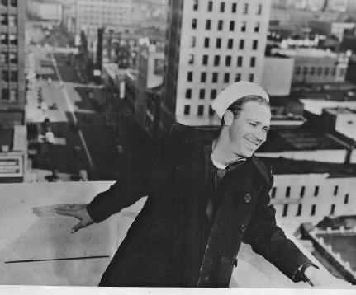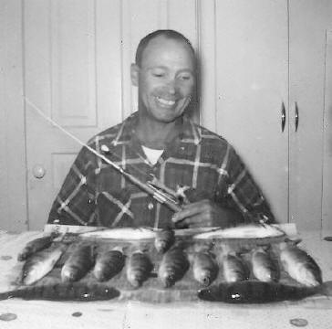
Submitted by Grandson, Jason Shepard

