Walter Finch Kwiecinski
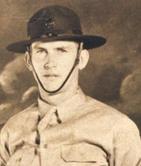  Staff Sergeant Walter Kwiecinski |  | 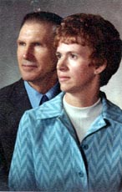  Walter and Mary Anne
Last Name: `  KWIECINSKI | First Name Middle Initial:  WALTER |  |  | Nick Name:  (FINCH)
Street: 729 12TH ST N | City & State: VIRGINIA, MN |  |  | E-Mail: steve_kwiecinski@yahoo.com
Conflict: WWII | Service Branch: ARMY |  |  | Unit: BATTERY ERIE, 60 TH COAST ARTILLERY
Theater: | Where Captured: CORREGIDOR |  |  | Date Captured: 05/06/42
Camps Held In: BILIBID CAB. MANILA CABANATUAN, CAMPS 17 & 12 IN JAPAN |  |  |  | How Long Interned: 1230 days
liberated / repatriated: liberated | Date Liberated: 09/17/45 |  |  | Age at Capture: 27
Medals Received: BRONZE STAR, PURPLE HEART, POW, GOOD CONDUCT, WORLD WAR 11 VICTORY, PHILLIPINE DEFENSE, ASIATIC PACIFIC CAMPAIGN, AMERICAN CAMPAIGN, AMERICAN DEFENSE SERVICE, PRESIDENTIAL UNIT EMBLEM
Military Job: MORTAR GUNNER |  |  | Company: SELF EMPLOYED
Occupation after War: AUTO BODY SHOP OWNER
Walter was born to Polish immigrants, Alexander and Dominica Kwiecinski, in Duluth Minnesota on August 9, 1914. He enlisted at Fort Snelling (Minneapolis) on February 6, 1941, and immediately was sent to Camp McDowell for training. On March 10 his company boarded the Republic, arriving at Manila on April 1.
From Manila, Walter went to Corregidor and was assigned to the 60th Coast Artillery, Battery E, under the command of Maj. "Wild Bill" Masselo. On December 1 Battery E went to Bataan to put up searchlights at Cabcaban, staying at Little Baguio. On the day Bataan fell, the majority of Battery E was returned to Corregidor, thereby missing the famous “Death March.”
Massello made Walter a gunnery sergeant on Battery Way. Early in the morning of May 6, Masselo was injured, but Walter's crew kept firing.
After 128 rounds and destroying at least 14 Japanese landing vessels on May 5 & 6, they were forced to stop firing at 11:00 AM because they were now in danger of hitting their own marines on tail of Corregidor. At the time they were ordered to stop firing, the gun coincidentally overheated and refused to fire. This gun, mortar #1, a 12-inch mortar, was the last big gun firing on Corregidor, and the last fixed gun ever fired by the US Army.
On May 23 the soldiers were transported by boat to Manila Bay, and on May 24 they were marched down Dewey Blvd. and imprisoned at Bilibad. Walter spent the next 5 months working at Port Area, Manila, loading Japanese cargo ships. He became paralyzed from the waist down and spent the next 5 months at the Bilibid hospital. From there he spent March of 1943 to June of 1944 in Cabanatuan.
On July 2 Walter boarded the unmarked prison ship Mati Mati Maru (Canadian Inventor.) The ship had constant boiler problems, and finally arrived in Moji on September 2. This was truly a “Hell Ship!”
In Japan Walter was interned at Camps 17, another camp near Fukuoko (name unknown) and then Camp 12, where he did coal mining as a slave laborer. On August 9, Walter’s 31st birthday, Walter heard a plane circle overhead for about an hour. He later learned that what he had heard was Bock’s Car, which had Kokura as it’s primary target for “Fat Man.” Due to smoke from the previous day’s bombing of next door Yawata, the bombardier called off the drop, and Nagasaki was destroyed instead, saving Walter and approximately 1600 other allied prisoners of war.
Harsh treatment ceased 5 days later, and although the prisoners were not informed for a few weeks, they suspected that the war was over. On September 17 Walter went through Nagasaki on his way to the hospital ship Walter, six foot six inches tall, spent several weeks in the hospital in Manila, in part to gain back the 70 pounds that he lost, since the half bowl of rice diet had gotten him down to 140 pounds. From there he went to Manila before returning to the United States.
Walter passed away in the arms of his loving wife on Mother's Day, May 8, 1988. He is survived by Mary Anne, 3 children, 8 grandchildren, and 5 great grandchildren.
Credit: CombatVets.net Home Page
Photos (below) Gallery credit: Steve Kwiecinski

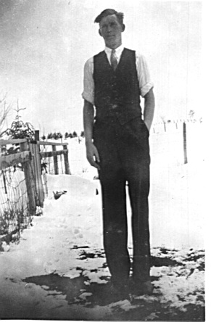
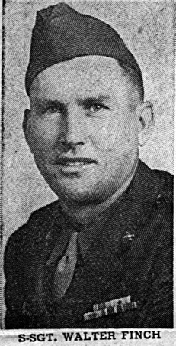
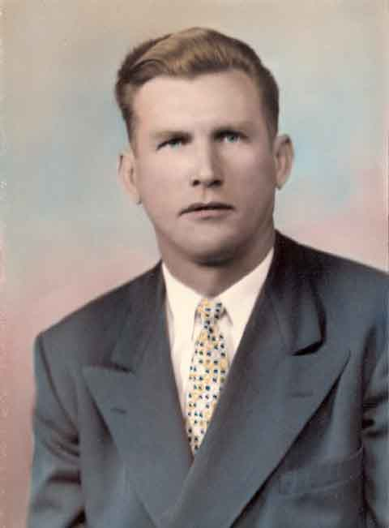
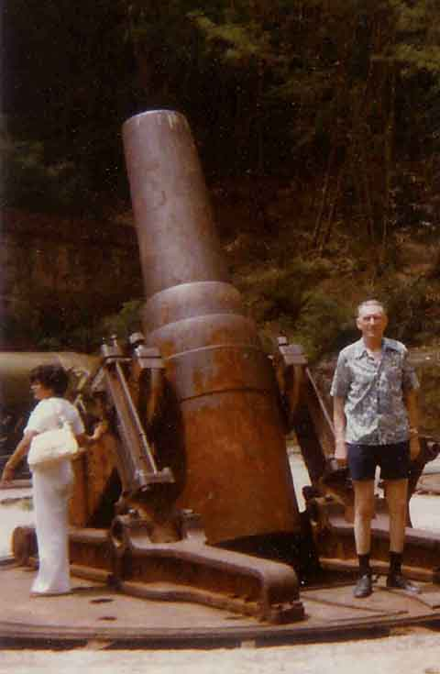

Photos left to right:
Walter as a young man on the farm; Walter as Staff Sgt; Walter as a young man; Walter visiting the Artillery in Corregidor, PI

