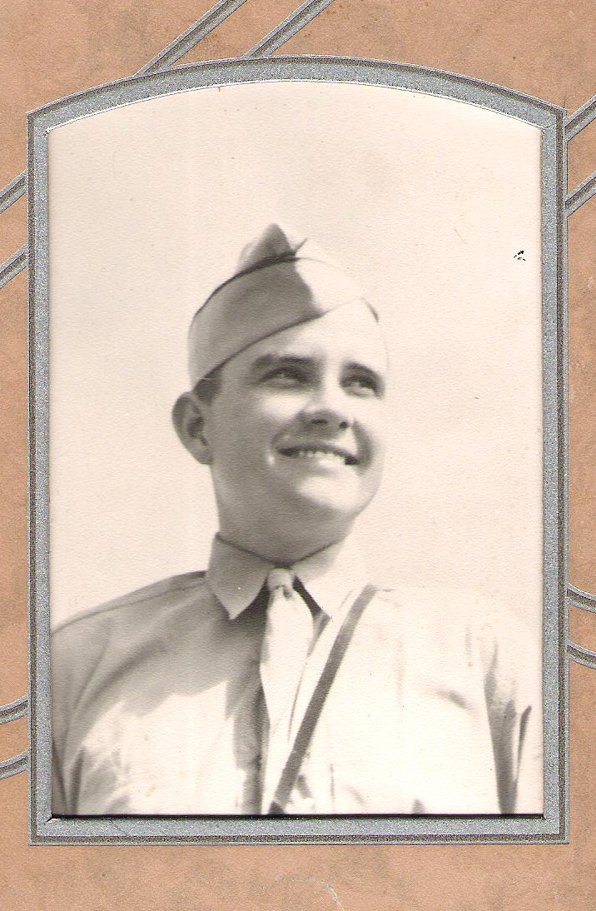
Jack Spratt Lewis
Bataan Death March/POW/Survivor

Staff Sergeant Jack Spratt Lewis (Nov. 5, 1920-July 26, 1984) was born in Walters, Oklahoma, to Clarence Raymond and Winnie Spratt Lewis. The Lewis’s moved to California before settling on a farm for most of the rest of their years in Deming, New Mexico. Jack’s sister, Betty Ruth Lewis Hornbeck, lives with her husband Bob in Silver City, and his sister Kathryn “Katy” Lewis Hofacket lives in Deming.

Jack joined the National Guard in 1939, attended NMSU for one year, and was in active military service in the Army from Jan. 6, 1941, to August 15, 1946. He was captured and imprisoned on April 9, 1942, by Japanese forces on Bataan Peninsula, Luzon Island, and the Philippine Islands. He was released from the Japanese POW (Fukuoka) Camp #17, Omuta Kyushu, Japan, on September 2, 1945, and was discharged from the military at Ft. Sam Houston, San Antonio, Texas, on Aug. 15, 1946.

On April 25, 1946, Jack married Marjorie “Marjie” Thompson Dodd, a native Demingite whom he knew when they were growing up. Marjie’s first husband, Lt. E. M. “Bud” Dodd, an Army Air Force pilot, died in China in a plane crash after flying the Hump; they had a daughter Kathryn. Jack adopted Kathryn “Katie” Dodd Lewis von Ende, and he and Marjie had three children: Patrick “Pat” G. Lewis (Jeanie), Elizabeth “Liz” Lewis Stuart (Doug), and Paul C. Lewis (Kathy); and four grandchildren: Coby Lewis, Curtis Lewis, Sarah Lewis, and Meghan Lewis. Everyone in Jack’s family is keenly aware and patently proud of his service to and sacrifice for his country.

Although he was reticent in talking about his wartime experiences, Jack did begin to open up as he talked with his war buddies twenty and thirty years after the end of WWII. His wife Marjie wrote down whatever he told her as he spoke, knowing the moments were rare when he felt like sharing a particular memory. Marjie also methodically preserved letters, articles, affidavits, service and medical records, and stories told to his children. All of these documents, especially Marjie’s notes, comprise the basis for this informal account of Jack’s WWII experiences and those of several others on the pages following.

(submitted by Kathryn Dodd Lewis von Ende)

Before the Bataan March

“Jack joined the NM National Guard in 1939. At that time, I was a Lt. in the unit here at Deming. I was his platoon commander until Jan. 6, 1941, when the 200th Coast Artillery (AA) was inducted into federal service [in the Army of the United States].” [Gerald Greeman]

From “Death March Began with Flipping of Coin” by Stephen Siegfried, June 8, 1999, the Silver City Daily Press:

It began with a coin flip in the desert.

The coin was only a nickel, but the stakes were high for the men from southwestern New Mexico who would become know as the Battling Bastards of Bataan.
In June 1941, two National Guard artillery regiments had completed training at Fort Bliss. The 200th Coast Artillery was a New Mexico unit; the 206th was made up of men from Arkansas.

There were cheers from the men of the 200th after the coin hit the sand. As luck would have it, the New Mexicans would be going to the warm islands of the South Pacific.

There was grumbling among the men of the 206th. They were headed to the freezing cold of Dutch Harbor, Alaska.

Jack’s occupation in the 200th CA was described in his military records:
Served as a meteorologist in the United States and Philippines. Used such instruments as theodolite, and other equipment to make weather observations to determine direction and velocity of wind in various zones of altitude in order to make corrections in firing anti-aircraft weapons. Made reports every two hours of findings which were relayed to gun batteries. Just prior to fall of Bataan fought as a rifleman.

Jack left San Francisco in August, 1941, on the USS Coolidge, travelling for 28 days to Manila in the Philippines. The Coolidge was a luxury liner acquired by the US for a troop carrier; civilians were on board, along with an orchestra. Non-coms (noncommissioned officers) ate in the largest dining room with the orchestra playing for the meals. Jack found an unused cabin below deck, which he and 3 others shared; other cabins were occupied by officers, so this was quite a lucky find. After leaving Pearl Harbor the ship was under blackout orders, so the four roommates hung blankets over the portholes and played poker all night.

In 1981 Mike Cook interviewed Deming residents Jack Lewis, Lee Pelayo, Ike Garrett, Fred Almeraz, and Phil Coleman for the Deming Headlight. The article is paraphrased below with quotes mostly from Jack Lewis.

. . . the largest group [sent to the Philippines], about 1,500 men, came from New Mexico—the 200th Coast Artillery, an anti-aircraft unit. It was commanded by then-Col. C. G. Sage of Deming with about 80 Deming men. In Sept., 1941, they joined others to total 20,000 American troops, who were in the Philippines apparently to delay the 300,000 Japanese troops and hold the Japanese as long as possible. This, the Americans did for almost five months before their insufficient supplies and outdated weapons gave out and they were forced to surrender.

The 200th Coast Artillery of the National Guard, including Jack Lewis, was stationed at Clark Field with light duties, which they usually finished by 10 a.m. Because “we didn’t have enough ammunition to do any more practicing, we were just sitting it out.”

On Dec. 8, 1941 (the same day as the bombing of Pearl Harbor but on the west side of the International Dateline), “I had a 30-power tripod-mounted telescope set up not very far from the mess hall,” Lewis remembers. “We watched the bomb bays open and the first bombs start to fall out.” The Japanese offensive had begun.

The American anti-aircraft guns were outdated, and almost the entire American fleet was wiped out. “The Japs would come over at 28 or 29 thousand,” Lewis remembers, “and we couldn’t even touch ‘em.” Lewis also remembers cleaning the ammunition for those anti-aircraft guns with wire brushes to get the rust and corrosion off. The ammunition had been packed in 1918, and the American rifles were also outdated; but the Japanese were well-equipped. Retreat and surrender were inevitable for the American troops by April 1942.

The Japanese were rumored to be landing at the northern end of Luzon. In fact, one shipload of Japanese troops had landed at Aparri as a diversion the first day of the war, Dec. 8, 1941. Jack and several others were sent to scout Lingayan Gulf by Col. Memory H. Cain, who could hardly believe their report of sighting 100-200 Japanese ships, spread out as far as they could see.

Jack received a Navy Commendation Medal for sinking a Japanese submarine with anti-aircraft weapons meant for the protection of bridges. The sub had to surface for the Japanese crew to work on it. The U.S. gunners fired at it, but the sub was too close. Jack’s job as a spotter was to tell the gunners how much charge to put on the shell to shoot down an airplane, but the sub was too close for setting the charge. So they shot the shells through the sub until it finally sank. [as told to Jack’s son Pat Lewis]

Clark Field was bombed just after lunch on Dec. 8th as Jack watched from his mountain outpost. The 300,000 Japanese troops pushed the 20,000 American and 150,000 untrained Filipino troops down into the Bataan Peninsula, where the out-numbered allies continued to defend the Philippines against tremendous odds through the winter and into spring.

The Filipino military and civilians fought alongside the U.S. military, trying to prevent the Japanese from capturing the Philippine Islands. Members of one indigenous Filipino group wore military uniforms and just relaxed around the U.S. compound during the day; but these “soldiers” earned their pay from the U.S. military at night. Clad in “g-strings” and carrying machetes and bamboo pieces carved even sharper than the machetes, the special forces terrorized the Japanese troops by dark. Stealthily sneaking up behind the enemy, the Filipinos cut off the Japanese soldiers’ heads with the bamboo sticks then severed their ears, which were strung around the waist; each pair of ears garnered payment. Next, the Japanese soldier was propped against a tree with his legs spread apart, his head between his legs, and his bayonet in his rear. Discovery of these gruesome remains surely had an intimidating effect on the Japanese. [as told to Pat Lewis]

Jack’s outfit was to have Christmas dinner (1941) on the northern end of Bataan and had dinner set out on tables in the open when a Japanese bomb landed in a sluice, scattering black slime all over the food. [Ike Garrett described this sluice as a water buffalo wallow.] By New Year’s Day, Jack was farther south with three other scouts, just across the bay from Manila. When Col. Cain heard they had only sandwiches to eat, he sent enough turkey dinner to feed 16. (Once Gen. MacArthur left, the camps were never re-supplied; the American soldiers, on 1/8th rations, eventually ate the horses and mules, their pack animals, according to Ike Garrett.)

The 200th Coast Artillery was divided. One-half of the men went to Manila as the 515th Regiment to help evacuate troops and civilians. Lee Pelayo, good friend of Jack, was sent to Manila and ultimately to the POW camp at Nichols Field. According to Jack, as bad as it was in his experience at Camp #17 in Fukuoka, Japan, by far the worst POW camp was at Nichols Field where only 5% of the prisoners survived. After building railroad tracks, the Nichols Field POW’s had to dig out mountains and haul rock by rail cars, pushing the cars themselves, surviving on the poorest rations of all the camps. There were no excuses accepted for being sick or hurt; POW’s worked, regardless—or lay down to die. Lee’s back was so badly injured, he was carried out on a stretcher when he was finally rescued.

About fifty men from the 200th Coast Artillery were given 2nd Lt. Commissions to join the Philippine Cavalry. All were killed. Bill Porter joined the Philippine Scouts, and his whole group was lost. About 100 men from the 200th transferred to the 31st Infantry, and all were killed. Two convoys were ambushed by the Japanese, and the last bomb hit in a tree at the B battery mess, killing many who sat there and injuring many nearby. Jack was sitting near a soldier whose arm was blown off. Over 100 were killed out in the open on gun batteries. Jack had wanted to be on a 37mm battery but was needed on outpost duty—fortunately for him.

No notice was given to the troops that the U.S. had surrendered; the soldiers truly believed their superiors when they said that reinforcements, food, and supplies were on their way. [See MacArthur’s letter to that effect at the end of this biography.] Jack was on mountain outpost duty when his telephone went out; he thought the lines had been cut. Jack teamed up with a “searchlight” group and tried to get from his outpost to his company. The area was overrun by Japanese troops, so Jack tried to go south to Mariveles. He and his buddies lived off the land, catching chickens and whatever else they could find. The Japanese were setting up to shell Corregidor, so Jack’s group veered north for two weeks before being captured. The Japanese demanded their dog tags, wallets, and watches, but one captive refused. The Japanese soldier pulled out a sword and whacked the American’s head off. Jack said he couldn’t get his dog tags out fast enough. [as told to Pat Lewis]

The American soldiers on the Philippine Islands came to realize that the European theatre, not the Pacific, would first receive the full support of American troops and supplies. The following chant written by journalist Frank Hewlett became the sad lament of the men who felt deserted by their country:

“We’re the battling bastards of Bataan;
No mama, no papa, no Uncle Sam;
No aunts, no uncles, no cousins, no nieces,
No pills, no planes, no artillery pieces.
And nobody gives a damn.
Nobody gives a damn.”

The Bataan Death March and POW Life in the Philippines

Mike Scott’s article in 1981 in the Deming Headlight described the following experiences, again with quotes from Jack:

The Bataan (Peninsula) Death March ensued. Captured on the west coast near Birac, “We walked across the upper end of the peninsula,” [Jack] said. “Actually, we trotted, about 30 miles.” Jack was urinating pure blood by the time he arrived at the first stop, Balanga. Then he walked 70 miles to San Fernando. "That 70 miles is really not too much of a march,” Lewis said, “except we’d walk 15 or 20 miles in one day without any water.” Then they’d stop 3 or 4 days without food. “I went 27 days without anything to eat.”

“The roads in the Philippines are built up high with a deep bar ditch because it rains so much,” Lewis said. “But for 70 or 80 miles that ditch was full of discarded clothing, equipment, and bodies. About 70 or 80 thousand Filipinos and 15 or 20 thousand Americans marched down the road, and the bodies were almost touching for 70 or 80 miles.”

Life was brutal in the Japanese POW camps in the Philippines, and escape was almost impossible. And as Lewis said, even if you did escape, “Where would you go? How would you hide?” POW’s were assigned to groups of ten, and if one tried to escape then all were shot. Lewis was in the hospital when one of his group escaped and the other 8 were shot. Lewis survived to be shipped to Japan on one of the ships which actually made the trip. Because none of the ships was marked as having POW’s, American subs and bombers sank some of the ships, killing many Americans.

Jack was captured on April 9, 1942, by the Japanese Cavalry. In what became known as the Bataan Death March, the Japanese took a certain number of prisoners (1,000-1,500) at a time and left others to wait their turn for the march. Jack joined the last contingent at Balanga [Batangas in M’s notes] for his part of the Death March. The American POW’s started the day with a canteen of water, but it was gone by about 9 a.m. and no more was provided. (No water was given to the Filipino prisoners.) Marchers had nothing to eat but one riceball a day and had little to drink in the 120-degree heat for four weeks. They walked on pavement along which there was water available, but they were not allowed to leave the pavement. Prisoners marched one day then rested three or four days. Jack marched a total of four days. Bodies lined the road along the entire way.

On the first day, Jack got a stalk of sugar cane that he chewed for several days. At the third stop he got a mess kit about half full of rice; on his last stop he got on a water detail. He had a little money; so he gave a Filipino all his money for a small watermelon, which was overripe and made him sick. This probably contributed to Jack’s being “out of it” the last day; he was told a buddy carried him the last couple of hours of marching.

For the last thirty or forty miles of the trip to the POW camp, Jack rode in the cattle car of a train so packed with men that they couldn’t fall down. He kept “coming to” during the trip then passing out again. The train proceeded to Statsenberg then to Cabanatuan. He doesn’t know how he actually got to Camp O’Donnell, but he does remember when he became aware of lying on a foot bridge with a 50-kilo (110-lb.) sack of rice he’d been carrying. He had no idea how he had been able to carry it.

While assigned to the prison camp at Cabanatuan (where he had a bad case of beri-beri until a doctor there gave him yeast tablets), Jack volunteered for a labor detail building an airstrip at Lipa south of Manila. Lipa had been a Filipino prison camp and was one of the better (“least terrible”) camps. The Filipinos had already dug a ditch waist deep and about half a mile long with railroad tracks alongside. The trains brought loads of rocks that were shoveled into the ditch. Then the prisoners used sledgehammers to make gravel of the top layer. Jack spent 6-8 months helping to construct a landing strip in a swampy area near Lake Taal. He dug ditches and built railroad tracks for hauling in huge rocks. Once when he was loosening a stake to release rocks from the railroad car, the stake and some boards gave way suddenly, releasing the rocks prematurely. Jack’s left knee was injured, subsequently resulting in a “mouse” joint. He was sent for treatment to a hospital at Bilibid Prison, said to be one of the best of the prison camps. Bilibid was also a location for the execution of prisoners, and Jack slept in a room with an electric chair. He couldn’t walk at all for the first of two months there.

At Lipa Jack never saw the Japanese beat any of the men except Wermuth, the commander of the camp and a highly-decorated soldier, who told the Japanese, “If you want to beat on somebody, beat on me.” Wermuth was fearless with the Japanese. At the first meal the prisoners were served, he dumped his food over the head of the Japanese commander and said his men wouldn’t work with that kind of rations. The Japanese beat him nearly to death, but the food improved. The Japanese challenged Wermuth to judo. He wasn’t familiar with it, but he would wrestle them and could beat any of them.

One story about Jack as a POW in the Philippines was related in Dorothy Cave’s book Beyond Courage (p. 160):

The Japanese, it seemed to [Walter] Donaldson [of Deming] enjoyed brutality. “A whole cavalry unit chased Jack Lewis and Wad Hall—ran ‘em down with their horses—just for fun.”

Another piece of the PI POW story was unearthed by Jack’s great-niece Leandra Hofacket Stewart in 2016: Sgt. Jack Lewis (identity #4879) was assigned as a tractor driver on Dec. 12, 1942, in Ward 2 of the Las Pinas detail, according to a yellowed and fragile document from that era. She also learned of the unfortunate nickname “Jackass” that followed him as a result of his middle initial (Jack S.); this was a sore subject that he didn’t really want to acknowledge after the war.

Upon returning to Cabanatuan, Jack helped make “sulfa” pills out of plaster of paris, using 30.06 shells for cutters. The prisoners sold the pills to their captors as venereal disease cures. The Japanese soldiers who bought them were discovered by their superiors and “busted” to private, receiving no pay until their disease was cured. Jack heard one day that the Japanese had picked up one of his partners in that little business venture. When he discovered there was a detail lined up to ship out, Jack traded places with a guy who was in the line and headed for Japan.

POW’s in Japan

The Japanese ship Clyde Maru from Manila to Japan was a Dutch freighter so old that one end of the deck was rusted out. The ship was hauling artillery shells in one hold, ore in the other end, and the prisoners in the center hold. The “latrine” was a board extended over the water. The ship left Manila on July 23, 1943, carrying 500 prisoners, the first to enter Camp 17; all of whom survived the voyage. During the 44-day trip [15 days according to official records] the prisoners spied a fortress on the coast of China. Jack and others were tempted to jump ship and swim for the coast but stayed aboard and docked in Moji, Japan, on August 9, 1943.

In Japan the POW’s fortunately didn’t reach the intended destination. Because it entered a roundhouse, the train was sent back to Fukuoka Prison Camp #17 at Omatu, 40 miles south of Fukuoka City on Kyushu Island. Thus, the Americans avoided being in Nagasaki when the atomic bomb was dropped; but they were nearby. “At Fukuoka #17 there was a low area about the size of a football field. The POW’s would be marched into that low spot when there might be a bombing raid. That’s where most of the POW’s who were not in the mine were located when the atomic bomb was dropped on Nagasaki, across a small bay from Fukuoka.” (as told to Jack’s sister Katy Hofacket)

Before the POW’s worked in the Mitsui company coal mines, they attended school for two weeks to learn the names of tools and to train for the task. From the POW camp, prisoners walked 1½ miles to the mine where they had roll call and changed clothes. They received part of their tools, a hat with a light, and a rechargeable battery that fit on a belt around the waist. They rode a train for 30 minutes down into the mine. After another roll call they were given the rest of the tools and proceeded to the work site to deposit the tools. Then they returned to the rail site and for a couple of hours hauled logs to be used while on the job. Finally they relieved the previous shift at the work site and actually began the “8-hour” work schedule.

At Camp #17 the prisoners got broth and a little rice—rarely any meat, which was domestic dogs for camp meat. They felt really lucky to get a piece of meat since there weren’t many dogs. A whale washed up on the beach, and they butchered it. They gorged themselves on blubber, and their digestive systems couldn’t handle it. It was winter, the ground was frozen, and the latrine was just a ditch outside. The guys developed bad cases of diarrhea, and some didn’t make it to the latrine. It was a “slippery slide” out to the latrine. [as told to Pat Lewis] Besides many bouts with diarrhea, Jack contracted bacillary dysentery, beriberi, dengue fever, malaria, pellagra, and pneumonia at various times during the war.

The POW’s were issued one toothbrush, one bar of soap, and one razor per barracks for each two-week period. They got to take a cold shower on their day off, the first and fifteenth of the month. With coal dust all over them, no hot water, and little soap—they weren’t very clean even when it wasn’t cold weather. [as told to Pat Lewis]

On one of the two days off, the Japanese made the POW’s march five miles to and from a cherry orchard to see blossoms falling from the trees—a total of about 8 hours of marching. On returning, the interpreter asked those who thought it was a beautiful sight to raise their hands. None did, although they knew it was beautiful. So, they had to stand in position for six hours—until they said it was a beautiful sight. They hadn’t had anything to eat in all that time but were finally fed the two meals of the day after admitting to the beauty of the cherry blossoms.

While Jack was working in the mine, a cave-in knocked him down, covering him with rocks and debris and injuring his feet and legs. Benny Daugherty of Alamogordo rescued Jack. When the Japanese guards were going to leave Jack yelling for help in the mine, Daugherty shoved them aside and pulled Jack out. Jack had a cut on his neck that bled profusely. Two companions took turns holding a hand against Jack’s neck as a compress during the walk back to camp because to stop pressing meant Jack’s certain death. One friend’s hand was painfully “frozen” into position for awhile because he pushed so long and hard on the wound. [as told to Pat Lewis]

In 1976 Dr. Thomas Hewlett wrote the following from his records as a physician at Fukuoka POW Camp #17:

Hand-written medical records from P.O.W. Camp #17 Fukuoka, Japan are still in my possession. Jack S. Lewis was among the American Prisoners confined in this camp.

The working ration allotted by the Japanese was 400 grams of rice per day, the ration for hospitalized patients was 300 grams of rice per day--thus malnutrition was endemic in this camp.

Existing records reveal that Jack S. Lewis was hospitalized within the camp on 24th June 1944 because of extensive injuries to both legs resulting from his having been entrapped in a mine cave-in. Camp labor was utilized in a coal mine operated by the Mitsui Corporation.

The surgical log of Camp #17 reveals that Jack S. Lewis underwent surgery on the following dates:
    - Secondary closure left foot & right leg (after initial treatment by Japanese)
    - Debridement right leg—skin grafting
  - Ambulated on crutches
Discharged in in-camp duty on crutches

Robert L. Aldrich described the following incidents in his affidavit for Jack:

I was imprisoned with Jack S. Lewis in Fukuoka Military Prison of War Camp No. 17 for a period of 26 months, ending in September, 1945. About 16 months before we were recovered by Allied Personnel, I saw Jack brutally beaten and battered by a Japanese known only to us as Clark Gable [a pencil mustache]. The situation was that Jack had some large timbers (kolobus) that he had stashed near his working area, and Clark Gable, the Jap, kept pilfering timbers from the pile. Jack accosted the Jap and told him to leave timbers in that pile alone. The Jap picked up a “narugi” (a timber about the size of a fence post) and beat Jack mercilessly about the head and body. Jack was confined to quarters for several days recovering from the beating.

A couple of weeks after the beating Jack was the victim of a mine cave-in. Among the injuries he suffered were:
- The back of his head was opened;
- His jugular vein was cut;
- His jaw was broken
- His right shoulder was broken;
- His right leg was broken; and
- His left foot was crushed.

I recall these incidents fairly well because Jack and I had buddied around in Bataan, Cabanatuan Prison Camp No. 1, and Camp 17, Bruns General Hospital in Santa Fe, NM, and at VA Hospital in Albuquerque.

Jack wouldn’t have lived through the mine accident had it not been for Capt. Thomas Hewlett, USA, M.D., of Westminister, CA. As Jack was recuperating—perhaps I should say “getting better” from the broken bones, he had an ulcerating sore on his leg. Dr. Hewlett did a pinch graft, taking pinches of skin in the form of Jack’s initials—“JSL”—from the left side of Jack’s belly. During the operation, Dr. Hewlett, who was not without a sense of humor, said, “Jack, I don’t have quite enough skin. What is your serial number?” [Only the initials were needed, and Jack later told the story as he showed them to family and friends.]

He [Jack] also had much more severe headaches than most of us
from breathing the gases from the dynamite explosions that were
used several times each work shift.

Affidavit by Jack Lewis:

During the months of June, July, and August, 1945, I was an ambulatory patient in the hospital at Fukuoka #17, recovering from a mine cave-in in June, 1944. At this time I had recovered sufficiently to assist as an attendant in the hospital for short periods of time each day. My duties were to help serve meals, empty urinals and other light duties. Either the last of July or the first part of August 1945, while helping serve meals to the patients, I was surprised to see Robert L. Aldrich had been admitted to the hospital that day. Since I had been a good friend of Bob’s for about 4 years, I was quite concerned about his well-being, for it was no place to be sick since there was absolutely no medication of any kind. I distinctly remember his high temperature and his swollen joints in his arms and legs. A couple of days later Dr. Proff, one of the two doctors in the hospital, told me that Bob had rheumatic fever and he doubted if Aldrich would survive without proper treatment. Fortunately, the war was over two or three weeks later and Bob was brought back to the U.S. where he was properly cared for.

Dr. Thomas Hewlett, M.D., U.S. physician at Camp #17 and Jack’s doctor, wrote in 1982,

I am troubled that the V.A. can recognize a broad range of psychologic and social problems in our current society, and not be cognizant of the fact that some of the patterns they encounter in former POW’s are long term results in individuals, who had no help available when the emotional or psychic traumas occurred during long confinement.

Further information about Fukuoka was contained in Mike Cook’s 1981 article in the Deming Headlight with quotes by Jack:

Besides the fact that the camps had no medicine at all, “The worst thing,” Lewis said, “was the amount of work we had to do and little food we got. I worked 12-hour shifts (for all but two days a month) for a year and a half and weighed 110. And I wasn’t any thinner than anyone else.”

The war was over August 15, Lewis said, “That was one of our days off. The next day they told us it was the Emperor’s birthday, so we didn’t have to go to work.” The POW’s didn’t know the war was over “until an interpreter announced it and the Japanese guards lined up and marched out of the gate.” It was no one’s birthday.

Both Lee Pelayo and Lewis defended President Truman’s use of the atomic bomb to end the war.

“The Americans would have had to invade Japan without it,” Pelayo said, “and the Japanese would have killed every prisoner they had.”

“Not only did it save the prisoners of war,” Lewis said, “I think there would have been another 2 or 3 million American casualties if they had not used the two atomic bombs.”

Near the end of the war, American planes bombed the coal supplies in Japan with napalm. The Japanese forced the prisoners to go out and stand by the coal piles. Of course, the American bombers didn’t know who was standing there. Some POW’s pushed the Japanese into the napalm in retaliation. [as told to Pat Lewis]

A Naval plane, not a B-29, dropped a metal cylinder attached to a parachute, which landed in a mud flat beyond the seawall near Fukuoka Camp #17. An American literally swam in mud to reach it. He took it to the camp commander, Major John Mamerow, who read the notes written on the front cover and inside of a Life magazine [announcing the defeat of the Japanese].

Jack’s sister Katy Lewis Hofacket remembered the following:

There was another prison camp located near Fukuoka #17, but it was a slave labor camp for Koreans. Korea was an ally of
Japan; however, the Japanese treated Koreans no better than the POW’s.

The POW’s were aware that the tides of the war were turning because the Japanese sometimes reported on their glorious, victorious battles. Those victories were gradually happening further north, closer to Japan. Shortly before the end of the war, a couple of times the POW’s saw a few very large planes and thought they surely must be American.

When the Japanese guards left the camp, the POW’s were just left on their own. Apparently the location of the camp was not known to the U.S. forces, so there was no rescue. There was a storage building at the camp. It was locked, and when the (now) ex-POW’s broke into it they found items that had apparently been sent for them (by the Red Cross?). Among the items were heavy wool blankets made in Canada. Being summer, the ex-prisoners had no use for the blankets, but they knew the Japanese prized wool as much as others prized silk.

Jack and some of his buddies took some blankets and traded them for an ox and cart. They went into town and loaded the cart with food and beer then returned to the camp. Later, they decided to go back for another load. When they went to get the ox, they discovered the cooks had already butchered it and were cooking it.

On one trip walking into town, the buddies found one of the guards who had been particularly cruel. Jack decided to fight him, hitting him a number of times but dislocating the little fingers on both Jack’s hands. At the time this was happening, he didn’t even have enough strength to walk the whole way to town and was mostly carried by “the big Canadian kid,” Ward Redshaw, who was also a Camp 17 POW.

Finally, when no one came to rescue them, the ex-POW’s commandeered a train and went looking for U.S. troops. Later, when war crimes trials were being conducted in Japan, one particular Japanese guard could not be found. Jack indicated that he knew what happened and where it happened, and he was sure that the guard would not ever be found.

Home from the War

The ex-POW journey from Japan to San Francisco lasted 35 days. The trip could have been shorter, but the government wanted the soldiers to have as much time as possible to recuperate with proper medical attention, plentiful nutritious food, and rest and relaxation. When they reunited with their families, the ex-POW’s were a little less emaciated but nevertheless haunted by their torturous treatment and the inexplicable cruelties they had witnessed and endured.

Jack’s sister Betty Ruth Lewis Hornbeck recalled the following:

When Jack landed in San Francisco he was met by Uncle George Lewis, 34, the slim 6’ 4” youngest brother of Jack’s father. (George had lived with Jack’s family for a few months after high school graduation when he worked in California for a few months.) George was in the Navy during WWII and lived with his wife Ruth in California before returning to civilian life selling furniture in Lawton, Oklahoma. Jack immediately recognized his uncle and said, “It must have been pretty bad when they [US Navy] took an old man like you.” George then visited Jack in the hospital, and Jack once sneaked out of the hospital in his pajamas and went to George and Ruth’s home.

George was always so nice. It was a great comfort to Mom and Dad for him to be there. He also came to Jack’s funeral in 1984 along with Aunt Tincey’s oldest son Bill, who drove.

Mom, Dad, Kathryn, and I went to Santa Fe to pick Jack up. We had never been to Santa Fe. When Dad asked someone for instructions to the Railway Depot, the guy tried to tell him how to go. Finally he said, “You can’t get there from here; you have to go someplace else to start.” We finally found it, though. Jack looked good. On the way home, Kathryn and I sang all the songs we knew. They were all new to Jack, of course.

Jack lived a full life after the war, in spite of extensive surgeries on his legs, constant pain, excruciating cluster headaches, heart disease, and other health problems related to the Death March, his imprisonment, and other wartime experiences. His relatively young heart failed at age 63 in Arizona at a favorite fishing spot, fishing pole in hand, in the company of Marjie and close friends.

For his service to his country, Jack was awarded the Bronze Star (posthumously by one month), the Purple Heart, a Distinguished Unit Badge with two Oak Leaf Clusters, the American Defense Service Medal with one Bronze Star, an Asiatic-Pacific Campaign Ribbon with two Bronze Stars, a Philippine Defense Ribbon, a Philippine Liberation Medal, a Prisoner of War Medal, several other commendations, and the eternal gratitude of his family, friends, and nation.

[See MacArthur letter below.]

Remembered by Pat Sept. 14, 2016:

One time on a trip back from fishing in Chama (ca. 1957), Daddy stopped on the highway and we walked over to the [Rio Grande] Gorge, climbed down into it and fished the Rio. The water was swift with huge rocks coming up out of the water, very rough current--not a place to fall in. Daddy was standing on a flat rock casting out into the pools formed behind the rocks. He hooked something that was way too big for our light tackle. It took off downstream and ran off all of his line. We never saw it. I had forgotten about it, but the picture (of the Gorge) reminded me. I miss those fishing trips. Those were about the only times he ever really talked to me. Just guessing at the age, but it was definitely while we lived in Abq, 8-12 for me. I know that at least one of the Chama trips was in the 1956 Rambler. Daddy, Bill (Capshaw) and I were sleeping in the back. It had a roll-down rear window. We were awakened by a couple of thugs trying rob us. Bill pulled a pistol on them, cussed them out, and they took off. Mother never knew that story.

January 15, 1942
Headquarters
U.S. Arm Force in the Far East
Message from General MacArthur

To All Unit Commanders:

The following message from General MacArthur will be read and assigned to all troops:

Every company commander is charged with the personal responsibility for the delivery of this message. Each headquarter will follow up to insure reception by every company of similar units.

“Help is on the way from the U.S. Thousands of troops and hundreds of planes are being dispatched. The exact time of arrival of reinforcements is unknown, as they will have to fight their way through the Japs against them. It is imperative that our troops hold until the reinforcements arrive, no further retreat is possible. We have more troops in Bataan than the Japs have thrown against us, our supplies are ample; a determined defense will defeat the enemy’s attack.

It is a question now of courage and of determination. Men who run will merely be destroyed but men who fight will save themselves and their country.

I will call upon every soldier in Bataan to fight in his assigned position, resisting every attack. This is the only road to salvation. If we fight we will win; if we retreat we will be destroyed.”

“MacArthur”

By command of General MacArthur
(signed) Carl H. Seals
Colonel, A.O.D.
Adjutant General

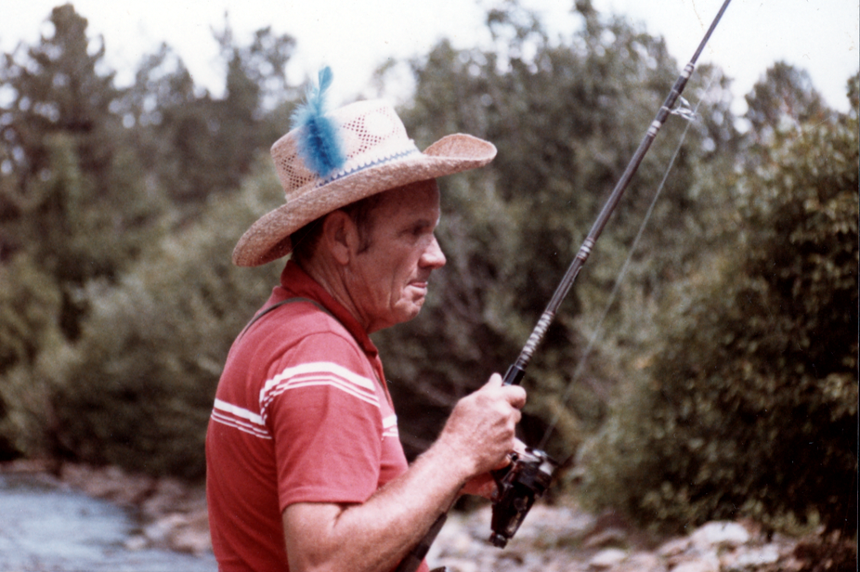

Note: Jack died 26 July 1984 from a heart attack on a fishing trip in Arizona.

