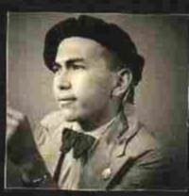
Ortwin P. A. Louwerens
Name: Ortwin Pieter Aurelius Louwerens
Born: August 8- 1921 Prambanan (Java). Dutch East Indies (Indonesia)
Nationality: Dutch (by birth)
Born and raised in Indonesia like my parents and grandparents from fathers side since about 1865; from mother’s side since 1750. Finished High School and College; was 1st-grade student on the Technical University in Bandung (Java) from July 1940-June 1941.

Solicited for and went over to the Royal Military Academy (RMM) in June 1941 like some other colleague-students, because of the German occupation of Holland and the war in Asia was looking around the corner. The cadets were Dutch and Indonesian, the Dutch mainly from ancestors borne and grown up in the Dutch East Indies (also called Indo-Europeans because of Indonesian blood in the ancestral family line). Several of our Indonesian cadets played a very important role in Indonesia getting its sovereignty and independence in the years 1945 to the late 1970-ies, like Field Marshal Harris Nasution, the generals Simatupang, Askari, Alex Kawilarang. Up till now we always have respected each other and kept contact after the independence of Indonesia.

Before going to the RMM I visited my parents in Semarang (Mid-Java) and I would see them again, then after 7 years as a married man with a half-year old son.
In December 1942 came that war and ended for us with the capitulation of Java. At that time at the 31st of December 1941, we (the first-years cadets) were regrouped at Garut, (south Bangdung). On 29th february 1942, we came to Lembang (a small mountain village between Bandung and the Tjiater defense lines) in Hotel Lembang about 8 KM south of the Tjiater defense-lines and in which hotel the South East Asian command under General Wavell and his staff had his headquarters and like a Speedy Gonzales, had lifted their heels and not only left his combined Army alone, but also all their personal and intimate belongings. They expected to live a very comfortable life on Java!

It was a miserable war; too little troops available and hardly any material left for the defense of the island Java. When the Japs invaded Java, the Jap took a very important and tactical military airfield Kalidjati north of Bandung, which should be defended by an English company, within a day after the landing on the north coast of West-Java. Our last 3 GlenMartin bombers were shot down in the night (it was full moon) of the landing of the Japs and our 2 last Brewster fighter planes also were shot down the next day.
The following days we were swarmed over by Japanese warplanes of all kinds!! Our senior-cadets (the second-years) were already detailed all over the available Dutch troops on Java and we, the last-year cadets (corporals) of about 95 men, were added to the commander in chief of the Tjiater defense lines north of Bandung. Colonel van de Veer who was killed, along with his second in Command Major Teerling, the day before the capitulation. Also one of our senior-cadets, Han de Vries who was detailed in one of the groups in the Tjiater defense-lines. 2 others were wounded there.
As POW in the Dutch East Indies.
So we became POW’s and our group of cadets gathered back in Bandung for further orders. From one of my sisters in Bandung I learned that my brother (married with a one-year old son) serving in the navy on the destroyer Piet Hein, was missing. The Piet Hein was sunk in the sea-street of Bali trying to intercept, on it’s own, a Japanese invasion convoy. My brother’s name was not on the list of the 15 survivors, so we assumed he was killed. Later, after Japan’s capitulation it appeared that he was taken out of the water by a Jap destroyer and brought to Makassar (Celebes, now Sulawesi) and from there also by one of the hell-ships to Japan, to a camp at a Nagasaki shipyard. There my brother died in 1944 because of pneumonia combined with malaria. His urn with his ashes lies in the Columbarium in Jakarta (Indonesia) with some 754 other urns of Dutch military died in Japan.
We were kept POW in a separated part of Bandung around the army barracks. Trying to escape from prison camp was rather easy in those days, but the penalty was always the same - death penalty by bullet or bayonet. In 2 cases we, all the other POW-s, were obliged to witness this; the first time 3 men by bayonet and the second time also 3 men by bullet.
After being kept POW in the towns Bandung, Tjimahi and Batavia (now Jakarta) a Dutch contingent of 3500 POW-s was shipped off to Singapore Island (with the Makassar Maru a small freighter with 3,500 men on board!!) a voyage that lasted almost 3 days. It is not hard to imagine how we lived on board during these days. Here the contingent of 3,500 men was split up in several parts, and one part of about 1200 men (in which I belonged with another 29 colleagues) was quartered in bamboo barracks. The other part of our colleagues were separated and transported by train to Birma and Thailand. In the meantime our Indonesian colleagues were set free in April 1942 by the Japanese as almost all of the Indonesian soldiers in our army.
During the time we had to wait for a ship’s convoy from Singapore to Japan we had to work on the tracking and leveling of a new airfield and what has now become Singapore Airport.
To Japan-one of the Hell-ships.
From here I was moved in a Jap convoy to Japan with the Hawaii Maru. (One of the Hellships that were up to now nameless in the list and must have been Maru-7). On board were these 1,200 Dutch POW-s; some 650 in the front hole (myself included) and the other 550 in the back hole of the ship. The Hawaii Maru (photo below) was armed with a gun on the stern. I think it was a 25-pounder and of course no indications of being a POW-transport. As a schoolboy I always dreamed of Hawaii as a paradise on earth, but this was a great disillusion!
The food on board also was a disaster, porridge of rice. Cooked rice and a kind of vegetable-soup, day in, day out.
Luckily the ship had in its inner-hole a load of copra and dried fruit, which we recognized as ¨kesemeck¨, and both products were eatable and gave some flavour to the damned meals.
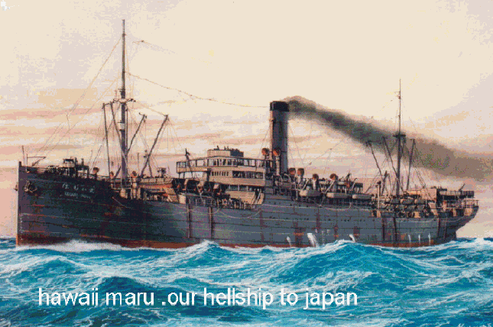
The voyage of the convoy was a zigzagging slow motion very close to the Vietnam coast and at Hainan we crossed over to Formosa (now Taiwan) and where we came in a typhoon with waves overlapping the front part of the ship (while we were locked up in the hole). When we reached Formosa, the convoy took shelter in a Bay (of Taipeh?).
Hereafter the convoy went in the North direction to Japan, but on the second day we were attacked by 3 American (?) light bombers and we were immediately ushered into the hole and locked up again. After the planes were gone we were allowed on deck and we saw that 2 freighters were hit, one of the 2 had almost sunk and the other close to us was leaning over and sinking.
The Hawaii Maru came alongside this ship to take the survivors (all Japanese) on board and the POW-s from the back hole was cramped into our front hole. In the meantime a Jap destroyer was circling around these 2 ships while the convoy continued his course. After having taken aboard the crew and passengers we continued our voyage in Northern direction under protection of the Jap destroyer and reached the Yellow Sea and went to Sjanghai harbor where the destroyer left us and the other ship’s survivors disembarked. From Sjanghai it went on, all alone, across the Korean Sea and along the South Korean coastline and then across the Japanese Sea straight to Moji where we arrived late in the afternoon on the 6th of December 1943 and where I saw and felt the first snow in my life in tropical
cotton army clothes!
POW-camps in Japan
Several hours later, I with another 9 of my colleagues in a group of about 50 POW-s were on a train on our way to a small camp of some 100 English POW-s. The work here was in general unloading building material from the train (cement, wooden poles, etc.) but the worst for us was the cold. Here I suffered a light frostbite in the fingers of both hands. (It hurt quite a lot).
After a month of 2 we (the Dutch group) were transferred to a camp in the neighborhood of Fukuoka and I think this was Camp Fukuoka 1-location 2. Just like we did on Singapore-island, our work was tracking and leveling for a new airfield, which now has become Fukuoka-airport.
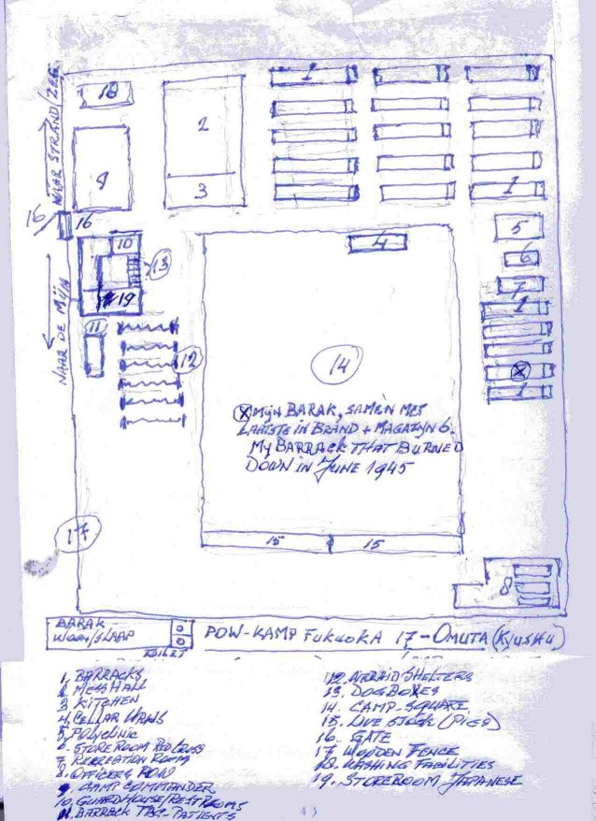
Camp Fukuoka 17 in Omuta
In May/June 1944 our group was transferred to Omuta Camp Fukuoka 17 where we had to work in the coalmines.
I made the situation sketch (left) of the camp as far as I can remember the situation and the layout. The sketch will give you an idea of the camp, but of course the proportions are not correct. The capacity of a barrack was 50 men and there must have been about 20.
The greater part of the POW-s were American, but I think most of them were Latino-Americans because of their looks and many of them spoke Spanish with each other, a language we did not understand. We also got the impression that these Latinos were more resistant or less vulnerable against the stressful life as a POW in this miserable camp and in the mines than the ¨white-colored Yankee¨.
Introduction in the mine was quite simple, off to the mining compound where we were detailed in groups of 15 to 20, get your material to work with (pics, shovels, stone hammer and pneumatic drills), go into a big hall to say some prayers to the god(s) of the mine and under guidance of a civilian foreman in the cable-train to descend into the mines. You leave jacket and trousers in some kind of storeroom for you had to work just only in a G-string - that is a cord with a flap of cotton and also leggings to protect your shins. Here you also got your battery and lamp and the hanchou (foreman) explained with hands and legs what you had to do and also how fast you had to work to finish the job. If we were working hard and making more than a certain amount of full coal-lorries we were likely to be rewarded with 1 or 2 buns. This last offer of course went in one ear and out the other; we had not the slightest intention at all to do our work in this way without or with extra buns!
The work was hard and in the first weeks one had the miserable feeling that the alley you were working in, could at any time cave in! And it sometimes did! One of our colleagues, Wouter Worms, died in such an accident and also another one, Edu Schol, who died of pneumonia. In those days, in camp, pneumonia was lethal. Another 2 colleague of us, Wim Möller and Dolf Aartsma, had more luck with a mine-accident; both survived, but W.Möller could not work for quite a long time. Now I am only talking about our group of 10 cadets. Work in the mines also had its ¨advantage¨; it always had the same temperature and no cold in winter.
And then in 1945 there was a kind of a turning point in our future. It must have been in May 1945 when some of us were detailed in a cleansing job in the office and dwelling-compartment of the camp commander. We could not read Japanese but we saw in a Japanese newspaper thrown away in the paper basket. On the front page was a map of Kiusjiu and the RiuKiu islands south of Kiusjiu. We then knew there was something going on over there and not in favor of the Japanese. We already had an air raid and the air-alarms were increasing and afterwards the B29-bombers became dive-bombers that could only been flown in with aircraft-carries. We then knew Japan was completely surrounded and besieged! An invasion would be eminent.
But everything went on as usual and also the air raids. One also noticed that the food-providing became less and irregular, and worst of all this also happened with the cigarettes. Nowadays the cigarette is condemned as a lethal drug, but in those days a cigarette had such a soothing effect, that many and several of my colleagues who were non-smokers started to smoke, although in the Mess-hall cigarettes were highly valued in the exchange-rate with food-rations.
A crazy plan for survival ??
One of our shift mates, a Dutch soldier Krens was punished by the Japs by confinement in the dogbox during a week. That meant that after returning from work in the mine he had to go straight into the dogbox, but also had to pass through the guardroom of the Japanese guard. He told us that his dogbox was next to the Japanese store-room and some of the boards were easy to loosen to get access into the store-room. But also the boards on the side of the camp-square were easy to loosen by hand. It was therefore quite simple to come into the inner square of the guard’s dwellings. Krens for his part became daily access to some rice-sacks during that week, and every day (a week long) he came out of the dogbox to join us to the mine with his canteen full of raw rice. He also told us that the unused dogboxes were always open and on one side of a small inner square. Opposite were the guard's restrooms and the right hand side gave access to the guard’s front sitting room with the rifle rack directly next to the inner square. The other side of the small square was the boards of the storeroom. Although the storeroom was situated on the other side of the camp-square opposite our barracks and out of bounds, it also was out of sight of the Japanese guards.
So it would be rather easy to get into the inner-square and to overwhelm by surprise and kill the guards on the spot, because we would be the first to get to the guns. Question was only: were the rifles in the rack loaded and where was the ammo??And what should be the timing of this assault, all dependable of our work in the mines?? We had to observe this in the meantime. The guards on duty always had their bayonet in their belt. We knew that when the USA should invade Japan we did not have to reckon on any mercy from the Japanese; we knew this from what happened on the Tjiater in March 1942 when a group of 67 (other sources speak of 72) soldiers surrendered. They were bound together with their puttees and mowed down with a machine-gun and those who still showed some sign of life were bayoneted; 2 of them survived this massacre and also their POW-time (one of them in Nagasaki).
We could expect an invasion in Kiusju because of the situation with the air raids and the presence of large beaches (like Omatu). We had seen this beach before, on a 15 minutes walking distance when we had to collect sea anemones for our soup in the kitchen. It then would be a question of kill or be killed. You also had to reckon with the exact moment (ten minutes from our camp was a Japanese army barracks loaded with well-armed Japanese military). Furthermore, were we available at this moment, inside or outside the mine, and would be Kiusju invaded in the first wave??? If so, the chances were not bad during the turmoil of an invasion. We of course did not know that there already was a standing order from Japanese Headquarters that to begin on the 26th of August all POW-s should be liquidated by bullet, gas or whatever means available . And Operation Olympics (invasion in Japan) would start at the end of September or first days of October 1945. Anyway this assault-plan was a possibility to keep in mind and look forward to, until that bombardment in June when our barrack was hit and burnt down, and we had to sleep and live in the mess hall. We – concerning a very small group of only six - therefore lost our tactical position opposite the storeroom across the camp-square. We also could not pass this on to others living in other barracks, because one leak would have cost us our lives.
The Atom-bomb
One day the 9th of August, we were lining up on the square to go to the mines for our shift starting at noon when we saw in the far distance a small ball-like cloud, rose colored, but of course we did not know anything of an atom bomb, and neither of the Hiroshima bomb or the mushroom cloud of an A-bomb. But what we saw in the far distance must have been the top of the mushroom-cloud. The next days we understood from the Japanese in the mines that Nagasaki was hit by a very big bomb! But everything went on as usual and also the air raids with smaller dive-bombers.
Then one day on the 15th of August 1945 as we were already prepared to march off to the mines, we suddenly were dismissed because we became a ¨Jasmë¨ (Rest for a day). We only could wonder why!! And so was the next day and the day thereafter, on the 17th, we were all summoned on the big camp-square. We were a little apprehensive, but there were no soldiers surrounding the square, but only the camp commander with his interpreter. He announced that the war was over and we could go anywhere and whenever we liked; the Japanese guards would stay on their posts to protect us and the camp!! Well, we really were too embarrassed to understand what this meant.
The next day we were out and searching for farms in the neighborhood to look for and find eggs, chickens and rabbits. We could not find anything of the kind and there we learned from a Japanese farmer that since Japan started the war in China (Mandsjuray) they already were rationed on rice and soybean sauce, and since then an ever increasing rationing.
Luckily the B-29 bombers came over dropping loads of delicious food, cigarettes, chocolate, canned fruit, and so on. One of the droppings got loose from its cords and caused a fatal drop on one of the (American) barracks. Of course we had stomach-trouble during the first week but this was worth the inconvenience. We also noticed that the B-29´s made their droppings on the other side of Omuta, and this appeared to be a Chinese POW-Camp
(must have been Camp Fukuoka 25).
After a week or 2 there came a military delegation of the USA-forces to arrange our evacuation. All of them soldiers in different ranks and at least 6 feet, 4inches tall!! It must have made an everlasting impression on the Japanese! Of course they lost their war against these giants!
One day before the evacuation some of us decided to visit our former camp Fukuoka 1-location 2 in the neighborhood of Fukuoka. We took the train to Fukuoka that was so overcrowded that we went into the postal wagon sitting on the postal sacks. In Fukuoka we had to cross through the town that was lately air raided on the 10th of August with fragmentation-firebombs and was still smoldering. And the smell of a delicious barbeque came to us, hungry people! Where came the smell? Animals and/or human bodies? I think both of them.
Evacuation in Sept. 1945
On the 3rd (or 5th) of September we were evacuated by train to Nagasaki to embark on ships. Every POW had plenty of room in the wagons (2 seats for every POW) so that we all had a pleasant, sightseeing journey through Japan. Suddenly after several hours we saw gas oil-tanks lifted from their platforms and when we looked from the window we saw a flattened Nagasaki with only the chimneys sticking out of it. That was the big bomb that eliminated Nagasaki. In Nagasaki-station (only the platform was left) we paused for about half an hour. Here we learned that it was an A-bomb and the causalities went into the count of 80,000; but oddly enough none of us had any pity on the Japanese!
Then we went on to Nagasaki harbor where we had to throw away all our clothing and belongings (was not much), were disinfected and pass through an alley of showers and soap. After being dried up we were weighed and mine was at that time 98 lbs. It had been when the war started, some 180 lbs. Now we were ready to be dressed in US khaki uniforms, given soap, toothcream, toothbrush and razors in a Red Cross hand sack, and walked over to the medical staff and registration. The doctor asked each of us “How do you feel?”
When the answer was “All Right”, you were directed to the battle cruiser USS Mobile, and otherwise (like “feeling not so good”) it was the hospital ship next to the USS Mobile. That same afternoon we (USS Mobile) took sea and also had our first meal on board, absolutely delicious! We of course tasted for more, and we approached carefully the chief-cook and asked him in the most friendly way if there was something left for some hungry POW-S. He laughed and said “I’ll be open until you all have eaten enough.”
Of course he became a friend of us and the next day he told us that these 650 POW-s ate twice as much as the whole crew of 1,200 men on his ship. Only one thing bothered us a little, namely that none of the officers on board made a visit to the Dutch exPOW-s, just for curiosity or being interested!

Manila-the Philippines
On the 3rd day we were at Okinawa and from there flown by Dakota-planes to Manila where we were concentrated in a Dutch Camp some 10 miles outside Manila, but taken care of by the US army. Food was excellent. The Red Cross rations marvelous and so on! We stayed there some 5 weeks in which time I had gained 52 lbs!!! During this time we got almost daily news about the situation in the Dutch Indies, especially the eastern part of Java (Soerabaja) where the English troops were not capable to restore any order.
Back to the Dutch East Indies
A Dutch Lieutenant-colonel Drost got permission to go to the Dutch Indies and organized some 2000 of the fittest men, detailed in 2 battalions, unarmed and being transported by the English aircraft-carrier HMS Implaccable, the Dutch Indies being under super command of the English Commander Lord MountBatten. But we did not come further than Balikpapan where we had to disembark with no further means of transportation by air or by sea. And our goal was Soerabaja (East-Java) where most of the trouble was. Anyway we now were back home again, where we know this people and understand or speak their language. Also we had the opportunity to re-arm our troops with lighter armory and ammo, sufficient enough to start with. The hills behind Balikpapan were full of left-behind military equipment.
But still we had no permission to go to Java, only the allowance to go for the 2 islands of Borneo (Kalimanten) and Celebes (Sulawesi). After a week in Balikpapan there appeared a small Dutch minesweeper Willem v.d. Zaan that could transport some 80 men to West-Borneo. Well I belonged to these 80 men and 3 days later we were in Pontianak as a re-enforcement of the 180 military men already stationed there and consisting of Dutch and Indonesian. Most of the Indonesian also had been in prison camp in Borneo.
The southern province of West-Borneo was Ketapang and also needed reinforcement, so 30 men (I was one of them) went by riverboat to Ketapang following the coastline. The trip lasted a day and a half before we could join the 70 men who already were there. The province Ketapang has about the size of Holland, and our transportation facilities were a jeep that ran on gasoline distilled from rubber and made in a small factory and an old riverboat running with an old Otto-diesel engine. But we had no diesel oil so we used coconut oil. Why all this trouble; because the other province South West Borneo had been invaded by insurgents operating at the border regions along the coast and already had slaughtered a small military post in that region. Indeed, we had not much military personal available but we knew what we had to do to restore order. Give the inhabitants-population the feeling that they always could rely on the army and give them a feeling of safety. A few days later we were on patrol for a week’s mission to check and control the only road of about 60 miles inside the province and leading to the region where the insurgents were active; this must have been in the first week of November 1945, about 2 months after we left Fukuoka 17.
You had to patrol during a week or so without any supply or transport or communication. But all of us were in a very good condition and I think the US army kitchen food had played a great part in it! I do not have pictures of this episode because there was no film material; no cameras at hand in those areas during that time.
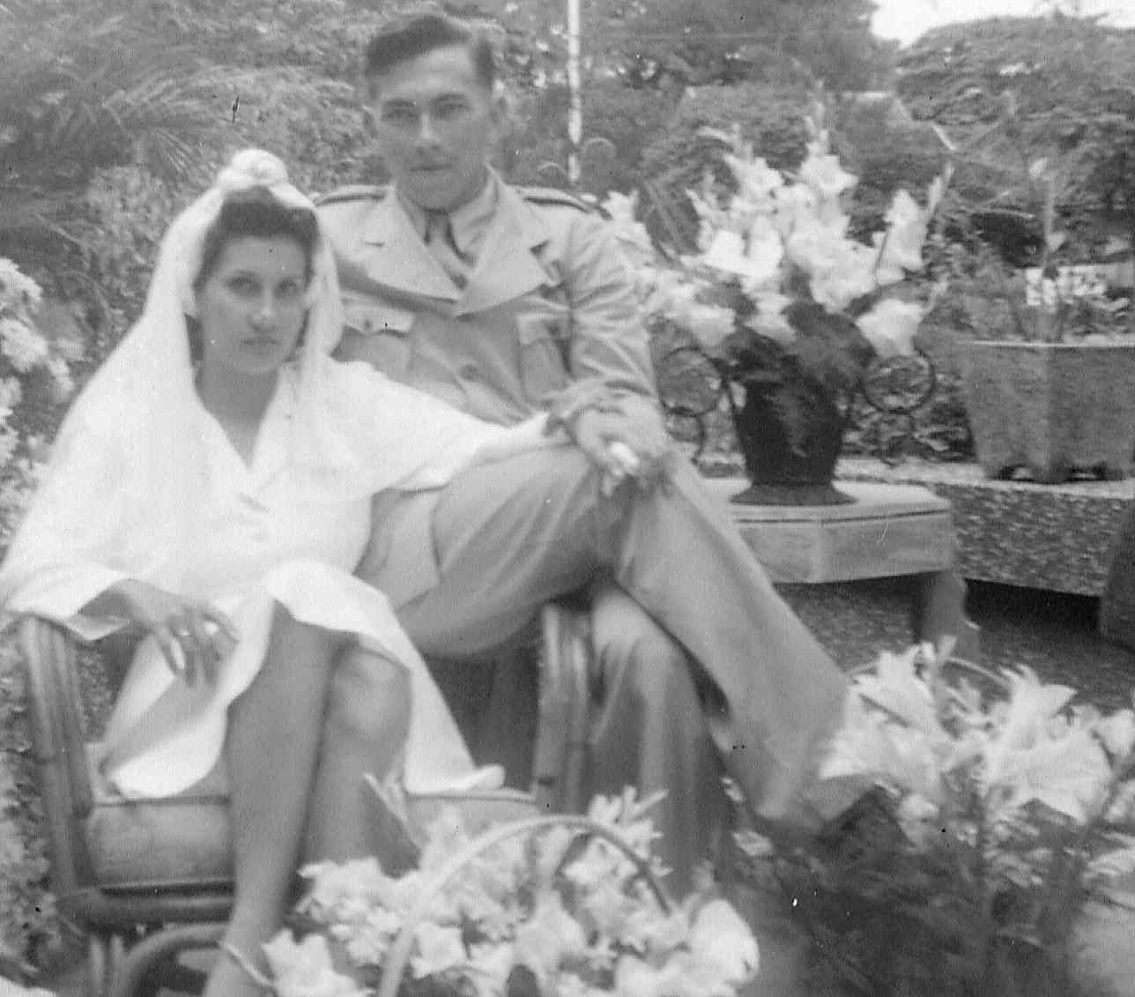
In December 1945 we succeeded to eliminate this group of insurgents and clear the whole area. Also, with help of the Navy, we cleared the Karimata Islands in January 1946 opposite that coastal area of West Borneo. In the meantime I was promoted to cadet-sergeant, together with a colleague of mine (Evert Franken), and some weeks later he was highly decorated with the Bronce Cross and promoted to second Lieutenant at the same time.
In April 1946 I was stationed in Batavia (Djakarta) and 6 months later I finally was stationed in Soerabaja where I had left my girlfriend, Hemelop Lilly (Lieke), in 1941. At last we were reunited, got married and started a family of 3 sons and 1 daughter. When we married on 3 October 1947 in Soerabaja, most of the essential things you need for a wedding were rationed and also the rayon clothe to make a wedding gown. With my marriage-to-come I got an allowance to buy some yards, just enough to make something that looked like a wedding gown as you will notice on the picture (left). To get married I got one day off from duty, although on that particular day there was a parade of the troops because of the change in command of the A-Division in Soerabaja. Two months after our marriage, I was stationed in Bali, where our first son Peter was born.
The hospital in DenPasar was improvises and still very primitive; made of bamboo-matted walls enforced with wooden boards. Instead of beds there were bamboo platforms that could be used as a bed and about a yard above ground level (not cement, just ground!). In such a hospital ward were about 20 of these ¨hospital beds, primitive but very efficient in those days. It also was very common in Bali that the dogs and pigs had free access to the gardens, etc. (there were no fences); and also on the grounds of the hospital with exception of the rooms of the surgery. The patients always had ¨visitors¨! Bali in those days was still very virginal, the women with naked breasts (after several weeks you did not notice it any more) and the beaches (Kutai and Sanur) were unmolested by buildings or hotels with their original clutches of palm tree-bushes.
In January 1949 back to Java and stationed in Bandung where my second son Robert was born in July. This also was the first time I saw my parents and 3 of my sisters again after almost 8 years and they could meet my wife and their grandson. That also was the month that I went over to the Royal Dutch Army because the Royal Dutch East Indies Army was abolished and became history. Several colleagues of mine and many more officers left the army and emigrated to the United States and Australia. The majority of the Indonesian part of the East Indies Army went over to the Indonesian Army and quite a few NCO-s from Indo-European birth. Shortly before the independence of Indonesia my family and I, and many others too, were transported by boat to the Netherlands on the 15th of December 1949 and arrived in Holland 3 weeks later. That was the first time my family and I saw Holland.
In May 1950 I volunteered to go back to Indonesia as an instructor for the Indonesian Army (TNI) and was detailed to the Nederlandse Militaire Missie (translated: Dutch Military Mission). My family (wife and two kids) had to stay behind until they could follow safely and that occurred in May 1951. The DMM lasted 3 and a half years, with transfers from Bandung to Semarang (Mid-Java) and back to Bandung. What I strongly noticed was that the Indonesian Army was very anxious to keep us in Indonesia, but their president¨ Soekarno and his ¨gang had controversial ideas.
In the meantime my family had grown with 2 other kids (a boy and as youngest a girl).
During the Korean War I also wanted to volunteer for the Dutch Battalion in Korea, but my wife would not let me go. !
In December 1953 back again to Holland where I was stationed at various places like Amersfoort, Utrecht and The Hague.
In 1962 I was transferred (with family) to Surinam (South America). Very interesting time, especially as a game hunter (which I always had been) in rainforest-jungles of that kind, I had never encountered or seen before. Just let me be clear about my hunting methods: I always stalk and trace the prey, sometimes with the help of dogs when the jungle was too dense. The moments you got the chance to shoot were never longer than some 2 seconds Unfortunately I did not have too much time for this hobby, also it was not always was without danger. In the 3 years I was in Surname we (my group of 7 hunters) lost 3 men on a tragic hunting-accident on one of the big rivers. We also lost in total 9 dogs on hunting trips. But I did see quite a lot of this country and its hidden places as you will see on this picture.
I also took my wife and the kids during a week-long trip with one of my fellow-hunters to the inlands of Surinam. You had to take food and gasoline for the whole trip with you, and this was quite a private expedition we had to organize, but worth all the trouble. Especially for my kids these 3 years were an unforgettable experience, particularly to get a taste of life in the tropics where they were born.
After the ultimate term of 3 years in Suriname back again to Holland and stationed at Utrecht till 1970. In July I could go to the NATO in Germany and be stationed on the Dutch army-base Seedorf (between Bremen and Hamburg.) where I had to take care of the finances, food and kitchens and the financial and material controls of the units in this army-base. Furthermore the German language was no problem to me, I speak it rather fluently. My wife followed me after 6 months when I had found a nice dwelling in Zeven, 3 miles away from the army-base Seedorf. My 3 youngest kids stayed in Holland in an apartment that I had rented for them.
Cooperation with the German forces and their financial, logistics StandOrt Verwaltung in NiederSachsen of the German Army was excellent. This also was with the German civil authorities. The director of the Dutch school and two army-officers (I was one of them) became charter member of the (new) German Lion´s Club of Zeven (Nieder-Sachsen). The town Zeven was where most of the Dutch families lived and of course Zeven flourished economically by this.
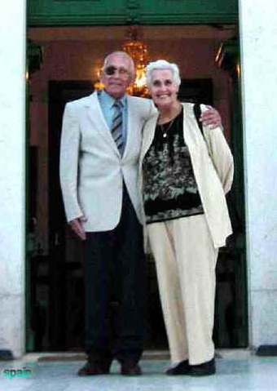
Of almost 36 years active duty in the Army I could luckily spend the last 7 years of active duty in the army in a most interesting, very busy and quite independent job. When I retired in November 1976 my wife and I returned to Holland and after 8 years moved permanently to Spain where I rented a house. I do not own houses or properties, but live happily and comfortably with my pension.
Looking back I could say that since my marriage I have moved quite a lot in this world; during active duty 13 times with my family and 4 times after retirement The last development is that most probably we move (may be for the last time) to a Senior Residence at the end of this year.
We are getting old!

Photo: celebrating 55 years of marriage

Note: See Fukuoka Camp 17 “Camp Description” where Ortwin has submitted input regarding the camp.

